Figure S1. 2D ligand-protein interaction of NS309 (A) and CyPPA analog 2 (B) at PSK2 binding site. The pink arrow is referred to hydrogen bond.

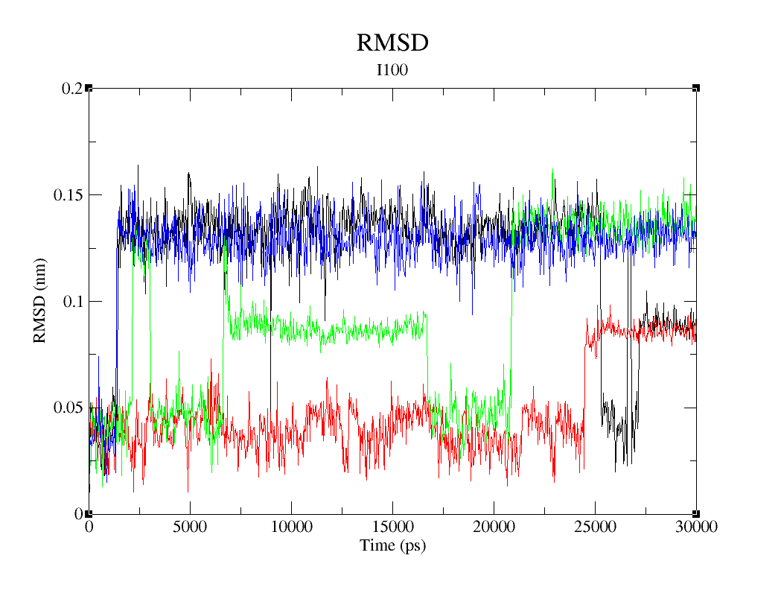
Figure S2. Root mean square deviation (RMSD) of I100 in PSK2 apo structure and its three complexes during the 30 ns molecular dynamics simulation. The black line indicates the apo structure; the red line indicates Riluzole bound complex; the green line indicates NS309 bound complex; the blue line indicates CyPPA analog 1 bound complex. The trajectories of apo structure and NS309 binding complex (black and green lines) are significantly different. We chose the conformations at four time points based on these trajectories.

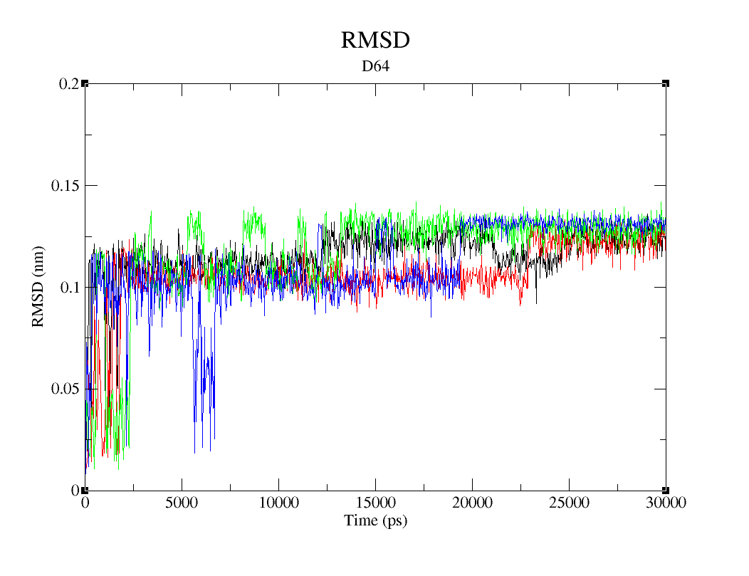

Figure S3. Root mean square deviation (RMSD) of D64 in PSK2 apo structure and its three complexes during the 30 ns molecular dynamics simulation. The black line indicates the apo structure; the red line indicates Riluzole bound complex; the green line indicates NS309 bound complex; the blue line indicates CyPPA analog 1 bound complex. The trajectories of apo structure and CyPPA analog 1 binding complex (black and blue lines) are significantly different. We chose the conformations at four time points based on these trajectories.

Table S1. The Binding Surfaces of CyPPA analog 1 and Riluzole in crystallized structures and predicted structures.
CyPPA analog 1 Binding Surface (<5Å SK2, 5V03) | Riluzole Binding Surface (<5Å SK2, 5V02) | CyPPA analog 1 Binding Surface (<5Å PSK2) | Riluzole Binding Surface (<5Å PSK2)
 |  | T401
 |  | A403
 |  | E404
 | N409 (4.8) | N409 | N409
 | F410 (3.7) | F410 | F410
Q470 (3.6)
L473 (4.4) |  | L473
N474 (3.7) |  | N474
 |  | D475
A477 (3.5) | A477 (3.9) | A477 | A477
 |  | N478 | N478
L480 (3.6) | L480 (3.3) | L480 | L480
V481 (4.5) | V481 (3.5) | V481 | V481
 |  | A484 | A484
CyPPA analog 1 Binding Surface (<5Å Calmodulin-5V03) | Riluzole Binding Surface (<5Å Calmodulin-5V02) | CyPPA analog 1 Binding Surface (<5Å Calmodulin-PSK2) | Riluzole Binding Surface (<5Å Calmodulin-PSK2)
F19 (3.7) | F19 (3.9) | F19 | F19
I27 (4.4) | I27 (4.2) | I27 | I27
L32 (4.0) | L32 (3.8) | L32 | L32
D50 (3.9) |  | D50 | D50
M51 (3.1) | M51 (3.6) | M51 | M51
I52 (4.6) |  | I52 | I52
E54 (3.2) | E54 (2.3) | E54 | E54
V55 (3.5) | V55 (4.6) | V55 | V55
I63 (3.5) | I63 (3.2) | I63 | I63
F68 (3.5) | F68 (3.5) | F68 | F68
M71 (3.8) | M71 (2.5) | M71 | M71
 |  | M72 | M72
 |  |  | R74
 |  | K75 | K75

