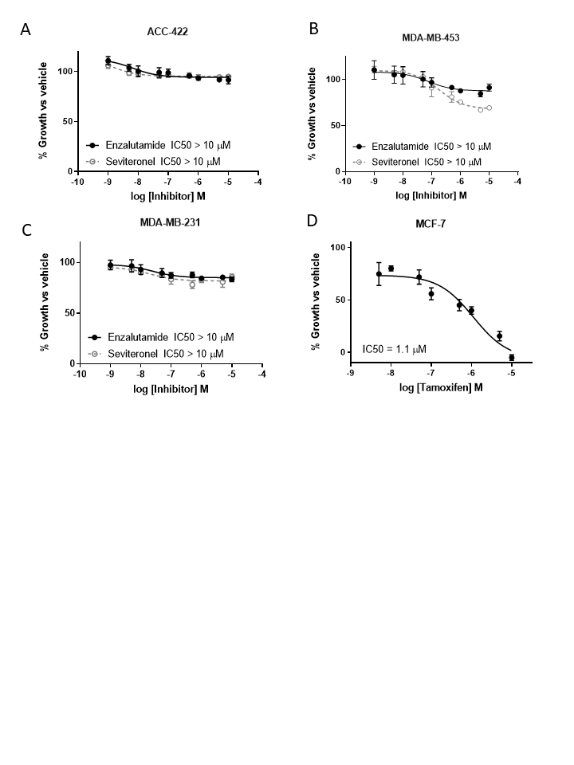
Supplementary Figure 1: Cell viability with inhibitor treatment
AR+ TNBC cell lines were pretreated with CSS and phenol free media overnight before treatment with enzalutamide or seviteronel. Cell viability was assessed via metabolic activity in (A) ACC-422 and (B) MDA-MB-453 cells. (C) Viability of MDA-MB-231 cells, an AR- TNBC cell line, was used as a control. (D) Viability of MCF-7 cells was inhibited with treatment of tamoxifen with an IC50 of 1.1 μM. Graphs represent mean ± SEM for triplicate experiments.

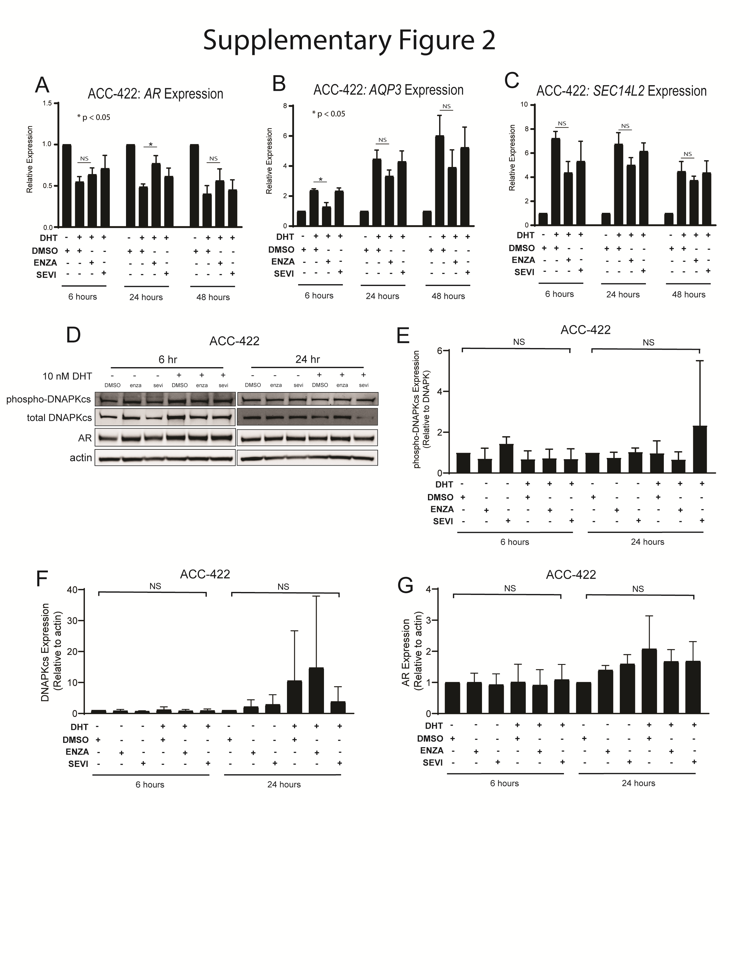

Supplementary Figure 2: Differential effects on AR and AR targets with enzalutamide and seviteronel in ACC-422 cells.
ACC-422, AR+ TNBC cells, were treated with 5 µM enzalutamide or seviteronel ± 10 nM DHT. mRNA expression was assessed via qPCR for (A) AR, (B) AQP3, (C) SEC14L2. Expression of p-DNAPKcs, total DNAPKcs, and AR protein levels were measured by immunoblot (D) and quantified (E-G). Gene expression data represent three independent experiments and are shown as mean ± SEM. Immunoblots are representative of triplicate experiments. (NS = p is not significant, * = p < 0.05).

Supplementary Figure 3: Quantification of DNAPKcs and AR Protein Expression in MDA-MB-453 cells
Quantification of immunoblots for (A) DNAPKcs and (B) AR expression in MDA-MB-453 cells. (NS = p is not significant, ** = p < 0.01).

Supplementary Methods:

Table 1: qPCR primers
XRCC2_AROR1_F1 | GCCTGAACAATGGAGATAAAAGAG
XRCC2_AROR1_R1 | TGCCTCAGGGAACAAATAAGAC
XRCC2_AROR2_F1 | AGCCAAAACACTCCCTCAAG
XRCC2_AROR2_R1 | CTCAAGTCATCTTCCCACCTC
XRCC3_AROR1_F1 | GCCAGCGTTTTGTTAACCTG
XRCC3_AROR1_R1 | GGATTTGGATCTACTGGACCTG
PKRDC_AROR1_F1 | GCATCGCTAGGGAACAAGG
PKRDC_AROR1_R1 | CTGCGATAAACATCTTGACAGAG
PKRDC_AROR2_F1 | AAGGTGTCACTTCCTGTTCAC
PKRDC_AROR2_R1 | TGAGCTATGCTGATTTTACCTAGG
AR Forward | CAGTGGATGGGCTGAAAAAT
AR Reverse | GGAGCTTGGTGAGCTGGTAG
AQP3 Forward | CCGTGACCTTTGCCATGTGCTT
AQP3 Reverse | TTGTCGGCGAAGTGCCAGATTG
SEC14L2 Forward | CCTGAAGACCAAGATGGGAGAG
SEC14L2 Reverse | GCTGTAGGTGTTGTCAAACCGC

Table 2: Plating Densities for Clonogenic Survival Assays
 | MDA-MB-453 | ACC-422 | SUM-185 | SUM-159 | MDA-MB-231 | MCF-7
0 Gy | 250 | 500 | 300 | 150 | 250 | 500
 | 500 | 1000
2 Gy | 1000 | 1000 | 600 | 300 | 500 | 1000
 | 2000 | 2000
4 Gy | 2000 | 10,000 | 1200 | 300 | 1000 | 5000
 | 4000 | 20,000
6 Gy | 2500 | 20,000 | 4500 | 450 | 2500 | 10,000
 | 5000 | 50,000
8 Gy | 5000 |  |  |  | 5000 | 12,500
 | 8000

