Supplementary Table 1. Oligonucleotide primers used for PCR analysis (Source: Yuan et al., 2009; Chiu et al., 2010)
Primer | Sequences (5’-3’) | Annealing temperature (°C)
BoMYB1- F | AGTATGACATATTGTAACAAAGCTGGGGAGAAG | 54.5
BoMYB1 -R | CGTACCTTTTGGAACGAGCCCGTCA | 57.9
BoMYB2- R | GGAAACAGGTGGTCTTTAATTGCT | 50.7
BoMYB2 -F | AGCTCAAATTTATCATCATCTTTGTTACATGTGATTA | 52.4
BoMYB3 -F | GTCCAAACGGTTGAGAAAAGGTGCATAT | 54.4
BoMYB3-R | CCAGCTCTTAAAGGAACTTGGTGCCATTTCCC | 58.8
BoMYB4-F | TGAGTAAGAAACATGAACCAGGTTGT | 51.5
BoMYB4-R | ATCCAAGGCATAGGGGAACAAAT | 51.6
BoMYB2m R | GCTTGAGGAAAAGGGTTTATATTGTGGCT | 54.2
BoMYB2m F | GTCGGAAGTGTTTAAAGAGAGAACATGAT | 51.9
BoMYB2m R | GCTTGAGGAAAAGGGTTTATATTGTGGCT | 54.2
BoMYB2m F | TTAGAGCTATCGGGGCGTGTCTAGAGA | 56.7
BoMYB3m R | TGAAACTGAAGGAGTACTCCCTTGGTAAC | 54.4
BoMYB3m F | GGTGCATGAAGCCGTTCTCTCTTTTAATC | 54.6
BoMYB4m R | AAGGAAGGTTTCTCTTTTTCATTTGGGTCTTAC | 54
BoMYB4m F | CCCAAGTGTATCAGCTACAGAAGAAGCCT | 54.2
BoMYB4m R | AAGGAAGGTTTCTCTTTTTCATTTGGGTCTTAC | 54
BoMYB4m F | TCGTTGTTGGTTTGTCGTTCAGTGAAAT | 56.2

Supplementary Figure 1(A-B) ǀ ‘Broccoli type’ plants in F₂ (A), fixed line DC-466-1-76 in F_{2:3} (B)

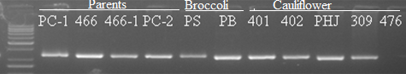

A. BoMYB2 (331 bp)
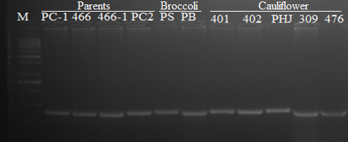
B. BoMYB1 (130 bp)

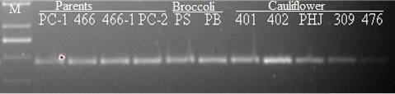
C. BoMYB2m (190 bp)
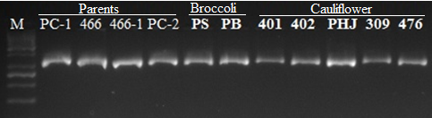
D. BoMYB3m (400 pb)
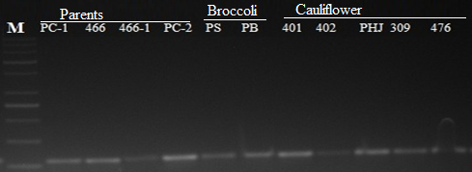
E. BoMYB4m (110 bp)
Supplementary Figure 2A-E ǀ Amplification of molecular markers in parents and other genotypes. BoMYB2 (A), BoMYB1 (B), BoMYB2m (C), BoMYB3m (D) and BoMYB4m (E) marker in genotypes. Here, M₅₀- Marker 50 bp; Parents: PC-1, 466; Bulks: 466-1 and PC-2; Broccoli: PS (Palam Samridhi) and PB (Pusa Purple Broccoli); and Indian white cauliflower- 401 (Pusa Shukti), 402 (DC-402), PHJ (Pusa Himjyoti), 309 (Pusa Sharad) and 476 (Pusa Paushja).
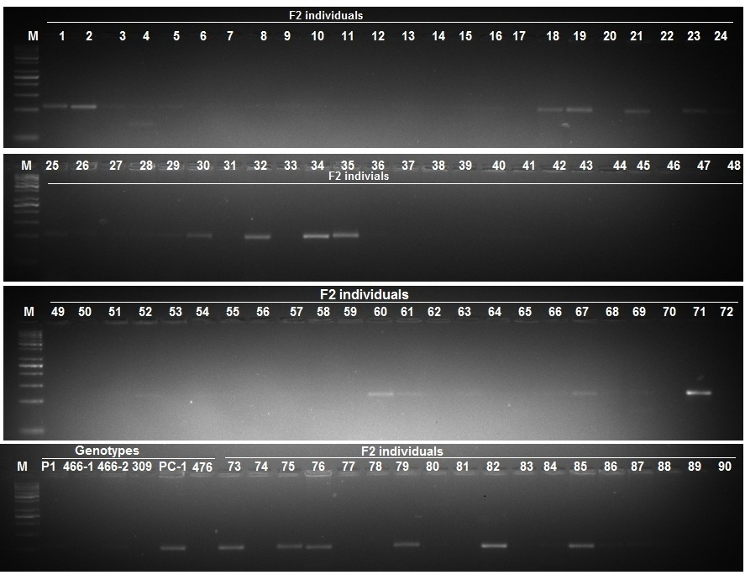

 | Phenotyping and genotyping of first 90 individuals of 173 F₂ population |  |  |  |  |  |  |  |  |  |  |  |  |  |  |  |  |  |  |  |  |  |  |  | Total of phenotyping scoring |  | Total of genotype scoring
Plant No. | 1 | 2 | 3 | 4 | 5 | 6 | 7 | 8 | 9 | 10 | 11 | 12 | 13 | 14 | 15 | 16 | 17 | 18 | 19 | 20 | 21 | 22 | 23 | 24 | Purple | White | Present | Absent
Phenotype | P | P | P | P | P | P | P | P | W | P | W | P | W | P | W | P | P | P | P | W | P | P | P | P | 19 | 5 | 9 | 15
Genotype | + | + | + | + | + | - | - | - | - | - | - | - | - | - | - | - | - | + | + | - | + | - | + | -
Plant No. | 25 | 26 | 27 | 28 | 29 | 30 | 31 | 32 | 33 | 34 | 35 | 36 | 37 | 38 | 39 | 40 | 41 | 42 | 43 | 44 | 45 | 46 | 47 | 48
Phenotype | P | W | P | P | P | P | P | P | P | P | P | P | P | W | W | W | P | P | P | P | P | W | P | W | 17 | 7 | 7 | 17
Genotype | + | + | - | - | + | + | - | + | - | + | + | - | - | - | - | - | - | - | - | - | - | - | - | -
Plant No. | 49 | 50 | 51 | 52 | 53 | 54 | 55 | 56 | 57 | 58 | 59 | 60 | 61 | 62 | 63 | 64 | 65 | 66 | 67 | 68 | 69 | 70 | 71 | 72
Phenotype | W | W | W | P | P | P | W | P | P | P | P | P | P | W | P | W | P | P | W | W | P | P | P | W | 15 | 9 | 7 | 17
Genotype | - | - | - | + | - | - | - | - | - | - | - | + | + | - | + | - | - | - | + | - | + | - | + | -
Plant No | P1 | P1 | P1 | 309 | P2 | 476 | 73 | 74 | 75 | 76 | 77 | 78 | 79 | 80 | 81 | 82 | 83 | 84 | 85 | 86 | 87 | 88 | 89 | 90
Phenotype | W | W | W | W | P | W | P | W | P | P | P | W | W | P | W | P | P | P | W | P | P | W | W | P | 13 | 5 | 7 | 11
Genotype | - | - | - | - | + | - | + | - | + | + | - | - | + | - | - | + | - | - | + | + | - | - | - | - | 64 | 26 | 30 | 60
No. of F₂ individuals observed here = 90; No. of recombinants = 41

Supplementary Figure 3 ǀ Amplification of BoMYB3 marker in genotypes and 90 F₂ plants. M₅₀- Marker 50 bp. White curd genotypes: DC-466 (Parent), DC-466-1, DC-466-2 and DC-309 (Pusa Sharad); purple curd genotypes: PC-1 (parent-2), 476 (Pusa Paushja)- a white curd genotype. S.No. 1 - 90 are F₂ plants.

