Supplementary Material
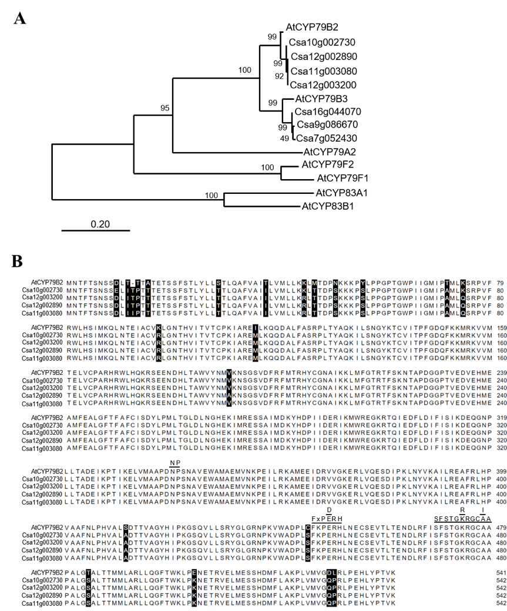

Supplementary Figure 1. A phylogenetic tree of CsCYP79Bs and AtCYP79B family.
(A) Phylogenetic tree of potential CY79Bs in Camelina. The tree was constructed with Maximum Likelihood method and Poisson correction model. Bootstrap with 1000 replicates was performed. (B) Alignment of AtCYP79B2 and its homologs from Camelina. Conserved motifs for CYP79 family protein were labeled with black lines.
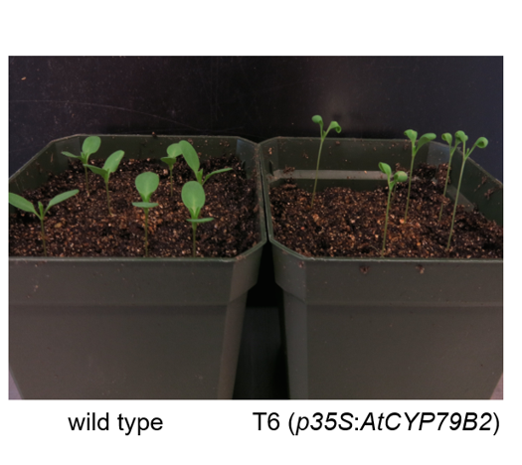

Supplementary Figure 2. Soil-grown Camelina plants overexpressing AtCYP79B2 display morphological phenotypes distinguishable from wild type.
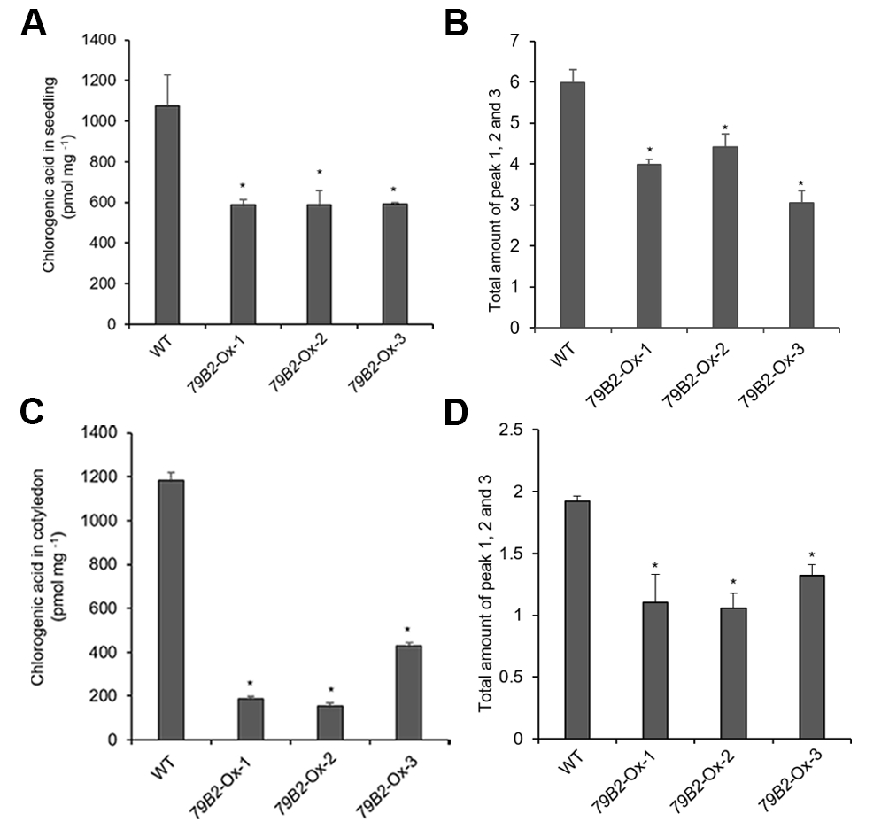

Supplementary Figure 3. Phenylpropanoid contents in seedlings and cotyledons.
Chlorogenic acid contents and the total sum of peak 1, 2 and 3 in seedlings (A, B) and cotyledons (C, D) of the AtCYP79 overexpression lines compared with wild type are shown. Cotyledon and leaf samples were collected from 2-week-old soil grown plants and seedlings were grown on MS plates for 7 days. Data represent mean ± SE from three independent biological replicates. * represents P < 0.05 (two-tailed student’s t-test) when compared with wild type.

Supplementary Table 1. A Diagnostic MRM transitions and optimized instrument setting for IAA quantification

Compound | MRM transition | CE (V) | RF (V) | Retention time (min) | LOD (fmol) | Linear range (pmol)/R²
IAA | 175.983 > 130.071  > 103.071  > 77.000 | 17.258  33.138  45.101 | 47.237 | 3.65 ± 0.051 | 5.0 | 0.01-500/0.9999
[¹³C₆]-IAA | 181.933 > 136.000  > 109.000  > 81.000 | 16.710  33.012  43.248 | 49.461 | 3.65 ± 0.051 | 5.0 | 0.01-500/0.9999

Supplementary Table 2. Sequence identities among Arabidopsis KFBs and Camelina KFBs

Group | Gene name | AtKFB1 (%) | AtKFB20 (%) | AtKFB39 (%) | AtKFB50 (%)
CsKFB1-like | Csa17g021220 | 89 | 70 | 36 | 34
CsKFB1-like | Csa03g019430 | 88 | 68 | 35 | 34
CsKFB1-like | Csa14g018700 | 87 | 66 | 36 | 34
CsKFB20-like | Csa09g094570 | 67 | 81 | 31 | 33
CsKFB20-like | Csa07g059430 | 67 | 83 | 31 | 34
CsKFB39-like | Csa06g050450 | 39 | 37 | 79 | 63
CsKFB39-like | Csa05g006160 | 37 | 36 | 78 | 62
CsKFB39-like | Csa04g061960 | 38 | 36 | 77 | 61
CsKFB50-like | Csa07g005130 | 37 | 35 | 59 | 85
CsKFB50-like | Csa05g091560 | 36 | 36 | 60 | 86
CsKFB50-like | Csa16g006020 | 35 | 34 | 59 | 85

Supplementary Table 3. Transcript abundance of CsKFBs in Camelina wild type.

Gene | Ct value (mean ± sd)
CsKFB1-like | 24.06 ± 0.257829
CsKFB20-like | 23.34 ± 0.298016
CsKFB39-like | 26.47 ± 0.122349
CsKFB50-like | 21.65 ± 0.202467

Supplementary Table 4. The list of primers used for this study

Primer Name | Sequence (5’ -> 3’)
P1 | ACGAACAAGGCAACCCATTGCTTAC
P2 | GGGATGTCGGATTCTTGAACGAGTCTC
P3 | ACA ATT TCC CGC TCT GCT GTT GTG
P4 | AGG GTT TCT CTC TTC CAC ATG CCA
P9 | GATGTGTCTACGTGGCAGTGGG
P10 | CACTTTCTTCCACGTGTCGTTCGT
P19 | GGGGACAAGTTTGTACAAAAAAG  CAGGCTTCATGGTAGTGTCAAAGAAGAAATC
P20 | GGGGACCACTTTGTACAAGAAAGC  TGGGTTTTTAGACATAGATTGAAGAATAAGAAAAAG
P47 | TGGTGGAGCCTTACAACGCTACTT
P48 | TTCACAGCAAGCTTACGGAGGTCA
P98 | ACGTGGCATAAAGTTGGGGAG
P99 | GAAGCAACCAGCTTGAACGTG
P100 | GAAGACGGGAAGTTCAGTTTTCGC
P101 | GGAAGAGTAGAGAAAGCTGAAGGTAT
P102 | GTTATGGAGACGATTAGGCTCCC
P103 | GAAGACTCGAAAAACCAGAGGGAG
P121 | GCTTCACGAGATGGATCCGTTAC
P122 | GAGTTGATCTCACGCTCGAT
P125 | GAGTCGGAGCTGAGATTGCTTC
P126 | GTTTTCCATCAGAAATCGCAGAC

