Supplementary Material

Table S1. Treg suppressive activity and reduced disease-modifying anti-rheumatic drug (DMARD) regimen of rheumatoid arthritis patients
Patient ID* | Suppressive activity (%) | DAS  28 | VAS | ESR | Serology | Reduced DMARD regimen
 |  |  |  |  |  | MTX, mg/wk | LEF, mg/wk | SSZ, mg/day | HCQ, mg/wk | AZA, mg/wk
DT001-1st | 42 | 2.3 | 0.0 | 27 | Negative | 10 | 80 | - | - | -
DT001-3^{rda} | 26 | 2.8 | 0.0 | 57 | - | Re-initiation original DMARD regimen
DT002-1st | 40 | 1.9 | 0.0 | 15 | Positive | 20 | 40 | 2,000 | - | -
DT002-2^{nda} | 11 | 3.4 | 50.0 | 14 | -
DT003-1st | 71 | 2.6 | 0.0 | 40 | Negative | 10 | - | 500 | 1,000 | -
DT003-2nd | 46 | 2.6 | 0.0 | 43 | - | 5 | - | 250 | 500 | -
DT003-3rd | 58 | 2.4 | 0.0 | 33 | - | 5 | - | 250 | 500 | -
DT003-4^{thb} | 42 | 2.6 | 0.0 | 41 | - | 5 | - | 250 | 500 | -
DT004-1st | 28 | 2.7 | 20.0 | 32 | Positive | 20 | 80 | - | 250 | -
DT004-2^{nda} | 17 | 3.5 | 30.0 | 24 | - | Re-initiation original DMARD regimen
DT005-1st | 34 | 1.0 | 0.0 | 4 | Negative | 15 | 80 | - | - | -
DT005-2nd | 36 | 0.8 | 0.0 | 3 | - | 7.5 | 40 | - | - | -
DT005-3^{rda} | 8 | 3.0 | 50.0 | 25 | - | Re-initiation original DMARD regimen
DT006-1st | 75 | 2.5 | 10.0 | 30 | Positive | 15 | - | - | 1,000 | -
DT006-2nd | 67 | 2.2 | 10.0 | 20 | - | 7.5 | - | - | 500 | -
DT006-3^{rda} | 47 | 3.2 | 30.0 | 34 | - | Re-initiation original DMARD regimen
DT007-1st | 51 | 1.4 | 0.0 | 7 | Positive | 5 | - | 500 | - | 100
DT007-2nd | 33 | 1.7 | 10.0 | 10 | - | 2.5 | - | 250 | - | 50
DT007-3^{rda} | 17 | 2.3 | 50.0 | 10 | - | Re-initiation original DMARD regimen
DT008-1st | 62 | 2.4 | 0.0 | 30 | Positive | 10 | 80 | - | 1,500 | -
DT008-2nd | 52 | 1.7 | 0.0 | 12 | - | 5 | 40 | - | 750 | -
DT008-3rd | 77 | 1.6 | 0.0 | 10 | - | 5 | 40 | - | 750 | -
DT008-4^{thb} | 77 | 2.6 | 20.0 | 14 | - | 7.5 | 60 | - | 750 | -
DT009-1st | 48 | 2.1 | 0.0 | 20 | Negative | 15 | 160 | 2,000 | - | -
DT009-2nd | 53 | 2.0 | 0.0 | 17 | - | 7.5 | 80 | 1,000 | - | -
DT009-3rd | 42 | 2.2 | 0.0 | 25.0 | - | 7.5 | 80 | 1,000 | - | -*
DT009-4^{thb} | 43 | 2.1 | 0.0 | 22.0 | - | 7.5 | 80 | 1,000 | - | -
*n^{th} refers to the visit following reduced DMARD dose regimen
ªRelapse after reduced DMARD dose regimen
^{b}Ongoing remission on week 24 post-reduced DMARD dosage regimen
AZA, azathioprine; DAS28, disease activity score-28; ESR, erythrocyte sedimentation rate; HCQ, hydroxychloroquine; LEF, leflunomide; MTX, methotrexate; SSZ, sulfasalazine; VAS, visual analogue scale; Serology, anti-citrullinated protein antibodies and/or rheumatoid factor
Note: Suppressive activity of DT001^{2nd} visit was not assessed.

Cytokines  (pg/mL), median ± IQR | Baseline | Remission | p-values
IL-4 | 20.21 ± 21.16 | 35.51 ± 177.78 | 0.309
IL-6 | 4.01 ± 4.02 | 6.52 ± 3.94 | 0.301
IL-9 | 2.08 ± 1.34 | 3.71 ± 1.01 | 0.051
IL-10 | 35.90 ± 23.11 | 42.02 ± 3.94 | 0.782
IL-17F | 2.42 ± 5.65 | 6.46 ± 3.50 | 0.301
IL-21 | 5.46 ± 10.18 | 13.33 ± 8.61 | 0.405
IL-22 | 28.27 ± 14.98 | 42.68 ± 103.77 | 0.167
IFN-γ | 8.27 ± 12.13 | 14.44 ± 6.55 | 0.309
TNF-α | 16.21±29.18 | 34.53 ± 9.02 | 0.165
TGF-β, ng/mL (mean ± SD) | 321.04 ± 210.82 | 283.57 ± 248.54 | 0.803

Table S2. Cytokine levels in rheumatoid arthritis patients with ongoing remission (n = 3)

*Significance at p-value<0.05. IFN-γ, interferon-γ; IL, interleukin; IQR, interquartile range; TGF-β, transforming growth factor β; TNF-α, tumour necrosis factor-α
Note: IL-2, IL-5, IL-13 and IL-17A levels were lower than the limit of detection at all visits (data not show)

Table S3 Univariate analysis: potential variables associated with a flare during DMARDs reduction
Parameters/Markers | OR | 95% CI | P-value
T cell properties
Foxp3+Tregs | 0.282 | 0.047–1.699 | 0.167
CD4+CD25high+CD127low− | 0.359 | 0.050–2.156 | 0.263
CD4+CD25+CD127+ | 1.175 | 0.684–2.017 | 0.560
CD4+CD25+ | 1.166 | 0.708–1.922 | 0.546
Foxp3+Treg intracellular ratio | 8.150 | 0.003–2.638 | 0.611
Treg extracellular ratio | 0.007 | 0.000–1.185 | 0.058
Treg suppressive activity | 0.841 | 0.731–0.968 | 0.016*
Plasma cytokines
IL-2 | 0.248 | 0.035–1.777 | 0.165
IL-4 | 0.934 | 0.726–1.201 | 0.595
IL-6 | 1.204 | 0.931–1.556 | 0.157
IL-9 | 1.206 | 0.689–2.110 | 0.512
IL-10 | 1.058 | 0.998–1.116 | 0.058
IL-13 | 3.161 | 0.734–13.606 | 0.122
IL-17A | 11.542 | 0.562–237.023 | 0.113
IL-17F | 0.614 | 0.113–2.830 | 0.532
IL-21 | 1.120 | 0.795–1.579 | 0.517
IL-22 | 1.095 | 0.788–1.521 | 0.590
IFN-Ƴ | 1.078 | 0.859–1.352 | 0.517
TNF-α | 0.991 | 0.923–1.064 | 0.805
TGF-β | 1.003 | 0.997–1.008 | 0.373
Others
Age | 1.049 | 0.946–1.162 | 0.366
WBC | 1.320 | 0.745–2.341 | 0.342
Lymphocyte | 0.882 | 0.756–1.028 | 0.108
ESR | 0.965 | 0.862–1.081 | 0.539
ACPA/RF positive | 1.183 | 0.891–1.573 | 0.246
DAS28 | 1.201 | 1.051–9.543 | 0.037*
VAS | 1.164 | 1.034–1.210 | 0.012*
*Significance at p-value<0.05. Tregs: regulatory T cells, WBC: white blood cell count, ESR: erythrocyte sedimentation rate, ACPA: anti-citrullinated protein antibodies, RF: rheumatoid factor, VAS: visual analogue scale, DAS28: disease activity score-28

Table S4 Multivariable predictors associated with a flare during DMARDs reduction
Parameters/Markers | OR | 95% CI | P-value
Treg suppressive activity | 0.843 | 0.726–0.978 | 0.025*
DAS28 | 2.213 | 0.006–7.747 | 0.197
VAS | 1.122 | 0.979–1.285 | 0.098
*Significance at p-value<0.05. VAS: visual analogue scale, DAS28: disease activity score-28

Table S5 Clinical course of 9 patients regarding to symptom onset, disease duration, bone erosion and extra-articular manifestation
Patient/Code | Symptom onset | Disease duration | Bone erosion | Extra-articular
DT001 | 1 month | 6 years | no | no
DT002 | 1 year | 11 years | yes | no
DT003 | 3 months | 7 years | yes | no
DT004 | 2 months | 11 year | no | no
DT005 | 2 months | 5 years | yes | yes
DT006 | 1 month | 7 years | no | no
DT007 | 10 years | 11 years | yes | yes
DT008 | 6 months | 4 years | no | no
DT009 | 3 months | 7 years | no | no

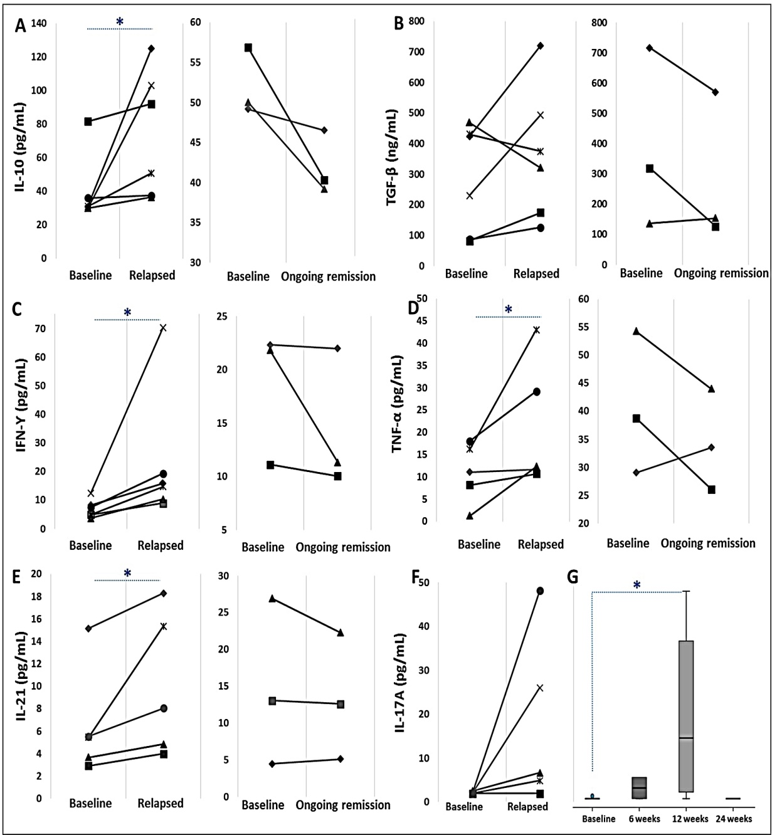
Supplementary Figure 1. Plasma cytokine levels in the peripheral blood of rheumatoid arthritis (RA) patients with disease-modifying anti-rheumatic drug (DMARD) dose reduction. (A) IL-10, (B) TGF-β, (C) IFN-γ, (D) TNF-α, (E) IL-21 and (F) IL-17A levels were determined at baseline and at relapse visits as well as during ongoing remission (at 24 weeks). These cytokine levels were compared between baseline and at disease relapsed (left-hand side of each figure) and between baseline and ongoing remission (right-hand side of each figure). (G) IL-17A levels at different visits of patients with relapse at 6 and 12 weeks and of patients with ongoing remission at 24 weeks after DMARD dose reduction. Paired sample t-test analysis for TGF-β and Wilcoxon signed-rank test for other cytokines were conducted. Mann–Whitney U-test was used for IL-17A at different visits. *p < 0.05.

