Supplementary Figure 1. Timeline of the study.
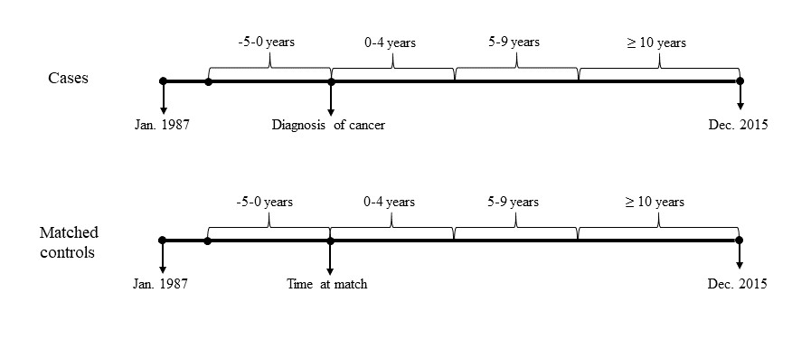

Supplementary Table 1. Definition and number of cancer types.
Cancer types | ICD-7 codes | Number
Oral (upper aerodigestive tract) | 140, 141, 143-148, 161 | 13874(1.9%)
Salivary gland | 142 | 1284(0.2%)
Oesophageal | 150 | 6796(0.9%)
Stomach | 151 | 17571(2.4%)
Small intestine | 152 | 3315(0.5%)
Colon | 153 | 60712(8.3%)
Rectum | 154 (except 1541) | 31868(4.4%)
Anus | 1541 | 1725(0.2%)
Liver | 155, 156 | 16697(2.3%)
Pancreas | 157 | 17248(2.4%)
Nose | 160 | 946(0.1%)
Lung | 162, 163 | 57763(7.9%)
Breast | 170 | 87300(11.9%)
Cervix | 171 | 4143(0.6%)
Endometrium | 172 | 22253(3.0%)
Uterus | 173 | 6(0.0%)
Ovary | 175 | 12022(1.6%)
Other female genital | 176 | 3405(0.5%)
Prostate | 177 | 152624(20.8%)
Testis | 178 | 446(0.1%)
Other male genital | 179 | 1314(0.2%)
Kidney | 180 | 16721(2.3%)
Urinary bladder | 181 | 39584(5.4%)
Melanoma | 190 | 25137(3.4%)
Skin | 191 | 49455(6.8%)
Eye | 192 | 1600(0.2%)
Nervous system | 193 | 14334(2.0%)
Thyroid gland | 194 | 3142(0.4%)
Endocrine glands | 195 | 9397(1.3%)
Bone | 196 | 538(0.1%)
Connective tissue | 197 | 3742(0.5%)
Non-Hodgkin's lymphoma | 200, 202 | 32053(4.4%)
Hodgkin's lymphoma | 201 | 1176(0.2%)
Myeloma | 203 | 10161(1.4%)
Leukaemia | 204, 209 | 12549(1.7%)

Supplementary Table 2. E-value
Cancer types | E-value for the point estimate | E-value for the upper CI
Oral (upper aerodigestive tract) | 1.96 | 1.60
Salivary gland | 1.21 | 1.00
Oesophageal | 5.33 | 2.97
Stomach | 2.78 | 2.17
Small intestine | 2.04 | 1.11
Colon | 1.77 | 1.60
Rectum | 2.17 | 1.92
Anus | 2.00 | 1.00
Liver | 4.57 | 3.11
Pancreas | 6.12 | 3.68
Nose | 1.28 | 1.00
Lung | 2.45 | 2.08
Breast | 1.60 | 1.46
Cervix | 1.63 | 1.00
Endometrium | 1.81 | 1.60
Ovary | 2.72 | 2.12
Other female genitals | 1.74 | 1.00
Prostate | 1.96 | 1.88
Testis | 1.74 | 1.00
Other male genitals | 2.08 | 1.00
Kidney | 2.08 | 1.70
Urinary bladder | 1.56 | 1.39
Melanoma | 2.12 | 1.88
Skin | 1.56 | 1.39
Eye | 2.21 | 1.00
Nervous system | 1.16 | 1.00
Thyroid gland | 1.96 | 1.11
Endocrine glands | 1.21 | 1.00
Connective tissue | 1.77 | 1.00
Non-Hodgkin's lymphoma | 2.00 | 1.74
Hodgkin's disease | 2.12 | 1.00
Myeloma | 1.88 | 1.39
Leukaemia | 1.81 | 1.32
Smoking-related# | 1.96 | 1.85
Non-smoking-related | 1.81 | 1.77
All | 1.85 | 1.81

