Appendix

We performed an additional study to determine if the addition of compliance (captured by an electrical analog of a capacitor) in parallel to the pulmonary arterial system (Fig. S1a) can match clinically-measured pressure and diameter waveforms more accurately. To do so, Eq. (1f) was modified as follows:

$\frac{dV_{pa}(t)}{dt}=q_{pvv}\left(t\right)-q_{pa}\left(t\right)-q_{pa2}\left(t\right)$ (A1a)

$q_{pa2}=C_{pa}\frac{{dP}_{pa}}{dt}$ (A1b)

with$C_{pa}=0.0025 Pa•ml$ as well as increasing the stiffness of the pulmonary arteries with the parameters $c_{PA,1}$ = 90kPa, $c_{PA,2}=200kPa, c_{PA,4} = 10 kPa.$ This addition of compliance led to a better match of the pulmonary artery pressure and diameter waveforms, as well as the pressure-volume loops with the experimental data (Fig. S1b - d).
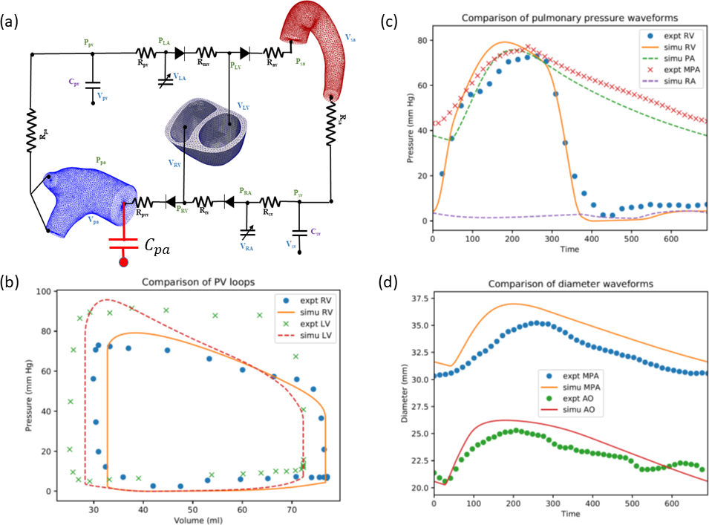
Figure S1 (a): Modified framework with an additional compliance (in red) in the pulmonary circulation. Comparison of (b): pressure-volume loops, (c): pressure waveforms of the pulmonary circulation and (d) pressure-diameter waveform.

