Supplementary Material

Supplementary Figures
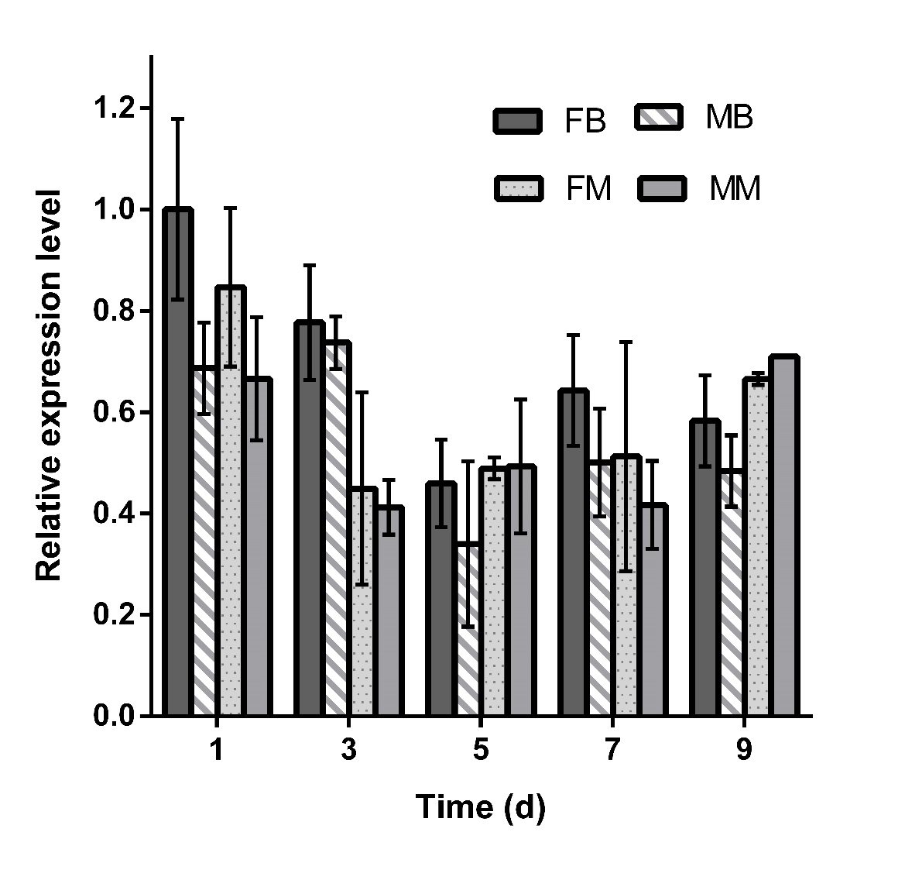
Supplementary Figure 1. Expression patterns of NlATG1 in adults at different days after eclosion. The mRNA level was normalized relative to the RPS11 levels, and the reference was the mRNA level of BPH 1 day after eclosion. FB: female brochypterous; MB: male brochypterous; FM: female macropterous; MM: male macropterous.
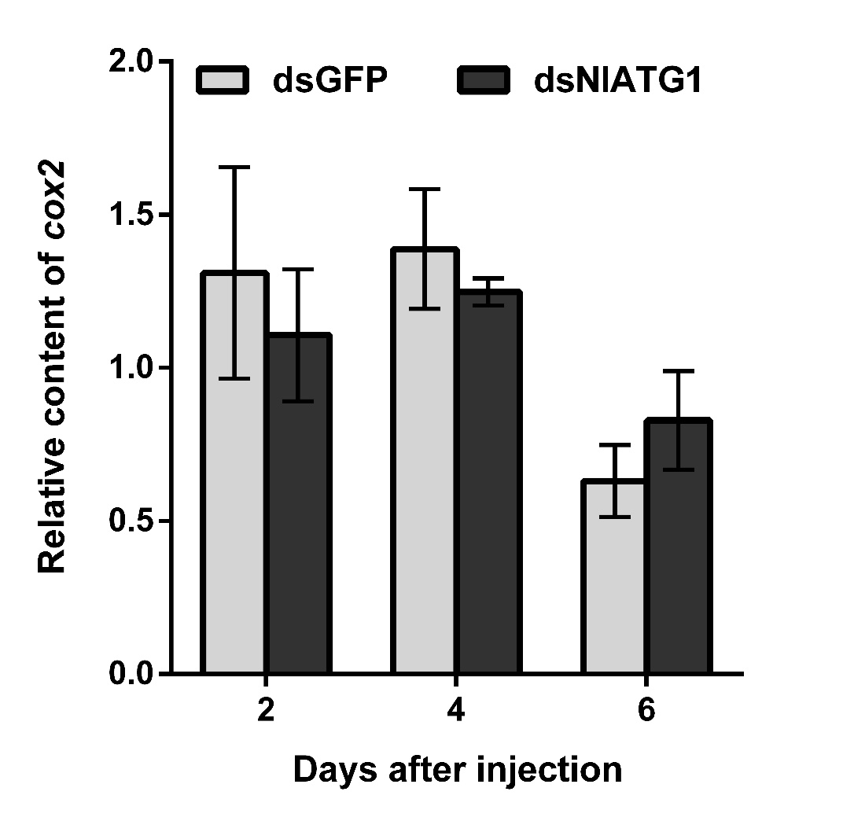
Supplementary Figure 2. Mitochondrial DNA (mtDNA) content after dsNlATG1 injection. MtDNA was quantified by qPCR, normalized relative to the nuclear gene as an internal reference. The mitochondrial-encoded gene was cox2, and the nuclear-encoded gene was Ndufs7. The relative copy number of genes was analyzed by the 2^{–ΔΔCt} method. The primers for mitochondrial DNA are given in Table S1. All values are presented as the means ± SD of three independent replicates.

Supplementary table
Name | Sequence （5'→ 3'）
Primers for cDNA cloning
NlATG1-F | ATGAGAATGTCGTGGCGTTG
NlATG1-R | ACCGCCAGCACAAAGTTCAG
NlATG1-3′RACE outer | GTTATGGCTGCTACGCTGTGTGG
NlATG1-3′RACE inner | TCACAGTTTCCCAGTTTGCCTC
NlATG1-5′RACE outer | TGAGAAAGGGCGAACTGACCACT
NlATG1-5′RACE inner | TCATCGGGAGGCGTTTGGTTTT
NlATG1-FL-F | CGGAGACAGAAGGCAGATTG
NlATG1-FL-R | TTCCAATACCCCAACTAATG
Primers for real-time qPCR
NlATG1-qF | GACGCCTTCTTTTCGCACGC
NlATG1-qR | GGAAGACAACTGGGTGGGGG
NlRPS11- qF | CCGATCGTGTGGCGTTGAAGGG
NlRPS11- qR | ATGGCCGACATTCTTCCAGGTCC
cox2- qF | CACAGATTTCGGAGCAT
cox2 qR | CTTCCTTACCCAACTAC
Ndufs7- qF | ATTCTATCGCATCCTCT
Ndufs7- qR | CTCGCTGGGTTATTTCA
NlFis1- qF | GCATCGGAGACAGGACA
NlFis1 qR | CCTTTGCGTACATCAGC
NlMarf- qF | ATGGCAAAGCTACTACCC
NlMarf- qR | CTCCACGAGAACCTGAACT
dsRNA synthesis
dsNlATG1-F | GGATCCTAATACGACTCACTATAGGGCTGGCGGTGAGCGAGTGCGTGA
dsNlATG1-R | GGATCCTAATACGACTCACTATAGGGTCTTCCAATACCCCAACTAATG
dsGFP-F | GGATCCTAATACGACTCACTATAGGGAAGGGCGAGGAGCTGTTCACCG
dsGFP-R | GGATCCTAATACGACTCACTATAGGGCAGCAGGACCATGTGATCGCGC
Supplementary Table 1. PCR primers used in the study

