Supplementary Material
Supplementary Figure S1. Height of control and PBTS1 and PBTS2 co-infected ‘UCB-1’ clonal plants monitored over a growth period of 4.5 months in a greenhouse. The data were first checked for normality of residuals per treatment (Shapiro-Wilk test) and homoscedasticity of variances. These assumptions were met and subsequent analysis was done using one-way analysis of variance (ANOVA), followed by a post hoc Tukey test to compare control and infected plants. No statistical differences were detected between both plant groups (p<0.05; n=10 for controls; n=25 for infected plants).
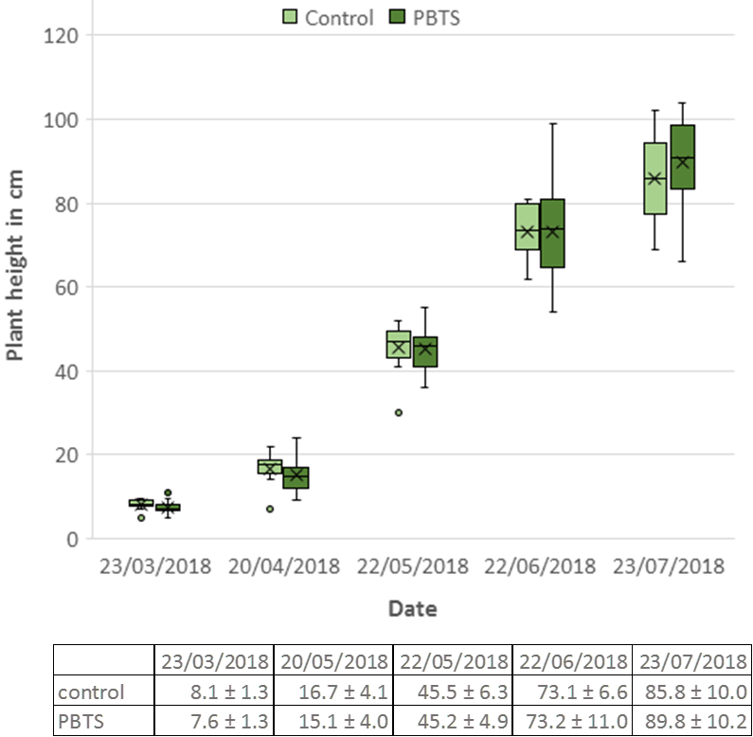

Supplementary Figure S2. Alignment of the vic, fasC, fasD, fasE, and fasF sequences obtained via (q)PCR from PBTS1, PBTS2, and D188 generated by Clustal Omega.
(A) Alignment of the vicA qPCR products generated with the vicA-EN primers on gDNA of PBTS1 and PBTS2 with vicA of D188 (NZ_CP015235)

vicA_PBTS1 ---------------------------------------------------------ATC 3
vicA_D188 GTCGATCTGGATCTCGAAGTGCAAACCGTTGTGCACGAACAAGATTGCCGTCGGCGCATC 1500
vicA_PBTS2 ---------------------------------------------------------ATC 3
***

vicA_PBTS1 GGGTGTGCCCTGGTATCCCAACAGCTGTGCCGGATCCTTCAGGCCCACGGTGCTGCCATC 63
vicA_D188 GGGTGTGCCCTGGTAGCCCAACAGCTGGGACGGATCCTTCAGGCCGACGGTGCTGCCGTC 1560
vicA_PBTS2 GGGTGTGCCCTGGTAGCCCACCAGCTGGGACGGATCCTTCAGGCCGACGGTGCTGCCGTC 63
*************** **** ****** * *************** *********** **

vicA_PBTS1 GGCCAACGTCACTGTCAGCGACGCGGCGTCGACGACGTATCCGGTGGTCCCGACGTGCGA 123
vicA_D188 GGCCAACGTCACCGTCAGCGAGGCGGCGTCGACGACGTATCCGGTGGTCCCGACGTGCGA 1620
vicA_PBTS2 GGCCAACGTCACCGTCAGCGAGGCGGCGTCGACGACGTATCCGGTGGTCCCCACGTGCGA 123
************ ******** ***************************** ********

vicA_PBTS1 GCCGGAGCTCAGCGGCAATGCCTCGTCGAGGAAGTCACGCGCGAACGCGATGACCTTGTC 183
vicA_D188 GCCGGAGCTCAGCGGCAATGCCTCGTCCAGGAAGTCACGCGCGAACGCGATGACCTTGTC 1680
vicA_PBTS2 GCCGGAGCTCAGCGGCAATGCCTCGTCGAGGAAGTCACGCGCGAACGCAATGACTTTGTC 183
*************************** ******************** ***** *****

vicA_PBTS1 TCCGCGGACCTTGTTGTAGCTCGAGCCCTTCTCGGCTCCGTCGGTCTCGGGAATGGCGTC 243
vicA_D188 TCCGCGGACCTTGTTGTAGCTCGTGCCCTTCTCGGCTCCGTCGGTCTCGGGGATGGCGTC 1740
vicA_PBTS2 TCCGCGGACCTTGTTGTAGCTCGTGCCCTTCTCGGCTCCGTCGGTCTCGGGGATGGCGTC 243
*********************** *************************** ********

vicA_PBTS1 CGTTCCGTAGAGGGCGTCGTAGAGCGAGCCCCATCGTGCGTTGGAGGCATTGATCGCAAA 303
vicA_D188 CGTTCCATAGAGGGCGTCGTAGAGCGAGCCCCATCGTGCGTTGGAGGCATTGATCGCAAA 1800
vicA_PBTS2 CGTTCCGTAGAGGGCGTCGTAGAGCGAGCCCCATCGTGCGTTGGAGGCATTGATCGCGAA 303
****** ************************************************** **

vicA_PBTS1 GCGTGCATTGAGCACAGGAACCACCAGCTGCGGCCCGGCCGTGGTGGTGATCTCGGTGTC 363
vicA_D188 GCGTGCATTGAGCACGGGAACCACGAGCTGCGGCCCGGCCGTGGTGGTGATCTCGGTGTC 1860
vicA_PBTS2 GCGTGCGTTGAGCACGGGAACCACCAGCTGCGGCCCGGCCGTGGTGGTGATCTCGGTGTC 363
****** ******** ******** ***********************************

vicA_PBTS1 CACGCCGGAGGTGGTGATCTGGAAGTCGGCAGGCTCGTCGAGCAGGTAGCCGATCTCTTT 423
vicA_D188 CACGCCGGACGTGGTGATCTGGAAGTCGGCGGGCTCGTCGAGCAGGTAGCCGATCTCTTT 1920
vicA_PBTS2 CACGCCGGACGTGGTGATCTGGAAGTCGGCGGGCTCGTCGAGCAGGTAGCCGATCTCTTT 423
********* ******************** *****************************

vicA_PBTS1 CAG--------------------------------------------------------- 426
vicA_D188 CAGGAAGGCCTTGTACGCTGCGCGGTCGTATTCGGCACCGGCATGCTCGCCGTGCCACGC 1980
vicA_PBTS2 CAG--------------------------------------------------------- 426
***

(B) Alignment of the vicA2 qPCR product generated with the vicA2-JR primers on gDNA of PBTS1 with the published vicA2 sequence of PBTS1 (NZ_CP015219)

vicA2 ACCACCTCCGGGGTGGACCGGGAGATCACCTCCACCGCGGGTCCGCAGTTGGTGGTGCCG 360
vicA2_PBTS1 --------------------------CACCTCCACCGCGGGTCCGCAGTTGGTGGTGCCG 34
**********************************

vicA2 GTGCTCAACGCCCGCTTCGCGATCAACGCCTCCAACGCTCGCTGGGGCTCGCTCTACGAC 420
vicA2_PBTS1 GTGCTCAACGCCCGCTTCGCGATCAACGCCTCCAACGCTCGCTGGGGCTCGCTCTACGAC 94
************************************************************

vicA2 GCCCTGTACGGCACGGACGCCATCACCGAGGACGGGGGCGCCGAGAAGGGCACCTCCTAC 480
vicA2_PBTS1 GCCCTGTACGGCACGGACGCCATCACCGAGGACGGGGGCGCCGAGAAGGGCACCTCCTAC 154
************************************************************

vicA2 AACCGGGTCCGCGGCGACAAGGTCATCGCCTACGCGCGGGCGTTCCTCGACGAGGCCGTG 540
vicA2_PBTS1 AACCGGGTCCGCGGCGACAAGGTCATCGCCTACGCGCGGGCGTTCCTCGACGAGGCCGTG 214
************************************************************

vicA2 CCGCTGGAGTCGGGCTCGCACGTCGACGCCACGTCCTACGTGATCGACGGCTCCGCCCTC 600
vicA2_PBTS1 CCGCTGGAGTCGGGCTCGCACGTCGACGCCACGTCCTACGTGATCGACGGCTCCGCCCTC 274
************************************************************

vicA2 GTGGTCACCCTCGCCTCGGGTGAGACCACCGGCCTGGCCGACCCCGCCCTGCTCGTCGGC 660
vicA2_PBTS1 GTGGTCACCCTCGCCTCGGGTGAGACCACCGGCCTGGCCGACCCCGCCCTGCTCGTCGGC 334
************************************************************

vicA2 TACACCGGCGAGCCGTCGGCGCCCACGGGCATCCTGTTCCGCCACCACGGCCTGCACCTC 720
vicA2_PBTS1 TACACCGGCGAGCCGTCGGCGCCCACGGGCATCCTGTTCCGCCACCACA----------- 383
************************************************

(C) Alignment of the fasD PCR products generated with the fasD_DV primers and qPCR products generated with the fasD-JR primers on gDNA of PBTS1 and PBTS2 with fasD (pFi_080; JN093097) of pFiD188

pFi_080 ATGAAGGAATCAACCATGGCACAGACGCAAGCAAGGTTTGATCGGGTGCGATGGGAACCC 60
PBTS1_qPCR ------------------------------------------------------------ 0
PBTS2_qPCR ------------------------------------------------------------ 0
PBTS1_PCR ----------------------------------GGTTTGATCGGGTGCGATGGGAACCC 26
PBTS2_PCR ----------------------------------GGTTTGATCGGGTGCGATGGGAACCC 26

pFi_080 GGCGTATACGCAATCGTCGGTGCCACCGGAATTGGAAAGAGCGCCGAAGCGAGCAAGTTG 120
PBTS1_qPCR ------------------------------------------------------------ 0
PBTS2_qPCR ------------------------------------------------------------ 0
PBTS1_PCR GGCGTATACGCAATCGTCGGTGCCACCGGAATTGGAAAGAGCGCCGAAGCGAGCAAGTTG 86
PBTS2_PCR GGCGTATACGCAATCGTCGGTGCCACCGGAATTGGAAAGAGCGCCGAAGCGAGCAAGTTG 86

pFi_080 GCATTGAGTCACTCGGCTCCGATTGTTGTTGCCGACCGTATCCAGTGTTACTCCGATCTC 180
PBTS1_qPCR ------------------------------------------------------------ 0
PBTS2_qPCR ------------------------------------------------------------ 0
PBTS1_PCR GCATTGAGTCACTCGGCTCCGATTGTTGTTGCCGACCGTATCCAGTGTTACTCCGATCTC 146
PBTS2_PCR GCATTGAGTCACTCGGCTCCGATTGTTGTTGCCGACCGTATCCAGTGTTACTCCGATCTC 146

pFi_080 CTGGTCACCAGTGGTCGAGCGTTCGACGCGAAAGTGGAAGGGCTCAACCGCGTTTGGCTC 240
PBTS1_qPCR ------------------------------------------------------------ 0
PBTS2_qPCR ------------------------------------------------------------ 0
PBTS1_PCR CTGGTCACCAGTGGTCGAGCGTTCGACGCGAAAGTGGAAGGGCTCAACCGCGTTTGGCTC 206
PBTS2_PCR CTGGTCACCAGTGGTCGAGCGTTCGACGCGAAAGTGGAAGGGCTCAACCGCGTTTGGCTC 206

pFi_080 GACAACCGGACCATACATCAGGGCAACTTCGATCCGGACGAGGCCTTTGACCGGCTGATA 300
PBTS1_qPCR ------------------------------------------------------------ 0
PBTS2_qPCR ------------------------------------------------------------ 0
PBTS1_PCR GACAACCGGACCATACATCAGGGCAACTTCGATCCGGACGAGGCCTTTGACCGGCTGATA 266
PBTS2_PCR GACAACCGGACCATACATCAGGGCAACTTCGATCCGGACGAGGCCTTTGACCGGCTGATA 266

pFi_080 AAAGTACTGACCTCGTACGTTGATCGCGGCGAAGCGGTGGTAATGGAGGGCGGTTCGATA 360
PBTS1_qPCR ------------------------------------------------------------ 0
PBTS2_qPCR ------------------------------------------------------------ 0
PBTS1_PCR AAAGTACTGACCTCGTACGTTGATCGCGGCGAAGCGGTGGTAATGGAGGGCGGTTCGATA 326
PBTS2_PCR AAAGTACTGACCTCGTACGTTGATCGCGGCGAAGCGGTGGTAATGGAGGGCGGTTCGATA 326

pFi_080 TCGCTCATTCTTCGATTCGCGCAAACGATATCCAACCTACCGTTCCCAGCTGTCGTGAAT 420
PBTS1_qPCR ------------------------------------------------------------ 0
PBTS2_qPCR ------------------------------------------------------------ 0
PBTS1_PCR TCGCTCATTCTTCGATTCGCGCAAACGATATCCAACCTACCGTTCCCAGCTGTCGTGAAT 386
PBTS2_PCR TCGCTCATTCTTCGATTCGCGCAAACGATATCCAACCTACCGTTCCCAGCTGTCGTGAAT 386

pFi_080 GTTATGCCTATTCCTGATAGGCAACACTACTTTGCCCAGCAGTGCGCAAGGGCACGACAA 480
PBTS1_qPCR ---------------------CAACACTACTTTGCCCAGCAGTGCGCAAGGGCACGACAA 39
PBTS2_qPCR ---------------------CAACACTACTTTGCCCAGCAGTGCGCAAGGGCACGACAA 39
PBTS1_PCR GTTATGCCTATTCCTGATAGGCAACACTACTTTGCCCAGCAGTGCGCAAGGGCACGACAA 446
PBTS2_PCR GTTATGCCTATTCCTGATAGGCAACACTACTTTGCCCAGCAGTGCGCAAGGGCACGACAA 446
***************************************

pFi_080 ATGTTACGGGGAGATTCAACGGGCAGGAATTTACTCACCGAACTGGCGGAAGCGTGGGTT 540
PBTS1_qPCR ATGTTACGGGGAGATTCAACGGGCAGGAATTTACTCACCGAACTGGCGGAAGCGTGGGTT 99
PBTS2_qPCR ATGTTACGGGGAGATTCAACGGGCAGGAATTTACTCACCGAACTGGCGGAAGCGTGGGTT 99
PBTS1_PCR ATGTTACGGGGAGATTCAACGGGCAGGAATTTACTCACCGAACTGGCGGAAGCGTGGGTT 506
PBTS2_PCR ATGTTACGGGGAGATTCAACGGGCAGGAATTTACTCACCGAACTGGCGGAAGCGTGGGTT 506
************************************************************

pFi_080 CTAGGCGATCAGCACAACTTCATAGCCTCGGTTGCGGGTCTGGACTGTGTACTCGACTGG 600
PBTS1_qPCR CTAGGCGATCAGCACAACTTCATAGCCTCGGTTGCGGGTCTGGACTGTGTACTCGACTGG 159
PBTS2_qPCR CTAGGCGATCAGCACAACTTCATAGCCTCGGTTGCGGGTCTGGACTGTGTACTCGACTGG 159
PBTS1_PCR CTAGGCGATCAGCACAACTTCATAGCCTCGGTTGCGGGTCTGGACTGTGTACTCGACTGG 566
PBTS2_PCR CTAGGCGATCAGCACAACTTCATAGCCTCGGTTGCGGGTCTGGACTGTGTACTCGACTGG 566
************************************************************

pFi_080 TGCGCCACGCATTCCGTAACACCAGAGGAGTTGGCCAACCGAGACCTCACCACGGAGGTG 660
PBTS1_qPCR TGCGCCACGCATTCCGTAACACCAGAGGAGTTGGCC------------------------ 195
PBTS2_qPCR TGCGCCACGCATTCCGTAACACCAGAGGAGTTGGCC------------------------ 195
PBTS1_PCR TGCGCCACGCATTCCGTAACACCAGAGAAGTTTGGC------------------------ 602
PBTS2_PCR TGCGCCACGCATTCCGTAACACCAGAGAAAGTTGGC------------------------ 602
*************************** * * * *

(D) Alignment of the fasC qPCR products generated with the fasD-PJ primers on gDNA of PBTS1 and PBTS2 with fasC (pFi_079; JN093097) of pFiD188

fasC_PBTS1 -------------------------------------------CGGTTGAGTTCGCCTTC 17
fasC_D188 GATGTCGGCGCAGTCCTGGTCAGTTGGGGAGCCTCCTACGACTTGTCGGAGTTCGCCTTC 180
fasC_PBTS2 ------------------------------------------------GAGTTCGCCTTC 12
************

fasC_PBTS1 TCCCATTTCACCCCGGGCGATATCACCGTCATCGATTCGATGCCCAACTGGACAGTTCAC 77
fasC_D188 TCCCATTTCACCCCGGGCGATATCACCGTCATCGATTCGATGCCCAACTGGACAGTTCAC 240
fasC_PBTS2 TCCCATTTCACCCCGGGCGATATCACCGTCATCGATTCGATGCCCAACTGGACAGTTCAC 72
************************************************************

fasC_PBTS1 GTGCCAGGCCATCCACAGGAGGCCGCCGATCTTCTCCTCGAATCGCTACCAGGCGATGGA 137
fasC_D188 GTGCCAGGCCATCCACAGGAGGCCGCCGATCTTCTCCTCGAATCGCTACCAGGCGATGGA 300
fasC_PBTS2 GTGCCAGGCCATCCACAGGAGGCCGCCGATCTTCTCCTCGAATCGCTACCAGGCGATGGA 132
************************************************************

fasC_PBTS1 CGGGTCTACCTACGGCTGTCGAGTCAGGTCAACCGTTACCCCCATGCGGTCCGAGGGACA 197
fasC_D188 CGGGTCTACCTACGGCTGTCGAGTCAGGTCAACCGTTACCCCCATGCGGTCCGAGGGACA 360
fasC_PBTS2 CGGGTCTACCTACGGCTGTCGAGTCAGGTCAACCGTTACCCCCATGCGGTCCGAGGGACA 192
************************************************************

fasC_PBTS1 TCGTTCACACCTATCAAGTACGGCACCCGCGGAGTCGTCCTCGCAGTCGGGCCCTGTTTA 257
fasC_D188 TCGTTCACACCTATCAAGTACGGCACCCGCGGAGTCGTCCTCGCAGTCGGGCCCTGTTTA 420
fasC_PBTS2 TCGTTCACACCTATCAAGTACGGCACCCGCGGAGTCGTCCTCGCAGTCGGGCCCTGTTTA 252
************************************************************

fasC_PBTS1 GATGCGGTGCTGTCG--------------------------------------------- 272
fasC_D188 GATGCGGTGCTGTCGGCAACCTCCATGCTCGACGTAACCATCCTCTACGCGGCGACGATT 480
fasC_PBTS2 GATGCGGTGCTGTCG--------------------------------------------- 267
***************

(E) Alignment of the qPCR products generated with the fasE-PJ primers on gDNA of PBTS1 and PBTS2 with fasE (pFi_081; JN093097) of pFiD188

fasE_D188 AGTGAACTTTTCGACGCCGTGCGCGGCGGCCTCGGTCAATTCGGCGTAATCGTCAACGCG 360
fasE_PBTS1 ------------------------------------------------------------ 0
fasE_PBTS2 ------------------------------------------------------------ 0

fasE_D188 ACAATCCGTCTGACCGCTGCTCACGAGTCGGTTCGACAGTACAAATTGCAGTATTCCAAC 420
fasE_PBTS1 ACAATCCGTCTGACCGCTGCTCACGAGTCGGTTCGACAGTACAAATTGCAGTATTCCAAC 60
fasE_PBTS2 ACAATCCGTCTGACCGCTGCTCACGAGTCGGTTCGACAGTACAAATTGCAGTATTCCAAC 60
************************************************************

fasE_D188 CTCGGCGTATTCCTTGGCGACCAACTCCGCGCCATGTCCAACAGACTATTCGACCATGTA 480
fasE_PBTS1 CTCGGCGTATTCCTTGGCGACCAACTCCGCGCCATGTCCAACAGACTATTCGACCATGTA 120
fasE_PBTS2 CTCGGCGTATTCCTTGGCGACCAACTCCGCGCCATGTCCAACAGACTATTCGACCATGTA 120
************************************************************

fasE_D188 CAAGGACGAATTCGTGTCGATGCCGACGGCCACTTACGTTATCGACTGGACCTAGCCAAG 540
fasE_PBTS1 CAAGGACGAATTCGTGTCGATGCCGACGGCCACTTACGTTATCGACTGGACCTAGCCAAG 180
fasE_PBTS2 CAAGGACGAATTCGTGTCGATGCCGACGGCCACTTACGTTATCGACTGGACCTAGCCAAG 180
************************************************************

fasE_D188 TACTTCACCCCACCACGAAGGCCAGACGACGATGCGCTGTTGTCATCGCTCCAATACGAT 600
fasE_PBTS1 TACTTCACCCCACCACGAAGGCCAGACGACGATGCGCTGTTGTCATCGCTCCAATACGAT 240
fasE_PBTS2 TACTTCACCCCACCACGAAGGCCAGACGACGATGCGCTGTTGTCATCGCTCCAATACGAT 240
************************************************************
fasE_D188 TCGTGCGCCGAATACAACTCGGACGTAGATTATGGTGACTTTATCAACCGTATGGCGGAT 660
fasE_PBTS1 TCGTGCGCCGAATACAACTCGGACGTAGATTATGGTGACTTTATCAACCGTATGGCGGAT 300
fasE_PBTS2 TCGTGCGCCGAATACAACTCGGACGTAGATTATGGTGACTTTATCAACCGTATGGCGGAT 300
************************************************************

fasE_D188 CAGGAGCTTGATCTTCGGCACACAGGTGAGTGGTTCTATCCACATCCATGGGCCAGCCTG 720
fasE_PBTS1 CAGGAGCTTGATCTTCGGCACACAGGTGAGTGGTTCTATCCACATCCATGGGCCAGCCTG 360
fasE_PBTS2 CAGGAGCTTGATCTTCGGCACACAGGTGAGTGGTTCTATCCACATCCATGGGCCAGCCTG 360
************************************************************

fasE_D188 CTGATCCCGGCAGACAAGATCGAGCAGTTCATCGAAACTACCAGCTCCTCATTGACGGAT 780
fasE_PBTS1 CTGATCCCGGCAGACAAGATCGAGCAGTTCATCGAAACTACCAGCTCCTCATTGACGGAT 420
fasE_PBTS2 CTGATCCCGGCAGACAAGATCGAGCAGTTCATCGAAACTACCAGCTCCTCATTGACGGAT 420
************************************************************

fasE_D188 GACCTAGGAAACTCCGGGCTGATCATGGTTTACCCGATTCCAACAACACCGATCACCGCA 840
fasE_PBTS1 GACCTAGGAAACTCCGGGCTGATCATGGTTTACCCGATTCCAACAACACCGATCACCGCA 480
fasE_PBTS2 GACCTAGGAAACTCCGGGCTGATCATGGTTTACCCGATTCCAACAACACCGATCACCGCA 480
************************************************************

fasE_D188 CCGTTCATTCCGATTCCTCACTGCGACACATTCTTCATGTTGGCCGTACTTCGAACAGCA 900
fasE_PBTS1 CCGTTCATTCCGATTCCTCACTGCGACACATTCTTCATGTTGGCCGTACTTCGAACAGCA 540
fasE_PBTS2 CCGTTCATTCCGATTCCTCACTGCGACACATTCTTCATGTTGGCCGTACTTCGAACAGCA 540
************************************************************

fasE_D188 TCCCCAGGGGCCGAAGCCCGAATGATTGCCAGCAACCGCCTGCTCTATGAACAGGCTCGG 960
fasE_PBTS1 TCCCCAGGGGCCGAAGCCCGAATGATTGCCAGCAACCGCCTGCTCTATGAACAGGCTCGG 600
fasE_PBTS2 TCCCCAGGGGCCGAAGCCCGAATGATTGCCAGCAACCGCCTGCTCTATGAACAGGCTCGG 600
************************************************************

fasE_D188 GATGTAGGCGGGGTGGCCTACGCAGTCAATGCTGTCCCCATGTCACCGGGAGATTGGTGT 1020
fasE_PBTS1 GATGTAGGCGGGGTGGCCTACGCAGTCAATGCTGTCCCCATGTCACCGGGAGATTGGTGT 660
fasE_PBTS2 GATGTAGGCGGGGTGGCCTACGCAGTCAATGCTGTCCCCATGTCACCGGGAGATTGGTGT 660
************************************************************

fasE_D188 ACGCACTTCGGTTCGCGATGGCAGGCCATCGCACGGGCTAAGCGTCGCTTCGACCCATAC 1080
fasE_PBTS1 ACGCACTTCG-------------------------------------------------- 670
fasE_PBTS2 ACGCACTTCGG------------------------------------------------- 671
**********

(F) Alignment of the qPCR products generated with the fasF-PJ primers on gDNA of PBTS1 and PBTS2 with fasF (pFi_082; JN093097) of pFiD188

fasF_D188 GTCGGCCTCATGGGCACCCTCGCGAACGCGGCCTTGGACTCCGGCGGAACCGTCGTTGGC 240
fasF_PBTS1 ----------------------------------------------GAACCGTCGTTGGC 14
fasF_PBTS2 ----------------------------------------------GAACCGTCGTTGGC 14
**************

fasF_D188 GTGATCCCTGAGAGCTTCACTGCGATACCCGAGGCTGCGCATCATGGACTGACAGAACTA 300
fasF_PBTS1 GTGATCCCTGAGAGCTTCACTGCGATACCCGAGGCTGCGCATCATGGACTGACAGAACTA 74
fasF_PBTS2 GTGATCCCTGAGAGCTTCACTGCGATACCCGAGGCTGCGCATCATGGACTGACAGAACTA 74
************************************************************

fasF_D188 CACGTCGTCCATGACATGCACCAACGCAAAGCTCTCATGGCCGAACTCGGTGACGCATTC 360
fasF_PBTS1 CACGTCGTCCATGACATGCACCAACGCAAAGCTCTCATGGCCGAACTCGGTGACGCATTC 134
fasF_PBTS2 CACGTCGTCCATGACATGCACCAACGCAAAGCTCTCATGGCCGAACTCGGTGACGCATTC 134
************************************************************

fasF_D188 ATTGCCCTCCCCGGCGGTGTCGGAACCGCAGAAGAGTTCTTCGAGGTCCTTACGTGGTCA 420
fasF_PBTS1 ATTGCCCTCCCCGGCGGTGTCGGAACCGCAGAAGAGTTCTTCGAGGTCCTTACGTGGTCA 194
fasF_PBTS2 ATTGCCCTCCCCGGCGGTGTCGGAACCGCAGAAGAGTTCTTCGAGGTCCTTACGTGGTCA 194
************************************************************

fasF_D188 CACCTGGGGCTTCACAATAAACCCTGTGTACTGCTGAACGACAACGAGTATTACCGCCCC 480
fasF_PBTS1 CACCTGGGGCTTCACAATAAACCCTGTGTACTGCTGAACGACAACGAGTATTACCGCCCC 254
fasF_PBTS2 CACCTGGGGCTTCACAATAAACCCTGTGTACTGCTGAACGACAACGAGTATTACCGCCCC 254
************************************************************

fasF_D188 TTGCTCTCCTACATCGAGCACGCTGCCGTCGAAGGATTTATCACCCCCGCAACCCGGTCT 540
fasF_PBTS1 TTGCTCTC---------------------------------------------------- 262
fasF_PBTS2 TTGCTCTC---------------------------------------------------- 262

Supplementary Figure S3. Pairwise ANI and isDDH values of the published PBTS1 and PBTS2 genome sequences, those from two newly sequenced PBTS1-like and PBTS2-like isolates, and R. fascians D188 and R. corynebacterioides NBRC 14404 as references.
The lower triangle displays ANI values (%), and the upper triangle displays isDDH values (%). Boxes with ANI ≥96% or isDDH ≥69.5% are colored red. Strains belonging to the same species are marked with the same color.
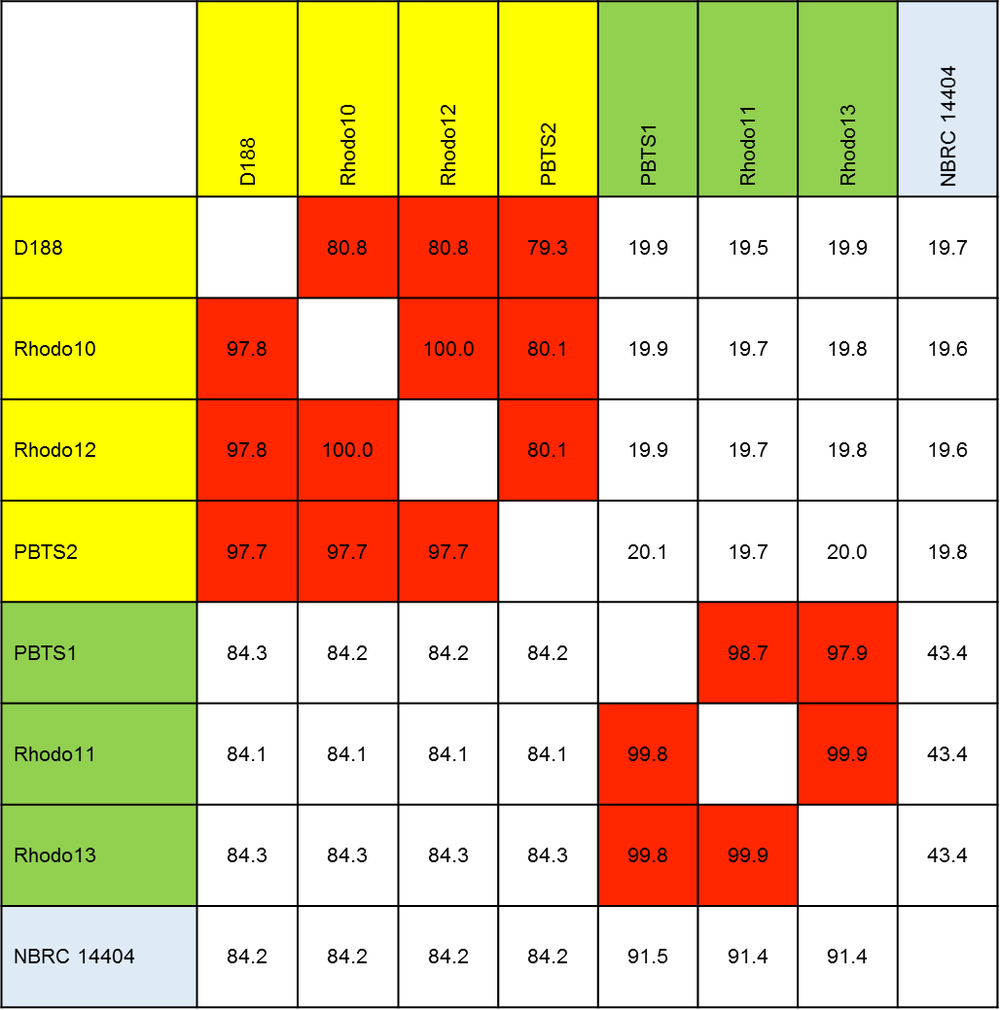

Supplementary Figure S4. Cytokinin production pathway via tRNA degradation in PBTS1, PBTS2, and D188.
Precursor production via the MEP pathway, modification of iP in the tRNA and subsequent degradation results in the production of iP, cZ, and 2MeSZ. The production of these cytokinins by PBTS1 and PBTS2 needs to be experimentally demonstrated. Gene locus tags in PBTS1 are indicated in red, those of PBTS2 in orange, and those of D188 in black.
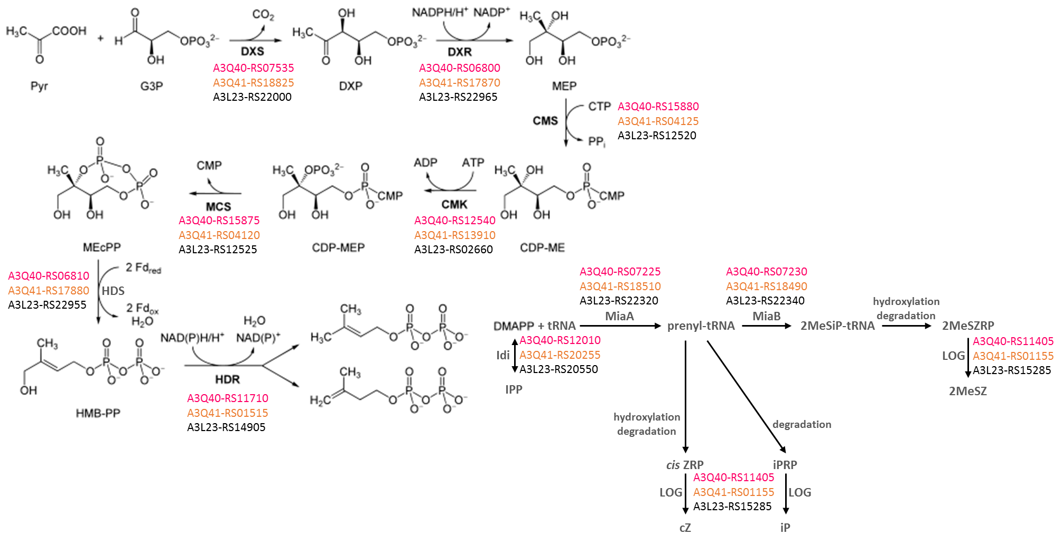

Supplementary Figure S5. Tryptophan, 2,3-butanediol, and IAA biosynthesis pathway in PBTS1, PBTS2, and D188. Gene locus tags in PBTS1 are indicated in red, those of PBTS2 in orange, and those of D188 in black.
