Supplementary Material

Efficacy of a Plant-Microbe System: Pisum sativum (L.) Cadmium-Tolerant Mutant and Rhizobium leguminosarum Strains, Expressing Pea Metallothionein Genes PsMT1 and PsMT2, for Cadmium Phytoremediation
Viktor E. Tsyganov^{1,2*}, Anna V. Tsyganova¹, Artemii P. Gorshkov¹, Elena V. Seliverstova^{1,3}, Viktoria E. Kim¹, Elena P. Chizhevskaya¹, Andrey A. Belimov¹, Tatiana A. Serova¹, Kira A. Ivanova¹, Olga A. Kulaeva¹, Pyotr G. Kusakin¹, Anna B. Kitaeva¹, Igor A. Tikhonovich^{1,4}
¹All-Russia Research Institute for Agricultural Microbiology, Pushkin 8, Saint-Petersburg, Russia
²Saint Petersburg Scientific Center RAS, Universitetskaya embankment 5, 199034, Russia
³Sechenov Institute of Evolutionary Physiology and Biochemistry of the Russian Academy of Sciences, Toreza prospect 44, Saint Petersburg, 194223, Russia
⁴Saint Petersburg State University, Department of Genetics and Biotechnology, Saint Petersburg, Russia
* Correspondence:
Viktor E. Tsyganov
tsyganov@arriam.spb.ru

Supplemental Table 1. Primers used in this study.

Primer name | Sequence (5’–3’)
MT1-F | ATGTCTGGATGTGGTTGTGGA
MT1-R | GCCTCCAATATCTCTGCTTCA
MT2-F | ATGTCTTGCTGTGGTGGAAACT
MT2-R | ATCCTGCCACTAAACGGGG
nifH-F | GGATCCCGTCGTTGCCTGCTG
nifH-R | GTTTGGCGTTCCTTCATGTGTTC
PsMT-1F | ATGTCTGGATGTGGTTGTGGAAG
PsMT-1R | TCATTTGCAGTTGCAAGGGTCA
PsMT-2F | TGGAAACTGTGGTTGCGGTACTAG
PsMT-2R | TCCACATTTGCAGCCATCATTCTC

Supplemental Table 2. Content of nutrient elements in shoots of pea genotypes SGE and SGECd^{t} grown in nutrient solution and inoculated with R. leguminosarum bv. viciae strains 3841, 3841-PsMT1 or 3841-PsMT2, respectively.
Treatments | B,  ng g⁻¹ DW | Ca,  mg g⁻¹ DW | Co,  µg g⁻¹ DW | Cu,  µg g⁻¹ DW | Fe,  µg g⁻¹ DW | K,  mg g⁻¹ DW | Mg,  mg g⁻¹ DW | Mn,  µg g⁻¹ DW | Mo,  µg g⁻¹ DW | N,  mg g⁻¹ DW | Na,  µg g⁻¹ DW | Ni,  µg g⁻¹ DW | P,  mg g⁻¹ DW | Zn,  µg g⁻¹ DW
 | Untreated plants
SGE + 3841 | 28 ± 0.8^{cd} | 8,0 ± 0.2^{abc} | 4,4 ± 0.1^{ab} | 84 ± 2^{d} | 73 ± 8^{cd} | 30 ± 0.2^{cd} | 5,1 ± 0.1ª | 64 ± 1ª | 46 ± 2^{b} | 18.1 ± 0.6^{abc} | 288 ± 12^{d} | 3,6 ± 0.1^{c} | 70 ± 2^{c} | 107 ± 4^{cd}
SGECd^{t} + 3841 | 27 ± 0.8^{cd} | 8,6 ± 0.2^{c} | 4,4 ± 0.1^{ab} | 73 ± 3^{bc} | 68 ± 5^{bc} | 30 ± 0.6^{cd} | 5,1 ± 0.2ª | 67 ± 3ª | 37 ± 1ª | 17.8 ± 0.5^{abc} | 262 ± 20^{cd} | 3,5 ± 0.1^{bc} | 58 ± 3^{b} | 102 ± 2^{c}
SGE + 3841-PsMT1 | 26 ± 0.8^{bc} | 8,3 ± 0.2^{bc} | 4,4 ± 0.1^{ab} | 72 ± 2^{ab} | 72 ± 5^{cd} | 28 ± 0.7^{b} | 5,2 ± 0.1ª | 66 ± 2ª | 32 ± 2ª | 17.4 ± 0.7^{ab} | 248 ± 12^{bcd} | 3,4 ± 0.1^{bc} | 59 ± 2^{b} | 86 ± 3^{bc}
SGECd^{t} + 3841-PsMT1 | 26 ± 0.6^{bc} | 8,4 ± 0.3^{bc} | 4,2 ± 0.1^{ab} | 72 ± 3^{ab} | 69 ± 8^{c} | 28 ± 0.9^{b} | 5,0 ± 0.2ª | 65 ± 2ª | 38 ± 3ª | 17.7 ± 0.9^{abc} | 246 ± 19^{bcd} | 3,2 ± 0.1^{bc} | 58 ± 3^{b} | 91 ± 3^{bc}
SGE + 3841-PsMT2 | 33 ± 1.6e | 7,3 ± 0.4^{ab} | 4,4 ± 0.1ª | 79 ± 1^{bcd} | 58 ± 4^{abc} | 28 ± 0.3^{b} | 5,4 ± 0.1^{ab} | 68 ± 3^{ab} | 36 ± 2ª | 19.7 ± 0.7^{bc} | 273 ± 7^{cd} | 3,4 ± 0.1^{bc} | 62 ± 1^{bc} | 93 ± 3^{bc}
SGECd^{t} + 3841-PsMT2 | 36 ± 1.0e | 7,3 ± 0.4^{ab} | 4,4 ± 0.2^{ab} | 75 ± 2^{bc} | 55 ± 7^{abc} | 29 ± 0.6^{bc} | 5,6 ± 0.3^{bc} | 83 ± 3^{c} | 37 ± 2ª | 19.0 ± 1.4^{bc} | 294 ± 32^{d} | 3,4 ± 0.3^{bc} | 59 ± 3^{b} | 96 ± 2^{bc}
 | Plants treated with 0.5 µM CdCl₂
SGE + 3841 | 27 ± 1.7^{bcd} | 7,5 ± 0.5^{ab} | 4,5 ± 0.1^{bc} | 75 ± 2^{bcd} | 86 ± 5^{d} | 31 ± 0.5^{cd} | 6,0 ± 0.2^{cd} | 105 ± 4de | 36 ± 3ª | 19.8 ± 0.4^{c} | 252 ± 15^{bcd} | 3,3 ± 0.1^{bc} | 60 ± 2^{b} | 106 ± 7^{cd}
SGECd^{t} + 3841 | 24 ± 1.3^{abc} | 8,0 ± 0.5ª | 4,1 ± 0.1^{ab} | 70 ± 4^{ab} | 58 ± 3^{abc} | 27 ± 1.2^{ab} | 5,6 ± 0.2^{bc} | 101 ± 5de | 34 ± 3ª | 19.9 ± 1.0^{c} | 171 ± 15ª | 2,7 ± 0.1^{ab} | 56 ± 4^{ab} | 97 ± 7^{c}
SGE + 3841-PsMT1 | 18 ± 1.1ª | 7,2 ± 0.5ª | 4,3 ± 0.2^{ab} | 65 ± 4^{ab} | 56 ± 5^{abc} | 28 ± 1.2^{b} | 6,1 ± 0.3^{cd} | 90 ± 6^{cd} | 38 ± 3ª | 18.6 ± 0.7^{bc} | 198 ± 15^{ab} | 2,8 ± 0.2^{ab} | 51 ± 4^{ab} | 73 ± 4ª
SGECd^{t} + 3841-PsMT1 | 23 ± 0.8^{b} | 8,3 ± 0.5^{bc} | 3,9 ± 0.2^{b} | 64 ± 3ª | 50 ± 3ª | 25 ± 0.8ª | 5,7 ± 0.3^{bcd} | 98 ± 6de | 34 ± 4ª | 16.2 ± 0.3ª | 160 ± 12ª | 2,5 ± 0.1ª | 49 ± 3ª | 73 ± 4ª
SGE + 3841-PsMT2 | 24 ± 1.0^{b} | 8,1 ± 0.5^{abc} | 4,3 ± 0.1ª | 72 ± 2^{b} | 69 ± 5^{c} | 32 ± 0.7^{d} | 6,2 ± 0.2de | 106 ± 7e | 38 ± 1ª | 17.9 ± 0.9^{abc} | 155 ± 8ª | 2,8 ± 0.1^{ab} | 59 ± 2^{b} | 89 ± 3^{bc}
SGECd^{t} + 3841-PsMT2 | 30 ± 1.1^{d} | 7,6 ± 0.2^{ab} | 5,0 ± 0.3^{c} | 81 ± 5^{cd} | 76 ± 6^{cd} | 32 ± 0.8^{d} | 6,7 ± 0.2e | 144 ± 7^{f} | 47 ± 3^{b} | 18.2 ± 0.7^{abc} | 230 ± 38^{bc} | 3,5 ± 0.3^{bc} | 65 ± 5^{bc} | 114 ± 4^{d}
 | Average for all inoculation treatments
Untreated SGE | 29 ± 1.0# | 7,9 ± 0.2* | 4,4 ± 0.1* | 78 ± 2# | 68 ± 4* | 29 ± 0.4* | 5,2 ± 0.1* | 66 ± 1* | 38 ± 2* | 18.4 ± 0.4* | 270 ± 7# | 3,5 ± 0.1# | 64 ± 2# | 95 ± 3*
Untreated SGECd^{t} | 30 ± 1.2# | 8,1 ± 0.2* | 4,3 ± 0.1* | 73 ± 2*# | 64 ± 4* | 29 ± 0.5* | 5,3 ± 0.1* | 72 ± 3* | 37 ± 1* | 18.1 ± 0.6* | 267 ± 14# | 3,4 ± 0.1# | 58 ± 2*# | 96 ± 2*
Cd-treated SGE | 23 ± 1.2* | 7,6 ± 0.3* | 4,4 ± 0.1* | 71 ± 2* | 70 ± 4* | 30 ± 0.6* | 6,1 ± 0.1# | 101 ± 4# | 37 ± 1* | 18.8 ± 0.4* | 202 ± 13* | 3,0 ± 0.1* | 56 ± 2* | 89 ± 4*
Cd-treated SGECd^{t} | 26 ± 1.0* | 8,0 ± 0.2* | 4,3 ± 0.2* | 72 ± 3* | 62 ± 4* | 28 ± 0.9* | 6,0 ± 0.2# | 114 ± 7@ | 38 ± 2* | 18.2 ± 0.6* | 187 ± 16* | 2,9 ± 0.2* | 57 ± 3* | 94 ± 5*
Different letters show significant differences between treatments within sub columns for untreated and Cd-treated plants, whereas different symbols show significant differences between average values for all inoculation treatments (least significant difference test, P < 0.05, n = 5). De data are means ± SE. DW stands for dry weight.

SUPPLEMENTAL FIGURE S1 Ultrastructural organization of untreated nodules of wild-type SGE inoculated with R. leguminosarum bv. viciae strain 3841. (A) An infected cell from the nitrogen fixation zone. (B) An infected cell from the infection zone. ba, bacteroid; cw, cell wall; v, vacuole; a, amyloplast; arrows indicate symbiosome membrane. Scale bar = 500 nm.

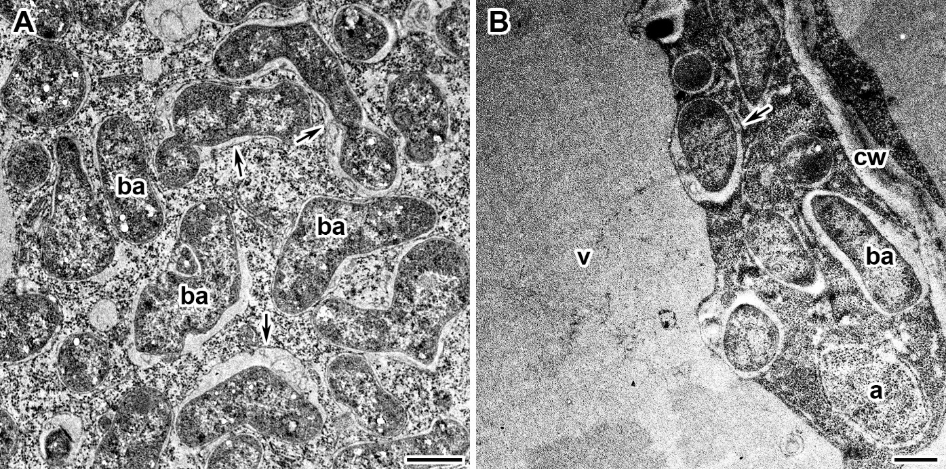

SUPPLEMENTAL FIGURE S2 Accumulation of the electron dense crystals in vacuole in the cadmium treated nodules of wild-type SGE (A,C,E) and mutant SGECd^{t} (B,D,F) inoculated with R. leguminosarum bv. viciae strain 3841 (A,B), 3841-MT1 (C,D) and 3841-MT2 (E,F). ba, bacteroid; b, bacterium; v, vacuole; triangles indicate electron dense crystals in vacuole. Scale bar = 500 nm.

