Supplementary Material

Supplementary Tables

Supplementary Table 1: Age group distribution
 | Chicken (n=417) | Ducks (n=203) | Total (n=620)
1-3 month | 168 (40.3%) | 27 (13.3%) | 195 (31.5%)
4-6 months | 92 (22.1%) | 52 (25.6%) | 144 (23.2%)
7-9 months | 19 (4.6%) | 9 (4.4%) | 28 (4.5%)
≥10 months | 67 (16.1%) | 80 (39.4%) | 147 (23.7%)
Unknown | 71 (17.0%) | 35 (17.2%) | 106 (17.1%)

Supplementary Table 2: Sample subsets
 | FRNT samples  (HIA positive) |  | HIA positive,  not-tested in FRNT |  | all HIA positive
Total | 65 |  | 115 |  | 180
Province
Kandal | 18 | 27.7% | 40 | 34.8% | 58 | 32.2%
Kratie | 27 | 41.5% | 71 | 61.7% | 98 | 54.4%
Mondulkiri | 20 | 30.8% | 4 | 3.5% | 24 | 13.3%
Species
Chicken | 39 | 60.0% | 60 | 52.2% | 99 | 55.0%
Duck | 26 | 40.0% | 55 | 47.8% | 81 | 45.0%
Age
1-3 months | 12 | 18.5% | 21 | 18.3% | 33 | 18.3%
4-6 months | 14 | 21.5% | 15 | 13.0% | 29 | 16.1%
7-9 months | 0 | 0.0% | 6 | 5.2% | 6 | 3.3%
≥10 months | 18 | 27.7% | 57 | 49.6% | 75 | 41.7%
unknown age | 21 | 32.3% | 16 | 13.9% | 37 | 20.6%
Mean HIA titer (95% CI)
JEV | 194.9 | (126.2 – 263.7) | 303.8 | (183.6 – 424.1) | 264.5 | (183.9 – 345.1)
DENV-2 | 395.4 | (156.7 – 634.1) | 708 | (394.8 – 1021) | 595.1 | (377.7 – 812.5)
DENV-3 | 568.6 | (124.2 – 1013) | 1059.4 | (496.6 – 1622) | 882.2 | (489.8 – 1275)
ZIKV | 105.1 | (53.54 – 156.6) | 146.3 | (76 – 216.5) | 131.4 | (83.1 – 179.7)

Supplementary Table 3: Japanese encephalitis and West Nile seroprevalence based on foci reduction neutralization test results (n=65)
FRNT50 | negative | JEV positive | WNV positive | JEV + WNV positive | Total
Total number | 30 (46.2%) | 16 (24.6%) | 7 (10.8%) | 12 (18.5%) | 65
Species
Chicken | 18 (46.2%) | 12 (30.8%) | 4 (10.3%) | 5 (12.8%) | 39
Ducks | 12 (46.2%) | 4 (15.4%) | 3 (11.5%) | 7 (26.9%) | 26
Age groups
1-3 months | 6 (50.0%) | 1 (8.3%) | 2 (16.7%) | 3 (25.0%) | 12
4-6 months | 7 (50.0%) | 5 (35.7%) | 1 (7.1%) | 1 (7.1%) | 14
7-9 months | 0 - | 0 - | 0 - | 0 - | 0
≥10 months | 4 (22.2%) | 3 (16.7%) | 2 (11.1%) | 7 (38.9%) | 18
Unknown | 11 (52.4%) | 7 (33.3%) | 2 (9.5%) | 1 (4.8%) | 21

Supplementary Figure

Supplementary Figure 1: Hemagglutination inhibition assay titers
Individual HIA titers against Japanese encephalitis virus (JEV), dengue virus serotype 2 (DENV-2), dengue virus serotype 3 (DENV-3), and Zika virus (ZIKV) for all tested samples (n=620) with mean values and 95% CI. Due to the scaling of the y axis only values ≥10 are visualized in the graph. Dotted line shows threshold of 80 for positive HIA result. Analysis for significance was performed by Friedman test with Dunn’s multiple comparison test with GraphPad Prism 7.00.

Supplementary Figure 2: Correlation plots of hemagglutination inhibition assay titers
Correlation of individual HIA titers of all HIA-positive samples (n=180). (A) JEV titers vs DENV-2 titers, (B) JEV vs DENV-3, (C) JEV vs ZIKV, (D) DENV-2 vs DENV-3, (E) DENV-2 vs ZIKV, (F) DENV-3 vs ZIKV. Analysis for significance was performed by Spearman rank correlation with GraphPad Prism 7.00

Supplementary Figure 3: FRNT₅₀ analysis
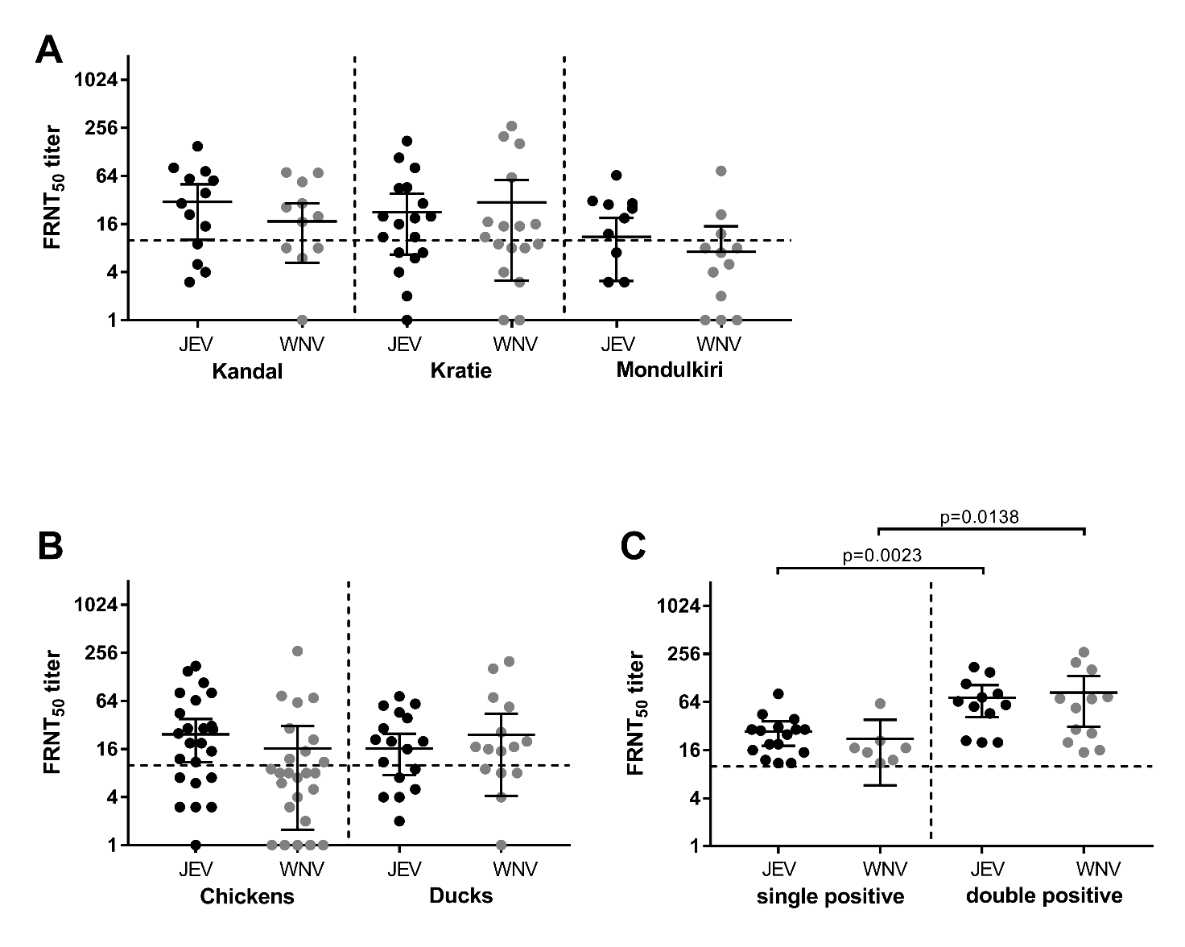
Individual FRNT₅₀ titers against JEV (black) and WNV (grey) with mean and 95% confidence interval, differentiated by (A) province of origin of the domestic birds; (B) chicken and duck samples; (C) single JEV, single WNV and double JEV+WNV positive results . The threshold for positivity was FRNT₅₀ ≥10 and is indicated by the dashed lines. Analysis for significance was performed by Mann-Whitney testing with GraphPad Prism 7.00.

