Supplementary Material
Supplementary Calculations 1 – Determination of the fraction of Wood-Ljungdahl pathway in the overall acetate production rate.
The overall reaction of the fermentation of d-galacturonate via the adapted Entner-Doudoroff pathway is shown in equation S2.a, with formate shown as H₂ and CO₂ for simplification. Equation S2.b shows the overall reaction of the Wood-Ljungdahl pathway.
– 1 d-Galacturonate – 1 H₂O + 2 H₂ + 2 CO₂ + 2 Acetate (S2.a)
– 4 H₂ – 2 CO₂ + 1 Acetate +2 H₂O (S2.b)
Hetero-acetogenesis was hypothesized to occur in “candidatus Galacturonibacter soehngenii” with the total acetate production rate (mmol h⁻¹) a function of the two reactions, S2.a and S2.b. The acetate production rate per pathway could be determined, with the d-galacturonate consumption rate and hydrogen and carbon dioxide production rate known, as shown in Table 1 in the main text.
The rate of S2.a could be determined by calculating the catabolic d-galacturonate consumption rate, subtracting the d-galacturonate going towards biosynthesis from the total d-galacturonate consumption rate (0.81 ± 0.01 mmol h⁻¹), as d-galacturonate was solely consumed in reaction S2.a.
The total hydrogen production rate (0.18 ± 0.1 mmol h⁻¹) was constituted from a hydrogen production rate (S2.a) and consumption rate (S2.b), enabling the determination of the rate of S2.b) (0.35 ± 0.03 mmol h⁻¹). Based on these calculation the fraction acetate produced from the WLP was determined to be 0.35.

Supplementary Calculations 2 – Chemostat model acetogenesis with labeled $H{}_{6}^{13}CO_{3}^{-}$
A principal model was used to estimate the fraction of labeled acetate ($CH_{3}{}_{6}^{13}COOH)$ versus unlabeled acetate ($CH_{3}{}_{6}^{12}COOH)$ over time $(t)$ in a chemostat system where at $t=0$ a constant titration of $NaH{}_{6}^{13}CO_{3}$ led to a shift in the fraction of labeled versus unlabeled inorganic carbon in the reactor broth. The model assumed that the carboxyl group $(COOH)$ in the anabolism of acetate was directly derived from the dissolved inorganic carbon. Carbon dioxide transfer from the liquid to the gas phase follows the ratio of labeled versus unlabeled inorganic carbon in the liquid phase. Values for the acetate concentration, dissolved inorganic carbon concentration, carbon transfer rate, and volumetric production rates were derived from online and offline measurements (Supplementary Table S1).

Supplementary Table S1 | Kinetic and process values for chemostat model.
Description | Symbol | Value | unit
Dilution rate | D | 0.1 | h⁻¹
CO₂ production rate | $R_{CO_{2}}$ | 1.05 | mmol h⁻¹
HCO₃⁻ titration rate | $R_{HCO_{3}^{-}}$ | 6.0 | mmol h⁻¹
Acetate production rate | $R_{Ac}$ | 1.83 | mmol h⁻¹
Fraction WLP | $f_{WLP}$ | 0.35 | mmol mmol⁻¹
ICª $(t=0, {}_{6}^{12}CO_{2})$ | $IC_{0}^{12}$ | 5 | mmol
ICª $(t=0, {}_{6}^{13}CO_{2})$ | $IC_{0}^{13}$ | 0.05 | mmol
Carbon transfer rate^{c} | CTR | 2.2 | mmol h⁻¹
Ac^{b} $(t=0, {}_{6}^{12}CO_{2})$ | $Ac_{0}^{12}$ | 6.40 | mmol
Ac^{b} $(t=0, {}_{6}^{13}CO_{2})$ | $Ac_{0}^{13}$ | 0.06 | mmol
a. Inorganic carbon, dissolved $CO_{2}$ species of labeled or unlabeled isotopes.
b. Total acetate of which the carboxyl group is either labeled or unlabeled.
c. The carbon transfer rate is the total inorganic carbon transferring from the liquid to the gas phase.

$$\begin{aligned}f_{IC^{12}}=\frac{IC^{12}}{IC^{12}+IC^{13}} \end{aligned}(1)$$
$$\begin{aligned}\frac{dIC^{12}}{dt}=-D∙IC^{12}+R_{CO_{2}}-f_{IC^{12}}∙CTR\end{aligned}(2)$$
$$\begin{aligned}\frac{dIC^{13}}{dt}=-D∙IC^{13}+R_{HCO_{3}^{-}}-\left(1-f_{IC^{12}}\right)∙CTR\end{aligned}(3)$$
$$\begin{aligned}\frac{dAc^{12}}{dt}=-D∙Ac^{12}+f_{WLP}∙{f_{IC^{12}}∙R}_{Ac}\end{aligned}(4)$$
$$\begin{aligned}\frac{dAc^{13}}{dt}=-D∙Ac^{13}+f_{WLP}∙{\left(1-f_{IC^{12}}\right)∙R}_{Ac}\end{aligned}(5)$$

Supplementary Figure S1 | The chemostat model of the “ca. G. soehngenii” enrichment culture of the expected acetate produced over time during the labelling experiment with acetate₁₂ (black line (-), mmol) and acetate₁₃ (dark grey line (-), mmol), the total amount of acetate produced (light grey line (-), mmol) from the Wood-Ljungdahl pathway, the percentage of labelled acetate versus unlabeled acetate in the reactor broth (dotted grey line
(- -), %) and the labelled acetate measured after 8 h (×, %) in bioreactor 2.

Supplementary Table S2 | Genes of the six carbon fixation pathways, excluding the Wood-Ljungdahl pathway, from the predictive proteome of the MAG “ca. G. soehngenii” with gene ID and EC number based on SwissProt alignment (BLASTP version 2.2.28+, MicroScope platform v3.13.2).
Route | EC number | Gene ID
Reductive pentose phosphate cycle (CBB)
Ribulose-bisphosphate carboxylase | 4.1.1.39
Phosphoglycerate kinase | 2.7.2.3 | F7O84_RS02895
Glyceraldehyde-3-phosphate dehydrogenase | 1.2.1.12 | F7O84_RS02890
Triose phosphate isomerase | 5.3.1.1 | F7O84_RS02900
Fructose-1,6-bisphosphate aldolase | 4.1.2.13 | F7O84_RS12150
Fructose-1,6-bisphosphatase class 3 | 3.1.3.11 | F7O84_RS00620
Transketolase | 2.2.1.1 | F7O84_RS11220-25
Sedoheptulose-bisphosphatase | 3.1.3.37
Ribose-5-phosphate isomerase A | 5.3.1.6 | F7O84_RS11205
Ribulose-phosphate 3-epimerase | 5.1.3.1 | F7O84_RS11250
Reductive citric acid cycle
Pyruvate ferredoxin:oxidoreductase | 1.2.7.1 | F7O84_RS03200
Aconitate hydratase | 4.2.1.3 | F7O84_RS03605
2-oxoglutarate/2-oxoacid ferredoxin oxidoreductase | 1.2.7.3 and 1.2.7.11 | F7O84_RS03615-20
Malate dehydrogenase | 1.1.1.37 | F7O84_RS05485
Isocitrate dehydrogenase (NADP+) | 1.1.1.42 | F7O84_RS06610
Propionyl-CoA carboxylase | 6.4.1.3 | F7O84_RS07040
Pyruvate phosphate dikinase | 2.7.9.1 | F7O84_RS07755
Pyruvate carboxylase subunit B | 6.4.1.1 | F7O84_RS12740
Aconitate hydratase | 4.2.1.3 | F7O84_RS14165
Fumarate hydratase | 4.2.1.2 | F7O84_RS14815
ATP citrate lyase | 2.3.3.8
Phosphoenolpyruvate carboxylase | 4.1.1.31
Fumarate reductase | 1.3.5.4
Succinate-CoA ligase | 6.2.1.5
Hydroxypropionate bi-cycle
Pyruvate ferredoxin:oxidoreductase | 1.2.7.1 | F7O84_RS03200
pyruvate phosphate dikinase | 2.7.9.1 | F7O84_RS07755
Phosphoenolpyruvate carboxylase | 4.1.1.31
Malate dehydrogenase | 1.1.1.37 | F7O84_RS05485
Fumarate hydratase | 4.2.1.2 | F7O84_RS14815
Succinate dehydrogenase | 1.3.5.1
Fumarate reductase | 1.3.4.1
Fumarate reductase (NADH) | 1.3.1.6
Fumarate reductase (quinol) | 1.3.5.4
Succinate-CoA ligase | 6.2.1.5
3-Hydroxypropionate/4-Hydroxybutyrate cycle
Acetyl-CoA carboxylase | 6.4.1.2
Manonyl-CoA reductase (NADP dependent) | 1.2.1.75
3-hydroxypropionate dehydrogenase (NADP+) | 1.1.1.298
3-hydroxypropionyl-CoA synthase | 6.2.1.36
Table S2 | Continued
3-hydroxypropionyl-CoA dehydratase | 4.2.1.116
Acrylyl-CoA reductase (NADPH) | 1.3.1.84
Propionyl-CoA carboxylase | 6.4.1.3 | F7O84_RS03215
Methylmalonyl-CoA epimerase | 5.1.99.1
Methylmalonyl-CoA mutase | 5.4.99.2
Succinyl-coA reductase | 1.2.1.76
Succinate semialdehyde reductase (NADPH) | 1.1.1.-
4-hydroxybutyrate-CoA ligase | 6.2.1.40
4-hydroxybutanoyl-CoA dehydratase | 4.2.1.120
Enoyl-CoA hydratase | 4.2.1.17
3-hydroxyacyl-CoA dehydrogenase | 1.1.1.35
Acetyl-CoA acetyltransferase | 2.3.1.9
Malyl-CoA lyase | 4.1.3.24
2-methylfumaryl-CoA hydratase | 4.2.1.148
2-methylfumaryl-CoA isomerase | 5.4.1.3
3-methylfumaryl-CoA hydratase | 4.2.1.153
(S)-citramalyl-CoA lyase | 4.1.3.25
Dicarboxylate/hydroxybutyrate cycle
Malyl-CoA lyase | 4.1.3.24
Succinyl-Coa l-malate-CoA transferase | 2.8.3.22
Malate dehydrogenase | 1.1.1.37 | F7O84_RS05485
Phosphoenolpyruvate carboxylase | 4.1.1.31
Pyruvate phosphate dikinase | 2.7.9.1 | F7O84_RS07755
Pyruvate:ferredoxin oxidoreductase | 1.2.7.1 | F7O84_RS03200
Reductive glycine pathway
Formate dehydrogenase | 1.17.1.9 | F7O84_RS07405
Ferredoxin hydrogenase | 1.12.7.2 | F7O84_RS09545-50 F7O84_RS04820
Formate-tetrahydrofolate ligase | 6.3.4.3 | F7O84_RS05385
Methylenetetrahydrofolate dehydrogenase | 3.5.4.9 | F7O84_RS05380
Glycine cleavage system H protein
Dihydrolipoamide dehydrogenase | 1.8.1.4
Glycine cleavage system T protein | 2.1.2.10
Glycine dehydrogenase subunit A | 1.4.4.2
Glycine dehydrogenase subunit B | 1.4.4.2
Glycine hydroxymethyl transferase | 2.1.2.1 | F7O84_RS01545
Serine dehydratase | 4.3.1.17 | F7O84_RS04460-5

Supplementary Table S3 | Enzyme assay of the putative CO dehydrogenase expressed in an E. coli BL21 strain. The mean ± average deviation have been determined from independent duplicate experiments. B.d.l. below detection limit.
CO | Hydroxylamine | Metals | pUD1074 | E. coli BL21 | Activity (slope/min)
+ | - | + | + | - | 0.013 ± 0.013
- | + | + | + | - | 0.02
+ | - | - | + | - | b.d.l.
- | - | + | + | - | b.d.l.
+ | - | + | - | + | b.d.l.
- | + | + | - | + | b.d.l.
+ | - | + | - | - | b.d.l.
Supplementary Table S4 | BLASTp (version 2.2.28+, (Altschul et al., 1997)) search with the organism, genome id, gene (locus tag) and E-value, of the putative CODH (F7O84_RS11645) in Lachnospiraceae species obtained from the public JGI-IMG/M database (Markowitz et al, 2012).
Strain | Genome id | Gene | E-value
Anaerobutyricum hallii L2-7 | 2826986812 | Ga0265454_2814 | 0
Pseudobutyrivibrio xylanivorans MA3014 v2 | 2836274772 | Ga0400149_2313 | 0
Butyrivibrio fibrisolvens INBov1 | 2841549333 | Ga0364991_2769 | 0
Lachnoclostridium phytofermentans ISDg | 641228486 | Cphy_2846 | 0
Lachnoclostridium saccharolyticum WM1, DSM 2544 | 648028018 | Closa_2590 | 0
Lachnoclostridium cf. saccharolyticum K10 | 650377923 | CLS_14500 | 0
Roseburia hominis A2-183, DSM 16839 | 2511231128 | RHOM_10215 | 7.0 e⁻¹⁷⁸
Roseburia intestinalis L1-82 | 2836830276 | Ga0399605_1213 | 1.0 e⁻¹⁷⁵
Roseburia intestinalis M50/1 | 650377964 | ROI_37590 | 2.0 e⁻¹⁷⁵
Roseburia intestinalis XB6B4 | 650377965 | RO1_26150 | 2.0 e⁻¹⁷⁵
Anaerobutyricum hallii L2-7 | 2826986812 | Ga0265454_1517 | 3.0 e⁻¹⁷³
Roseburia hominis A2-183, DSM 16839 | 2511231128 | RHOM_06150 | 1.0 e⁻¹⁶⁶
Lachnoclostridium saccharolyticum WM1, DSM 2544 | 648028018 | Closa_2549 | 6.0 e⁻¹⁶⁵
Roseburia intestinalis L1-82 | 2836830276 | Ga0399605_896 | 8.0 e⁻¹⁶⁰
Roseburia intestinalis XB6B4 | 650377965 | RO1_03190 | 1.0 e⁻¹⁵⁹
Roseburia intestinalis M50/1 | 650377964 | ROI_29330 | 2.0 e⁻¹⁵⁹
Lachnoclostridium sp. YL32 | 2721755796 | Ga0175994_113462 | 4.0 e⁻¹⁵²
Lachnoclostridium bolteae ATCC BAA-613 | 2825694722 | Ga0225995_2847 | 3.0 e⁻¹⁵⁰
Lachnoclostridium phytofermentans ISDg | 641228486 | Cphy_2847 | 2.0 e⁻¹³⁴

Table S5 | Strain, KEGG T number and pathway map used for the KEGG analysis (Kanehisa et al., 2014) for the presence of the CODH/ACS complex.
Strain | KEGG T number | Pathway map
Anaerobutyricum hallii EH1 | T05310 | ehl01200
Pseudobutyrivibrio xylanivorans MA3014 | T06217 | pxv01200
Butyrivibrio fibrisolvens 16/4 | T02581 | bfi01200
Lachnoclostridium phytofermentans ISDg | T00619 | cpy01200
Clostridium saccharolyticum WM1, DSM 2544 | T01288 | csh01200
Clostridium cf. saccharolyticum K10 | T02614 | cso01200
Roseburia hominis A2-183, DSM 16839 | T01621 | rho01200
Roseburia intestinalis M50/1 | T02598 | rim01200
Roseburia intestinalis XB6B4 | T02597 | rix01200
Lachnoclostridium sp. YL32 | T04430 | lacy01200
Clostridium bolteae ATCC BAA-613 | T05466 | cbol01200

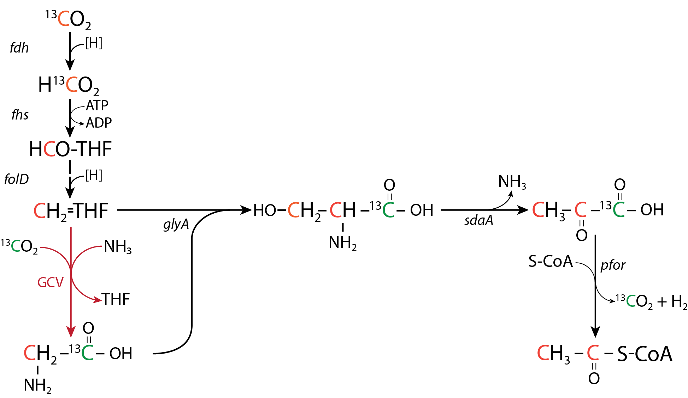
Supplementary Figure S2 | The predicted ¹³C-labelling pattern produced by the reductive glycine pathway, with formate dehydrogenase fdh, formate-tetrahydrofolate ligase fhs, methylenetetrahydrofolate dehydrogenase folD, GCV (glycine cleavage system (GcvH, lipoate-binding protein; GcvP, glycine dehydrogenase; GcvT, aminomethyltransferase; Lpd, dihydrolipoyl dehydrogenase); glyA, serine hydroxymethyltransferase; sdaA, serine deaminase and pfor; pyruvate ferredoxin oxidoreductase. The GCV depicted in red was not identified in the genome of “ca. G. soehngenii” (Supplemental material Table S2), the ¹³C-labelled carbon integrated via the methyl-branch is depicted in orange and the ¹³C-labelled carbon integrated via the GCV is depicted in green. (adapted from (Figueroa et al., 2018)).

