Supplement 1. The selection criteria with a “PICOS” structure for the enrolled studies:
Items | Specific Criteria
Patients | Patients were at least 18 years old and had biopsy-proven systemic AL amyloidosis
Interventions/Comparisons | Interventions/Comparisons included ASCT, MDex, BMDex, CTD, BDex, CyBorD, CLD
Outcomes | Outcomes were haematological response (HR), complete response (CR), renal response or cardiac response
Study designs | Studies were randomized controlled trials (RCTs) or observational controlled trials (OCTs)
ASCT: autologous stem cell transplantation; MDex: Melphalan + dexamethasone; BMDex: bortezomib + melphalan + dexamethasone; CTD: thalidomide + cyclophosphamide + dexamethasone; BDex: bortezomib + dexamethasone; CyBorD: bortezomib + cyclophosphamide + dexamethasone; CLD: cyclophosphamide + lenalidomide + dexamethasone.

Supplement 2. The quality of enrolled randomized controlled studies evaluated by version 2 of the Cochrane risk-of-bias tool for randomized trials (RoB 2):
Fig. 1: Risk of bias summary of enrolled RCTs
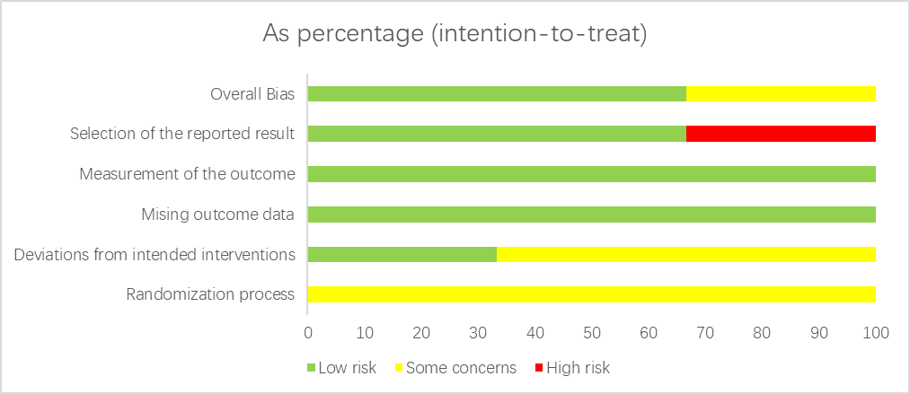

Fig. 2: Risk of bias graph of enrolled RCTs:
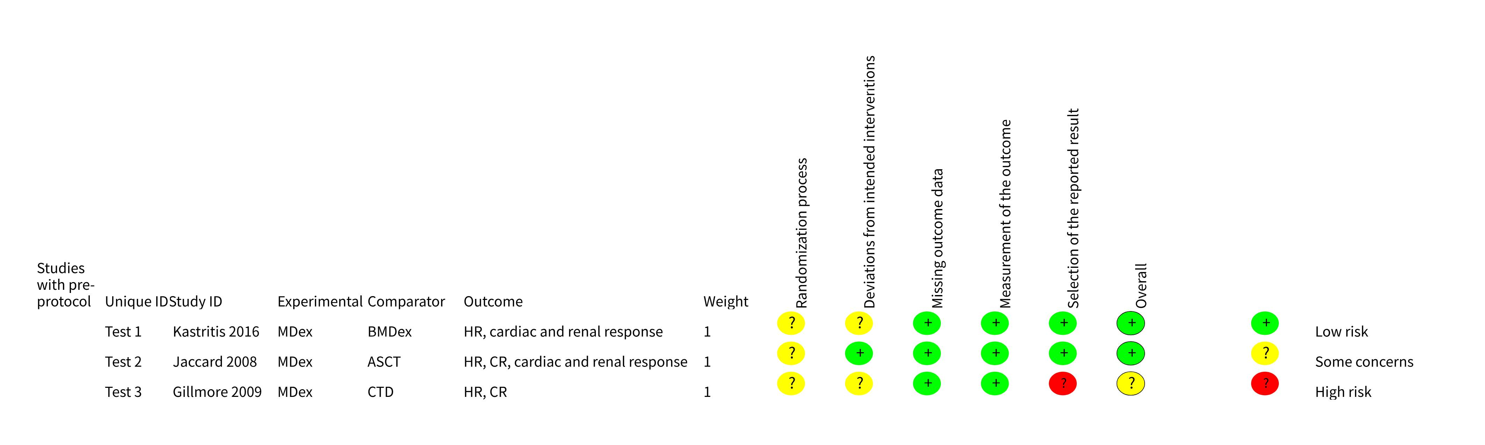

Supplement 3. The diagnostic and trace plots for the convergence of this network meta-analysis

Fig. 1 Haematological response
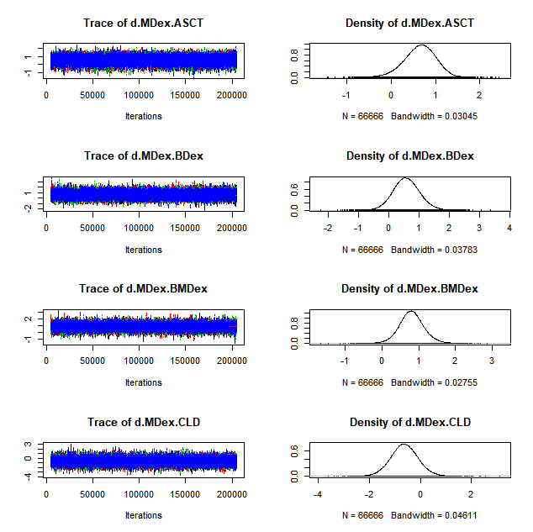

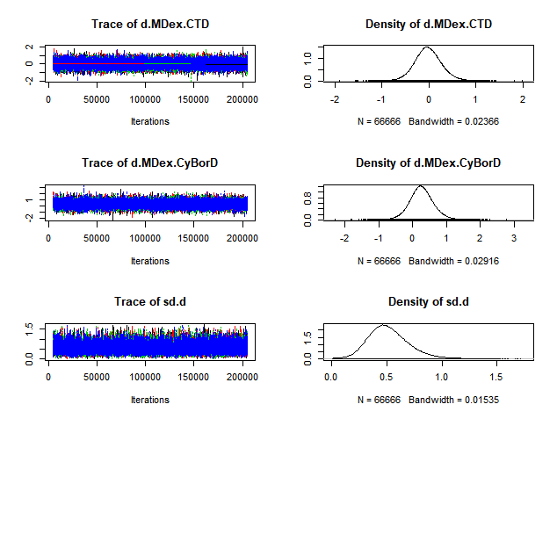
Fig. 2 Complete response

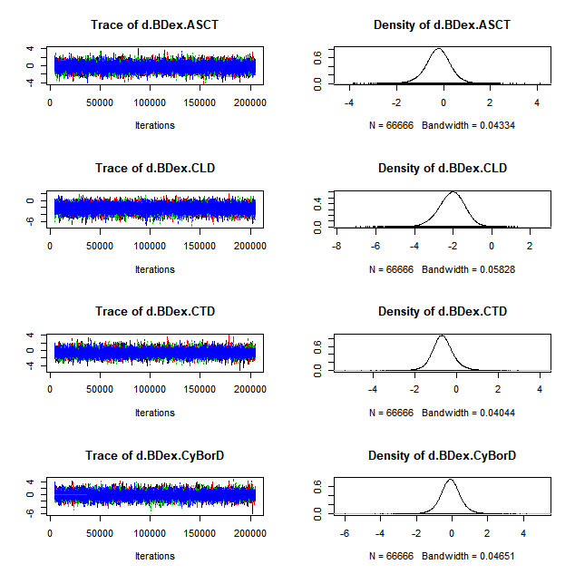
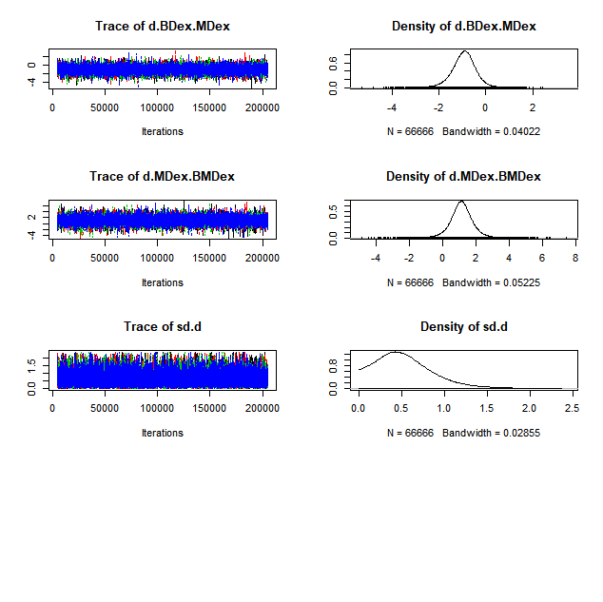
Fig. 3 Renal response

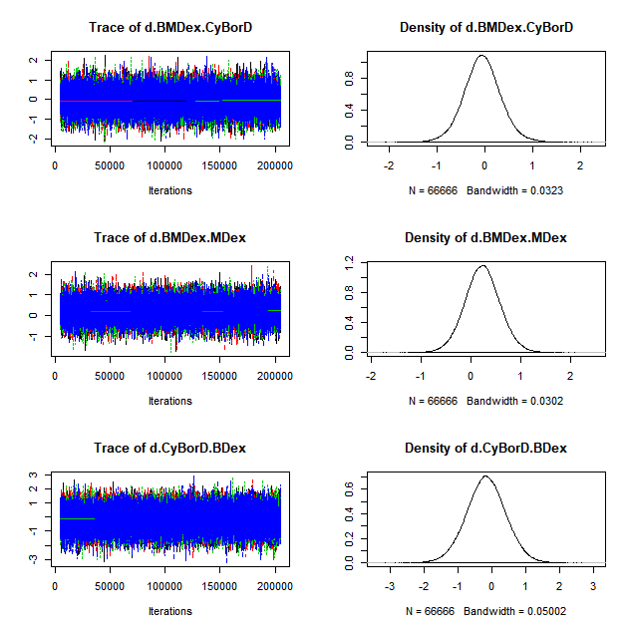
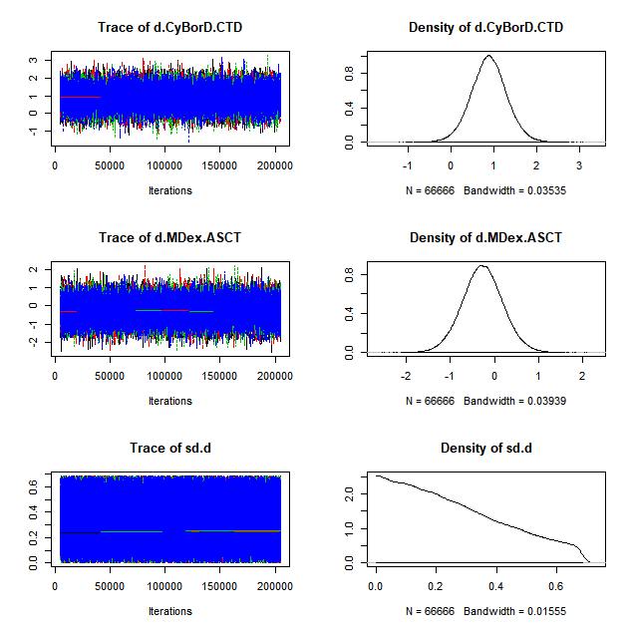
Fig. 4 Cardiac response

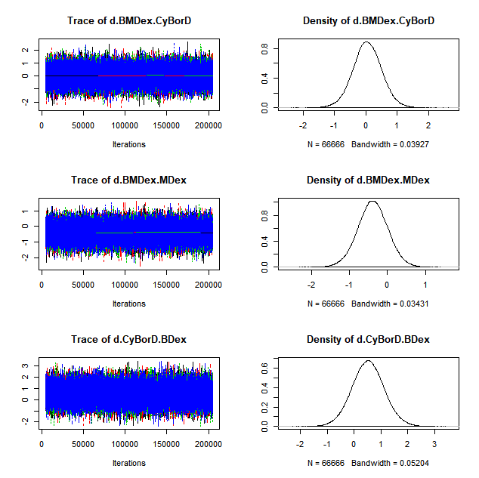
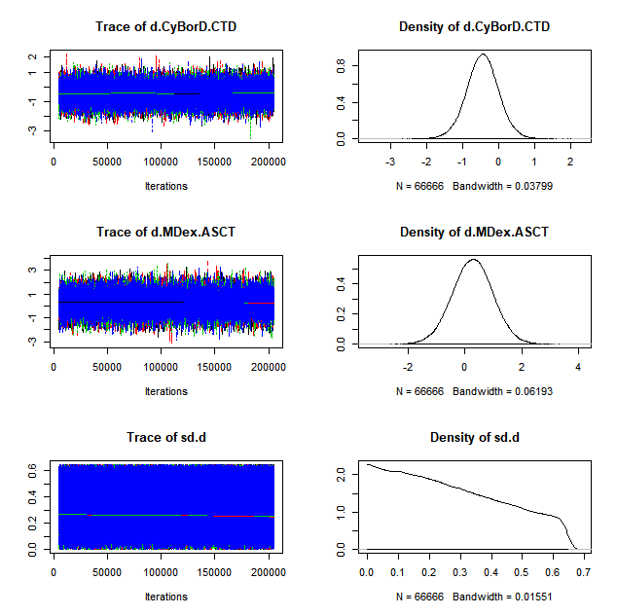
Supplement 4. The heterogeneity of both pairwise meta-analysis and network meta-analysis

Fig. 1 Haematological response
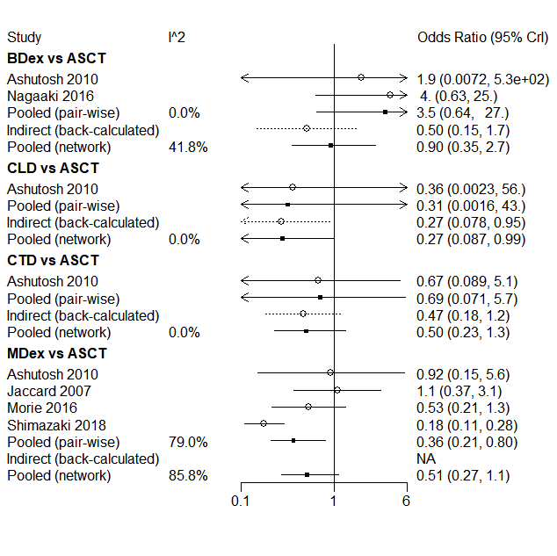
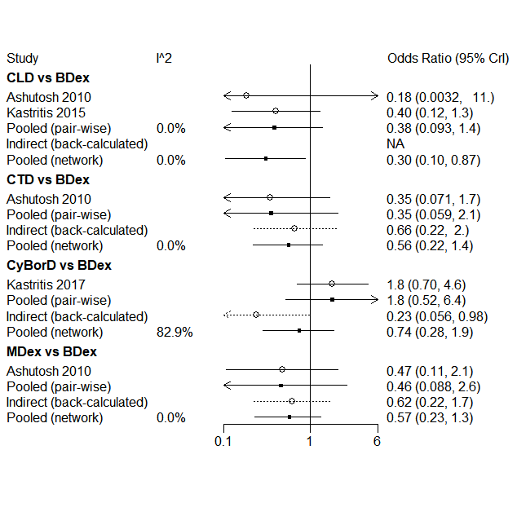
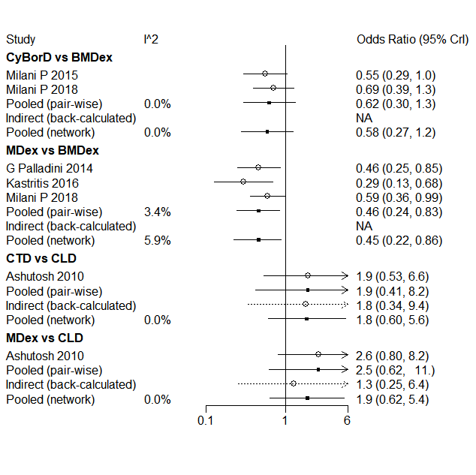
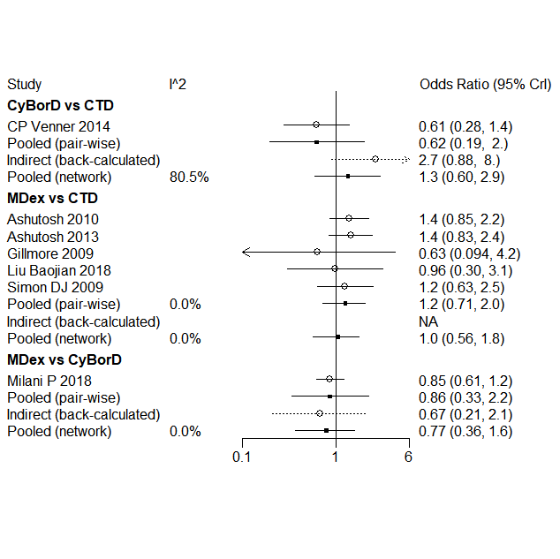

Fig. 2 Complete response
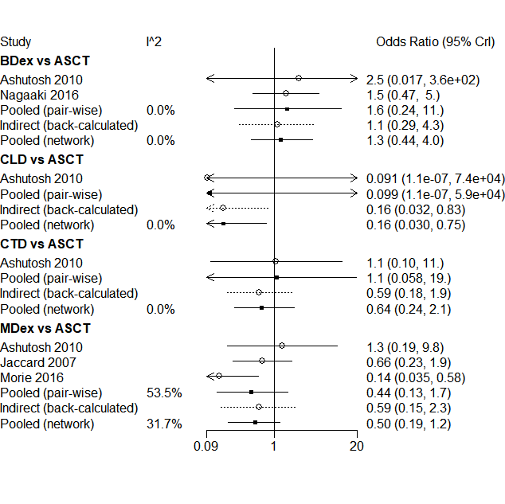
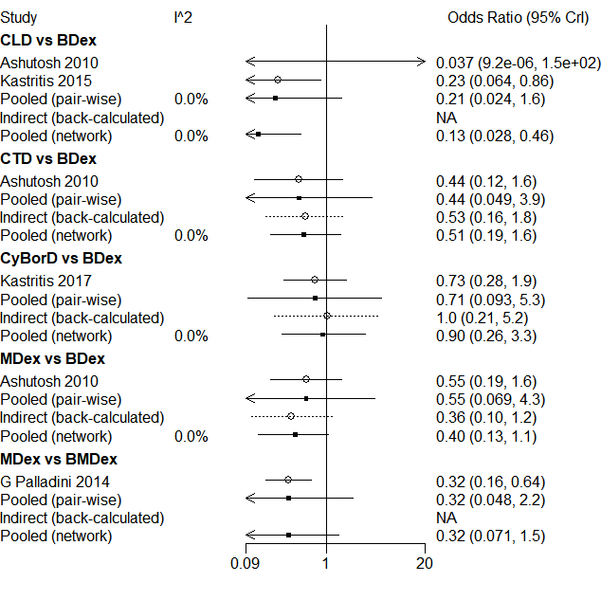
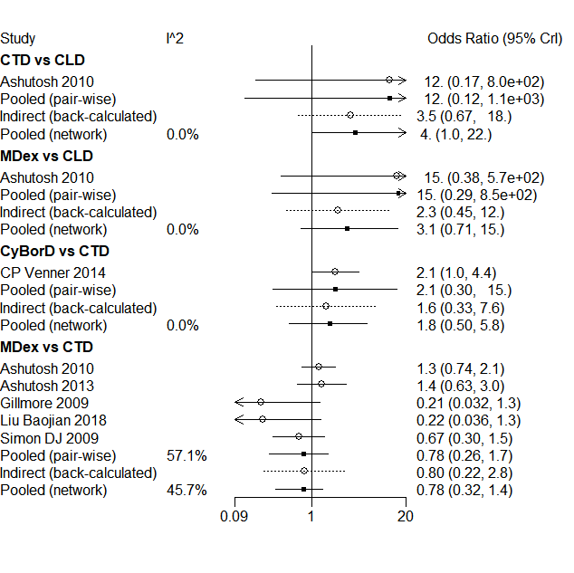
Fig. 3 Renal response

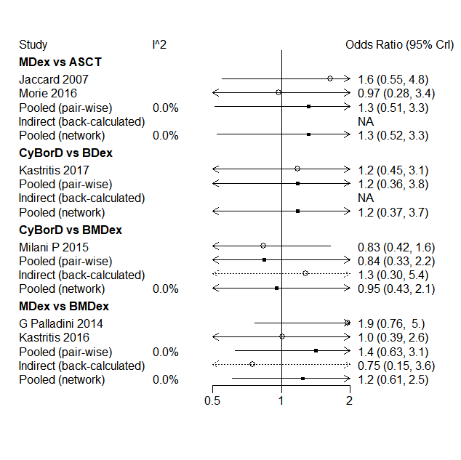
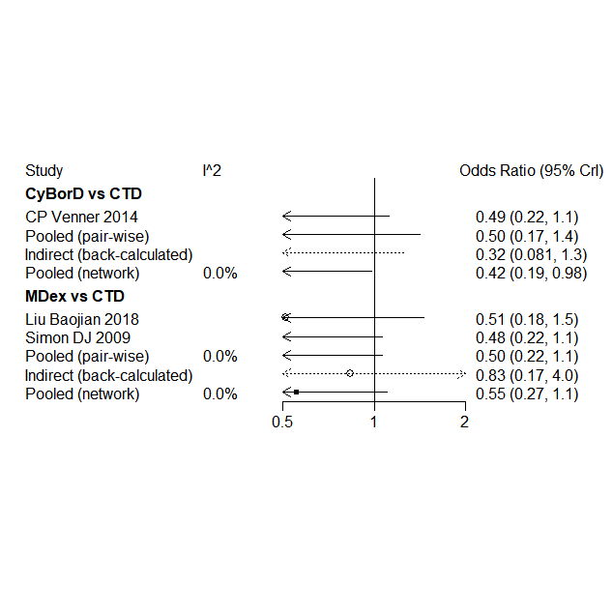
Fig. 4 Cardiac response
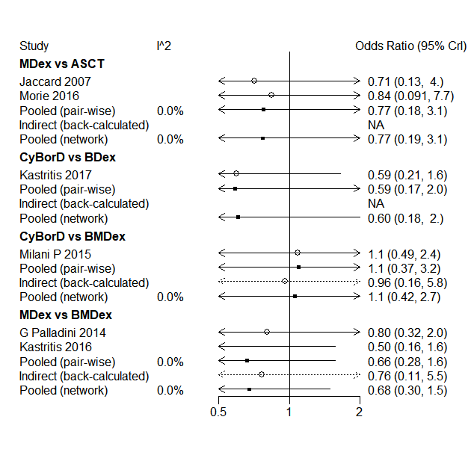
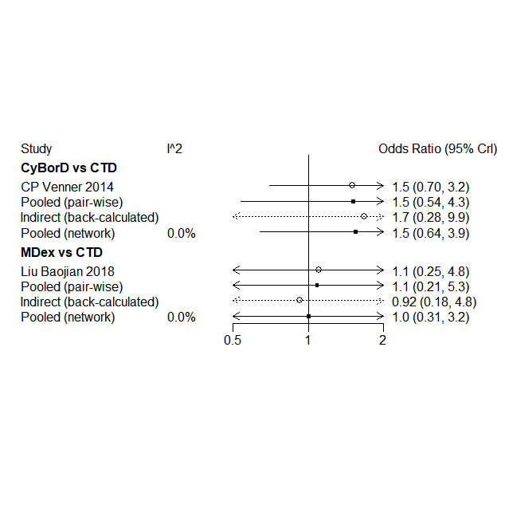

Supplement 5. Comparisons between direct and indirect evidence

Fig. 1 Haematological response
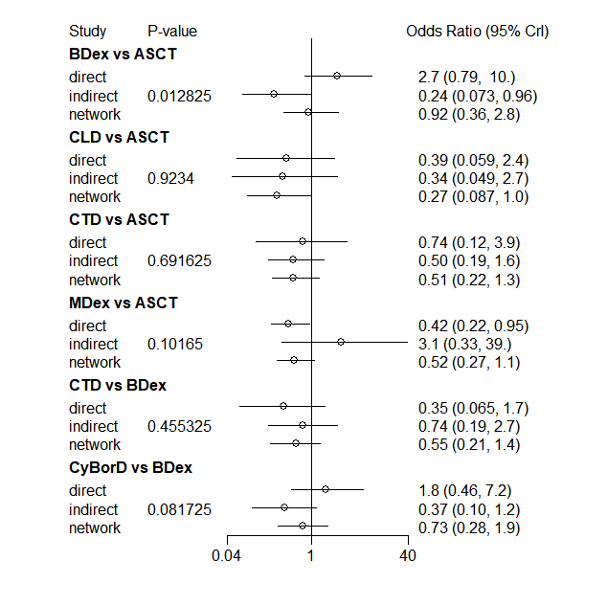
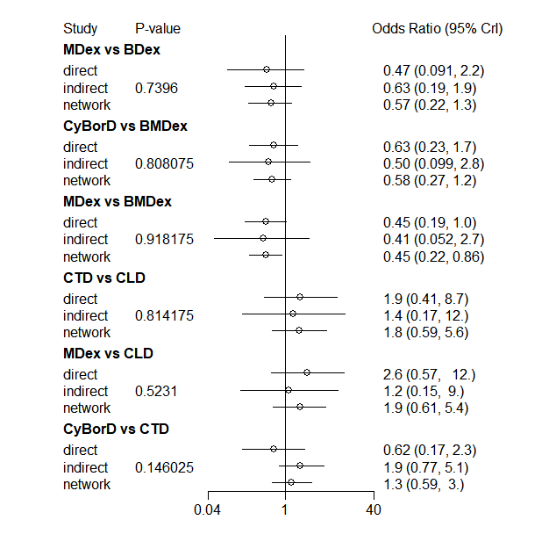
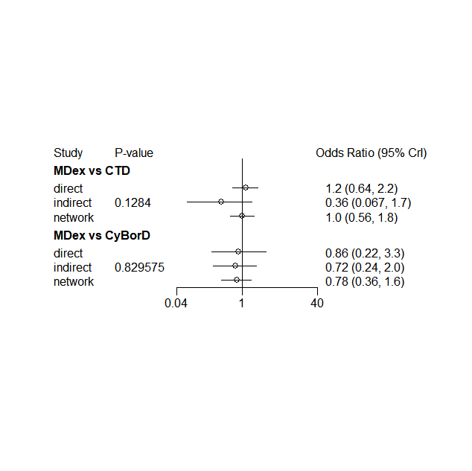
Fig. 2 Complete response
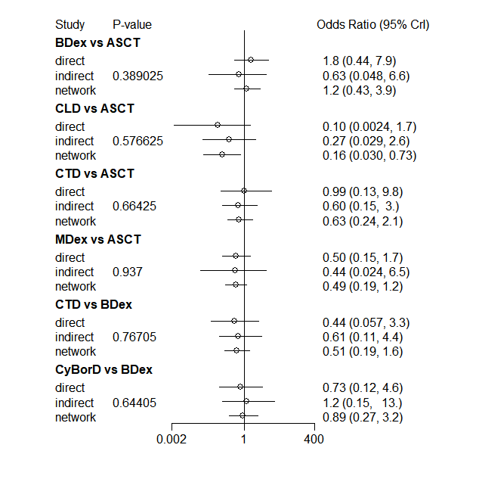
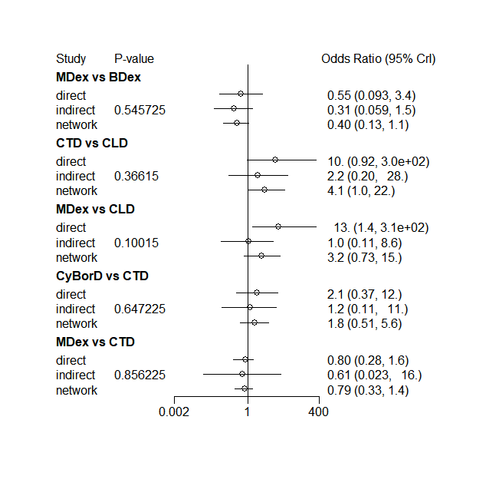
Fig. 3 Renal response
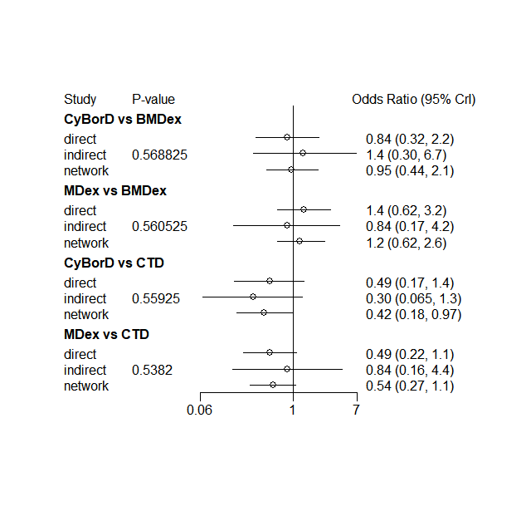
Fig. 4 Cardiac response
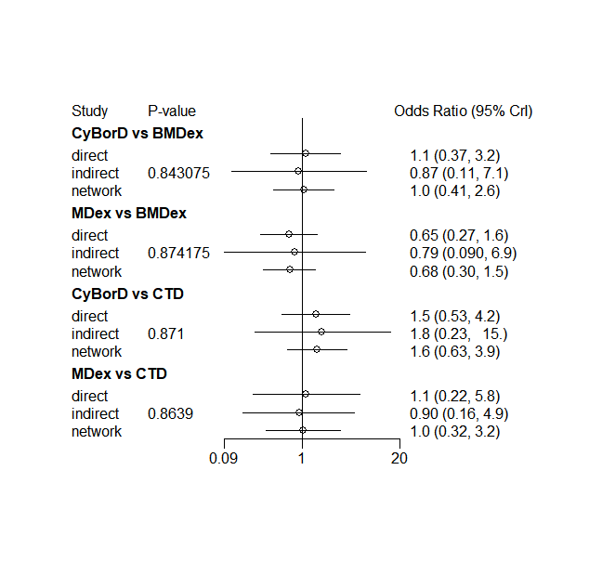
Supplement 6. Funnel plots for publication bias

Fig. 1 Haematological response
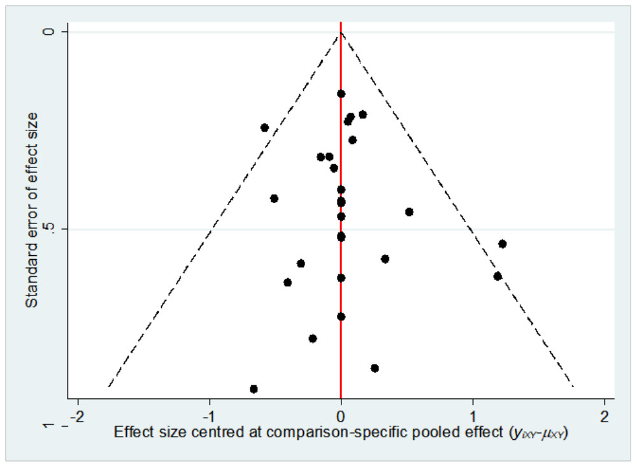

Fig. 2 Complete response
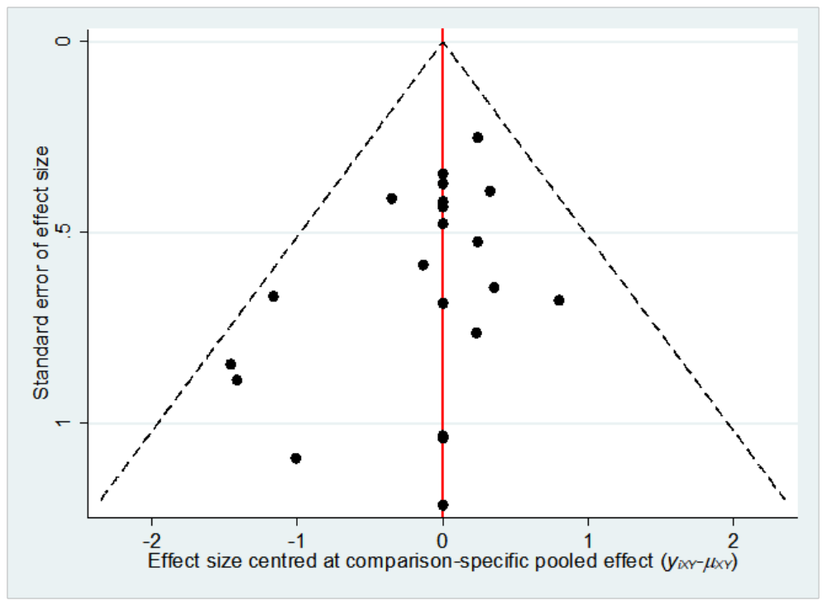

Fig. 3 Renal response
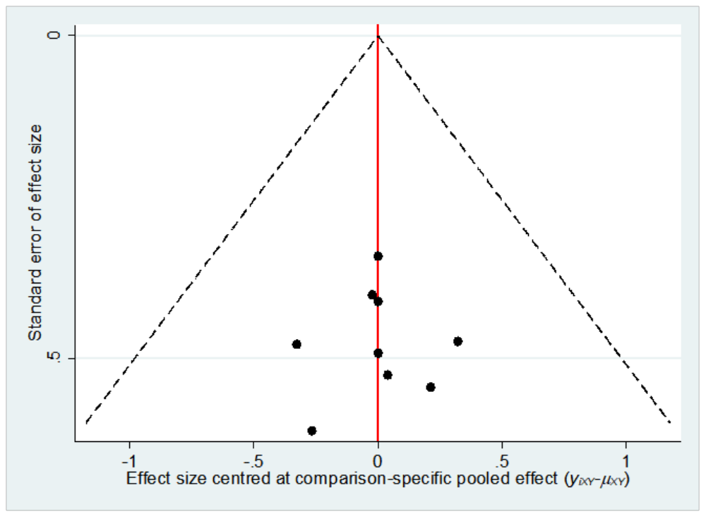

Fig. 4 Cardiac response
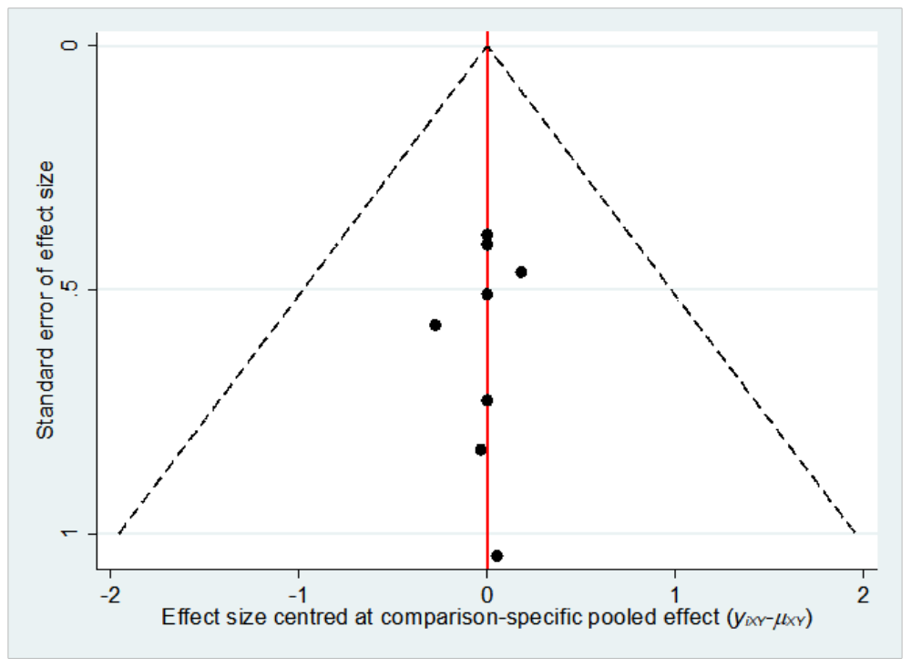

Supplement 7. The heterogeneity of both pairwise meta-analysis and network meta-analysis without study “Chihiro 2018”
Fig. 1: The insignificant heterogeneity for HR
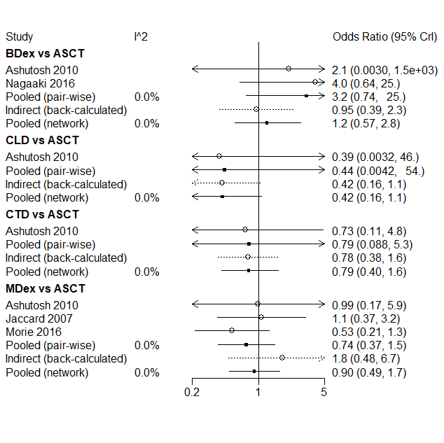
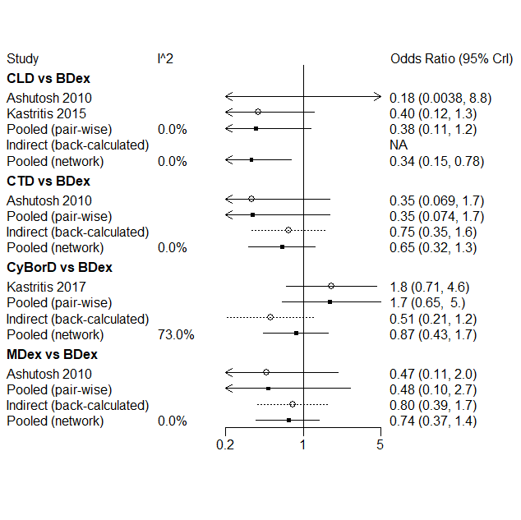
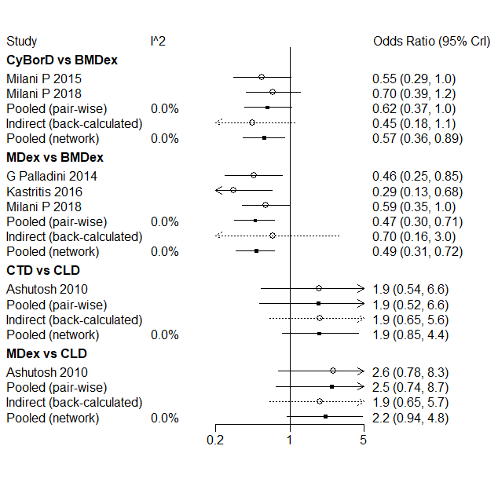
Fig. 2: The insignificant heterogeneity for HR
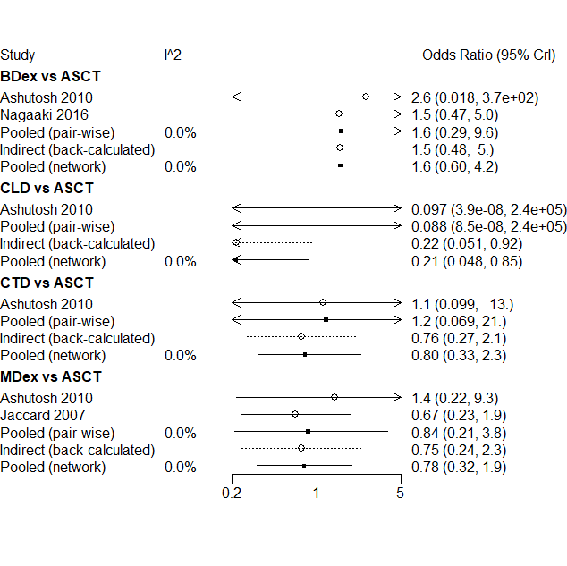
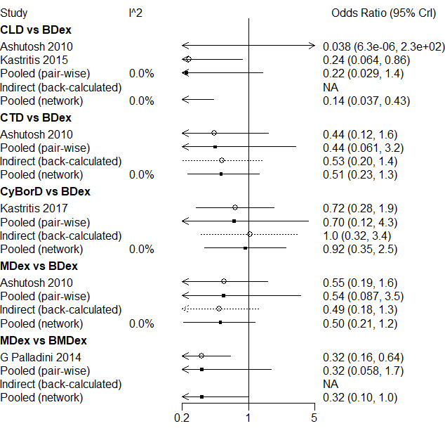
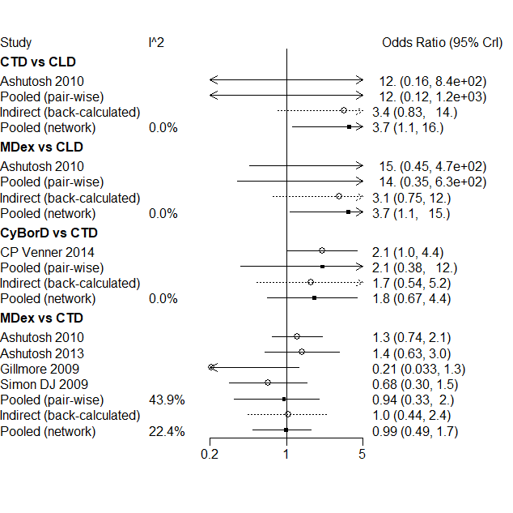
Supplement 8. Comparisons between direct and indirect evidence for HR without study “Chihiro 2018”



