Supplementary Material

Supplementary Figure 1: Mechanism of action of inhaled gases.
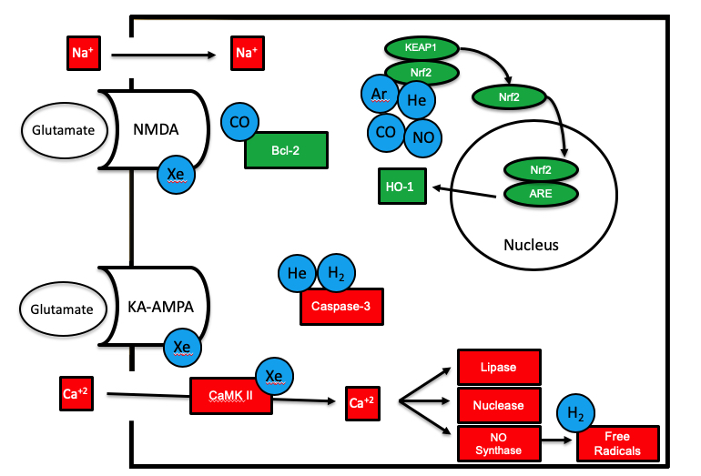
Figure legend:
During hypoxia ischemia, glutamate accumulates in the synaptic junction due to lack of ATP and binds α-amino-3-hydroxy-5-methyl-4-isoxazolepropionic acid [AMPA], kainite [KA], and N-methyl-D-aspartate [NMDA] leading to excitotoxicity. Neuroprotection occurs in several ways: Xenon [Xe] blocks NMDA and AMPA receptors and interferes with calcium/calmodulin-dependent protein kinase II [CaMKII]. Hydrogen [H₂] and helium [He] reduce oxidative stress by inhibiting caspase-3 activity. He, extrinsic nitric oxide [NO], argon [Ar] and carbon monoxide [CO] stimulate nuclear factor erythroid 2-related factor [NRF-2] dissociation and translocation to the nucleus and transcription of cytoprotective genes. One important product is Heme-oxygenase-1 [HO-1], which degrades heme and generates antioxidant molecules. B-cell lymphoma 2 [Bcl-2] is a regulator of apoptosis and is regulated by CO.

