SUPPLEMENTARY MATERIAL
Table S1. Primers used to amplify the full-length of NtMYB12 and relative genes for RT-qPCR.

Gene | No. ID | Primer sequences F (5’ to 3’) | Primer sequences R (5’ to 3’)
35S:NtMYB12 | XM_016624824 | AACCGGTACCATGGGAAGAGCACCTTGTTGT | TTAACCTAGGCTAAGACAAAAGCCAAGCGACAA
NtMYB12  -YXB | XM_016624824 | CAGTCGTCTCACAACATGGGAAGAGCACCTTGTTG | CAGTCGTCTCATACAAGACAAAAGCCAAGCGACAAG
35S:NtPT2 | AB042951 | CGAGCTCATGTCTGCAGATAACAATC | GCTCGAGTCATTCTTCAGTTATAGTTTCC
35S:CHS | AF311783 | ACGAGCTCATGGTGACCGTCGAGGAATTTCG | CAGGTACCAAGTAGCAACACTGTGGAGAAC
NtMYB12 | XM_016624824 | AGCTCATGGTTAGAAGGTAAC | CATTCCATCCCACTATCTGAAC
NtCHS | AF311783 | CGTAGGGCGCAATGTGCCGAG | CGAAAATAATAATCAGGATAAG
NtCHI | XM_016600175 | GAATTACGTGTTCCCATCAAC | ACAAACTTCCCTTCAATTTC
NtF3H | AF036093 | GTGGACACGAAGATGTTATCAG | TGAAGATGGCTAGAAACGATG
NtFLS | DQ435530 | CTCAGAGTGCAACAACCCTAAC | CTGGCTGCTCGTTCTCTGAC
NtPT1 | AB020061 | ATGGGCTTCTTTACTGATGC | TTCCCATTTTATCTCCGAGCC
NtPT2 | AB042951 | CTTGGGCGTTTATACTACACC | CCATGATAATCAAAGTCATACC
NtDFR | AB289448 | GTTCACGCTACTGTTCGTGATCC | CAAGTCCGCTTTCCACAGCG
NtL25 | L18908 | CCGTCCAAAAAATCTGACCC | TCTTCAAAGTCTTAGGTCGG

Figure S1

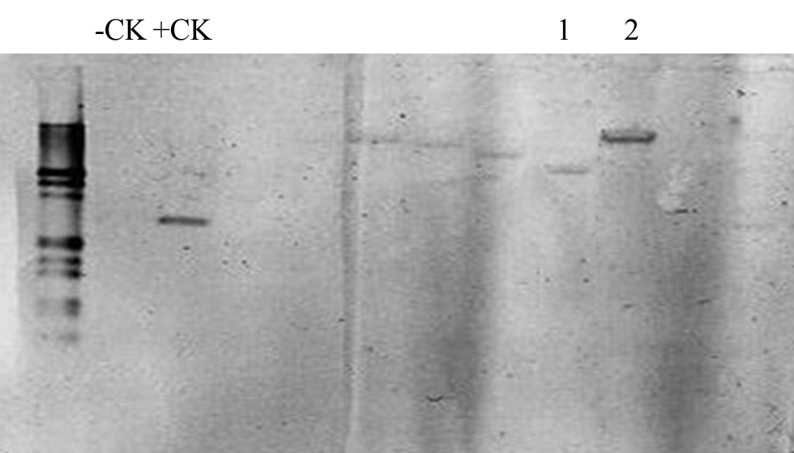

Figure S1 Southern blot analysis of 35S:NtMYB12 plant and WT.
Hygromycin gene was used as probe and ﬁve micrograms of genomic DNA of each sample were digested by SacI, and separated by agarose gel. -CK, negative control; +CK, positive control. 1, 35S:NtMYB12-1; 2, 35S:NtMYB12-2.

Figure S2

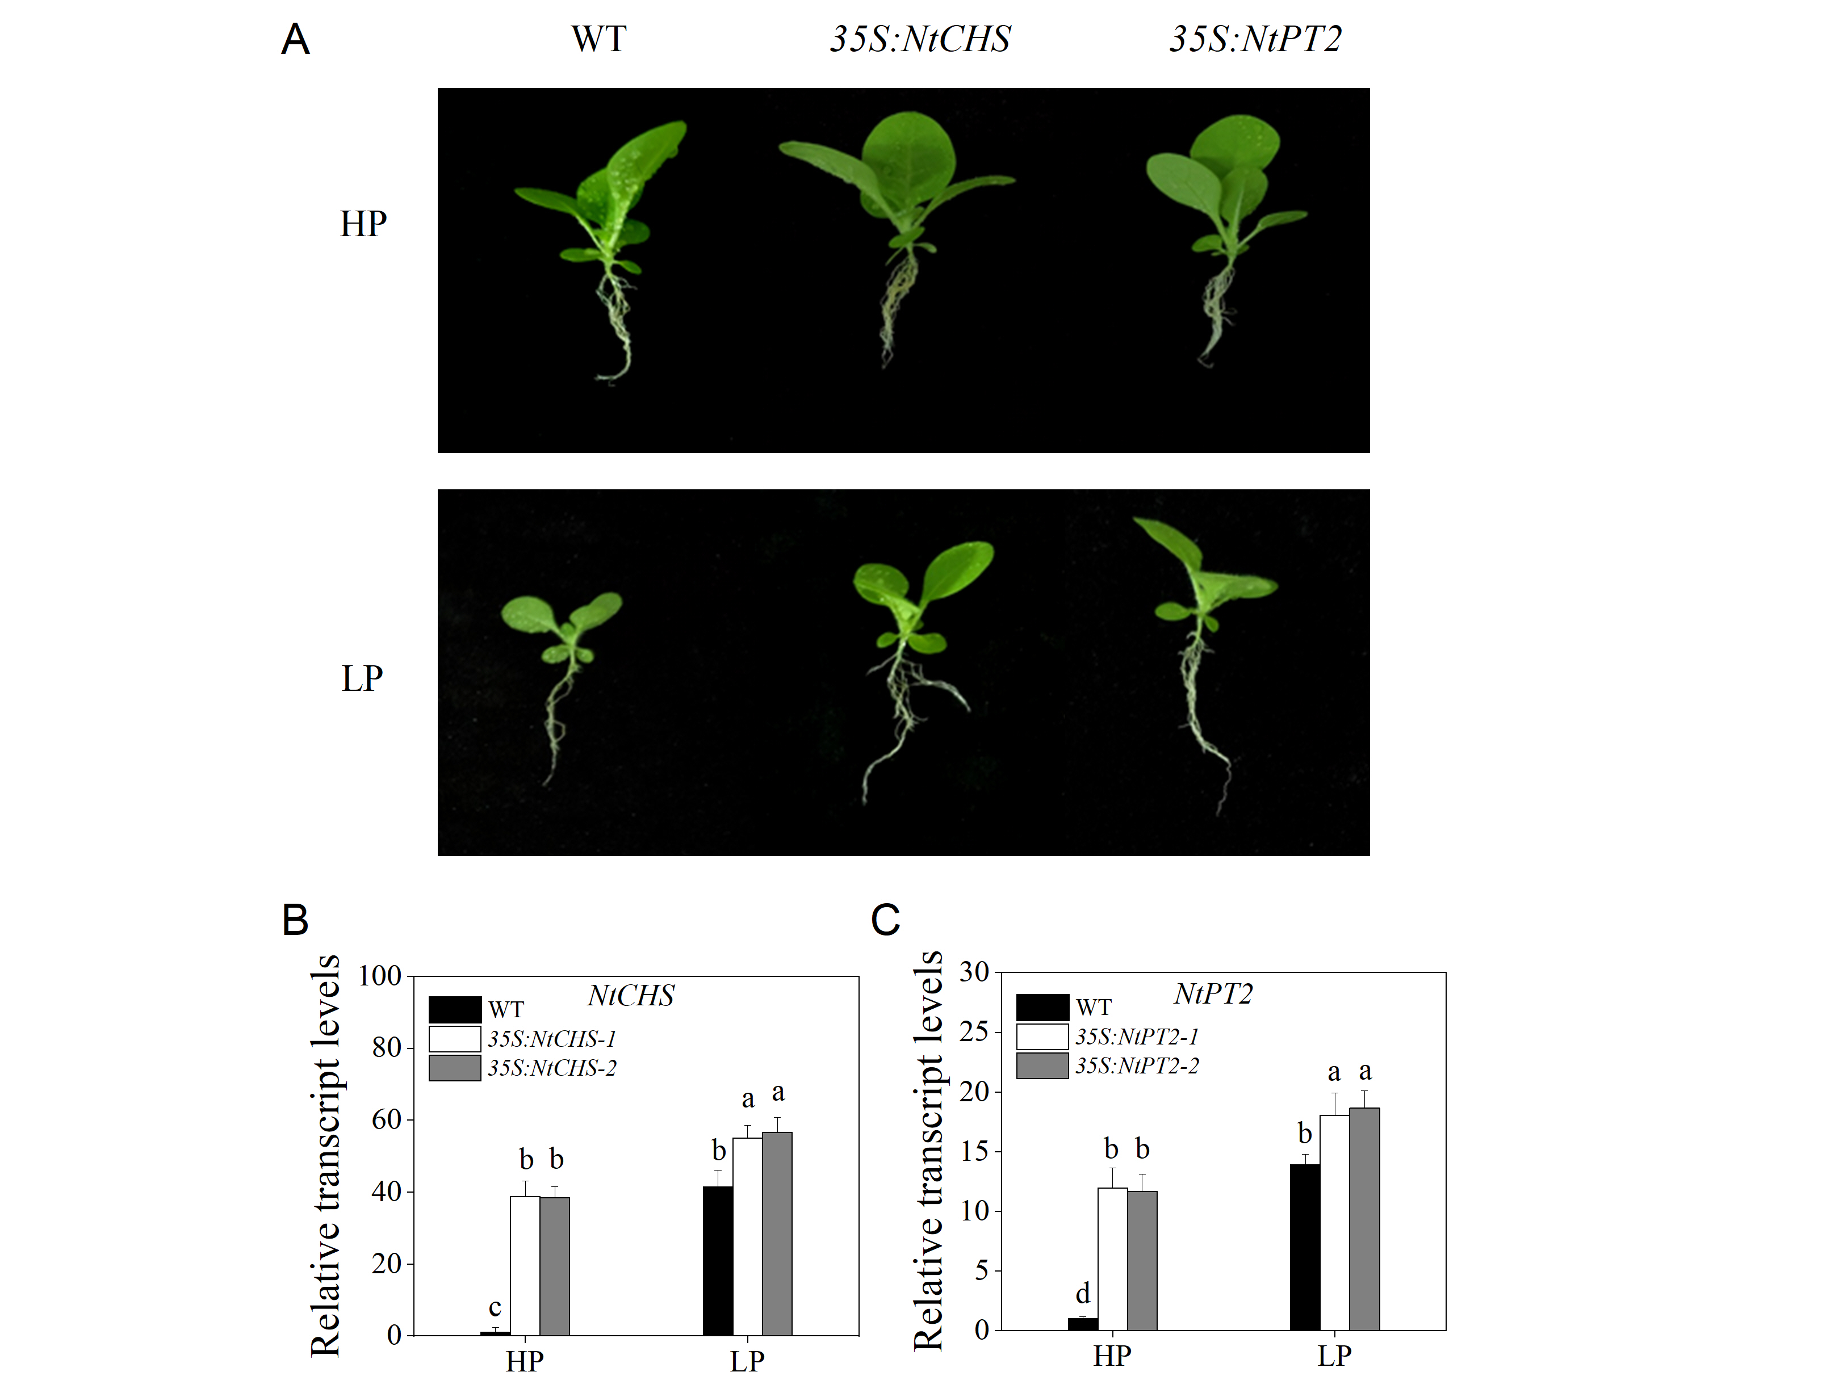
Figure S2 Expression of NtCHS and NtPT2 in transgenic tobacco and characterization of the WT and transgenic tobacco plants.
(A), Characterization of the transgenic tobacco 35S:NtCHS and 35S:NtPT2 under HP and LP conditions. (B-C), Relative transcript levels of NtCHS and NtPT2 in transgenic plants. Sixteen-day-old seedlings were transferred to the full-strength culture solution supplied with high Pi (HP; 1mM Pi) or low Pi (LP; 0.02mM Pi) for 14 days. Data are the means ± SDs of three biological replicates. Different letters indicate significant differences (P < 0.05).

Figure S3
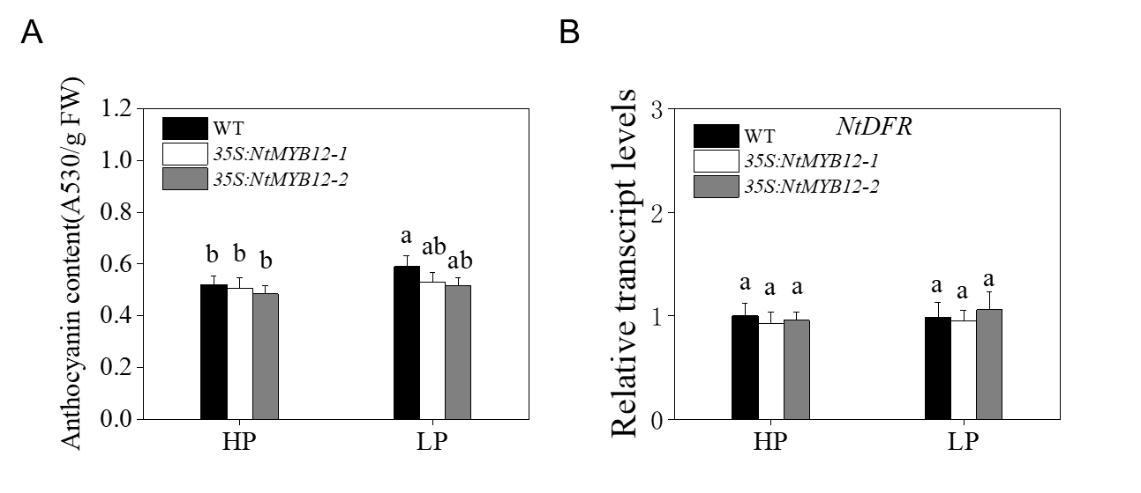
Figure S3 Anthocyanin concentration and relative transcript levels of anthocyanin biosynthesis genes NtDFR in WT, 35S:NtMYB12 plants.
(A), Anthocyanin concentration of WT and transgenic plants in tobacco. (B), the relative transcript levels of anthocyanin biosynthesis genes NtDFR. Sixteen-day-old seedlings were transferred to the full-strength culture solution supplied with high Pi (HP; 1mM Pi) or low Pi (LP; 0.02mM Pi) for 21 days. FW, fresh weight. DFR: dihydroflavonol reductase. Data are the means ± SDs of five biological replicates. Different letters indicate significant differences (P < 0.05).

Figure S4
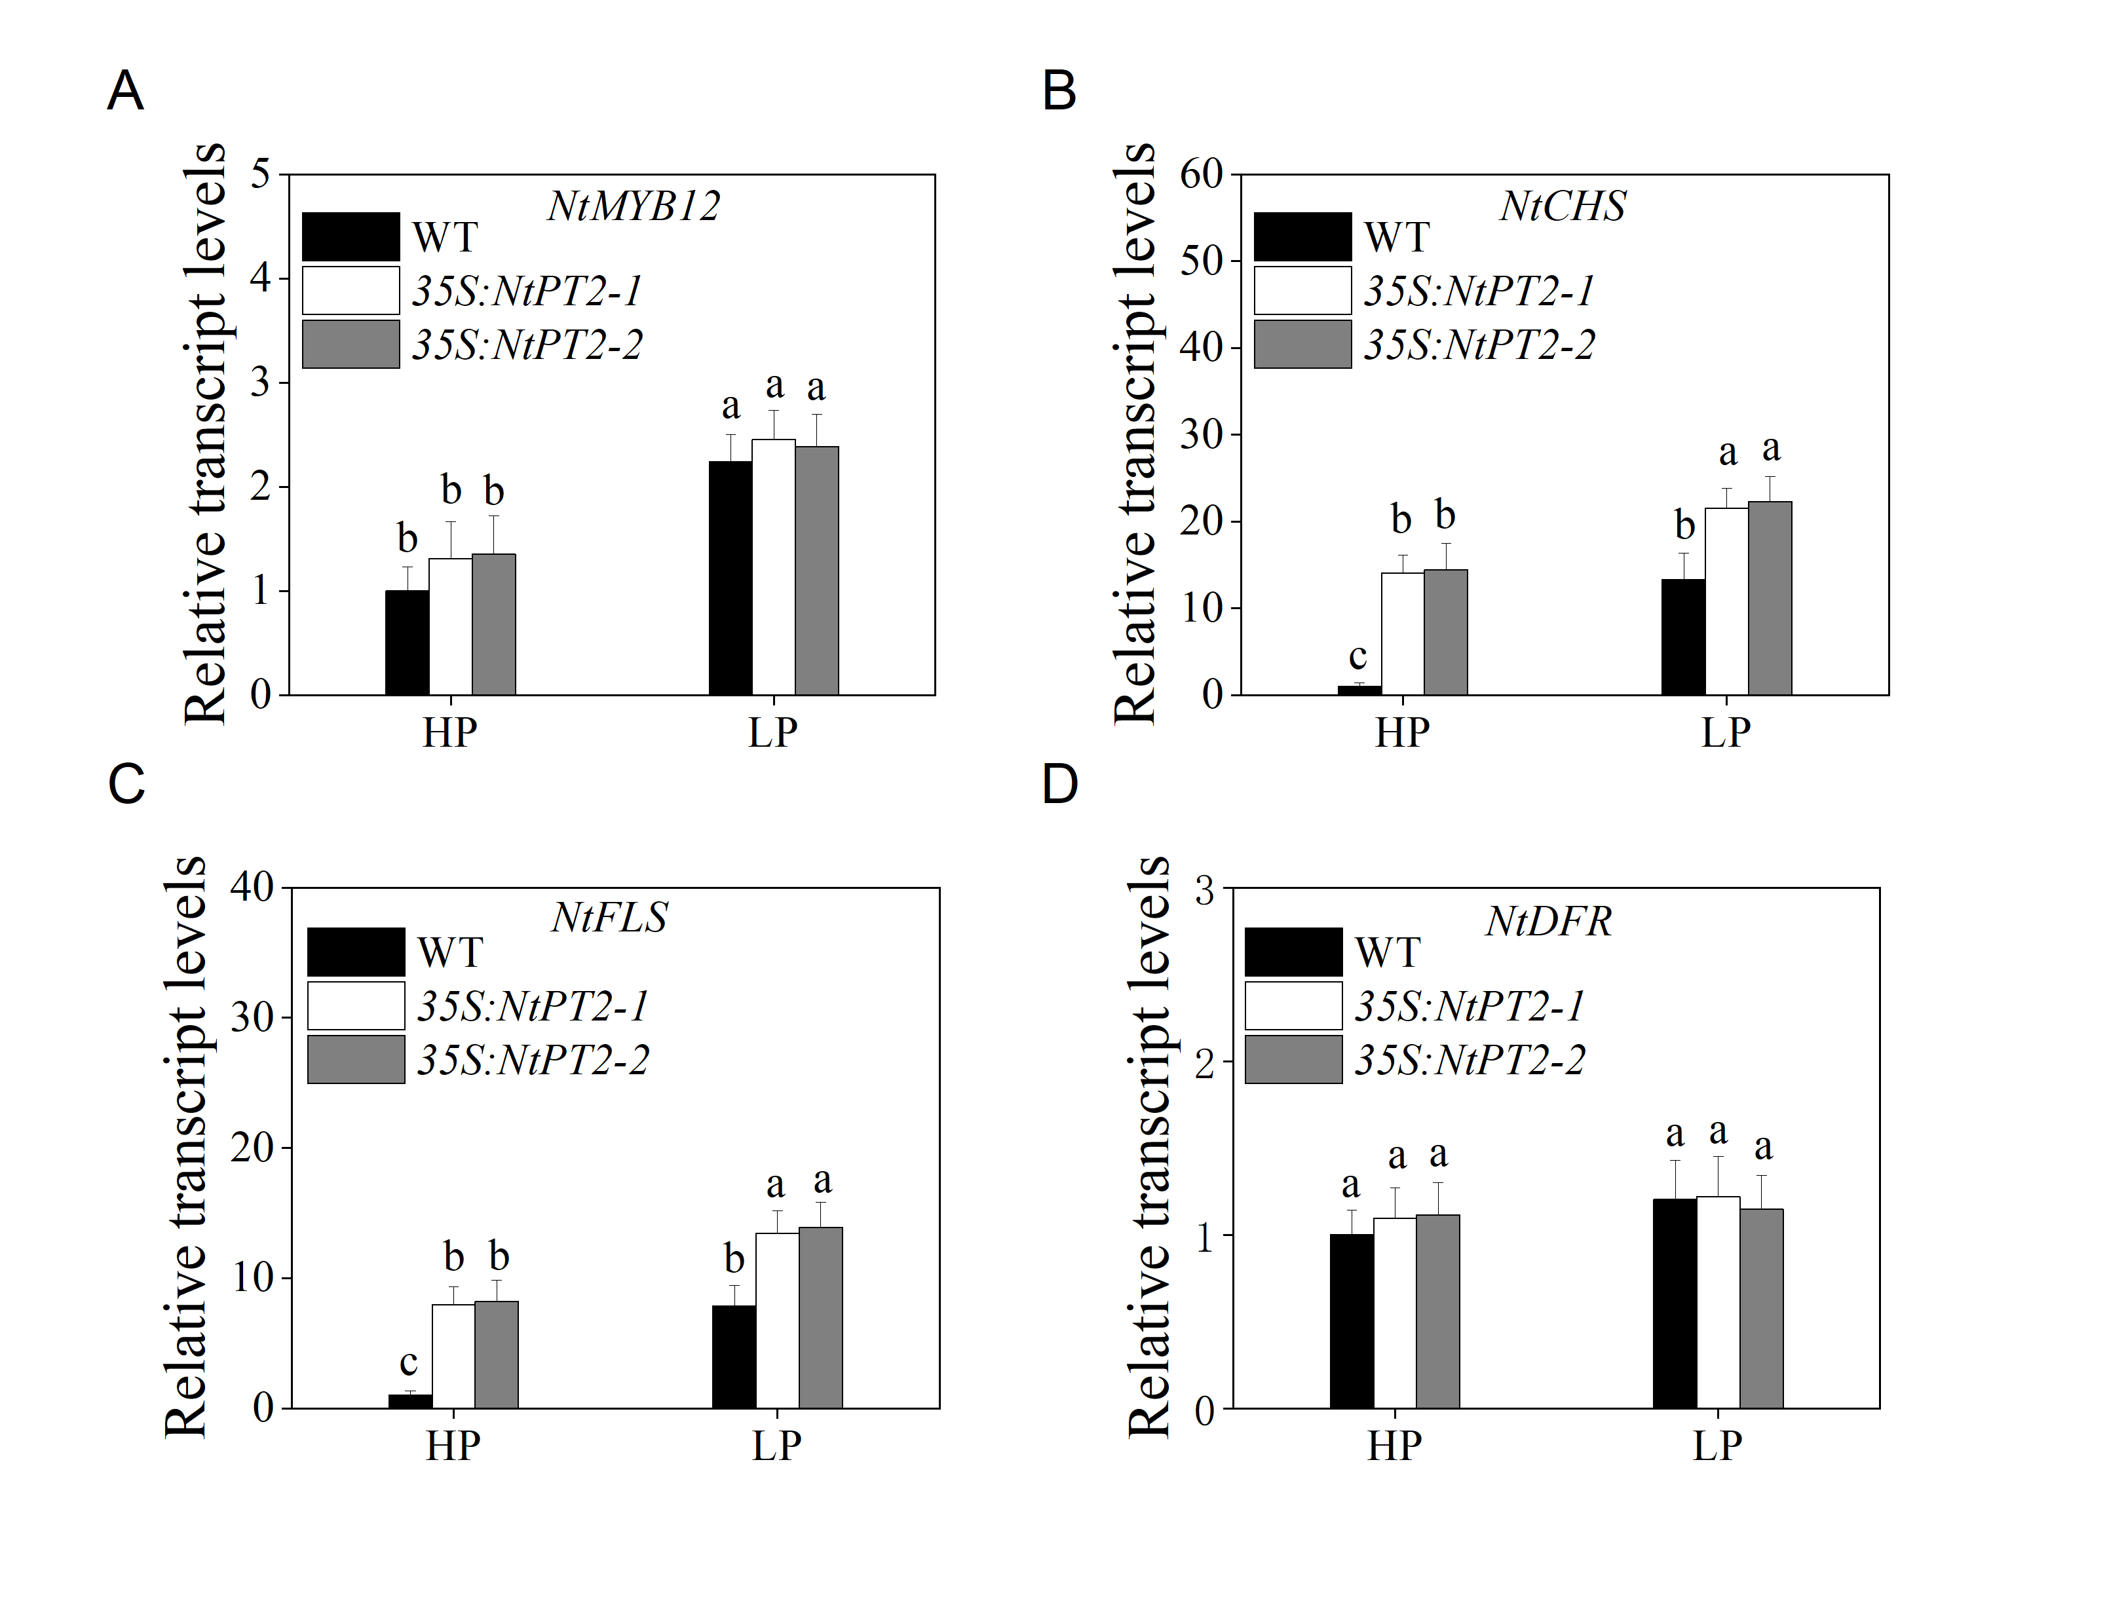
Figure S4 Relative transcript levels of NtMYB12, NtCHS, NtFLS and NtDFR in 35S:NtPT2 plants.
(A-D), Relative transcript levels of NtMYB12, NtCHS, NtFLS and NtDFR in 35S:NtPT2 plants. Sixteen-day-old seedlings were transferred to the full-strength culture solution supplied with high Pi (HP; 1mM Pi) or low Pi (LP; 0.02mM Pi) for 14 days. Data are the means ± SDs of three biological replicates. Different letters indicate significant differences (P < 0.05).

