Supplementary data sheet. Analysis of embryonic outcomes that might have influenced the probabilities of an MII oocyte turning into a euploid blastocyst in the study centers performing NGS (Anatolia and Androfert) and qPCR (Genera). The multiple comparison of means was performed using the Tukey-Kramer HSD (honestly significant difference) test, which is an exact alpha-level test if the sample sizes are the same, and conservative if the sample sizes are different. The graphs below show the distribution of 2PN fertilization rates (A) and blastulation rates (B) by study center. On the right-hand side, comparison circles plot provides a visual representation of group means comparisons. The circles are nested, thus indicating that the means are not significantly different. The threshold matrix shows the actual absolute difference in the means minus the HSD, which is the difference that would be significant. Pairs with a positive value are significantly different. The q* (appearing above the HSD Threshold Matrix table) is the quantile that is used to scale the HSDs. It has a computational role comparable to a Student’s t.

- Fertilization rates

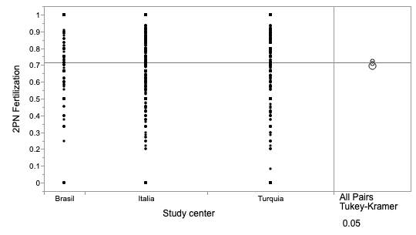

Means Comparisons
Comparisons for all pairs using Tukey-Kramer HSD
Confidence Quantile
q* | Alpha
2.34632 | 0.05
HSD Threshold Matrix
Abs(Dif)-HSD
 | Genera | Anatolia | Androfert
Genera | -0.03711 | -0.02053 | -0.02591
Anatolia | -0.02053 | -0.03660 | -0.04206
Androfert | -0.02591 | -0.04206 | -0.06468
Positive values show pairs of means that are significantly different.
Connecting Letters Report
Level |  |  |  |  |  |  |  |  |  |  |  |  |  |  |  | Mean
Genera | A |  |  |  |  |  |  |  |  |  |  |  |  |  |  | 0.72608797
Anatolia | A |  |  |  |  |  |  |  |  |  |  |  |  |  |  | 0.70976215
Androfert | A |  |  |  |  |  |  |  |  |  |  |  |  |  |  | 0.69926643
Levels not connected by same letter are significantly different.

Ordered Differences Report
Level | - Level | Difference | Std Err Dif | Lower CL | Upper CL | p-Value
Genera | Androfert | 0.0268215 | 0.0224741 | -0.025910 | 0.0795530 | 0.4573
Genera | Anatolia | 0.0163258 | 0.0157090 | -0.020533 | 0.0531842 | 0.5522
Anatolia | Androfert | 0.0104957 | 0.0223977 | -0.042057 | 0.0630479 | 0.8860

B. Blastulation rates
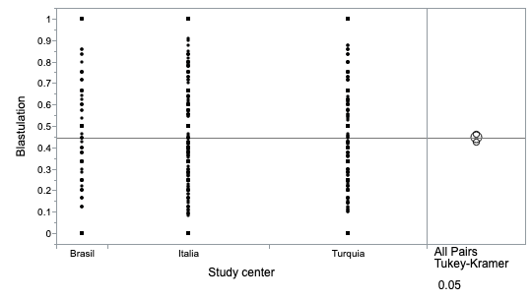

Means Comparisons
Comparisons for all pairs using Tukey-Kramer HSD
Confidence Quantile
q* | Alpha
2.34649 | 0.05
HSD Threshold Matrix
Abs(Dif)-HSD
 | Genera | Androfert | Anatolia
Genera | -0.04393 | -0.04949 | -0.00841
Androfert | -0.04949 | -0.07759 | -0.04102
Anatolia | -0.00841 | -0.04102 | -0.04433
Positive values show pairs of means that are significantly different.
Connecting Letters Report
Level |  |  |  |  |  |  |  |  |  |  |  |  |  |  |  | Mean
Genera | A |  |  |  |  |  |  |  |  |  |  |  |  |  |  | 0.46116610
Androfert | A |  |  |  |  |  |  |  |  |  |  |  |  |  |  | 0.44761224
Anatolia | A |  |  |  |  |  |  |  |  |  |  |  |  |  |  | 0.42544492
Levels not connected by same letter are significantly different.

Ordered Differences Report
Level | - Level | Difference | Std Err Dif | Lower CL | Upper CL | p-Value
Genera | Anatolia | 0.0357212 | 0.0188070 | -0.008409 | 0.0798516 | 0.1393
Androfert | Anatolia | 0.0221673 | 0.0269288 | -0.041021 | 0.0853556 | 0.6887
Genera | Androfert | 0.0135539 | 0.0268680 | -0.049492 | 0.0765995 | 0.8692

