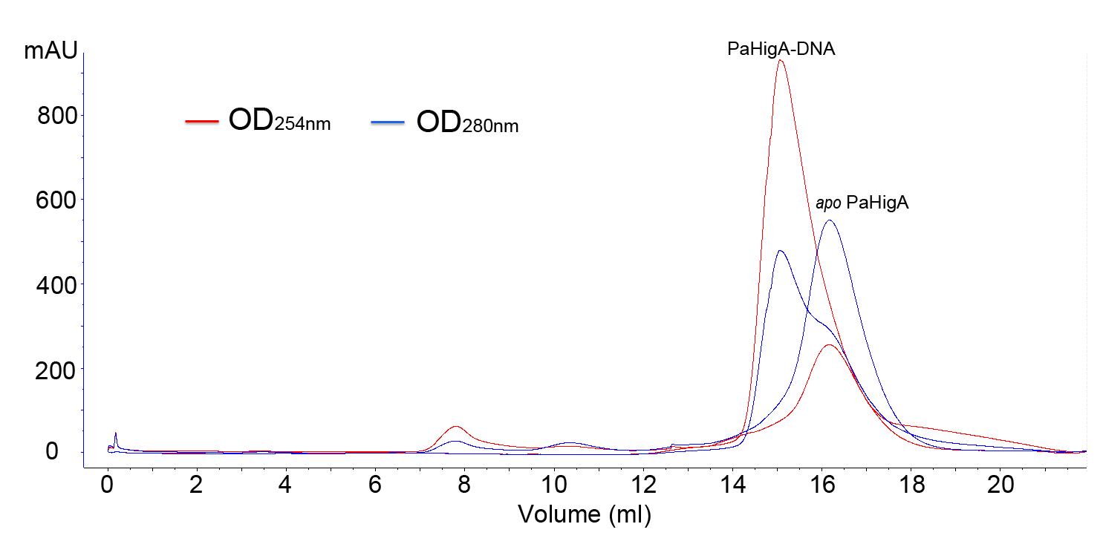
Figure S1. Analysis of binding of a 28-bp DNA duplex derived from higBA promoter by size-exclusion chromatography. Purified apo PaHigA and PaHigA-DNA complex eluted from gel filtration chromatogram (SuperdexTM 200 10/300 GL) at 16.2 and 15.1 ml, respectively.

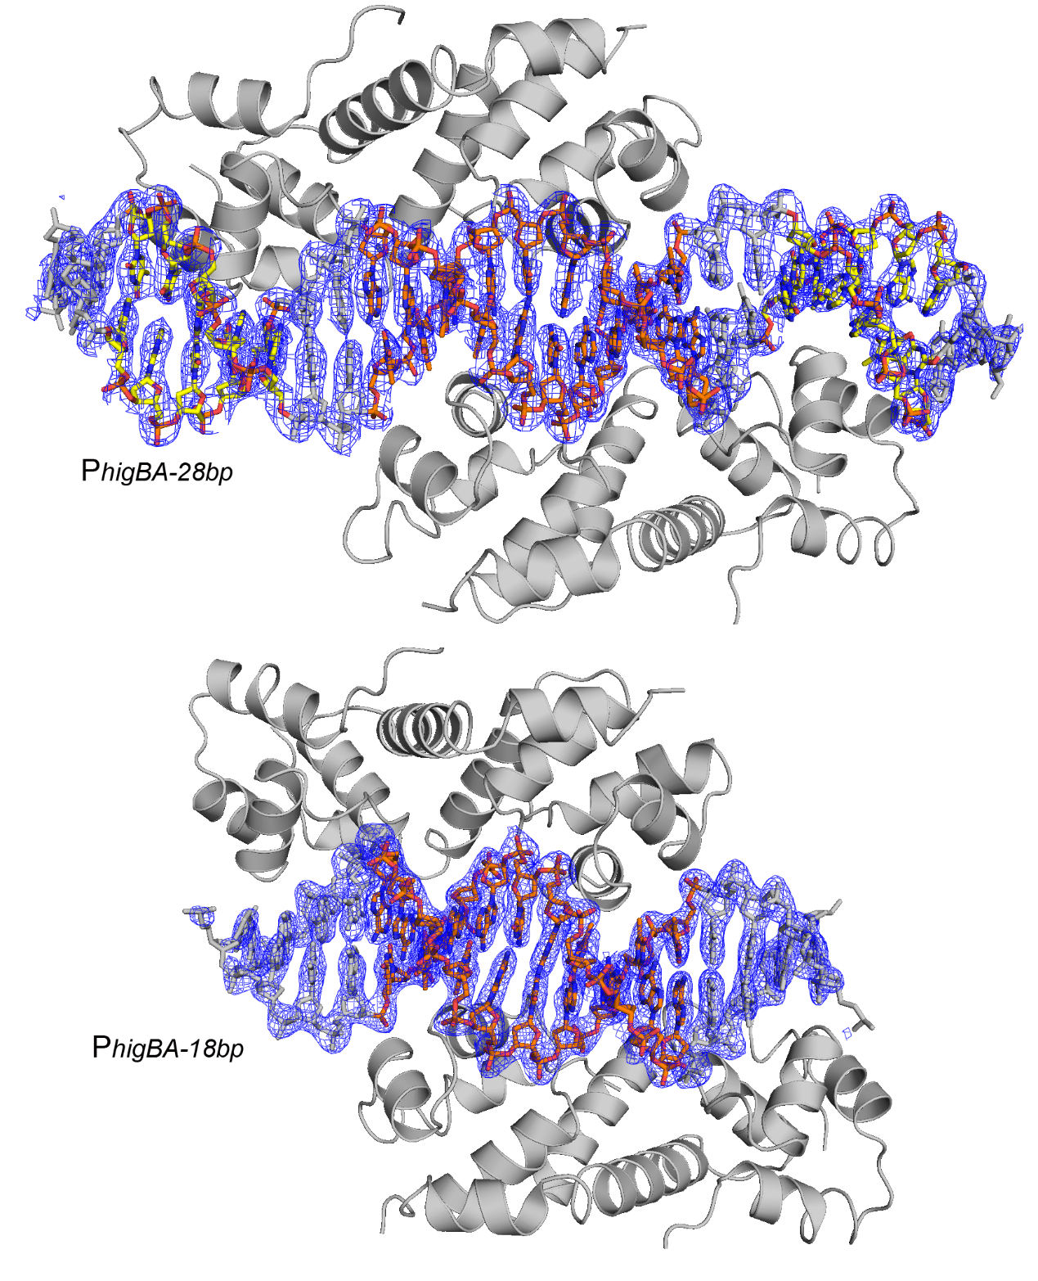
Figure S2. 2Fo-Fc electron density map (blue) of the 28-bp and 18-bp DNA duplex contoured at 1.5 σ level.

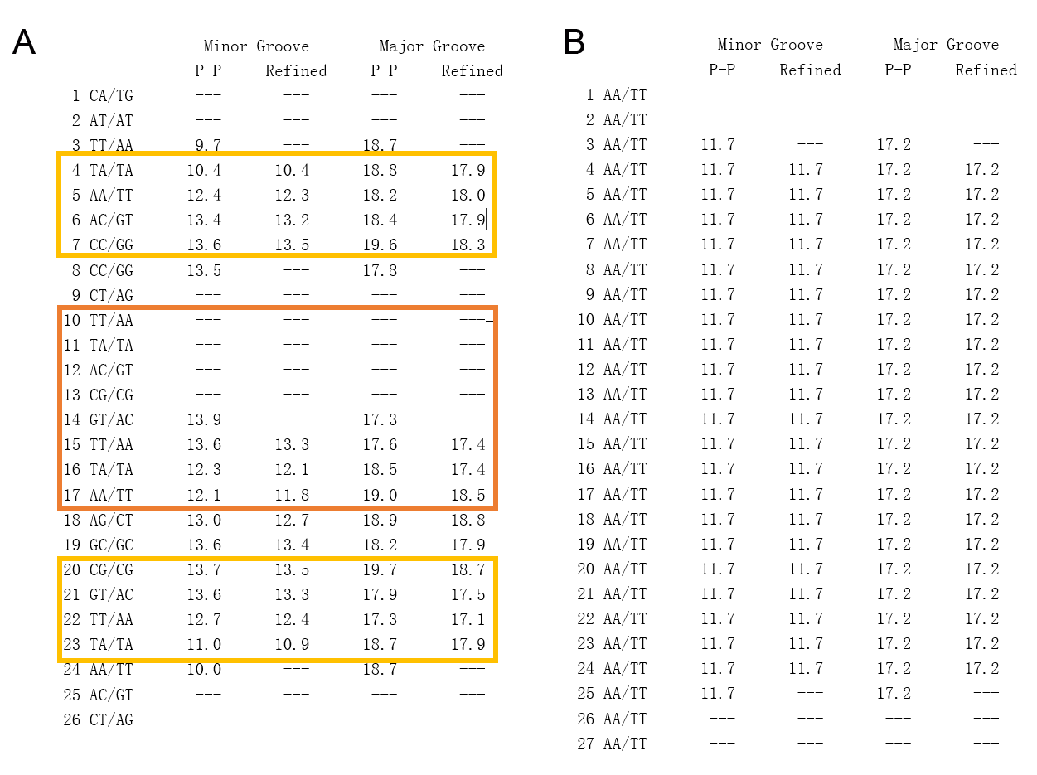
Figure S3. The width of the major groove and minor groove of the promoter DNA (A) and the ideal B-form DNA calculated by the w3DNA web server (http://web.x3dna.org/). Minor and major groove widths use direct P-P distances and refined P-P distances which take into account the directions of the sugar-phosphate backbones (Subtract 5.8 Angstrom from the values to take account of the vdw radii of the phosphate groups, and for comparison with FreeHelix and Curves.)

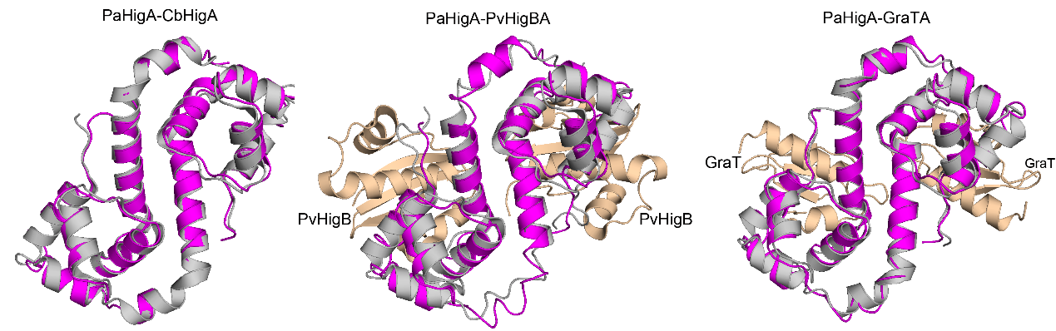
Figure S4. Structural superimposition of DNA-binding PaHigA dimer with its homologs in apo form or toxin-binding form. PaHigA is shown in magenta. Apo CbHigA (PDB ID: 3TRB, with Z-score 16.3 and r.m.s.d. 0.9 Å for 92 Cα atoms), PvHigA (PDB ID: 4MCX, with Z-score 13.4 and r.m.s.d. 2.1 Å for 92 Cα atoms) and GraA (PDB ID: 6F8S, with Z-score 15.4 and r.m.s.d. 1.5 Å for 89 Cα atoms) are shown in gray, and the corresponding toxins are shown in wheat.

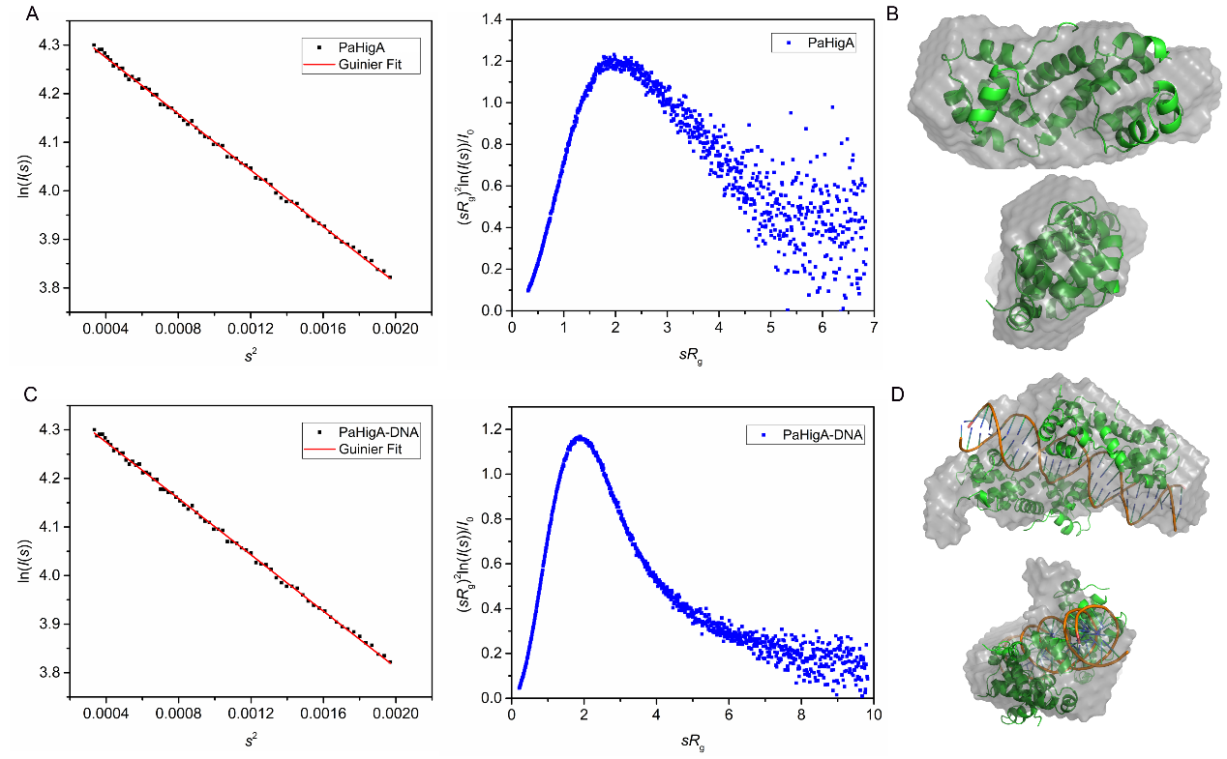
Figure S5. Guinier plot and Kratky plot analysis of apo PaHigA (A-B) and PaHigA-DNA complex (C-D) by SAXS.

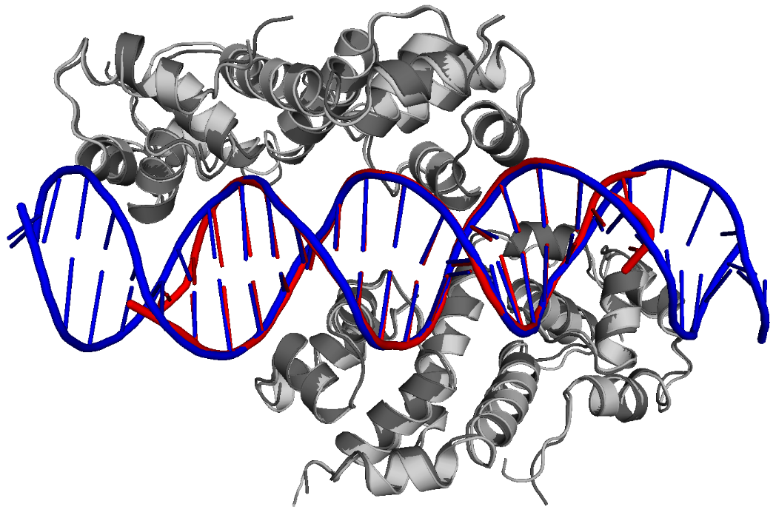
Figure S6. Structural superposition of the structures of PaHigA in complex with the 28-bp and 18-bp DNA duplex. The proteins in the two structures are shown in light gray and dark gray, respectively. The two DNA fragments are highlighted in blue and red, respectively.

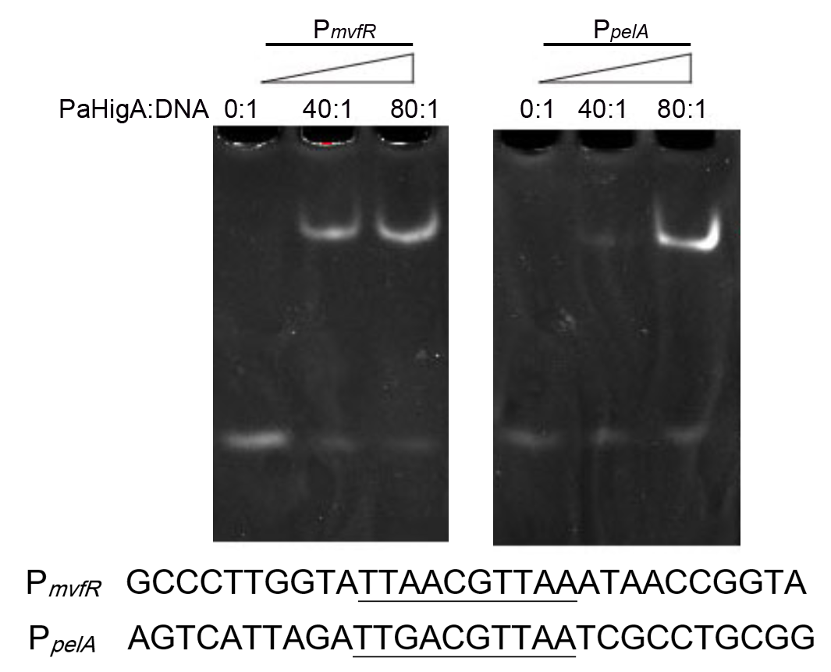
Figure S7. EMSA assays for the DNA binding capacity of PaHigA to the DNA fragments derived from the promoters of mvfR (P_{mvfR}) and pelA (P_{pelA}). The palindromic sequences are underlined.

Table S1. The list of PaHigA (wild-type and mutants) primers in this study. The mutated nucleic acids are shown in lower case. Restriction enzyme sites are underlined. F indicates forward primer and R indicates reverse primer.

primer | sequences
Wild-type | F | 5’- CTAGCCATGGGCATGGCTACCAATGGTATGCGCC -3’
 | R | 5’-CGCGGATCCCTAGTGGTGGTGGTGGTGGTGTCCGT GAGCAAGCAGCGGC-3’
R49A | F | 5’-ATCGTTCGTGAGCAG gc TGGTATCT -3’
 | R | 5’-gc CTGCTCACGAACGATATCGTTCA -3’
T40A | F | 5’-AAAGTCTCCGCTCCG g CAGTGAAC -3’
 | R | 5’-c CGGAGCGGAGACTTTCAAAGCGC -3’
D43A | F | 5’-CTCCGACAGTGAACG c TATCGTTCGTG -3’
 | R | 5’-gCGTTCACTGTCGGAGCGGAGACTTTC’

Table S2. Statistics on SAXS data collection, analysis and modeling.
Data Collection Parameters
Instrument |  | BL19U2 beamline, equipped with a Pilatus 1M Detector
Beam geometry |  | Scatterless Slits
Wavelength (Å) |  | 1.033
qrange (Å⁻¹) |  | 0.01-0.31
Temperature (K) |  | 295
Exposure time (s) |  | 1s per frame
Protein concentration (mg/ml) |  | 1, 3 and 5
Protein samples |  | apo PaHigA | PaHigA-DNA complex
Structural Parameters
From Guinier fit | I(0) (cm⁻¹) | 18.77±0.04 | 80.36±0.17
 | Rg(Å) | 19.66±0.07 | 29.35±0.08
From P(r) | I(0) (cm⁻¹) | 18.90 | 80.42
 | Rg(Å) | 20.14 | 29.71
 | Dmax (Å) | 66.0 | 98.3
Molecular Mass Determination
MM (kDa) from I(0) |  | 22.1 | 73.8
MM (kDa) from sequence |  | 24.5 | 69
Modeling
DAMMIN | χ² | 1.064 | 1.039
 | NSD | 0.831±0.019 | 0.714±0.056
 | Ensemble Resolution | 27±2 | 38±3

