Supplementary Figures and Tables

# Supplementary Figures

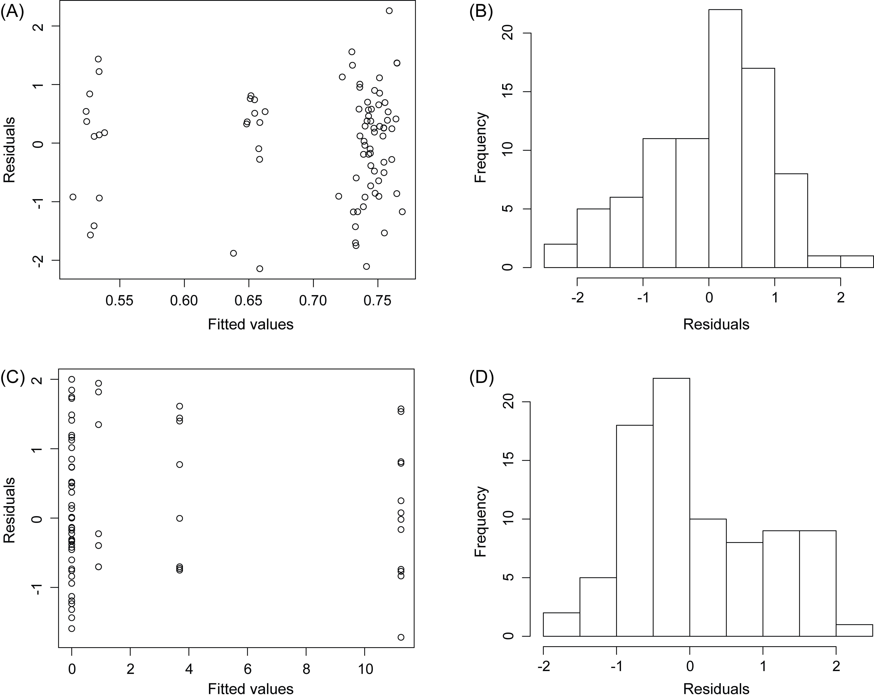

Supplementary Figure 1. Residual plots of LME models on Fv/Fm (A and B) and percentage of tissue bleached (C and D). Kolmogorov-Smirnov tests confirmed that residuals were normally distributed (Fv/Fm: *p* = 0.160, tissue bleached: *p* = 0.06).

Macintosh HD:Users:user:Dropbox:school:PhD:2. coral-algal outcomes:fig:sup fig2 tissue y lobo.pdf

**Supplementary Figure 2.** Differences in tissue bleaching and Fv/Fm of the sides of coral fragments that were in direct contact with *Lobophora* sp. (black) and the opposite sides of the same coral fragments that were not in direct contact with the alga (grey).

Macintosh HD:Users:user:Dropbox:school:PhD:2. coral-algal outcomes:fig:sup fig3 y hyp.pdf

**Supplementary Figure 3.** Differences in Fv/Fm of the sides of coral fragments that were in direct contact with *Hypnea pannosa* (black) and the opposite sides of the same coral fragments that were not in direct contact with the alga (grey).

Macintosh HD:Users:user:Dropbox:school:PhD:2. coral-algal outcomes:fig:sup fig1 tissue PAM over time.pdf

**Supplementary Figure 4.** Effects of direct contact with *Hypnea pannosa* and *Lobophora* sp. on coral tissue and Fv/Fm in three coral species across eight weeks.

**Supplementary Figure 5.** The mean relative abundance of phyla for the *Montipora stellata* (Ms) coral treatments, as well as the seawater collected from the field and the treatment tanks. Treatments are coral from the field (Ctrl_Ms), tank acclimated coral (00_Ms), coral without any algal treatment (01_Ms), contact with *Lobophora* sp. (MsL) contact with *Hypnea pannosa* (MsH), close proximity with *Lobophora* sp (Ms_L), close proximity with *H. pannosa* (Ms_H), contact with mimic *Lobophora* sp. (MsLctrl), contact with mimic *H. pannosa* (MsHctrl), field seawater from the reef (Ctrl_SW), and seawater from the experimental tanks (Tank_SW). *Proteobacteria has been included as Class.

**Supplementary Figure 6.** The mean relative abundance of phyla for the *Pocillopora acuta* (Pa) coral treatments, as well as the seawater collected from the field and the treatment tanks. Treatments are coral from the field (Ctrl_Pa), tank acclimated coral (00_Pa), coral without any algal treatment (01_ Pa), contact with *Lobophora* sp. (PaL) contact with *Hypnea pannosa* (PaH), close proximity with *Lobophora* sp (Pa_L), close proximity with *H. pannosa* (Pa_H), contact with mimic *Lobophora* sp. (PaLctrl), contact with mimic *H. pannosa* (PaHctrl), field seawater from the reef (Ctrl_SW), and seawater from the experimental tanks (Tank_SW). *Proteobacteria has been included as Class.

**Supplementary Figure 7.** The mean relative abundance of phyla for the *Merulina ampliata* (Ma) coral treatments, as well as the seawater collected from the field and the treatment tanks. Treatments are coral from the field (Ctrl_Ma), tank acclimated coral (00_Ma), coral without any algal treatment (01_Ma), contact with *Lobophora* sp. (MaL) contact with *Hypnea pannosa* (MaH), close proximity with *Lobophora* sp (Ma_L), close proximity with *H. pannosa* (Ma_H), contact with mimic *Lobophora* sp. (MaLctrl), contact with mimic *H. pannosa* (MaHctrl), field seawater from the reef (Ctrl_SW), and seawater from the experimental tanks (Tank_SW). *Proteobacteria has been included as Class.

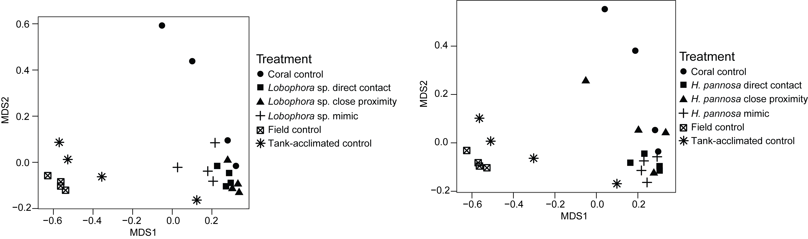

**Supplementary Figure 8.** nMDS plots of the prokaryotic community structure of *Montipora stellata* coral fragments.

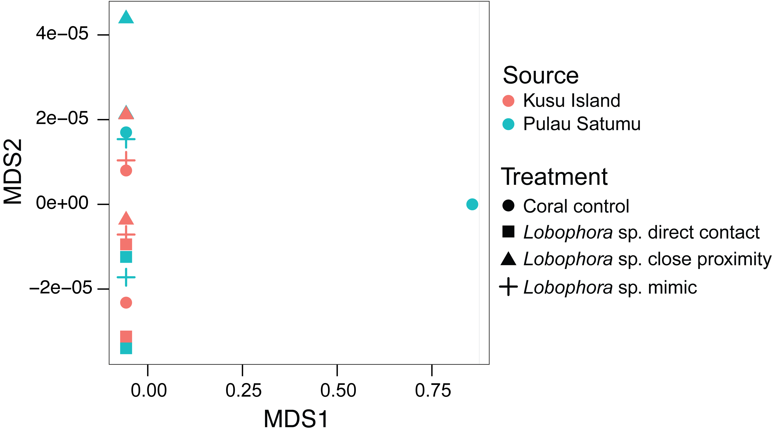

**Supplementary Figure 9.** nMDS plots of the prokaryotic community structure of *Merulina ampliata* coral fragments that had interactions with *Lobophora* sp. Color is used to indicate whether corals were collected from either Kusu Island (red) or Pulau Satumu (blue).

# Supplementary Tables

**Supplementary Table 1.** Mean alpha diversity measures for all *Montipora stellata* (Ms) treatments. Treatments are coral from the field (Ctrl_Ms), tank acclimated coral (00_Ms), coral without any algal treatment (01_Ms), contact with *Lobophora* sp. (MsL) contact with *Hypnea pannosa* (MsH), close proximity with *Lobophora* sp (Ms_L), close proximity with *H. pannosa* (Ms_H), contact with mimic *Lobophora* sp. (MsLctrl), contact with mimic *H. pannosa* (MsHctrl), field seawater from the reef (Ctrl_SW), and seawater from the experimental tanks (Tank_SW).

|  |  |  |  |  |
| --- | --- | --- | --- | --- |
| **Treatment** | **Richness (Obs.)** | **Richness (chao)** | **Evenness (Shannon)** | **Diversity**  **(Inv. Simpson)** |
| **Ctrl_Ms** | 452.00 ± 162.48 | 671.37 ± 185.41 | 0.46 ± 0.07 | 5.47 ± 2.18 |
| **00_Ms** | 1061.50 ± 1000.82 | 1361.08 ± 1068.22 | 0.61 ± 0.03 | 14.27 ± 2.77 |
| **01_Ms** | 1316.25 ± 908.40 | 1773.13 ± 1109.25 | 0.61 ± 0.12 | 19.16 ± 21.82 |
| **01_MsL** | 3044.75 ± 1181.69 | 3581.40 ± 1347.93 | 0.79 ± 0.05 | 118.25 ± 69.75 |
| **01_Ms_L** | 4856.50 ± 2547.80 | 5895.10 ± 3158.78 | 0.81 ± 0.02 | 184.11 ± 82.75 |
| **01_MsLctrl** | 1395.25 ± 325.65 | 1849.40 ± 333.60 | 0.74 ± 0.07 | 68.40 ± 71.93 |
| **01_MsH** | 2671.50 ± 901.40 | 3206.53 ± 1011.23 | 0.78 ± 0.06 | 98.06 ± 77.21 |
| **01_Ms_H** | 1564.25 ± 980.51 | 1957.62 ± 1036.86 | 0.73 ± 0.13 | 65.25 ± 39.79 |
| **01_MsHctrl** | 1955.50 ± 477.48 | 2456.86 ± 529.16 | 0.78 ± 0.04 | 62.00 ± 29.09 |
| **Ctrl_SW** | 4870.67 ± 284.99 | 9598.47 ± 759.56 | 0.54 ± 0.02 | 18.75 ± 3.81 |
| **Tank_SW** | 7155.00 ± 718.14 | 11588.02 ± 1011.29 | 0.62 ± 0.05 | 34.09 ± 14.00 |

**Supplementary Table 2.** Mean alpha diversity measures for all *Pocillopora acuta* (Pa) treatments. Treatments are coral from the field (Ctrl_Pa), tank acclimated coral (00_Pa), coral without any algal treatment (01_ Pa), contact with *Lobophora* sp. (PaL) contact with *Hypnea pannosa* (PaH), close proximity with *Lobophora* sp (Pa_L), close proximity with *H. pannosa* (Pa_H), contact with mimic *Lobophora* sp. (PaLctrl), contact with mimic *H. pannosa* (PaHctrl), field seawater from the reef (Ctrl_SW), and seawater from the experimental tanks (Tank_SW).

|  |  |  |  |  |
| --- | --- | --- | --- | --- |
| **Treatment** | **Richness (Obs.)** | **Richness (chao)** | **Evenness (Shannon)** | **Diversity**  **(Inv. Simpson)** |
| **Ctrl_Pa** | 375.00 ± 208.30 | 641.97 ± 184.30 | 0.64 ± 0.12 | 19.39 ± 14.21 |
| **00_Pa** | 440.75 ± 101.75 | 697.96 ± 80.02 | 0.58 ± 0.06 | 11.88 ± 6.62 |
| **01_Pa** | 1001.25 ± 799.66 | 1374.97 ± 844.15 | 0.57 ± 0.20 | 41.49 ± 69.87 |
| **01_PaL** | 1909.00 ± 1317.86 | 2511.30 ± 1564.22 | 0.61 ± 0.20 | 54.51 ± 90.78 |
| **01_Pa_L** | 2044.00 ± 1280.01 | 2589.09 ± 1410.44 | 0.76 ± 0.14 | 151.67 ± 140.16 |
| **01_PaLctrl** | 788.25 ± 290.12 | 1078.88 ± 289.07 | 0.66 ± 0.16 | 37.85 ± 33.72 |
| **01_PaH** | 2396.00 ± 1685.25 | 3002.90 ± 2005.91 | 0.68 ± 0.20 | 98.43 ± 99.16 |
| **01_Pa_H** | 2057.50 ± 969.65 | 2523.84 ± 1078.81 | 0.63 ± 0.19 | 28.33 ± 19.66 |
| **01_PaHctrl** | 1422.25 ± 773.86 | 1806.01 ± 850.68 | 0.55 ± 0.30 | 19.53 ± 15.91 |
| **Ctrl_SW** | 3395.17 ± 409.46 | 6330.33 ± 803.53 | 0.65 ± 0.01 | 48.15 ± 4.85 |
| **Tank_SW** | 5736.67 ± 705.36 | 10657.58 ± 1301.04 | 0.69 ± 0.04 | 64.26 ± 26.58 |

**Supplementary Table 3.** Mean alpha diversity measures for all *Merulina ampliata* (Ma) treatments. Treatments are coral from the field (Ctrl_Ma), tank acclimated coral (00_Ma), coral without any algal treatment (01_Ma), contact with *Lobophora* sp. (MaL) contact with *Hypnea pannosa* (MaH), close proximity with *Lobophora* sp (Ma_L), close proximity with *H. pannosa* (Ma_H), contact with mimic *Lobophora* sp. (MaLctrl), contact with mimic *H. pannosa* (MaHctrl), field seawater from the reef (Ctrl_SW), and seawater from the experimental tanks (Tank_SW).

|  |  |  |  |  |
| --- | --- | --- | --- | --- |
| **Treatment** | **Richness (Obs.)** | **Richness (chao)** | **Evenness (Shannon)** | **Diversity**  **(Inv. Simpson)** |
| **Ctrl_Ma** | 401.25 ± 370.41 | 592.10 ± 406.04 | 0.60 ± 0.14 | 17.54 ± 17.24 |
| **00_Ma** | 738.00 ± 573.62 | 946.82 ± 679.55 | 0.61 ± 0.23 | 32.66 ± 27.89 |
| **01_Ma** | 1565.75 ± 1258.24 | 2011.74 ± 1622.85 | 0.70 ± 0.09 | 27.80 ± 15.13 |
| **01_MaL** | 1547.50 ± 554.69 | 1925.02 ± 666.76 | 0.82 ± 0.03 | 125.13 ± 41.23 |
| **01_Ma_L** | 1345.50 ± 634.99 | 1685.58 ± 765.77 | 0.78 ± 0.02 | 71.22 ± 18.61 |
| **01_MaLctrl** | 2365.50 ± 1052.16 | 2931.70 ± 1346.64 | 0.80 ± 0.04 | 132.75 ± 109.52 |
| **01_MaH** | 1695.00 ± 512.36 | 2064.41 ± 588.88 | 0.82 ± 0.02 | 101.28 ± 45.87 |
| **01_Ma_H** | 1360.00 ± 542.92 | 1685.23 ± 624.82 | 0.77 ± 0.08 | 91.06 ± 82.28 |
| **01_MaHctrl** | 1501.75 ± 1014.24 | 1877.44 ± 1193.71 | 0.76 ± 0.08 | 88.90 ± 112.27 |
| **Ctrl_SW** | 2677.33 ± 339.52 | 5373.16 ± 616.55 | 0.67 ± 0.01 | 48.31 ± 4.77 |
| **Tank_SW** | 4538.33 ± 564.27 | 9087.41 ± 718.19 | 0.70 ± 0.04 | 64.14 ± 26.02 |

**Supplementary Table 4.** The number of unique and shared OTUs from each control colony of *Merulina ampliata* and *Pocillopora acuta* collected from Pulau Satumu and Kusu Island.

|  |  |  |  |  |  |  |  |  |
| --- | --- | --- | --- | --- | --- | --- | --- | --- |
|  | Pulau Satumu | | |  | Kusu Island | | | Total Shared OTUs |
|  | Unique OTUs Colony 1 | Unique OTUs Colony 2 | Shared OTUs  Colony 1+2 |  | Unique OTUs Colony 3 | Unique OTUs Colony 4 | Shared OTUs Colony 3+4 |
| *M. ampliata* | 115 | 882 | 74 |  | 183 | 165 | 56 | 27 |
| *P. acuta* | 154 | 183 | 54 |  | 290 | 561 | 102 | 31 |