Supplementary Material

Supplementary Figures and Tables

Supplementary Tables
Supplementary Table S1. Summary of ecoPCR results for up to three nucleotide mismatches on either the forward (LTCM2) or reverse primer (HDCM2) for species of freshwater and marine turtles present in North America with sequences available on GenBank.
Species | 0 nucleotide mismatches | 1 nucleotide mismatches | 2 nucleotide mismatches | 3 nucleotide mismatches
Apalone ferox | N | N | N | N
Apalone spinifera | N | N | N | N
Caretta caretta | N | N | N | Y
Chelonia mydas | Y | Y | Y | Y
Chelydra serpentina | N | N | N | N
Clemmys guttata | N | N | N | N
Deirochelys reticularia | N | N | N | N
Dermochelys coriacea | N | N | N | N
Emydoidea blandingii | N | N | N | N
Eretmochelys imbricata | N | N | N | N
Glyptemys insculpta | N | N | N | N
Glyptemys muhlenbergii | N | N | N | N
Gopherus agassizii | N | N | N | N
Gopherus polyphemus | N | N | N | N
Graptemys barbouri | N | N | N | N
Graptemys flavimaculata | N | N | N | N
Graptemys geographica | N | N | N | N
Graptemys ouachitensis | N | N | N | N
Graptemys pseudogeographica | N | N | N | N
Lepidochelys kempii | N | N | N | N
Lepidochelys olivacea | N | N | N | Y
Macrochelys temminckii | N | N | N | N
Malaclemys terrapin | N | N | N | N
Pseudemys alabamensis | N | N | N | N
Pseudemys concinna | N | N | N | N
Pseudemys floridana | N | N | N | N
Pseudemys gorzugi | N | N | N | N
Pseudemys nelsoni | N | N | N | N
Pseudemys peninsularis | N | N | N | N
Pseudemys rubriventris | N | N | N | N
Pseudemys texana | N | N | N | N
Sternotherus carinatus | N | N | N | N
Sternotherus minor | N | N | N | N
Terrapene carolina | N | N | N | N
Terrapene ornata luteola | N | N | N | N
Trachemys scripta elegans | N | N | N | N

Supplementary Table S2. Summary of ecoPCR results for up to three nucleotide mismatches on either the forward (LCMint2) or reverse primer (H950g) for species of freshwater and marine turtles present in North America with sequences available on GenBank.
Species | 0 nucleotide mismatches | 1 nucleotide mismatches | 2 nucleotide mismatches | 3 nucleotide mismatches
Apalone ferox | N | N | N | N
Apalone spinifera | N | N | N | N
Caretta caretta | Y | Y | Y | Y
Chelonia mydas | Y | Y | Y | Y
Chelydra serpentina | N | N | Y | Y
Clemmys guttata | N | N | N | N
Deirochelys reticularia | N | N | N | N
Dermochelys coriacea | N | N | Y | Y
Emydoidea blandingii | N | N | N
Eretmochelys imbricata | N | Y | Y | Y
Glyptemys insculpta | N | N | N | N
Glyptemys muhlenbergii | N | N | N | N
Gopherus agassizii | N | N | N | N
Gopherus polyphemus | N | N | N | N
Graptemys barbouri | N | N | N | N
Graptemys flavimaculata | N | N | N | N
Graptemys geographica | N | N | N | N
Graptemys ouachitensis | N | N | N | N
Graptemys pseudogeographica | N | N | N | N
Lepidochelys kempii | N | N | N | N
Lepidochelys olivacea | N | N | N | N
Macrochelys temminckii | N | Y | Y | Y
Malaclemys terrapin | N | N | Y | Y
Pseudemys alabamensis | N | N | N | N
Pseudemys concinna | N | N | N | N
Pseudemys floridana | N | N | N | N
Pseudemys gorzugi | N | N | N | N
Pseudemys nelsoni | N | N | N | N
Pseudemys peninsularis | N | N | N | N
Pseudemys rubriventris | N | N | N | N
Pseudemys texana | N | N | N | N
Sternotherus carinatus | N | N | N | N
Sternotherus minor | N | N | N | N
Terrapene carolina | N | N | N | N
Terrapene ornata luteola | N | N | N | N
Trachemys scripta elegans | N | N | N | N

Supplementary Table S3. Summary of measurements for net caught Chelonia mydas individual.
Sex | Weight (kg) | SCLª (cm) | SCW^{b} (cm) | CCL^{c} (cm) | CCW^{d} (cm) | Body Depth (cm) | TLe (cm)
Female | 117 | 99.5 | 67.1 | 108.6 | 93.3 | 35.6 | 30.5
ª straight carapace length, ^{b} straight carapace width, ^{c} curved carapace length,^{d} curved carapace length, ^{e} tail plastron to tip length

Supplementary Table S4. Mean cycle threshold (C_{t}) value and mean primer melting temperature (T_{m}) of tissue derived DNA (1 ng/μl) for each species of sea turtle tested against primer pair LTCM2/HDCM2.
Species | C_{t} mean | T_{m} mean
Chelonia mydas | 19.75 | 79.78
Caretta caretta | 25.88 | 79.10
Lepidochelys olivacea | 36.62 | 79.30
Eretmochelys imbricata | - | -

Supplementary Table S5. Mean cycle threshold (C_{t}) value and mean primer melting temperature (T_{m}) of tissue derived DNA (1 ng/μl) for each species of sea turtle tested against primer pair LCMint2/H950g.
Species | C_{t} mean | T_{m} mean
Chelonia mydas | 15.73 | 80.5
Caretta caretta | 15.87 | 78.13
Lepidochelys olivacea | 21.88 | 78.13
Eretmochelys imbricata | 32.88 | 79.14

Supplementary Figures

(A)
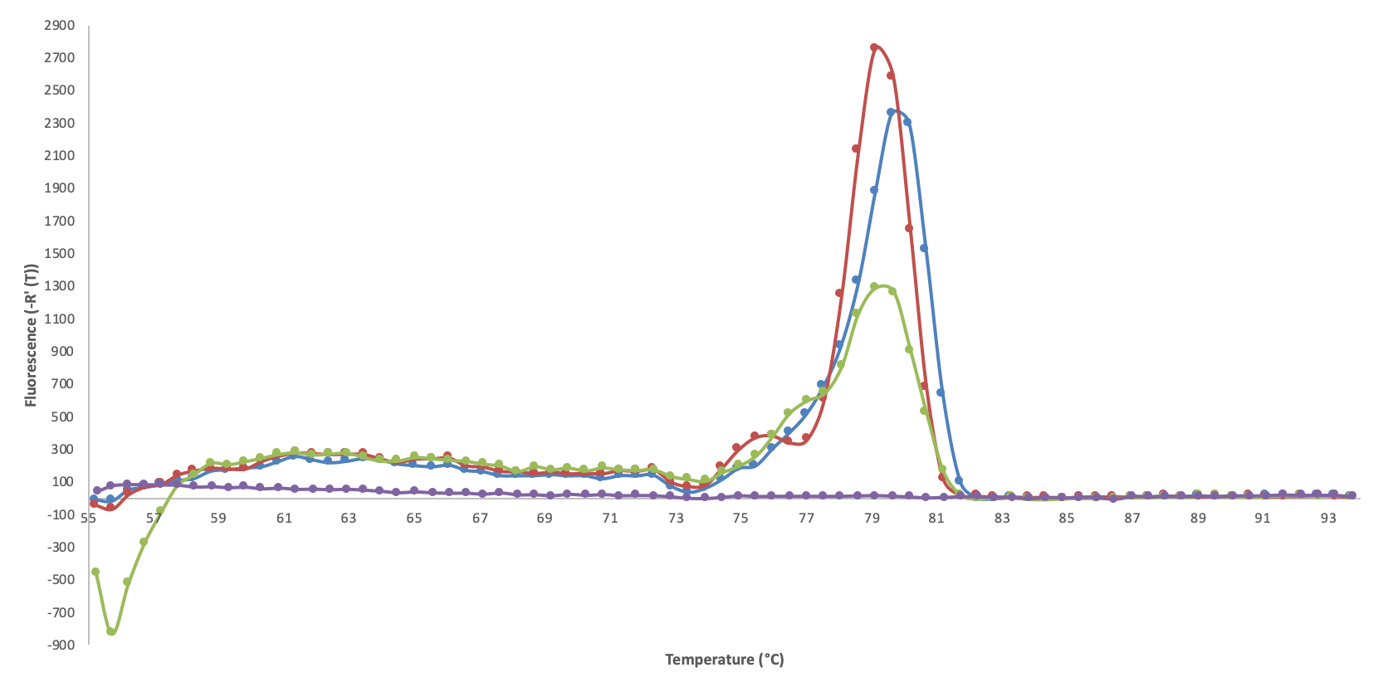
(B)
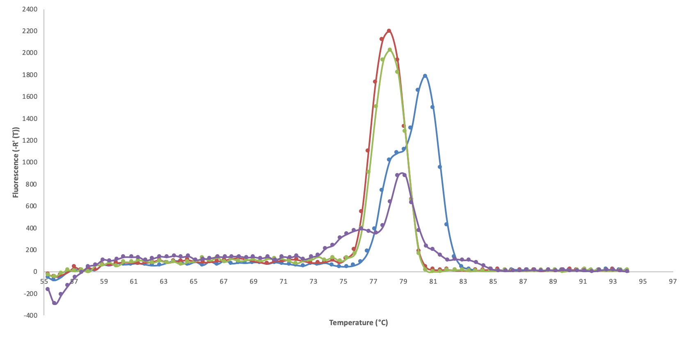
Supplementary Figure S1. Melt curve profile of tissue derived DNA (1 ng/μl) for each species of sea turtle for (A) primer pair LTCM2/HDCM2, and (B) primer pair LCMint2/H950g. Blue = Chelonia mydas, red = Caretta caretta, green = Lepidochelys olivacea, and purple = Eretmochelys imbricata.

