Supplementary Material

Supplementary materials and methods
UPLC chromatogram
¹H-NMR and ¹³C-NMR spectra were measured on a Bruker AV-400 spectrometer and calibrated by the solvent peak used (pyridine-d6). Ultra performance liquid chromatography (UPLC) was performed using a Waters Acquity. UPLC I class system (Waters, Milford, MA, USA), equipped with a binary solvent delivery system, an auto sampler and a photodiode array detection system. Chromatography was performed on a Waters ACQUITY BEHC18 column (2.1 mm × 100 mm I.D., 1.7 μm, Waters). The mobile phase consisted of (A) 0.1% formic acid in water and (B) acetonitrile. The UPLC eluting conditions were as follows: 60-70% B (0-2 min), 70-90% B (2-7 min), 90-100% B (7-12 min) and 100%-100% B (12-13 min). The flow rate was maintained at 0.3 mL min ⁻¹.The column and auto sampler were maintained at 40 and 10°C respectively. The detection wavelengths were set at 238, 254 and 360 nm.

Supplementary Figure
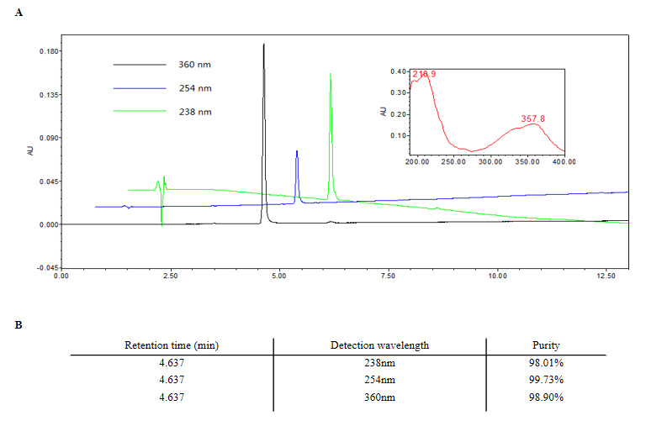
Supplementary Figure 1. (A) UPLC chromatogram of Gaudichaudione H. Column: Waters ACQUITY UPLC®BEH C18 (1.7 μm, 2.1 * 100 mm); mobile phase: (C) acetonitrile and (D) 0.1% formic acid in water, in gradient mode as follows: 60-70% B (0-2 min), 70-90% B (2-7 min) , 90-100% B (7-12 min) and 100%-100% B (12-13 min); detection wavelength: 238, 254 and 360 nm; and flow rate: 0.3 mL min ⁻¹. (B) Purity detection of Gaudichaudione H.
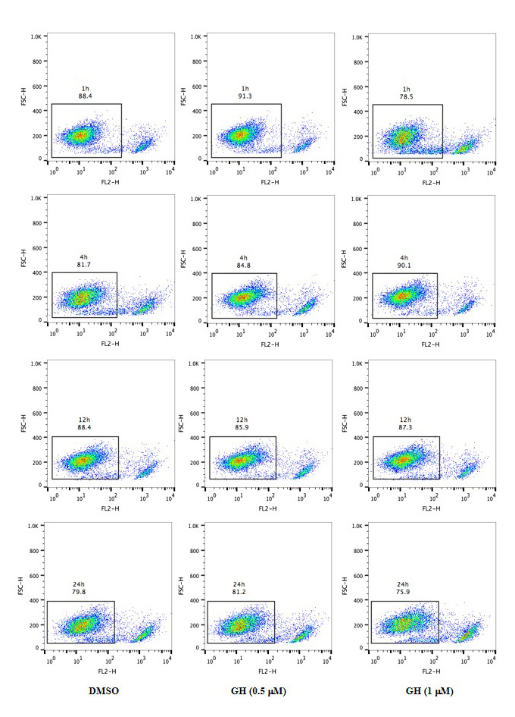
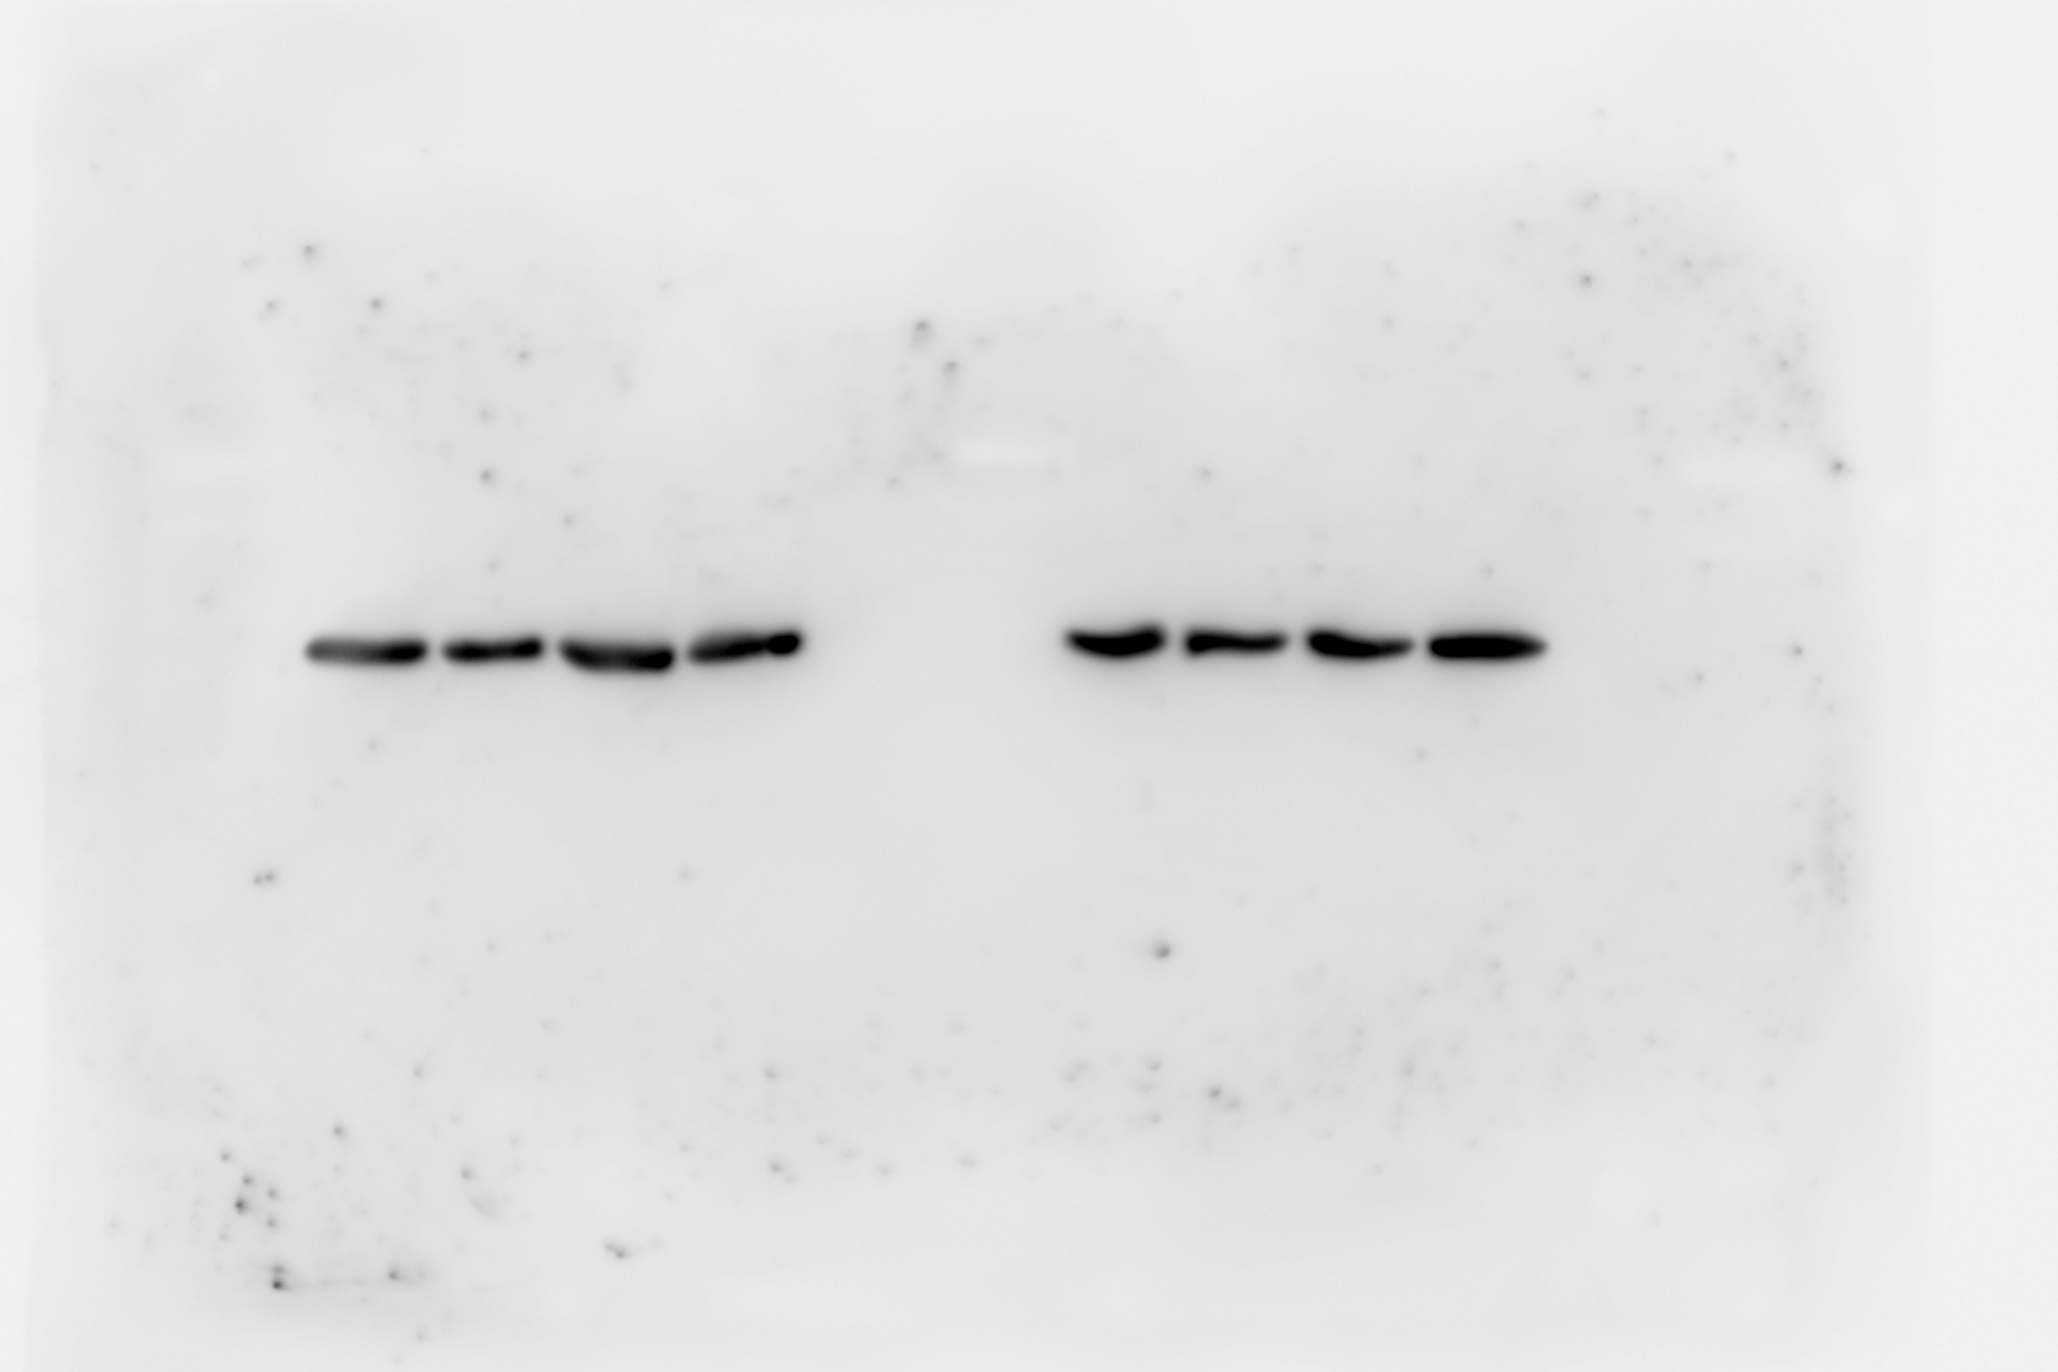
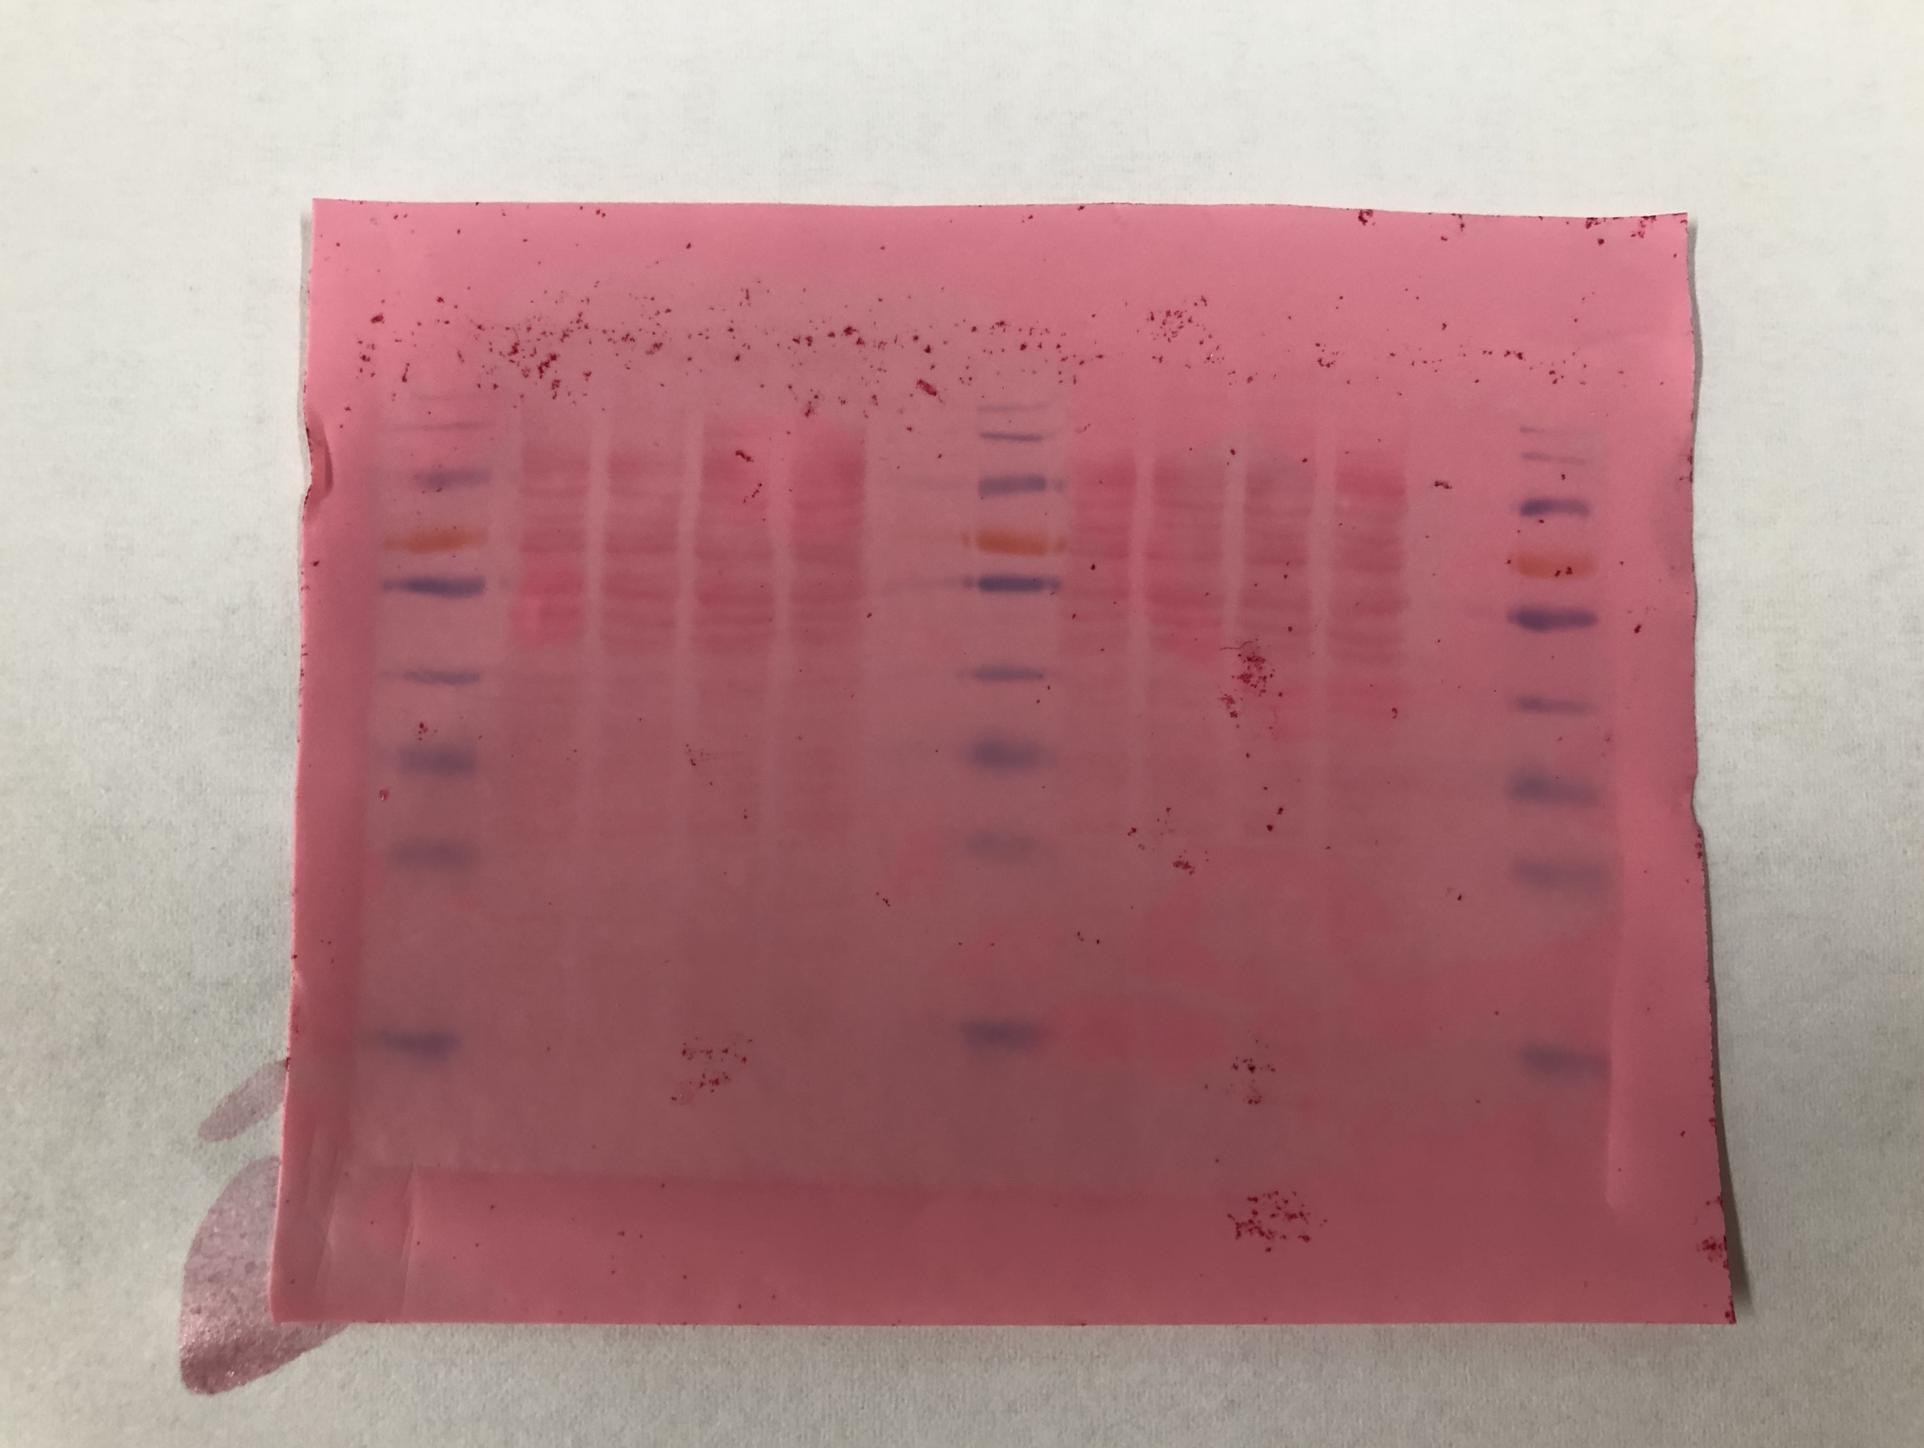
Supplementary Figure 2. GH did not affect the cell viability of Raw 264.7 cells at different time points. PI/AnnexinV analysis was performed to evaluate the effect of GH on the cell state at different time points (1h, 4h, 12h, 24h).
Supplementary Figure 3. The ponceau staining as loading control and the actin for the western blots.
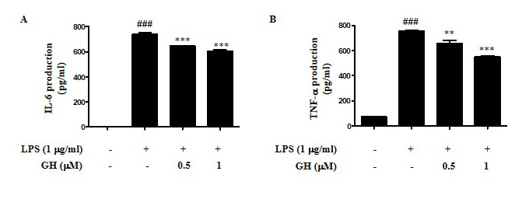
Supplementary Figure 4. GH inhibited cytokine IL-6 and TNF-α production and rescued LPS-induced inflammation in RAW 264.7 cells. RAW 264.7 cells were cultured at 5×10⁵ cells well⁻¹ in 12-well plates, and LPS (1 μg mL⁻¹) was pretreated for 1 h and then co-treated with GH for 24h. IL-6 (A) and TNF-α (B) in the cell supernatants were assayed using ELISA. ###p<0.001 compared with control, **p<0.01, ***p<0.001 compared with LPS.
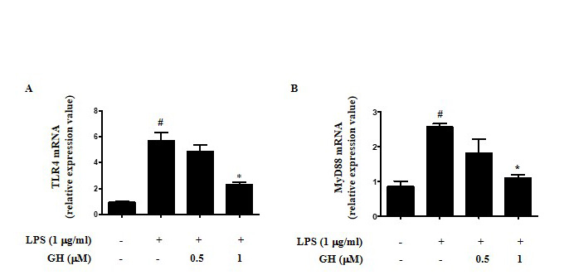
Supplementary Figure 5. GH inhibited TLR4 and MyD88 mRNA expression in LPS-stimulated RAW 264.7 cells. RAW 264.7 cells were cultured at 5×10⁵ cells well⁻¹ in 12-well plates, and GH was pretreated with GH for 1 h and then co-treated with LPS (1 μg mL⁻¹) for 15 minutes.
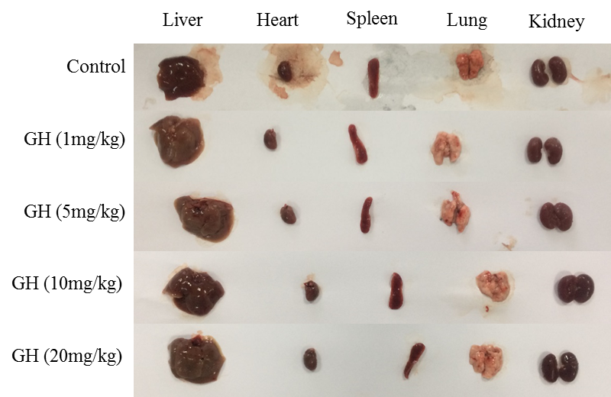
Supplementary Figure 6. The liver, heart, spleen, lung and kidney tissues of the control group and the GH group were observed. GH was administered once a day for 10 days. The mice were sacrificed at Day 10 and the liver, heart, spleen, lung and kidney tissues were taken.

