Supplementary Material

Supplementary Figures and Tables

Supplementary Figures
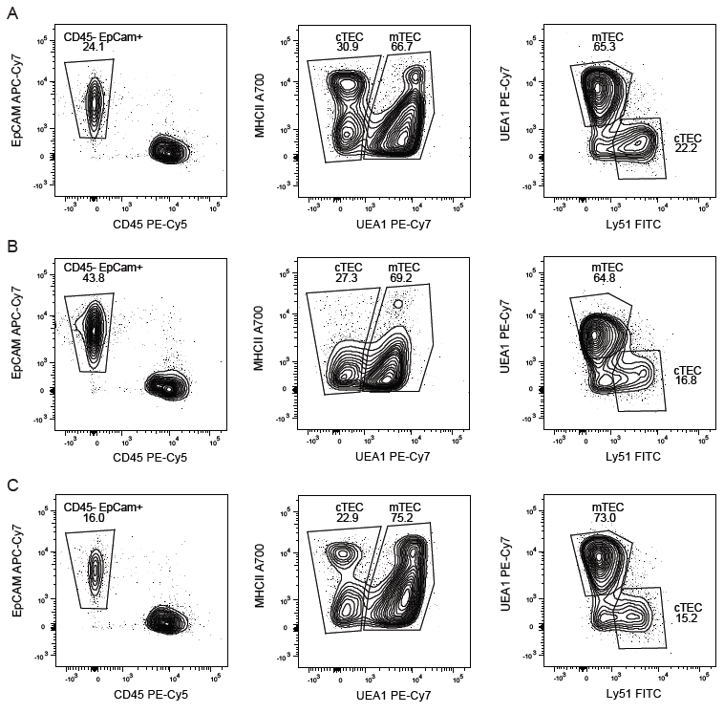Supplementary Figure 1. Representative profile of TECs in (A) NPC, (B) at D-2 and (C) D16 postpartum.
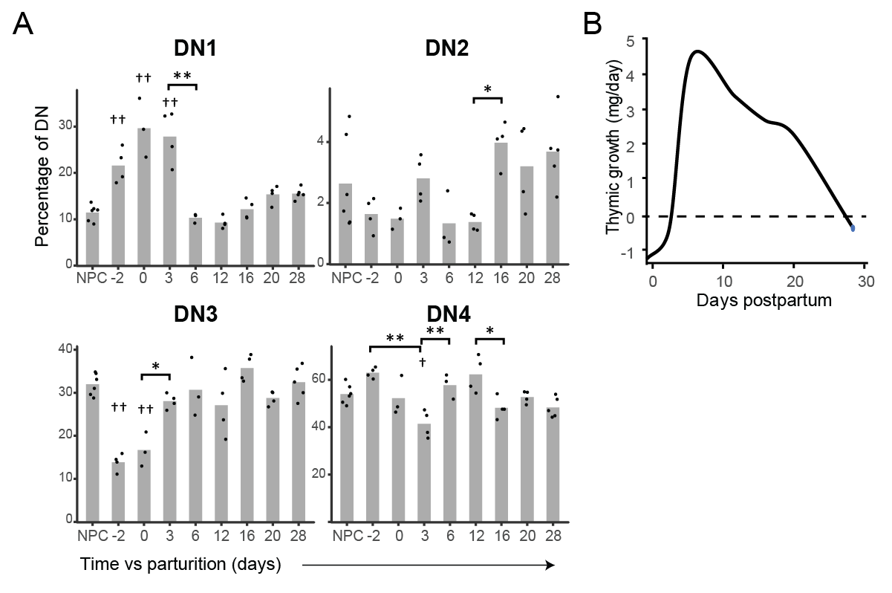
Supplementary Figure 2. (A) Percentage of DN1 to DN4 thymocytes over all DN thymocytes (n = 3 to 6). Means and individual replicates are shown as bars and dots, respectively. Significance was assessed with one-way ANOVA followed by post-hoc Tukey test. p values are shown against NPC († p < 0.05 and †† p < 0.01) or against the indicated time point (* p < 0.05 and ** p < 0.01). (B) Thymic growth rate in late pregnancy and during post-partum regeneration (from E18.5 to D28). The thymic growth (ΔC) was calculated as followed: ∆C= ∆weight/∆time vs previous timepoint.

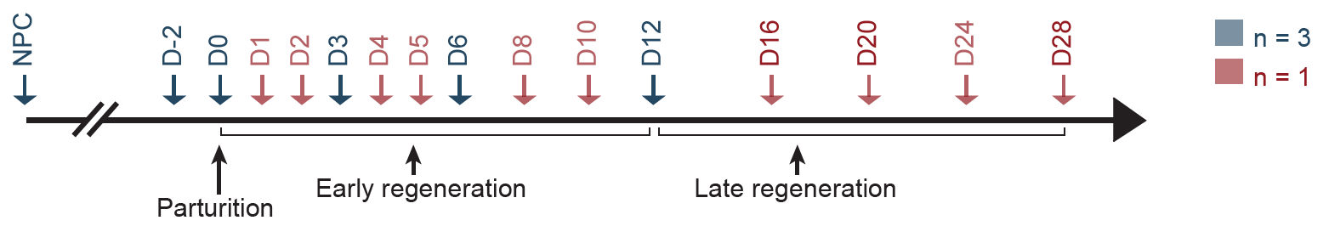
Supplementary Figure 3. Schematic representation of RNA sequencing analyses of TECs in late pregnancy and postpartum thymic regeneration. Timepoints for which 3 replicates were analyzed are indicated in blue. We divided the postpartum regeneration period in 2 phases: early regeneration, encompassing all timepoints from D0 to D12, and late regeneration, from D16 to D28.

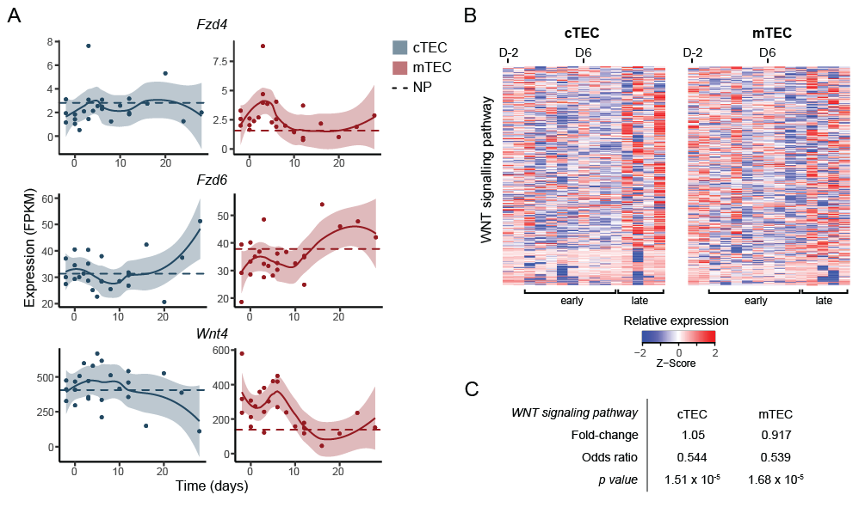
Supplementary Figure 4. (A) Expression of WNT receptors Fzd4 and Fzd6 and of Wnt4 in cTECs and mTECs. Each replicate is represented with a dot. Lines represent non-linear regression and the 95% confidence interval are displayed as shaded areas (blue for cTECs, red for mTECs). Average expression in NPC is depicted with a dashed line. (B) Relative expression (Z-score) of genes of the WNT signaling pathway (GO: 0016055). Relative expression (Z-score) from D-2 to D28 is shown. (C) Average fold-change in WNT signaling pathway expression between D-2 and D6. Odds ratio and significance were assessed with Fisher exact test, for fold-change > 2. Gene expression for each time point represents either average expression for triplicates, or raw expression value for single replicate (see Supplementary Figure S2 for number of replicates per timepoint).

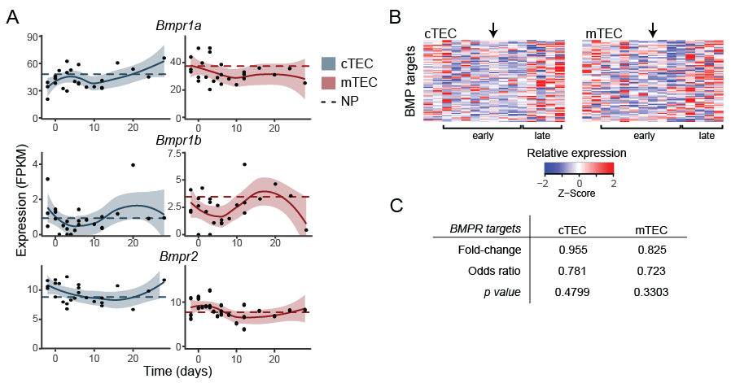
Supplementary Figure 5. (A) Expression of BMP4 receptors in cTECs and mTECs. Each replicate is represented with a dot. Lines represent non-linear regression and the 95% confidence interval is displayed as shaded area (blue for cTECs, red for mTECs). Average expression in NPC is depicted with a dashed line. (B) Relative expression (Z-score) of BMPR target genes (GO:0030510). Gene expression is shown as relative expression (Z-score), from D-2 to D28. Arrows indicate D6. (C) Average fold-change in BMPR targets expression between D-2 and D6. Odds ratio and significance were assessed with Fisher exact test, for fold-change > 2. Gene expression for each time point represents either average expression for triplicates, or raw expression value for single replicate (see Supplementary Figure S2 for number of replicates per timepoint).

Supplementary Tables
Supplementary Table 1. Reagents used for flow cytometry analysis.
Reagents | Catalog # | Clone | Supplier | Lot #
Collagenase D | 11088866001 | - | Sigma | 15731423
DNase I | D25-1G | - | Sigma | SLBF7798V
Papain | LS003119 | - | Worthington-Biochem | 37J17641
LS Columns | 130-042-401 | - | Miltenyi Biotec | 5180129007
CD326 (EpCAM) Microbeads mouse | 130-105-958 | - | Miltenyi Biotec | 5171027038
EpCAM - APC-Cy7 | 118218 | G8.8 | BioLegend | B244598
CD45 - PE-Cy5 | 553082 | 30-F11 | BD Biosciences | NA
UEA1 – biotinylated | B-1065 | - | Vector Laboratories | 0331
I-A/I-E - Alexa Fluor 700 | 107622 | M5/114.15.2 | BioLegend | B217859
I-A/I-E – APC | 107614 | M5/114.15.2 | BioLegend | B191785
Ly51 – FITC | 553160 | 6C3 | Biolegend | 83063
Streptavidin – PE-Cy7 | 557598 | - | BD Biosciences | 5126578
CD4 – Alexa Fluor 700 | 557956 | RM4-5 | BD Biosciences | 7047620
CD4 – BV421 | 100443 | GK1.5 | Biolegend | B223832
CD8a – FITC | 553031 | 53-6.7 | BD Biosciences | 05932
CD11c – PE-Cy7 | 558079 | HL3 | BD Biosciences | 7005642
CD25 – APC-Cy7 | 557658 | PC61 | BD Biosciences | 35781
CD44 – APC | 559250 | IM7 | BD Biosciences | 50592
PE Mouse anti-Human Ki67 set | 556027 | - | BD Biosciences | 5113744
Factor staining buffer set | 00-5523-00 | - | Invitrogen | 1957127
Propidium iodine | 51-66211E | - | BD Biosciences | 6155503

Supplementary Table 2. Differential expression of genes involved in thymopoiesis in cTECs.
Genes | Downregulated during pregnancy  (NPC to D-2) |  | Upregulated during regeneration  (between D-2 and D3 to D12) |  | Correlation with Foxn1
 | Fold-change | p value | Fold-change | p value | R (Pearson)
Foxn1 | -1.7x | 0.2336 | 2.0 to 2.7x | p < 0.05 | 1
Dll4 | -5.7x | 0.0009 | 5.3 to 15.0x | p < 0.002 | 0.542
Ccl25 | -4.6x | 0.0456 | 6.6 to 9.3x | p < 0.02 | 0.706
Cxcl12 | -1.8x | 0.0076 | 2.1 to 2.9x | p < 0.008 | 0.462
Il7 | -1.6x | 0.0446 | 1.5 to 1.9x | p < 0.054 | 0.533
Kitl* | -1.1x | n.s. | 2.2x | p < 0.008 | -0.02
Ctsl | -2.3x | 0.0048 | 2.3 to 3.7x | p < 0.003 | 0.133
Prss16 | -7.0x | 0.0058 | 8.3 to 12.9x | p < 0.009 | 0.731
Psmb11 | -6.5x | 0.0450 | 9.0 to 12.8x | p < 0.02 | 0.912
Cd83 | -6.1x | 0.0152 | 5.8 to 12.2x | p < 0.02 | 0.738
Significance was assessed using unpaired bilateral student T tests. *For Kitl, only the fold-change between D-2 and D6 are shown.

