Supplementary Material

Supplementary Table 1. Physical and chemical properties of collected soils.

Sample | Latitude | Longitude | pH | Cl⁻(g/kg) | SO₄²⁻(g/kg) | HCO₃⁻⁽g/kg) | CO₃²⁻(g/kg) | Ca²⁺(g/kg) | Mg²⁺(g/kg) | Na⁺(g/kg) | Exchangeable Na⁺(cmol/kg) | SOC(mg/g) | EC(ms/cm) | SAR | Main vegatation types
Jc1 | 44.249 | 123.857 | 10.26 | 0.26 | 0.83 | 0.99 | 0.01 | 0.24 | 0.27 | 0.12 | 19.30 | 2.26 | 0.41 | 0.16 | Leymus chinensis
Js1 | 45.056 | 124.634 | 9.93 | 0.27 | 0.96 | 2.38 | 0.02 | 0.64 | 0.20 | 0.23 | 32.30 | 4.58 | 0.71 | 0.25 | Phragmites australis
Jz2 | 45.959 | 123.705 | 10.37 | 0.27 | 0.70 | 2.76 | 0.02 | 0.24 | 0.39 | 0.38 | 32.00 | 2.54 | 0.75 | 0.47 | Chloris virgata, Leymus chinensis
Hda2 | 46.219 | 124.793 | 10.14 | 0.64 | 0.96 | 3.39 | 0.20 | 1.20 | 0.39 | 0.45 | 35.10 | 4.80 | 0.85 | 0.35 | Chloris virgata, Suaeda glauca
Hz1 | 46.029 | 125.835 | 10.20 | 2.22 | 3.17 | 3.66 | 0.21 | 1.20 | 0.32 | 0.55 | 42.90 | 5.00 | 1.34 | 0.44 | Chloris virgata
Jz1 | 45.807 | 123.823 | 10.61 | 0.36 | 0.60 | 2.98 | 0.03 | 0.56 | 0.15 | 0.51 | 43.00 | 2.65 | 0.86 | 0.61 | Leymus chinensis
Jd1 | 45.594 | 123.949 | 10.51 | 0.80 | 0.67 | 2.76 | 0.03 | 0.40 | 0.15 | 0.88 | 56.00 | 3.02 | 2.02 | 1.19 | Chloris virgata, Leymus chinensis
Jt1 | 44.635 | 123.139 | 10.66 | 0.49 | 1.20 | 2.56 | 0.03 | 0.55 | 0.35 | 0.51 | 46.10 | 6.50 | 1.76 | 0.54 | Leymus chinensis,Chloris virgata
Hz3 | 45.751 | 125.365 | 10.27 | 2.13 | 4.80 | 6.89 | 2.52 | 0.96 | 1.37 | 0.67 | 47.30 | 2.80 | 1.79 | 0.44 | Aster subulatus
Hdu1 | 46.32 | 124.137 | 10.26 | 0.89 | 12.48 | 1.21 | 0.73 | 0.20 | 0.07 | 0.45 | 40.30 | 2.77 | 1.30 | 0.86 | Chloris virgata,Tripolium vulgare
Hdu2 | 46.546 | 124.283 | 10.27 | 0.55 | 18.05 | 6.61 | 1.54 | 0.21 | 0.41 | 0.74 | 38.40 | 3.24 | 1.83 | 0.94 | Carex ischnostachya
Jc3 | 44.314 | 123.423 | 10.45 | 0.81 | 0.91 | 2.26 | 0.02 | 0.17 | 0.44 | 0.55 | 36.90 | 3.21 | 1.90 | 0.70 | Chloris virgata
Jt2 | 44.778 | 123.211 | 9.92 | 0.64 | 1.06 | 0.73 | 0.01 | 0.16 | 0.05 | 0.94 | 33.80 | 2.46 | 2.99 | 2.06 | Chloris virgata
Jq2 | 44.876 | 123.703 | 10.59 | 0.89 | 1.63 | 1.73 | 0.03 | 0.32 | 0.06 | 1.48 | 56.70 | 4.62 | 3.24 | 2.40 | Chloris virgata
Jc2 | 44.244 | 123.819 | 10.64 | 0.44 | 1.08 | 0.50 | 0.04 | 0.24 | 0.02 | 0.68 | 39.70 | 2.32 | 2.63 | 1.32 | Chloris virgata
Js2 | 45.021 | 124.586 | 10.35 | 0.39 | 1.10 | 1.81 | 0.03 | 0.44 | 0.12 | 0.59 | 45.30 | 1.93 | 2.05 | 0.79 | Salsola soda Linn., Leymus chinensis
Hda3 | 46.128 | 124.846 | 10.16 | 0.71 | 21.60 | 6.22 | 1.02 | 0.34 | 0.58 | 0.67 | 37.70 | 2.04 | 2.22 | 0.70 | Leymus chinensis
Jd2 | 45.579 | 123.942 | 10.51 | 0.50 | 0.79 | 1.65 | 0.03 | 0.38 | 0.06 | 0.64 | 54.30 | 5.34 | 2.06 | 0.96 | Chloris virgata
Js3 | 44.939 | 124.598 | 10.60 | 0.44 | 1.10 | 2.79 | 0.04 | 0.72 | 0.15 | 0.59 | 45.80 | 1.70 | 1.90 | 0.64 | Suaeda glauca
Hl2 | 47.169 | 124.668 | 10.30 | 0.44 | 14.21 | 7.17 | 1.44 | 0.72 | 0.29 | 0.72 | 59.40 | 7.18 | 2.03 | 0.72 | Leymus chinensis,Chloris virgata
Ha1 | 46.16 | 125.053 | 10.29 | 0.89 | 0.48 | 4.45 | 1.98 | 0.40 | 0.27 | 1.22 | 42.40 | 3.06 | 2.88 | 1.50 | Chloris virgata,Leymus chinensis,Setaria glauca
Hz5 | 45.634 | 124.972 | 9.89 | 3.20 | 4.70 | 0.88 | 0.34 | 0.36 | 0.05 | 0.85 | 42.70 | 4.59 | 2.99 | 1.33 | Chloris virgata
Jq1 | 44.868 | 123.641 | 9.97 | 1.01 | 1.23 | 1.16 | 0.01 | 0.23 | 0.10 | 1.27 | 47.50 | 7.58 | 4.24 | 2.20 | Chloris virgata
Hz6 | 45.727 | 124.782 | 10.40 | 1.78 | 13.44 | 5.25 | 2.70 | 2.40 | 0.73 | 1.43 | 65.80 | 6.59 | 4.43 | 0.81 | Chloris virgata
Jt3 | 44.772 | 123.333 | 10.42 | 0.43 | 1.19 | 2.04 | 0.04 | 0.08 | 0.05 | 1.39 | 54.00 | 1.53 | 6.58 | 3.87 | Chloris virgata
Hl1 | 46.989 | 124.591 | 10.01 | 2.49 | 1.73 | 4.90 | 3.96 | 0.40 | 0.10 | 2.01 | 51.70 | 4.56 | 5.40 | 2.85 | Imperata cylindrica, Phragmites australis, Leymus chinensis
Ha2 | 46.169 | 125.073 | 8.84 | 7.17 | 1.00 | 1.83 | 0.00 | 0.50 | 0.29 | 2.57 | 39.80 | 15.43 | 8.41 | 2.89 | Chloris virgata, Suaeda glauca
Hda1 | 46.434 | 124.821 | 10.13 | 4.47 | 3.84 | 1.46 | 2.28 | 0.22 | 0.21 | 2.11 | 36.90 | 3.99 | 7.31 | 3.23 | Suaeda glauca
Hda4 | 46.123 | 124.87 | 10.12 | 10.47 | 4.07 | 2.32 | 2.82 | 0.31 | 0.02 | 2.45 | 48.90 | 4.77 | 10.87 | 4.29 | Chloris virgata, Suaeda glauca

SOC: the organic carbon
EC: electrical conductivity
The Na⁺ absorption ratio (SAR) was calculated as: SAR = [Na⁺]/ (0.5[Ca²⁺ + Mg²⁺]1/2)

Supplementary Table 2. Classifications of indicator OTUs in network analysis.
 |  | Phlya | Class | Order | Family | Genus
L treatment | OTU106 | Planctomycetes | Planctomycetacia | Planctomycetales | Planctomycetaceae | Unclassified
 | OTU63 | Planctomycetes | Planctomycetacia | Planctomycetales | Planctomycetaceae | Unclassified
 | OTU87 | Unclassified | Unclassified | Unclassified | Unclassified | Unclassified
 | OTU513 | Planctomycetes | Planctomycetacia | Planctomycetales | Planctomycetaceae | Unclassified
 | OTU673 | Proteobacteria | Unclassified | Unclassified | Unclassified | Unclassified
 | OTU1147 | Bacteroidetes | Bacteroidia | Bacteroidales | Bacteroidaceae | Bacteroides
 | OTU941 | Gemmatimonadetes | Gemmatimonadetes | Unclassified | Unclassified | Unclassified
 | OTU430 | Chloroflexi | Unclassified | Unclassified | Unclassified | Unclassified
 | OTU781 | Bacteroidetes | Cytophagia | Cytophagales | Cytophagaceae | Hymenobacter
 | OTU98 | Proteobacteria | Gammaproteobacteria | Pseudomonadales | Pseudomonadaceae | Pseudomonas
M treatment | OTU777 | Proteobacteria | Unclassified | Unclassified | Unclassified | Unclassified
 | OTU311 | Gemmatimonadetes | Gemmatimonadetes | Unclassified | Unclassified | Unclassified
 | OTU70 | Synergistetes | Synergistia | Synergistales | Synergistaceae | Unclassified
 | OTU118 | Planctomycetes | Planctomycetacia | Planctomycetales | Planctomycetaceae | Unclassified
 | OTU511 | Unclassified | Unclassified | Unclassified | Unclassified | Unclassified
 | OTU945 | Bacteroidetes | Unclassified | Unclassified | Unclassified | Unclassified
 | OTU19 | Planctomycetes | Phycisphaerae | Unclassified | Unclassified | Unclassified
 | OTU508 | Bacteroidetes | Flavobacteria | Flavobacteriales | Flavobacteriaceae | Gillisia
 | OTU10 | Bacteroidetes | Cytophagia | Unclassified | Unclassified | Unclassified
 | OTU114 | Acidobacteria | Holophagae | Unclassified | Unclassified | Unclassified
H treatment | OTU144 | Bacteroidetes | Flavobacteria | Flavobacteriales | Flavobacteriaceae | Chryseobacterium
 | OTU555 | Proteobacteria | Gammaproteobacteria | Legionellales | Coxiellaceae | Aquicella
 | OTU274 | Proteobacteria | Betaproteobacteria | Nitrosomonadales | Nitrosomonadaceae | Nitrosomonas
 | OTU713 | Proteobacteria | Alphaproteobacteria | Unclassified | Unclassified | Unclassified
 | OTU467 | Firmicutes | Erysipelotrichia | Erysipelotrichales | Erysipelotrichaceae | Unclassified
 | OTU736 | Firmicutes | Bacilli | Bacillales | Unclassified | Unclassified
 | OTU161 | Actinobacteria | Nitriliruptoria | Nitriliruptorales | Nitriliruptoraceae | Nitriliruptor
 | OTU491 | Chloroflexi | Anaerolineae | Anaerolineales | Anaerolineaceae | Unclassified
 | OTU572 | Proteobacteria | Betaproteobacteria | Nitrosomonadales | Nitrosomonadaceae | Nitrosomonas
 | OTU783 | Proteobacteria | Gammaproteobacteria | Oceanospirillales | Halomonadaceae | Halomonas

Supplementary Table 3. Monte Carlo permutation test for CCA of community structure
 | CCA1 | CCA2 | r² | P
CO₃²⁻ | 0.978 | 0.21 | 0.619 | 0.001***
SO₄²⁻ | -0.54 | -0.84 | 0.335 | 0.043*
pH | 0.923 | 0.385 | 0.046 | 0.425
Mg²⁺ | 0.804 | 0.594 | 0.11 | 0.174
Exchangeable Na⁺ | 0.81 | -0.59 | 0.161 | 0.086
SOC | 0.237 | 0.971 | 0.07 | 0.272
Ca²⁺ | 0.358 | 0.934 | 0.048 | 0.39
SAR | -0.35 | -0.94 | 0.6 | 0.001***
HCO₃⁻ | 0.318 | 0.948 | 0.369 | 0.002**
Cl⁻ | 0.617 | -0.79 | 0.179 | 0.055
Na⁺ | -0.99 | -0.12 | 0.557 | 0.011*
EC | -0.28 | -0.96 | 0.672 | 0.001***
SOC: the organic carbon
EC: electrical conductivity
The Na⁺ absorption ratio (SAR) was calculated as: SAR = [Na⁺]/ (0.5[Ca²⁺ + Mg²⁺]1/2)
* The correlations are significant at P < 0.05.
***The correlations are significant at P < 0.001.

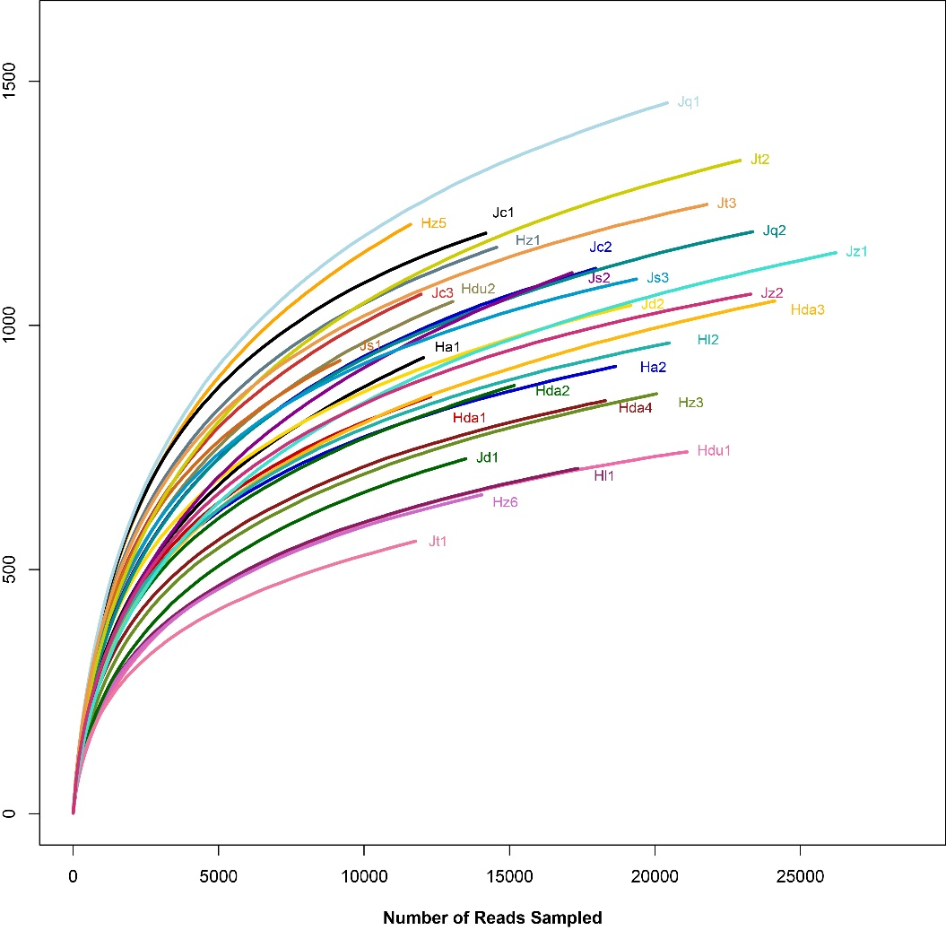
Supplementary Figure 1. The rarefaction curves of bacteria for different samples.

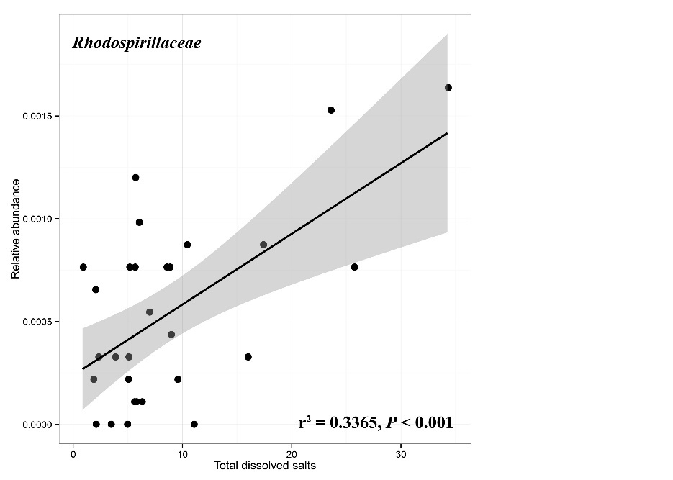
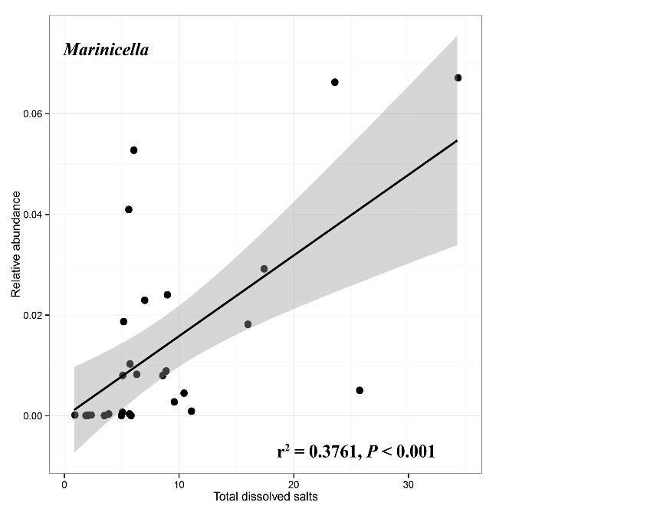
（a）
（b）
Supplementary Figure 2. Linear correlations between the relative abundance of different bacterial classification level and total dissolved salts. (a) At the Family level and (b) at the Genus level.

