Supplementary materials

1. Supplementary Figures
Supplementary Figure S1. A neighbour-joining phylogenetic tree of the sequences orthologous to classic MAPKs family (Kss1/Fus3, Slt2, and Hog1) and Ime2 from diverse fungi. GenBank accession numbers are provided in brackets.

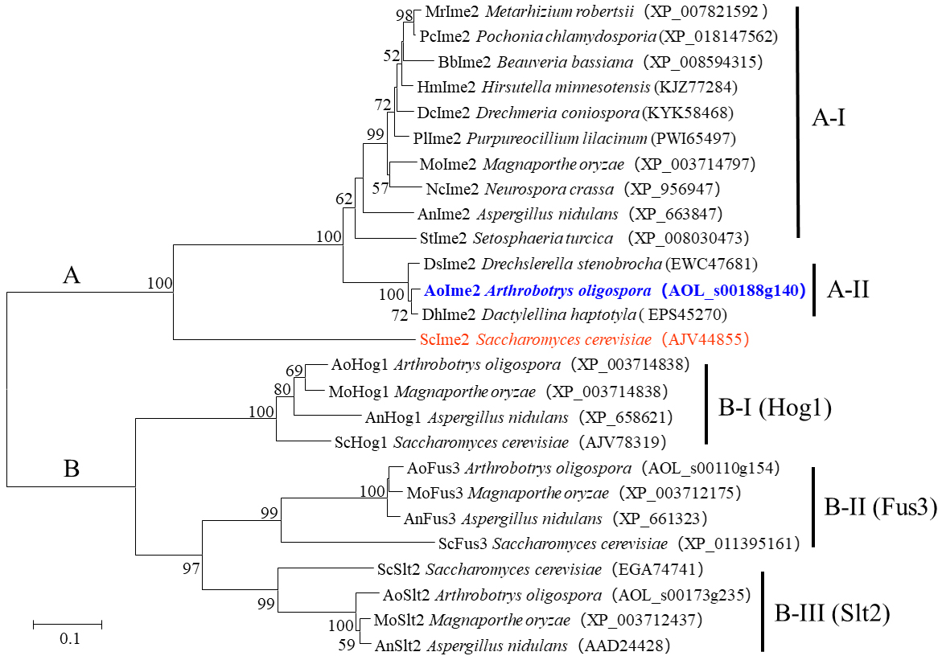

Supplementary Figure S2. Multiple alignment of the MAPK protein kinase domain (IPR000719) from different fungi. Areas shaded in black are conserved regions (100% similarity), Areas shaded in red have high degrees of homology (more than 75% similarity). The active site - D [L/I/V] K - and phosphorylation site - TXY -in different fungi were marked using underlines.

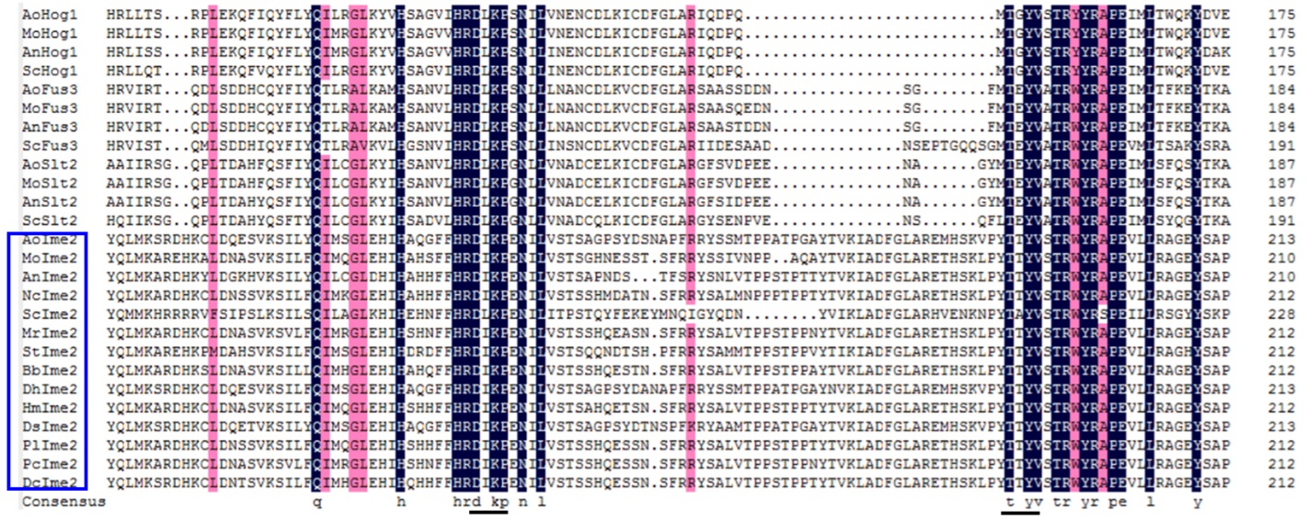

Supplementary Figure S3. Knock-out and verification of gene Aoime2 in A. oligospora. (A) Diagrammatic sketch of homologous recombination of Aoime2. The homologous flanking sequences of the target gene, Southern blot probe, and the KpnI restriction enzyme sites were marked. (B) Positive transformants were verified by PCR amplification. C. The ΔAoime2 mutants were confirmed by blotting analysis.

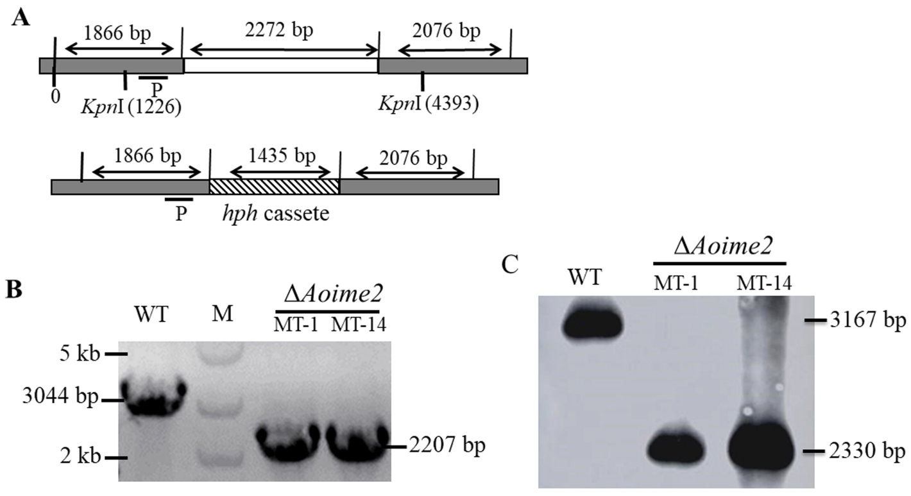

Supplementary Figure S4. Comparison of conidiophores between WT and ΔAoime2 mutant strains. Conidiophores and conidia of WT and mutants examined under a microscope.

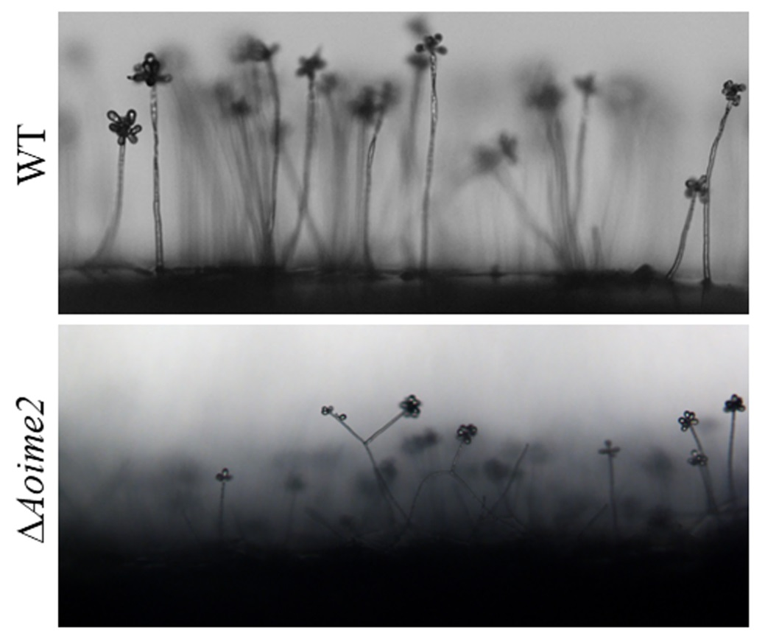

Supplementary Figure S5. Tolerance to oxidants and cell-wall-perturbing agents of WT and ΔAoime2 mutant strains. (A) Colony morphology under treatment with oxidants and cell-wall-perturbing agents: WT versus mutants. (B) RGI values of WT and mutants on TG plates supplemented with oxidants or cell-wall-perturbing agents.

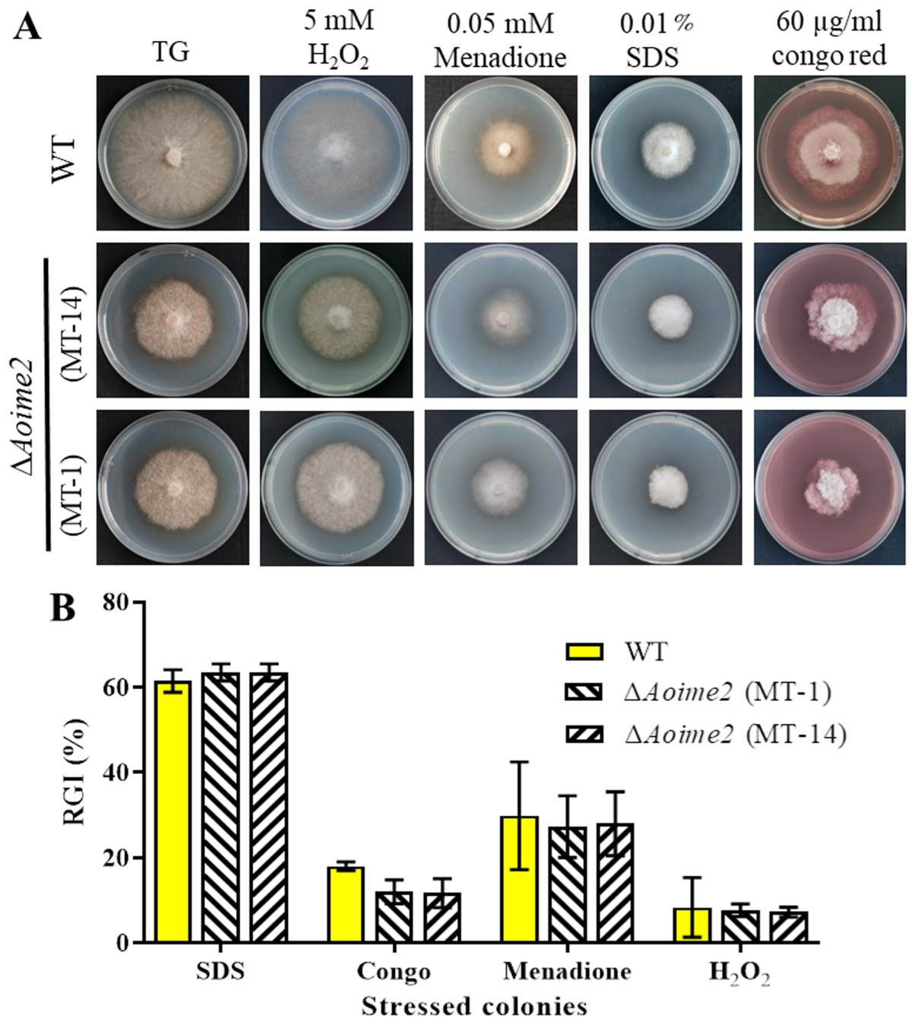

2. Supplementary tables
Supplementary Table S1. List of primers used in this study.

Primers | Sequence (5′-3′) | Description
AoIme2-5f | GTAACGCCAGGGTTTTCCCAGTCACGACGTGATGGGGTTGAAGTGAG | Amplify the Aoime2 gene 5’ flank
AoIme2-5r | ATCCACTTAACGTTACTGAAATCTCCAACTCTCCGAACAGACGCACCA
AoIme2-3f | CTCCTTCAATATCATCTTCTGTCTCCGACTTTGGCGAGCACAACACTAC | Amplify the Aoime2 gene 3’ flank
AoIme2-3r | GCGGATAACAATTTCACACAGGAAACAGCGAACCCCTGGCGAATCTGT
hphF | GTCGGAGACAGAAGATGATATTGAAGGAGC | Amplify the hph cassette
hphR | GTTGGAGATTTCAGTAACGTTAAGTGGAT
YZ140-5f | TTCGTGTCTGTTGGGTGATG | Verify the transformants
YZ140-3r | GAAAGGCTAAATCGGGGTC
probe5f | CTGGGGAAGAGTGAGTGAAAG | Make Southern blotting probe
probe3r | TGAAGATGACAGCCCGATC

Supplementary Table S2. Paired primers used for RT-PCR analysis, including sporulation-related genes and serine protease genes.
Sporulation genes | Sequence (5′-3′) | Serine protease genes | Sequence (5′-3′)
AOL_s00169g18  (veA) | 18-5F-AAGCTACACCCAATCAACGC | AOL_s00112g42 | 42-5F-CTGGCTCTTGGCCTACTTTG
 | 18-3R-TTGCGATGCTGACGATCTTG |  | 42-3R-AGGAGGTTGACGGTCTCCTT
AOL_s00007g157 (flbC) | 157-5F-CTCTCCGGCAAAGACAATCG | AOL_s00075g8 | 8-5F-TTGCTACTTTACTGCCCCTTG
 | 157-3R-GTCGACTGAGGATAGTAGCT |  | 8-3R-TCTTCAGCTTGAGTCCGGTT
AOL_s00075g211 (nsdD) | 211-5F-ATTACGGCCGCCTAGTAGTC | AOL_s00215g702 | 702-5F-GTCGCCGCTGACTTAACTGT
 | 211-3R-CTCGTTTGGACCTGGTTGTG |  | 702-3R-ATAATTGCTGATTCGCTGGG
AOL_s00043g361 (fluG) | 361-5F-GATTCCAGTCCCGTGAATTC | AOL_s00176g95 | 95-5F-CCCAAAAAGAATGCACCACT
 | 361-3R-GCTAAGGAGAGGATGGGCAT |  | 95-3R-AGAGGCGGGAAAATACCTGT
AOL_s00006g570 (rodA) | 570-5F-GCGGATCCAACATGAAGCTT | AOL_s00076g4 (PII) | 4-5F-CCATGGTGTTGGAAGGAAAT
 | 570-3R-GGTTGACAACTGGGATGCTG |  | 4-3R-GTCTGTTCAGCGTACGTAGT
AOL_s00080g63 (abaA) | 63-5F-AACTTTATGCGCCTTGTCGT | AOL_s00078g136 | 136-5F-ACACTTGCCCATTTCACTCC
 | 63-3R-TTGGCTAGGTGGTCTGTACG |  | 136-3R-GCTGGGTTTCACAACATCCT
AOL_s00054g811 (velB) | 811-5F-ATTCCGCAACTTCTCCCTCA | AOL_s00188g273 | 273-5F-GTGGATGAAACCCGGATATG
 | 811-3R-GGCATGTTTGGATTCTGGGG |  | 273-3R-CTCCCACTATCACCGCAACT
AOL_s00215g893 (aspB) | 893-5F-ATACCGCCAACACCCTCTAC
 | 893-3R-AACCATCTTCATCTCGGCCT
β-tubulin gene | Sequence (5′-3′)
AOL_s00076g640  (tub) | tubA-F-CCACCTTCGTCGGTAACTC
 | tubA-R-TCGTCCATACCCTCACCAG

