Supplementary Material

Demographic variables of dog and owner

Table 1: Description of categorical questions concerning the dogs and their owners (N=1207), and percentage breakdown of the groups. (BCS: Body condition score)

Title and description | Categorical Variable labels: | Count | %
Age group | Group One: 1 - 3 years | 185 | 15.3
 | Group Two: >3 - 6 years | 251 | 20.8
 | Group Three: >6 - 8 years | 191 | 15.8
 | Group Four: >8 - 10 years | 202 | 16.7
 | Group Five: >10 - 12 years | 170 | 14.1
 | Group Six: >12 years | 208 | 17.2
Neuter status | Intact | 529 | 43.8
 | Neutered | 678 | 56.2
Sensory problems | None | 980 | 81.2
 | Vision and/or hearing | 227 | 18.8
Off-leash activity: How long does your dog walk/run around outdoors without a leash on a typical day? | Less than 30 minutes | 164 | 13.6
 | 30 minutes -1 hour | 269 | 22.3
 | >1-3 hours | 367 | 30.4
 | >3-7 hours | 165 | 13.7
 | More than 7 hours | 242 | 20.0
Body condition score: What body shape does your dog have? | Thin (BCS 1-2) | 203 | 16.8
 | Normal (BCS 3) | 784 | 65.0
 | Over-weight (BCS 4-5) | 220 | 18.2
Food: What food are you currently feeding your dog for its main meal? | Dry food only | 267 | 22.1
 | Tinned &/or dry food | 147 | 12.2
 | Cooked food | 306 | 25.4
 | Mixed | 294 | 24.4
 | Raw meat | 193 | 16.0
Vitamins: Do you give your dog vitamins or supplements? | Almost never | 328 | 27.2
 | Rarely | 391 | 32.4
 | Often | 244 | 20.2
 | Regular (daily) | 244 | 20.2
Trauma: Has the dog experienced a traumatic event, which could still have an effect on it? | No | 694 | 57.5
 | Yes | 513 | 42.5
Health Problems: What kind of health problems does your dog have? | None | 479 | 39.7
 | Tooth problems only | 182 | 15.1
 | Joint problems + tooth problems | 126 | 10.4
 | Joint problems only | 246 | 20.4
 | Other disorders | 174 | 14.4
Medication: Is your dog currently taking any medication? | No | 1021 | 84.6
 | Yes | 186 | 15.4
Owner age | <29 years | 385 | 31.9
 | 30-39 years | 343 | 28.4
 | 40-49 years | 253 | 21.0
 | >50 years | 226 | 18.7
Owner experience: How would you evaluate your experience with dogs? | Dogs are my hobby/profession and/or I am a dog trainer/breeder | 307 | 25.4
 | I have had a dog before | 639 | 52.9
 | I had never had a dog before | 261 | 21.6
Other dogs in household: How many other dogs do you have living in your household? (Not including this one). | None | 433 | 35.9
 | One | 474 | 39.3
 | Two or more | 300 | 24.9
People in household: How many people are living in the household? | One person (myself) | 141 | 11.7
 | Two people | 503 | 41.7
 | Three people | 271 | 22.4
 | Four or more people | 292 | 24.2
Child: Do you have a child/children living in your household? | No | 919 | 76.1
 | Yes | 288 | 23.9
Age of the dog when arrived: The age of the dog when it arrived in the Owner’s household | less than 7 weeks | 265 | 22.0
 | 7-12 weeks | 530 | 43.9
 | 3-12 month | 198 | 16.4
 | more than 1 year | 214 | 17.7
Get dog: How did you get your dog? | I found it/got it from a shelter | 340 | 28.2
 | It was born at my place/ bought it | 544 | 45.1
 | I got it as a present | 323 | 26.8
Where dog is kept: Where do you keep your dog? | House with a garden and/or in a non-fenced area | 149 | 12.3
 | In a fenced garden | 384 | 31.8
 | Urban/Suburban apartment | 674 | 55.8
Dog obedience tasks: Which tasks can your dog reliably perform? (E.g., sit, lie down, come, fetch, stay, walk at heel, leave/drop it, watch me etc.). Open question. | maximum a task | 151 | 12.5
 | 2 kinds of tasks | 169 | 14.0
 | 3 kinds of tasks | 228 | 18.9
 | more than 3 kind of tasks | 659 | 54.6
Play: On an average day, how much time do you or other people spend together with your dog in different activities? (Play, walking, training) | less than 30 minutes | 122 | 10.1
 | 30 minutes -1 hours | 378 | 31.3
 | >1 -3 hours | 551 | 45.7
 | more than 3 hours | 156 | 12.9
Commands: How many commands can your dog execute reliably? | < 10 commands | 540 | 44.7
 | 11 – 30 Commands | 535 | 44.3
 | > 30 Commands | 132 | 10.9
Dog training activities: How many activities are you currently doing with your dog? | One activity | 385 | 31.9
 | 2 - 3 activities | 527 | 43.7
 | 4 or more activities | 295 | 24.4
Time spent alone: How much time does your dog spend alone on an average working day? | None | 169 | 14.0
 | 1- 2 hours | 276 | 22.9
 | 3- 8 hours | 594 | 49.2
 | More than 8 hours | 168 | 13.9
Dog behavior changed: Has your dog’s behavior changed over the last 3 months? | No | 910 | 75.4
 | Yes | 297 | 24.6

Table 2: Dog Personality Questionnaire (DPQ)
Here are a number of personality traits and behavioural descriptions that may or may not apply to your dog. Please write a number next to each statement to indicate the extent to which you agree or disagree with that statement. You should rate your dog based on his or her general, overall behaviour: 1 Disagree strongly, 2 Disagree, 3 Neither agree nor disagree, 4 Agree, 5 Agree strongly.

Item No. | Description
1 | Dog is relaxed when greeting people
2 | Dog behaves aggressively toward dogs
3 | Dog is anxious
4 | Dog is lethargic
5 | When off leash, dog comes immediately when called
6 | Dog is shy
7 | Dog behaves aggressively towards unfamiliar people
8 | Dog likes to chase squirrels, birds, or other small animals
9 | Dog gets bored in play quickly
10 | Dog is quick to sneak out through open doors, gates
11 | Dog is confident
12 | Dog is dominant over other dogs
13 | Dog avoids other dogs
14 | Dog works at tasks (eg, getting treats out of a Kong, shredding toys) until entirely finished
15 | Dog is boisterous
16 | Dog behaves fearfully during visits to the veterinarian
17 | Dog enjoys playing with toys
18 | Dog is friendly towards unfamiliar people
19 | Dog is playful with other dogs
20 | Dog seeks companionship from people
21 | Dog behaves submissively (e, rolls over, avoids eye contact, licks lips) when greeting other dogs
22 | Dog adapts easily to new situations and environments
23 | Dog likes to chase bicycles, joggers, and skateboarders
24 | Dog is curious
25 | Dog behaves aggressively in response to perceived threats from people (eg, being cornered, having collar reached for)
26 | Dog is aloof
27 | Dog behaves fearfully towards unfamiliar people
28 | Dog willingly shares toys with other dogs
29 | Dog is slow to respond to corrections
30 | Dog behaves aggressively during visits to the veterinarian
31 | Dog seeks constant activity
32 | Dog leaves food or objects alone when told to do so
33 | Dog retrieves objects (eg, balls, toys, sticks)
34 | Dog is friendly towards other dogs
35 | Dog exhibits fearful behaviors when restrained
36 | Dog aggressively guards coveted items (eg, stolen item, treats, food bowl)
37 | Dog is affectionate
38 | Dog ignores commands
39 | Dog behaves aggressively towards cats
40 | Dog shows aggression when nervous or fearful
41 | Dog tends to be calm
42 | Dog behaves fearfully towards other dogs
43 | Dog is able to focus on a task in a distracting situation (eg, loud or busy places, around other dogs)
44 | Dog behaves fearfully when groomed (eg, nails trimmed, brushed, bathed, ears cleaned)
45 | Dog is assertive or pushy with other dogs (eg, if in a home with other dogs, when greeting)

Table 3: Dog Personality Questionnaire (DPQ) Factors, Facets, item numbers and reliability (Cronbach’s alpha of the five personality Factors) in the current study.
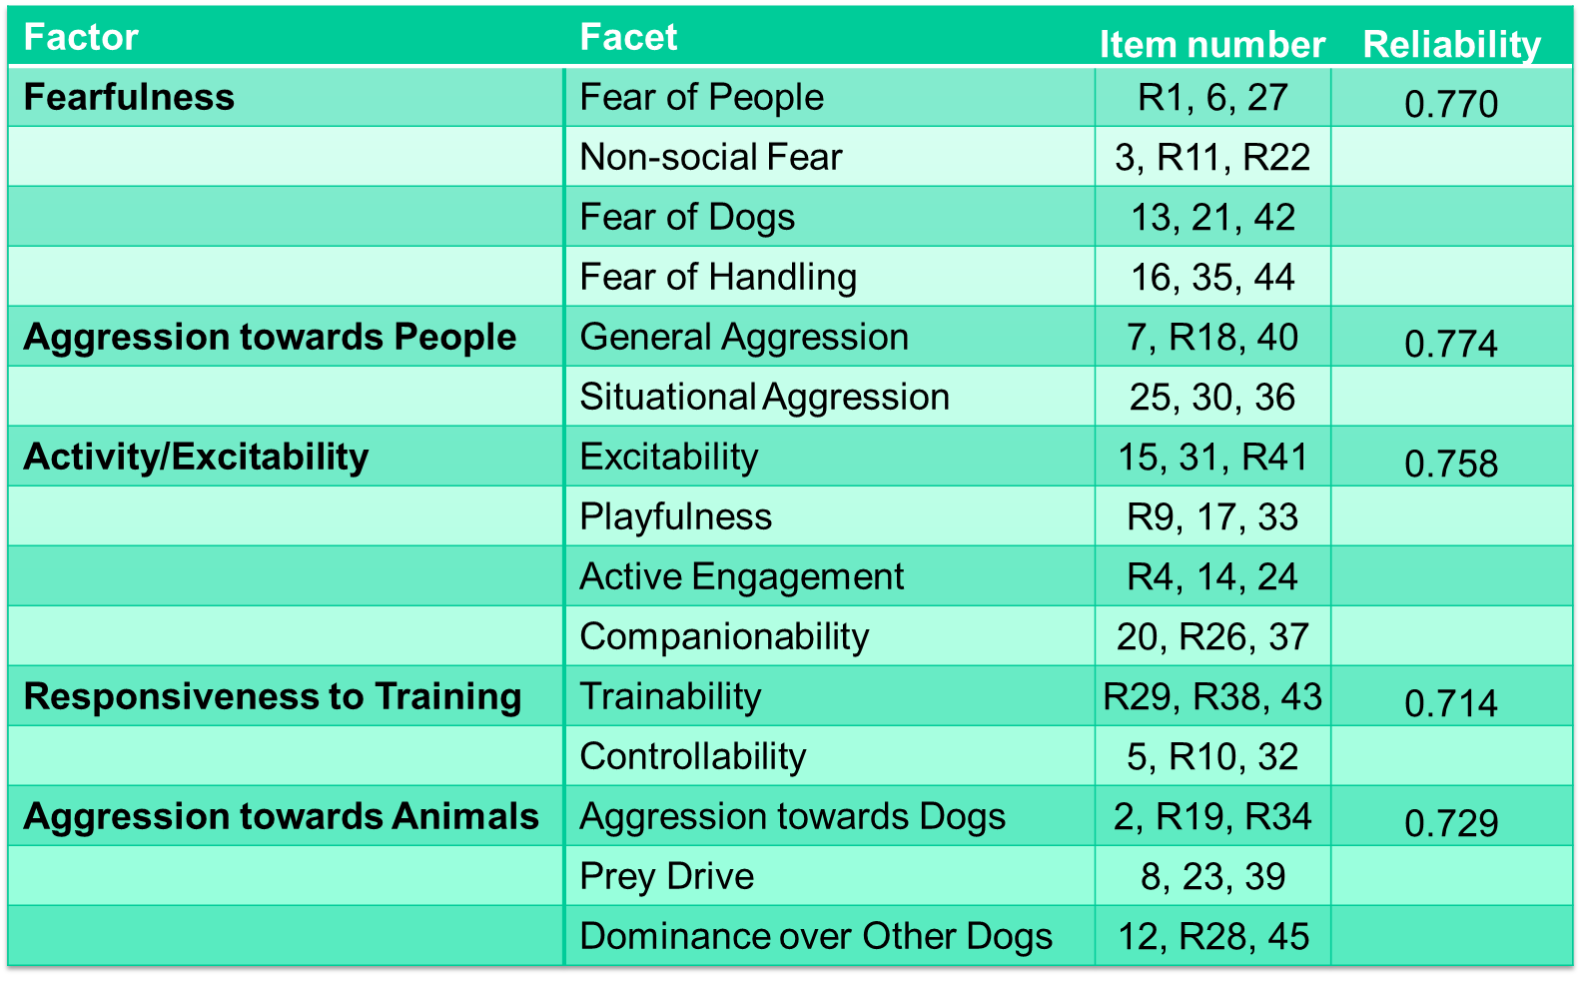

Correlations between the personality subscales
Correlations between the personality factor scores revealed two moderately significant relationships, shown in Table 3 (all sample sizes were 1078). The Aggression towards People factor correlated positively with the Fearfulness factor (r = 0.375, P < 0.001) and Aggression towards Animals (r = 0.488, P < 0.001). There were some other weak correlations, please see Table 4 for details.

Table 4: Correlations between the five factors of the DPQ.
Moderate correlations are highlighted in orange and weak correlations in yellow. *Correlation is significant at the 0.01 level (2-tailed). * Correlation is significant at the 0.05 level (2-tailed).
 |  | Aggression towards People | Activity/  Excitability | Responsiveness to Training | Aggression towards Animals
Fearfulness | r | .375** | -.153** | -.223** | .106*
 | Sig. (2-tailed) | .000 | .000 | .000 | .000
Aggression towards People | r |  | -.082* | -.203** | .488**
 | Sig. (2-tailed) |  | .007 | .000 | .000
Activity/  Excitability | r |  |  | .217** | .078**
 | Sig. (2-tailed) |  |  | .000 | .011
Responsiveness to Training | r |  |  |  | -.174**
 | Sig. (2-tailed) |  |  |  | .000

Main effect of age on the DPQ factors

Table 5: Results of the age group linear models for the three factors of the Dog Personality Questionnaire where a significant effect of age group was found.
Significant predictors are highlighted in bold (p≤0.05). Adjusted p values are presented and Turkey contrasts for multiple comparisons of means was utilised to examine differences between the age groups.
 | Estimate | Std. Error | T |  | F value |  | P |  | Multiple R² | Adjusted R²
Activity Excitability (lambda = 1.59)
Age group |  |  |  |  | 51.340 |  | <0.001 |  | 0.183 | 0.179
Age group 2: Age group 1 | -0.556 | 0.115 | -4.826 |  |  |  | <0.001
Age group 3: Age group 1 | -0.860 | 0.123 | -7.002 |  |  |  | < 0.001
Age group 4: Age group 1 | -1.068 | 0.121 | -8.809 |  |  |  | < 0.001
Age group 5: Age group 1 | -1.289 | 0.127 | -10.185 |  |  |  | < 0.001
Age group 6: Age group 1 | -1.752 | 0.120 | -14.606 |  |  |  | < 0.001
Age group 3: Age group 2 | -0.304 | 0.114 | -2.659 |  |  |  | 0.084
Age group 4: Age group 2 | -0.512 | 0.113 | -4.544 |  |  |  | < 0.001
Age group 5: Age group 2 | -0.733 | 0.118 | -6.191 |  |  |  | < 0.001
Age group 6: Age group 2 | -1.196 | 0.111 | -10.745 |  |  |  | < 0.001
Age group 4: Age group 3 | -0.208 | 0.121 | -1.725 |  |  |  | 0.515
Age group 5: Age group 3 | -0.429 | 0.126 | -3.406 |  |  |  | 0.009
Age group 6: Age group 3 | -0.892 | 0.119 | -7.479 |  |  |  | < 0.001
Age group 5: Age group 4 | -0.221 | 0.124 | -1.776 |  |  |  | 0.481
Age group 6: Age group 4 | -0.684 | 0.118 | -5.815 |  |  |  | < 0.001
Age group 6: Age group 5 | -0.463 | 0.123 | -3.763 |  |  |  | 0.003
Responsiveness to training (lambda = 1.31)
Age group |  |  |  |  | 10.220 |  | <0.001 |  | 0.042 | 0.038
Age group 2: Age group 1 | 0.114 | 0.116 | 0.983 |  |  |  | 0.923
Age group 3: Age group 1 | 0.072 | 0.123 | 0.584 |  |  |  | 0.992
Age group 4: Age group 1 | 0.047 | 0.121 | 0.390 |  |  |  | 0.999
Age group 5: Age group 1 | -0.219 | 0.127 | -1.726 |  |  |  | 0.514
Age group 6: Age group 1 | -0.573 | 0.120 | -4.766 |  |  |  | <0.001
Age group 3: Age group 2 | -0.042 | 0.114 | -0.368 |  |  |  | 0.999
Age group 4: Age group 2 | -0.067 | 0.112 | -0.593 |  |  |  | 0.992
Age group 5: Age group 2 | -0.332 | 0.118 | -2.806 |  |  |  | 0.057
Age group 6: Age group 2 | -0.687 | 0.112 | -6.158 |  |  |  | <0.001
Age group 4: Age group 3 | -0.024 | 0.120 | -0.205 |  |  |  | 1
Age group 5: Age group 3 | -0.290 | 0.125 | -2.315 |  |  |  | 0.188
Age group 6: Age group 3 | -0.645 | 0.119 | -5.424 |  |  |  | <0.001
Age group 5: Age group 4 | -0.266 | 0.124 | -2.150 |  |  |  | 0.262
Age group 6: Age group 4 | -0.621 | 0.117 | -5.302 |  |  |  | <0.001
Age group 6: Age group 5 | -0.355 | 0.123 | -2.884 |  |  |  | 0.046
Aggressiveness to animals (lambda = 0.46)
Age group |  |  |  |  | 4.628 |  | <0.001 |  | 0.019 | 0.015
Age group 2: Age group 1 | 0.017 | 0.044 | 0.376 |  |  |  | 0.999
Age group 3: Age group 1 | 0.136 | 0.047 | 2.883 |  |  |  | 0.046
Age group 4: Age group 1 | 0.139 | 0.046 | 2.993 |  |  |  | 0.033
Age group 5: Age group 1 | 0.040 | 0.049 | 0.827 |  |  |  | 0.962
Age group 6: Age group 1 | -0.020 | 0.046 | -0.439 |  |  |  | 0.998
Age group 3: Age group 2 | 0.120 | 0.044 | 2.728 |  |  |  | 0.070
Age group 4: Age group 2 | 0.122 | 0.043 | 2.849 |  |  |  | 0.051
Age group 5: Age group 2 | 0.023 | 0.045 | 0.519 |  |  |  | 0.995
Age group 6: Age group 2 | -0.037 | 0.043 | -0.865 |  |  |  | 0.955
Age group 4: Age group 3 | 0.003 | 0.046 | 0.060 |  |  |  | 1.000
Age group 5: Age group 3 | -0.096 | 0.048 | -2.000 |  |  |  | 0.342
Age group 6: Age group 3 | -0.157 | 0.046 | -3.421 |  |  |  | 0.008
Age group 5: Age group 4 | -0.099 | 0.047 | -2.093 |  |  |  | 0.291
Age group 6: Age group 4 | -0.159 | 0.045 | -3.548 |  |  |  | 0.005
Age group 6: Age group 5 | -0.060 | 0.047 | -1.284 |  |  |  | 0.793

Main effect of age on the DPQ facets
Results of the Kruskal Wallis Tests showed significant age effects in the following 11 facets (out of 15): Fear of people, Non-social fear, Excitability, Playfulness, Active engagement, Companionability, Trainability, Controllability, Aggression towards animals, Prey drive and Dominance over dogs (all p values < 0.003; Figure 1). Fear of people peaked in dogs aged three to six years and was lowest in dogs aged over ten years. Non-social fear increased with age, with dogs aged over 12 years showing the highest levels, and dogs aged under three years the lowest levels. Excitability, Playfulness, and Active engagement all showed a significant linear decrease with age (highest scores in dogs aged one to three, and the lowest in dogs aged over 12 years). Trainability scores remained high until declining from ten years onwards. Controllability showed a quadratic distribution, peaking in three to six year olds, and was lowest in dogs aged over 12 years. Aggression towards dogs was lowest in the youngest age group, and highest in the oldest. Conversely, prey drive was highest in the youngest age group and lowest in the oldest. Finally, Dominance over dogs showed a quadratic distribution and peaked in dogs aged 8 to 10.

Figure 1 a-k: Median Z score and interquartile range of the Dog Personality Questionnaire facets
c)
a)
a) Fear of people, b) Non-social fear, c) Excitability, d) Playfulness, e) Active engagement, f) Companionability, g) Trainability, h) Companionability, i) Aggression towards animals, j) Prey drive, and k) Dominance over dogs, in the six different dog age groups. For statistical differences, see text. Underneath each graph a table with a pairwise comparison of each age group is presented, along with test statistic, standard error, significance level, and adjusted significance level for multiple comparisons.

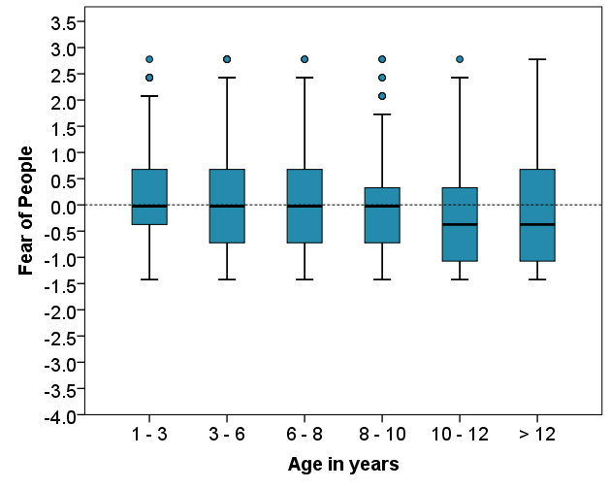

a)
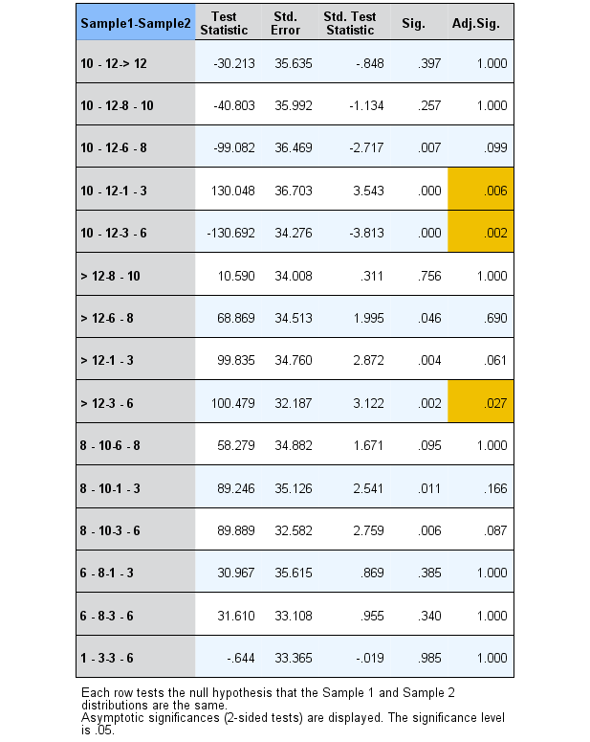
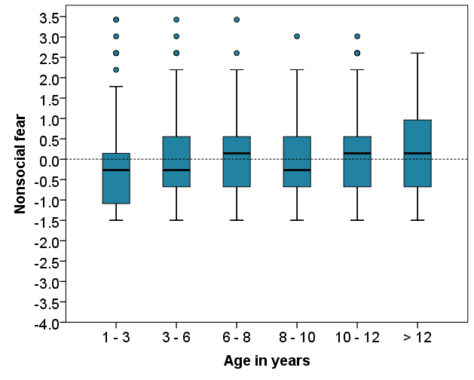

b)

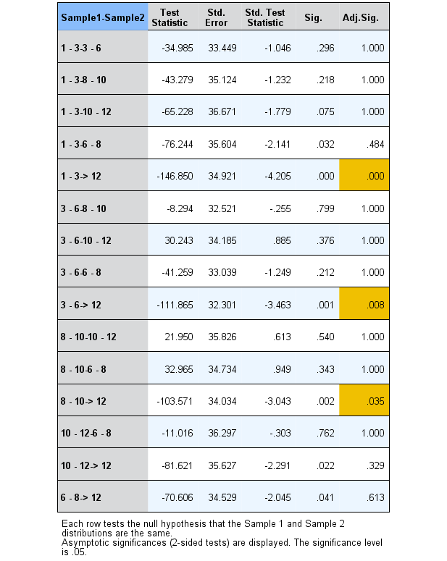
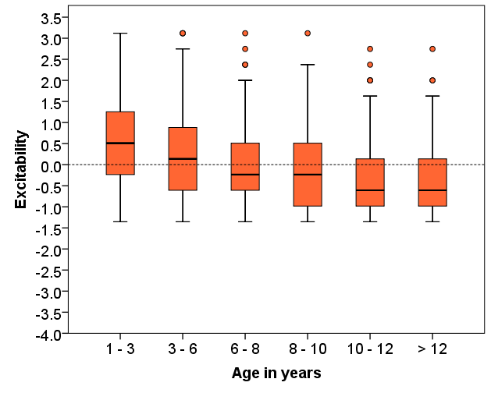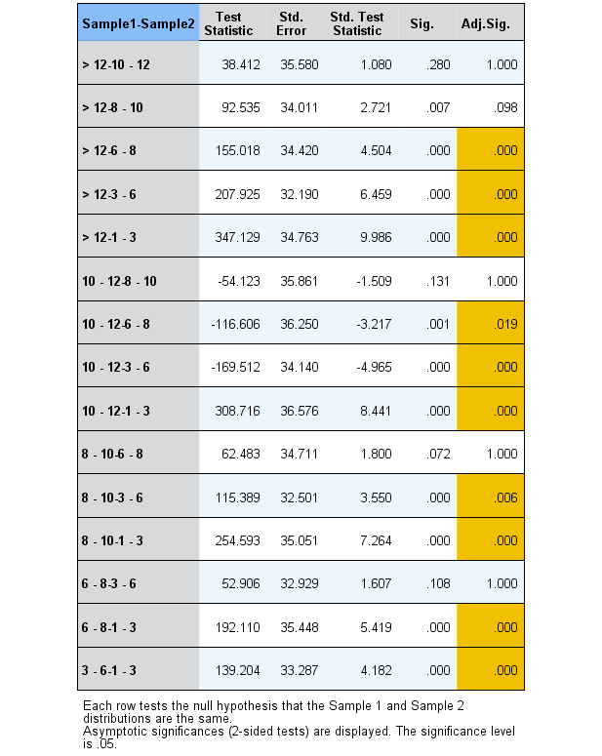

c)
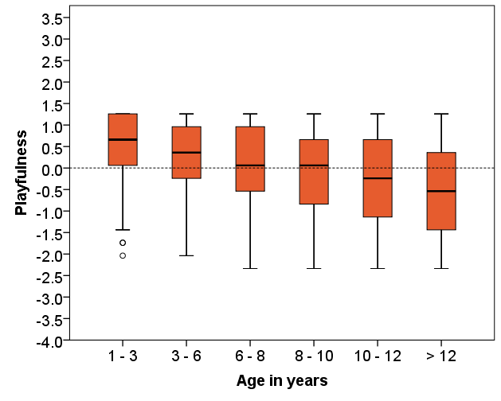

d)
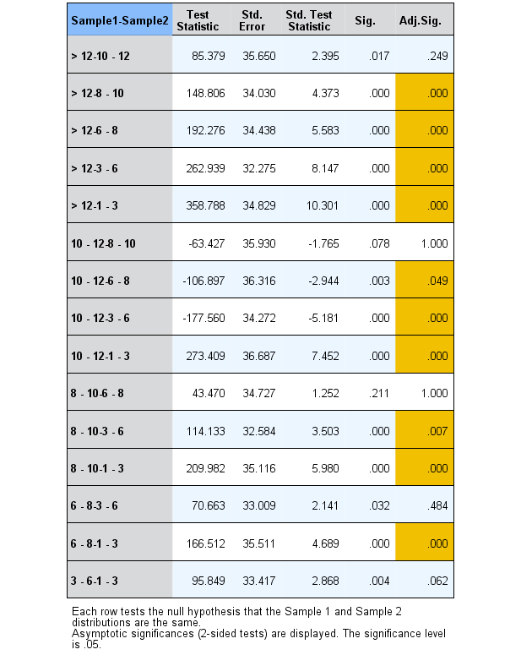
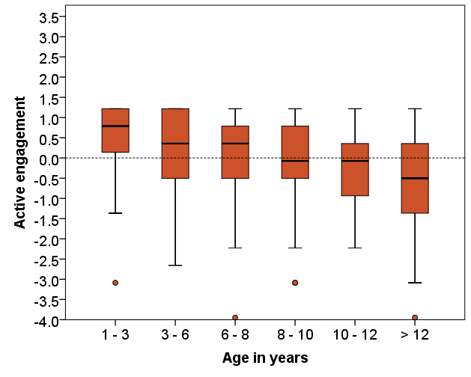

e)
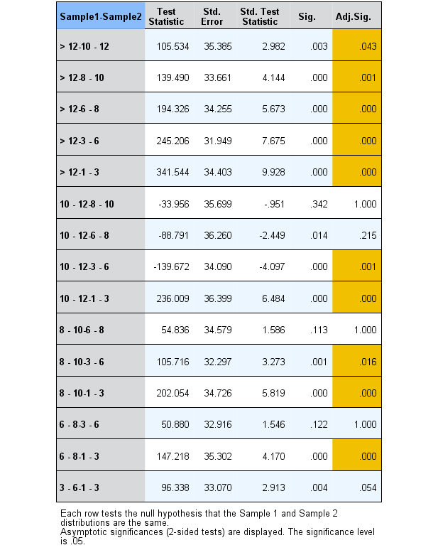
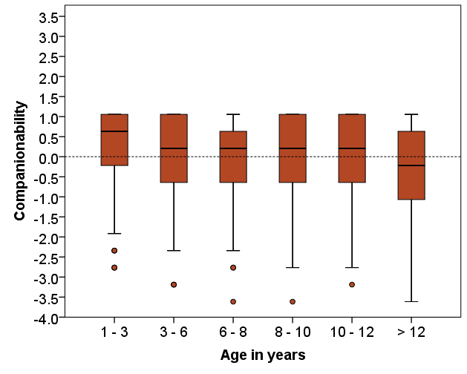

f)
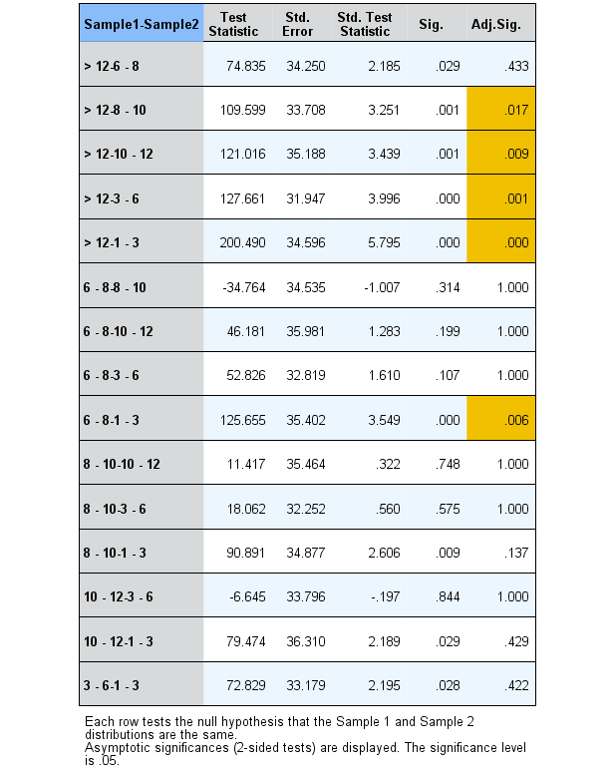
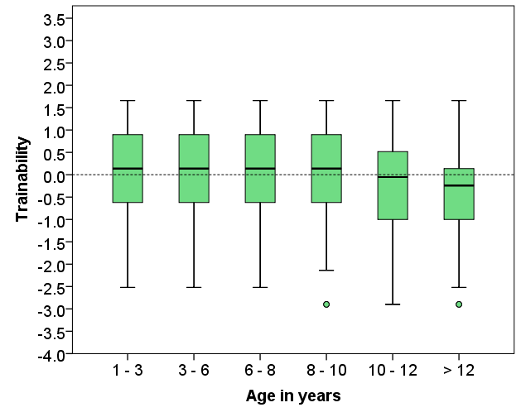

g)
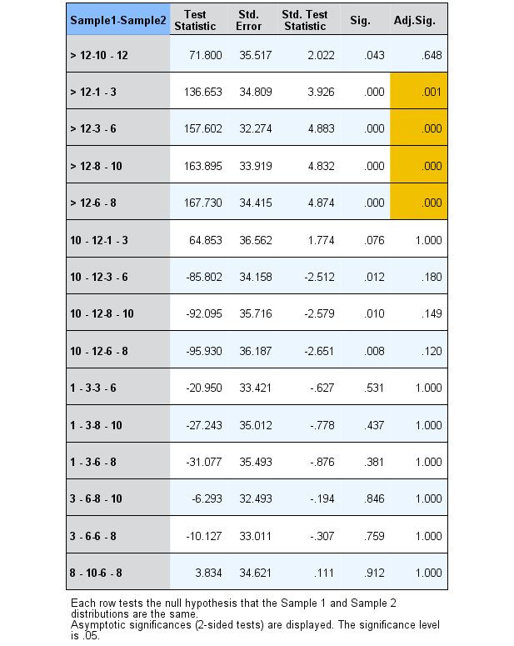
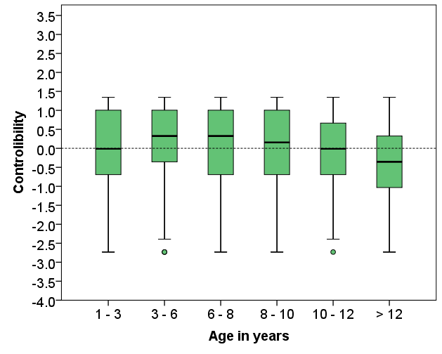

h)
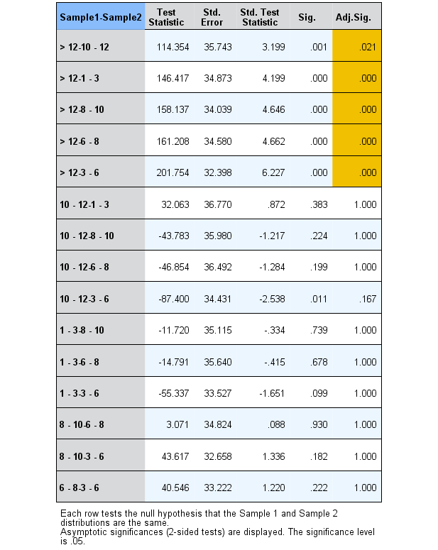
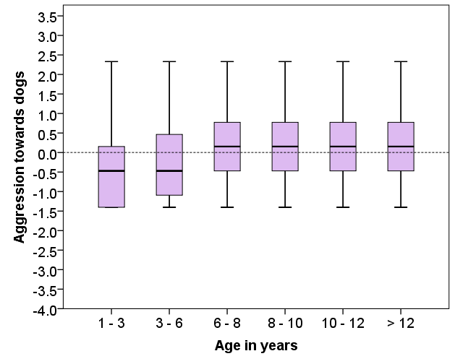

i)
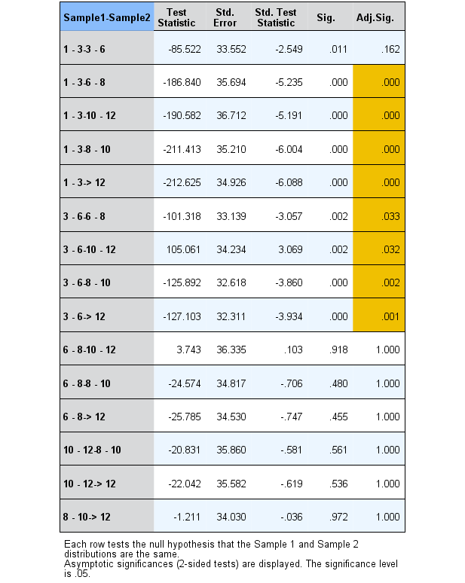
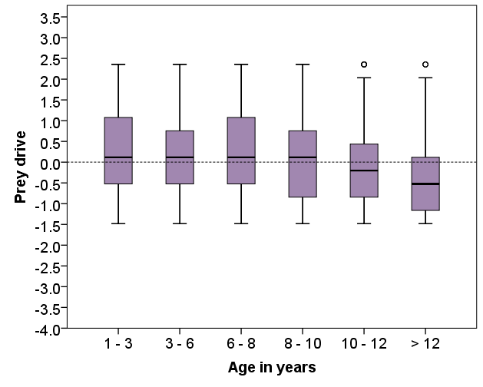

j)
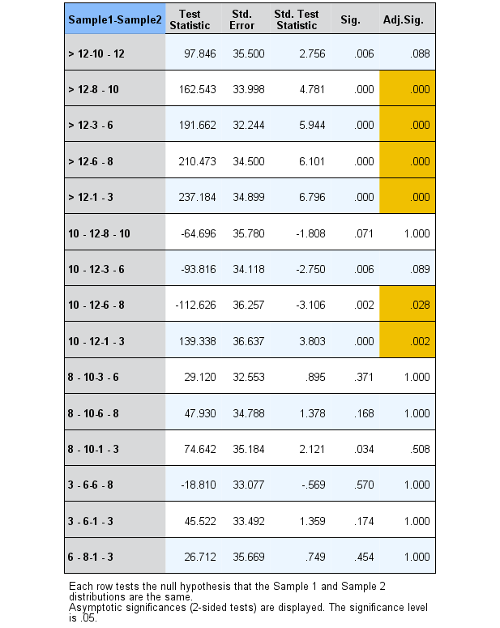
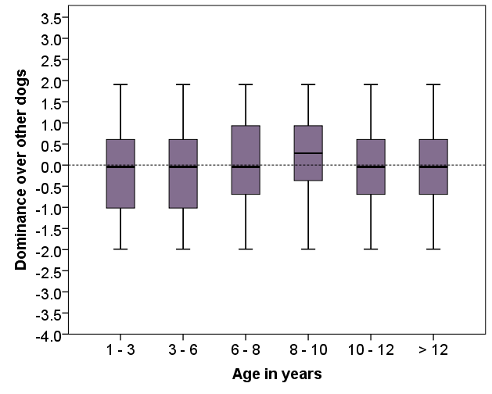

k)
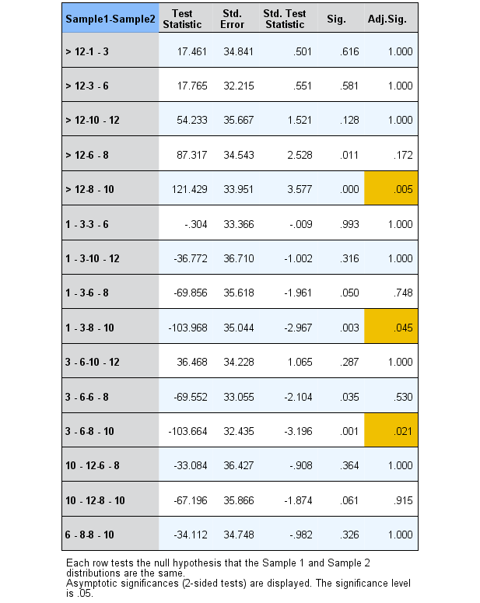

Linear models: Main effects of the demographic variables

Table 6: General linear models showing the direction of the effects and the significance level of the terms in the five factors of the DPQ.
Significant group differences are highlighted in bold (p≤0.05).

Response variable |  |  |  | Category | Reference category |  | Estimate |  | SE |  | t |  | P
Fearfulness (lambda = 0.38)
Weight |  |  |  |  |  |  | -0.007 |  | 0.001 |  | -5.391 |  | <0.001
Breed |  |  | Pure breed |  | Mixed breed |  | -0.118 |  | 0.029 |  | -4.070 |  | <0.001
Sex |  |  | Male |  | Female |  | -0.068 |  | 0.022 |  | -3.002 |  | 0.003
Trauma |  |  | Yes |  | No |  | 0.155 |  | 0.024 |  | 6.382 |  | <0.001
Dog obedience tasks |  |  |  | 2 kinds of tasks | maximum a task |  | -0.043 |  | 0.042 |  | -1.019 |  | 0.308
 |  |  |  | 3 kinds of tasks | maximum a task |  | -0.097 |  | 0.040 |  | -2.390 |  | 0.017
 |  |  |  | ≥ 4 kinds of tasks | maximum a task |  | -0.150 |  | 0.039 |  | -3.862 |  | <0.001
Dog training activities |  |  |  | 2 - 3 activities | One activity |  | 0.033 |  | 0.030 |  | 1.112 |  | 0.267
 |  |  |  | 4 or more activities | One activity |  | -0.105 |  | 0.034 |  | -3.061 |  | 0.002
Aggression towards people (lambda = -0.66)
Breed: Pure breed |  |  |  | Pure breed | Mixed breed |  | -0.065 | 0.021 |  | -3.180 |  | 0.002
Sex: Male |  |  |  | Male | Female |  | 0.061 | 0.016 |  | 3.793 |  | <0.001
Trauma |  |  |  | Yes | No |  | 0.081 | 0.017 |  | 4.706 |  | <0.001
Dog obedience tasks |  |  |  | 2 kinds of tasks | maximum a task |  | -0.002 |  | 0.030 |  | -0.082 |  | 0.934
 |  |  |  | 3 kinds of tasks | maximum a task |  | -0.118 |  | 0.029 |  | -4.072 |  | <0.001
 |  |  |  | ≥ 4 kinds of tasks | maximum a task |  | -0.126 |  | 0.028 |  | -4.530 |  | <0.001
Activity Excitability (lambda = 1.51)
Age group |  |  | >3 - 6 years |  | 1 - 3 years |  | -0.394 |  | 0.101 |  | -3.884 |  | <0.001
 |  |  | >6 - 8 years |  | 1 - 3 years |  | -0.661 |  | 0.109 |  | -6.058 |  | <0.001
 |  |  | >8 - 10 years |  | 1 - 3 years |  | -0.764 |  | 0.113 |  | -6.752 |  | <0.001
 |  |  | >10 - 12 years |  | 1 - 3 years |  | -0.918 |  | 0.120 |  | -7.626 |  | <0.001
 |  |  | >12 years |  | 1 - 3 years |  | -1.090 |  | 0.129 |  | -8.473 |  | <0.001
Sensory problems |  | Yes |  |  | No |  | -0.240 |  | 0.094 |  | -2.555 |  | 0.011
Body condition score |  |  | Normal |  | Thin |  | -0.003 |  | 0.061 |  | -0.038 |  | 0.999
 |  |  | Overweight |  | Thin |  | -0.264 |  | 0.104 |  | -2.535 |  | 0.030
 |  |  | Overweight |  | Normal |  | -0.261 |  | 0.081 |  | -3.240 |  | 0.004
Age of dog when arrived |  |  |  | 7-12 weeks | <7 weeks |  | -0.208 |  | 0.078 |  | -2.677 |  | 0.008
 |  |  |  | 3-12 months | <7 weeks |  | -0.474 |  | 0.099 |  | -4.781 |  | <0.001
 |  |  |  | >1 year | <7 weeks |  | -0.673 |  | 0.109 |  | -6.172 |  | <0.001
Get dog |  |  |  | It was born at my place/ I bought it | I found it/got it from a shelter |  | -0.330 |  | 0.105 |  | -3.127 |  | 0.002
 |  |  |  | I got it as a present | I found it/got it from a shelter |  | -0.173 |  | 0.092 |  | -1.890 |  | 0.059
Dog obedience tasks |  |  |  | 2 kinds of tasks | maximum a task |  | 0.302 |  | 0.114 |  | 2.649 |  | 0.008
 |  |  |  | 3 kinds of tasks | maximum a task |  | 0.321 |  | 0.110 |  | 2.918 |  | 0.004
 |  |  |  | ≥ 4 kinds of tasks | maximum a task |  | 0.617 |  | 0.105 |  | 5.888 |  | < 0.001
Responsiveness to training (lambda = 1.31)
Weight |  |  |  |  |  |  | 0.009 |  | 0.003 |  | 2.653 |  | 0.008
Sex |  | Male |  |  |  | Female | -0.181 |  | 0.056 |  | -3.215 |  | 0.001
Off-leash activity |  | 30 minutes -1 hour |  |  |  | < 30 minutes | 0.135 |  | 0.093 |  | 1.440 |  | 0.150
 |  | >1-3 hours |  |  |  | < 30 minutes | 0.316 |  | 0.091 |  | 3.482 |  | <0.001
 |  | >3-7 hours |  |  |  | < 30 minutes | 0.315 |  | 0.107 |  | 2.936 |  | 0.003
 |  | more than 7 hours |  |  |  | < 30 minutes | 0.220 |  | 0.106 |  | 2.087 |  | 0.037
Dog obedience tasks |  | 2 kinds of tasks |  |  |  | maximum a task | 0.251 |  | 0.105 |  | 2.396 |  | 0.017
 |  | 3 kinds of tasks |  |  |  | maximum a task | 0.665 |  | 0.100 |  | 6.626 |  | <0.001
 |  | ≥ 4 kinds of tasks |  |  |  | maximum a task | 1.326 |  | 0.096 |  | 13.780 |  | <0.001
Play |  | 30 minutes -1 hours |  |  |  | < 30 minutes | 0.182 |  | 0.099 |  | 1.840 |  | 0.066
 |  | >1 -3 hours |  |  |  | < 30 minutes | 0.287 |  | 0.100 |  | 2.854 |  | 0.004
 |  | more than 3 hours |  |  |  | < 30 minutes | 0.402 |  | 0.121 |  | 3.316 |  | < 0.001
Commands |  | 11 - 30 |  |  |  | < 10 | 0.308 |  | 0.068 |  | 4.564 |  | < 0.001
 |  | >31 |  |  |  | < 10 | 0.657 |  | 0.108 |  | 6.058 |  | < 0.001
Aggressiveness towards animals (lambda = 0.46)
Age group |  |  |  | >3 - 6 years | 1 - 3 years |  | 0.020 |  | 0.045 |  | 0.449 |  | 0.653
 |  |  |  | >6 - 8 years | 1 - 3 years |  | 0.126 |  | 0.049 |  | 2.586 |  | 0.010
 |  |  |  | >8 - 10 years | 1 - 3 years |  | 0.119 |  | 0.050 |  | 2.392 |  | 0.017
 |  |  |  | >10 - 12 years | 1 - 3 years |  | 0.026 |  | 0.053 |  | 0.484 |  | 0.628
 |  |  |  | >12 years | 1 - 3 years |  | -0.057 |  | 0.057 |  | -0.985 |  | 0.325
Food |  |  |  | Tinned &/or dry food | Dry food only |  | -0.105 |  | 0.047 |  | -2.221 |  | 0.171
 |  |  |  | Cooked food | Dry food only |  | 0.025 |  | 0.039 |  | 0.662 |  | 0.964
 |  |  |  | Mixed | Dry food only |  | 0.062 |  | 0.040 |  | 1.523 |  | 0.545
 |  |  |  | Raw meat | Dry food only |  | 0.038 |  | 0.043 |  | 0.890 |  | 0.900
 |  |  |  | Cooked food | Tinned &/or dry food |  | 0.130 |  | 0.045 |  | 2.867 |  | 0.034
 |  |  |  | Mixed | Tinned &/or dry food |  | 0.166 |  | 0.047 |  | 3.540 |  | 0.004
 |  |  |  | Raw meat | Tinned &/or dry food |  | 0.143 |  | 0.050 |  | 2.843 |  | 0.036
 |  |  |  | Mixed | Cooked food |  | 0.036 |  | 0.039 |  | 0.933 |  | 0.883
 |  |  |  | Raw meat | Cooked food |  | 0.013 |  | 0.042 |  | 0.302 |  | 0.998
 |  |  |  | Raw meat | Mixed |  | -0.023 |  | 0.043 |  | -0.544 |  | 0.982
Trauma |  |  |  | Yes | No |  | 0.085 |  | 0.029 |  | 2.916 |  | 0.004
Dog obedience tasks |  |  |  | 2 kinds of tasks | maximum a task |  | 0.059 |  | 0.051 |  | 1.165 |  | 0.244
 |  |  |  | 3 kinds of tasks | maximum a task |  | -0.053 |  | 0.049 |  | -1.096 |  | 0.273
 |  |  |  | ≥ 4 kinds of tasks | maximum a task |  | -0.135 |  | 0.047 |  | -2.891 |  | 0.004

Dog Personality Factor Linear Models R code

DPQFAC1 – Fearfulness

Age only
> lm<-lm(bcPower(DPQFAC1new,0.38)~(age), data = data, na.action = na.omit)
> etasq(lm, anova = TRUE, type=3)
Anova Table (Type III tests)

Response: bcPower(DPQFAC1new, 0.38)
Partial eta^2 Sum Sq Df F value Pr(>F)
(Intercept) 0.45090 154.92 1 955.8315 <2e-16 ***
age 0.00574 1.09 5 1.3447 0.2429
Residuals 188.66 1164
---
Signif. codes: 0 ‘***’ 0.001 ‘**’ 0.01 ‘*’ 0.05 ‘.’ 0.1 ‘ ’ 1
> summary(lm)

Call:
lm(formula = bcPower(DPQFAC1new, 0.38) ~ (age), data = data,
na.action = na.omit)

Residuals:
Min 1Q Median 3Q Max
-0.9387 -0.2897 0.0142 0.2832 1.0270

Coefficients:
Estimate Std. Error t value Pr(>|t|)
(Intercept) 0.935562 0.030261 30.917 <2e-16 ***
ageGroup2 0.057580 0.039715 1.450 0.147
ageGroup3 0.049773 0.042330 1.176 0.240
ageGroup4 0.003163 0.041645 0.076 0.939
ageGroup5 -0.030145 0.043705 -0.690 0.490
ageGroup6 0.035709 0.041450 0.862 0.389
---
Signif. codes: 0 ‘***’ 0.001 ‘**’ 0.01 ‘*’ 0.05 ‘.’ 0.1 ‘ ’ 1

Residual standard error: 0.4026 on 1164 degrees of freedom
(37 observations deleted due to missingness)
Multiple R-squared: 0.005743, Adjusted R-squared: 0.001472
F-statistic: 1.345 on 5 and 1164 DF, p-value: 0.2429

> Residuals <- residuals (lm)
> qqnorm(Residuals)
> shapiro.test (Residuals)

Shapiro-Wilk normality test

data: Residuals
W = 0.99363, p-value = 6.623e-05

Full Model
> lm<-lm(bcPower(DPQFAC1new,0.38)~(age+sensory+height+weight+breed+sex+neuter+offleash_activity+BCS+food+Add_vitamins+trauma+Health_prob+medication+Owner_age+Owner_dog_exp+How_many_dogs_in_house+How_many_people+Child+Age_of_dog_when_arrived+get_dog+Where_dog_is_kept+dog_obedience+play+commands+training+Time_dog_spend_alone+dog_beh_changed_3month), data = data, na.action = na.omit)
> etasq(lm, anova = TRUE, type=3)
Anova Table (Type III tests)

Response: bcPower(DPQFAC1new, 0.38)
Partial eta^2 Sum Sq Df F value Pr(>F)
(Intercept) 0.097047 15.543 1 118.9769 < 2.2e-16 ***
Age 0.011822 1.730 5 2.6487 0.0217269 *
sensory 0.001563 0.226 1 1.7332 0.1882778
height 0.000200 0.029 1 0.2211 0.6383243
weight 0.024473 3.628 1 27.7712 1.640e-07 ***
breed 0.013463 1.973 1 15.1066 0.0001076 ***
sex 0.009584 1.399 1 10.7122 0.0010972 **
neuter 0.002912 0.422 1 3.2333 0.0724270 .
offleash_activity 0.004839 0.703 4 1.3457 0.2509659
BCS 0.000839 0.121 2 0.4646 0.6285174
food 0.002624 0.380 4 0.7281 0.5727854
Add_vitamins 0.002431 0.352 3 0.8991 0.4410215
trauma 0.034761 5.208 1 39.8665 3.929e-10 ***
Health_prob 0.009200 1.343 4 2.5696 0.0365694 *
medication 0.000033 0.005 1 0.0361 0.8493583
Owner_age 0.001977 0.287 3 0.7311 0.5335260
Owner_dog_exp 0.001530 0.222 2 0.8481 0.4285127
How_many_dogs_in_house 0.001564 0.227 2 0.8671 0.4204684
How_many_people 0.001308 0.189 3 0.4832 0.6939953
Child 0.000039 0.006 1 0.0432 0.8354138
Age_of_dog_when_arrived 0.002636 0.382 3 0.9752 0.4036565
get_dog 0.001692 0.245 2 0.9381 0.3916660
Where_dog_is_kept 0.002095 0.304 2 1.1619 0.3132760
dog_obedience 0.016579 2.438 3 6.2209 0.0003443 ***
play 0.000416 0.060 3 0.1537 0.9273334
commands 0.000680 0.098 2 0.3768 0.6861150
training 0.011852 1.735 2 6.6390 0.0013610 **
Time_dog_spend_alone 0.004837 0.703 3 1.7934 0.1466462
dog_beh_changed_3month 0.003987 0.579 1 4.4315 0.0355062 *
Residuals 144.616 1107
---
Signif. codes: 0 ‘***’ 0.001 ‘**’ 0.01 ‘*’ 0.05 ‘.’ 0.1 ‘ ’ 1
> summary(lm)

Call:
lm(formula = bcPower(DPQFAC1new, 0.38) ~ (age3 + sensory2 + height +
weight + breed + sex + neuter2 + offleash_activity + shape +
food + Add_vitamins + trauma + Health_prob + medication +
Owner_age + Owner_dog_exp + How_many_dogs_in_house + How_many_people +
Child + Age_of_dog_when_arrived + get_dog + Where_dog_is_kept2 +
dog_jobs + play + commands + training + Time_dog_spend_alone +
dog_beh_changed_3month), data = new_cog_no_missing3, na.action = na.omit)

Residuals:
Min 1Q Median 3Q Max
-1.03946 -0.26056 0.00112 0.25700 1.28626

Coefficients:
Estimate Std. Error t value Pr(>|t|)
(Intercept) 1.195e+00 1.095e-01 10.908 < 2e-16 ***
ageGroup2 2.647e-02 3.774e-02 0.701 0.483271
ageGroup3 1.203e-02 4.055e-02 0.297 0.766829
ageGroup4 -6.371e-02 4.206e-02 -1.515 0.130090
ageGroup5 -9.928e-02 4.477e-02 -2.218 0.026781 *
ageGroup6 -6.170e-02 4.820e-02 -1.280 0.200788
sensory_probPresent -4.617e-02 3.507e-02 -1.317 0.188278
height 5.067e-04 1.078e-03 0.470 0.638324
weight -7.062e-03 1.340e-03 -5.270 1.64e-07 ***
breedPure -1.127e-01 2.900e-02 -3.887 0.000108 ***
sexMale -7.489e-02 2.288e-02 -3.273 0.001097 **
neuterNeutered 4.414e-02 2.454e-02 1.798 0.072427 .
offleash_activity30m-1h 1.329e-03 3.798e-02 0.035 0.972096
offleash_activity1-3h -1.003e-02 3.665e-02 -0.274 0.784419
offleash_activity2-7 -2.557e-02 4.347e-02 -0.588 0.556589
offleash_activity>7 -7.787e-02 4.263e-02 -1.827 0.068042 .
BCSNormal -2.216e-02 3.034e-02 -0.730 0.465449
BCSOverweight 3.593e-05 3.914e-02 0.001 0.999268
foodTinned dry 2.859e-02 4.010e-02 0.713 0.476011
foodCooked -2.089e-03 3.241e-02 -0.064 0.948623
foodMixed 1.677e-02 3.398e-02 0.493 0.621865
foodRaw -3.566e-02 3.596e-02 -0.992 0.321516
Add_vitaminsRarely 1.818e-02 2.869e-02 0.634 0.526426
Add_vitaminsOften -2.398e-02 3.289e-02 -0.729 0.466234
Add_vitaminsDaily 2.602e-02 3.439e-02 0.757 0.449507
traumaYes 1.545e-01 2.447e-02 6.314 3.93e-10 ***
Health_probTooth only 4.517e-02 3.635e-02 1.243 0.214259
Health_probJoint & Tooth 8.110e-02 4.323e-02 1.876 0.060895 .
Health_probJoint only 2.791e-04 3.318e-02 0.008 0.993291
Health_probOther 9.189e-02 3.590e-02 2.560 0.010611 *
medicationYes 6.195e-03 3.261e-02 0.190 0.849358
Owner_age30-39 -1.888e-02 3.093e-02 -0.610 0.541732
Owner_age40-49 2.675e-02 3.437e-02 0.778 0.436496
Owner_age>50 1.378e-02 3.614e-02 0.381 0.702983
Owner_dog_expHad dog 5.720e-03 2.851e-02 0.201 0.841031
Owner_dog_expNever had dog 3.927e-02 3.441e-02 1.141 0.253966
How_many_dogs_in_houseOne -7.734e-03 2.513e-02 -0.308 0.758290
How_many_dogs_in_houseTwo more -3.928e-02 3.074e-02 -1.278 0.201550
How_many_peopleTwo -1.643e-02 3.693e-02 -0.445 0.656570
How_many_peopleThree 1.715e-02 4.468e-02 0.384 0.701112
How_many_peopleFour more -1.290e-02 4.579e-02 -0.282 0.778238
ChildYes 6.777e-03 3.261e-02 0.208 0.835414
Age_of_dog_when_arrived7-12w 2.329e-02 2.871e-02 0.811 0.417254
Age_of_dog_when_arrived3-12m -2.839e-02 3.685e-02 -0.770 0.441207
Age_of_dog_when_arrived>1y -2.719e-02 4.039e-02 -0.673 0.500959
get_dogBorn bought 1.028e-02 3.922e-02 0.262 0.793228
get_dogPresent 3.955e-02 3.407e-02 1.161 0.245918
Where_dog_is_keptGarden 5.770e-02 3.861e-02 1.494 0.135393
Where_dog_is_keptApartment 2.860e-02 3.620e-02 0.790 0.429654
dog_obedience2 tasks -4.592e-02 4.253e-02 -1.080 0.280455
dog_obedience3tasks -1.014e-01 4.067e-02 -2.494 0.012786 *
dog_obedience>3 -1.551e-01 3.899e-02 -3.978 7.39e-05 ***
play30m-1h 1.398e-02 3.966e-02 0.353 0.724483
play1-3h 1.291e-03 4.026e-02 0.032 0.974431
play>3h -9.255e-03 4.901e-02 -0.189 0.850267
commands11-30 -5.344e-03 2.743e-02 -0.195 0.845574
commands>30 -3.665e-02 4.420e-02 -0.829 0.407077
training2-3 3.697e-02 2.992e-02 1.236 0.216874
training4 more -9.897e-02 3.443e-02 -2.874 0.004126 **
Time_dog_spend_alone1-2h 4.250e-02 3.758e-02 1.131 0.258339
Time_dog_spend_alone3-8h -1.832e-02 3.376e-02 -0.543 0.587462
Time_dog_spend_alone>8h 2.499e-02 4.288e-02 0.583 0.560189
dog_beh_changed_3monthYes 5.537e-02 2.630e-02 2.105 0.035506 *
---
Signif. codes: 0 ‘***’ 0.001 ‘**’ 0.01 ‘*’ 0.05 ‘.’ 0.1 ‘ ’ 1

Residual standard error: 0.3614 on 1107 degrees of freedom
(37 observations deleted due to missingness)
Multiple R-squared: 0.2379, Adjusted R-squared: 0.1952
F-statistic: 5.573 on 62 and 1107 DF, p-value: < 2.2e-16

> Residuals <- residuals (lm)
> qqnorm(Residuals)
> shapiro.test (Residuals)

Shapiro-Wilk normality test

data: Residuals
W = 0.99753, p-value = 0.07197

Reduced Model
> lm<-lm(bcPower(DPQFAC1new,0.38)~(age+sensory+height+weight+breed+sex+neuter+offleash_activity+BCS+food+Add_vitamins+trauma+Health_prob+medication+Owner_age+Age_of_dog_when_arrived+get_dog+Where_dog_is_kept+dog_obedience+play+commands+training+dog_beh_changed_3month), data = data, na.action = na.omit)
> etasq(lm, anova = TRUE, type=3)
Anova Table (Type III tests)

Response: bcPower(DPQFAC1new, 0.38)
Partial eta^2 Sum Sq Df F value Pr(>F)
(Intercept) 0.124829 20.844 1 159.4640 < 2.2e-16 ***
age 0.011887 1.758 5 2.6900 0.0200043 *
sensory 0.001968 0.288 1 2.2046 0.1378832
height 0.000174 0.025 1 0.1944 0.6593568
weight 0.025333 3.798 1 29.0580 8.565e-08 ***
breed 0.014598 2.165 1 16.5623 5.039e-05 ***
sex 0.007998 1.178 1 9.0134 0.0027397 **
neuter 0.002830 0.415 1 3.1731 0.0751303 .
offleash_activity 0.005374 0.790 4 1.5102 0.1969222
BCS 0.000735 0.108 2 0.4112 0.6629554
food 0.003315 0.486 4 0.9297 0.4458267
Add_vitamins 0.002058 0.301 3 0.7686 0.5116739
trauma 0.035154 5.325 1 40.7336 2.551e-10 ***
Health_prob 0.009634 1.422 4 2.7190 0.0285061 *
medication 0.000267 0.039 1 0.2986 0.5848677
Owner_age 0.002695 0.395 3 1.0072 0.3887268
Age_of_dog_when_arrived 0.003112 0.456 3 1.1633 0.3225946
get_dog 0.002077 0.304 2 1.1633 0.3128384
Where_dog_is_kept 0.002583 0.378 2 1.4476 0.2355703
dog_obedience 0.015573 2.312 3 5.8952 0.0005433 ***
play 0.000243 0.036 3 0.0906 0.9652342
commands 0.000929 0.136 2 0.5200 0.5946902
training 0.012458 1.844 2 7.0517 0.0009050 ***
dog_beh_changed_3month 0.003734 0.548 1 4.1908 0.0408782 *
Residuals 146.140 1118
---
Signif. codes: 0 ‘***’ 0.001 ‘**’ 0.01 ‘*’ 0.05 ‘.’ 0.1 ‘ ’ 1
> summary(lm)

Call:
lm(formula = bcPower(DPQFAC1new, 0.38) ~ (age + sensory + height +
weight + breed + sex + neuter + offleash_activity + BCS +
food + Add_vitamins + trauma + Health_prob + medication +
Owner_age + Age_of_dog_when_arrived + get_dog + Where_dog_is_kept +
dog_obedience + play + commands + training + dog_beh_changed_3month),
data = data, na.action = na.omit)

Residuals:
Min 1Q Median 3Q Max
-1.02791 -0.25785 0.00955 0.25295 1.27588

Coefficients:
Estimate Std. Error t value Pr(>|t|)
(Intercept) 1.1909668 0.0943123 12.628 < 2e-16 ***
ageGroup2 0.0224045 0.0375385 0.597 0.550734
ageGroup3 0.0133799 0.0404446 0.331 0.740842
ageGroup4 -0.0658520 0.0417041 -1.579 0.114612
ageGroup5 -0.0995403 0.0444756 -2.238 0.025412 *
ageGroup6 -0.0681230 0.0478595 -1.423 0.154900
sensoryPresent -0.0518317 0.0349086 -1.485 0.137883
height 0.0004722 0.0010710 0.441 0.659357
weight -0.0071812 0.0013322 -5.391 8.56e-08 ***
breedPure -0.1175308 0.0288796 -4.070 5.04e-05 ***
sexMale -0.0681134 0.0226876 -3.002 0.002740 **
neuterNeutered 0.0435394 0.0244421 1.781 0.075130 .
offleash_activity30mins/1hour 0.0022214 0.0377642 0.059 0.953103
offleash_activity1/3 -0.0088849 0.0365374 -0.243 0.807916
offleash_activity3/7 -0.0267173 0.0430407 -0.621 0.534894
offleash_activity>7 -0.0809671 0.0423742 -1.911 0.056291 .
BCSNormal -0.0181089 0.0300089 -0.603 0.546331
BCSOverweight 0.0048653 0.0387491 0.126 0.900105
foodTinned and/or Dry food 0.0326935 0.0397199 0.823 0.410626
foodCooked food 0.0011362 0.0319948 0.036 0.971678
foodMixed 0.0127531 0.0333805 0.382 0.702496
foodRaw -0.0426014 0.0357700 -1.191 0.233914
Add_vitaminsRarely 0.0096573 0.0284679 0.339 0.734497
Add_vitaminsOften -0.0316406 0.0325334 -0.973 0.330984
Add_vitaminsDaily 0.0135347 0.0339854 0.398 0.690520
traumaYes 0.1553504 0.0243408 6.382 2.55e-10 ***
Health_probTooth problem only 0.0478190 0.0361099 1.324 0.185687
Health_probJoint & Tooth probs 0.0879641 0.0429820 2.047 0.040937 *
Health_probJoint problems only 0.0027748 0.0329954 0.084 0.932995
Health_probOther disorders 0.0929146 0.0356156 2.609 0.009207 **
medicationYes 0.0176668 0.0323302 0.546 0.584868
Owner_age30-39 -0.0204600 0.0285536 -0.717 0.473804
Owner_age40-49 0.0318045 0.0307405 1.035 0.301074
Owner_age>50 0.0141278 0.0326543 0.433 0.665355
Age_of_dog_when_arrived7-12w 0.0244779 0.0284406 0.861 0.389606
Age_of_dog_when_arrived3-12m -0.0317563 0.0367096 -0.865 0.387187
Age_of_dog_when_arrived>1y -0.0304995 0.0403080 -0.757 0.449412
get_dogborn bought 0.0128509 0.0389149 0.330 0.741287
get_dogpresent 0.0443872 0.0337859 1.314 0.189191
Where_dog_is_keptGarden 0.0647794 0.0383700 1.688 0.091635 .
Where_dog_is_keptApartment 0.0354109 0.0357507 0.990 0.322146
dog_obedience2 tasks -0.0430889 0.0422838 -1.019 0.308405
dog_obedience3 tasks -0.0967217 0.0404623 -2.390 0.016994 *
dog_obedience>3 tasks -0.1499746 0.0388316 -3.862 0.000119 ***
play30m-1h 0.0119406 0.0394914 0.302 0.762434
play1-3h 0.0037299 0.0400093 0.093 0.925740
play>3h -0.0059172 0.0486697 -0.122 0.903255
commands11-30 -0.0068856 0.0272195 -0.253 0.800342
commands>30 -0.0428306 0.0436009 -0.982 0.326149
training2-3 0.0330983 0.0297725 1.112 0.266504
training4 more -0.1046861 0.0342022 -3.061 0.002260 **
dog_beh_changed_3monthYes 0.0536570 0.0262108 2.047 0.040878 *
---
Signif. codes: 0 ‘***’ 0.001 ‘**’ 0.01 ‘*’ 0.05 ‘.’ 0.1 ‘ ’ 1

Residual standard error: 0.3615 on 1118 degrees of freedom
(37 observations deleted due to missingness)
Multiple R-squared: 0.2298, Adjusted R-squared: 0.1947
F-statistic: 6.542 on 51 and 1118 DF, p-value: < 2.2e-16

> Residuals <- residuals (lm)
> qqnorm(Residuals)
> shapiro.test (Residuals)

Shapiro-Wilk normality test

data: Residuals
W = 0.99725, p-value = 0.04155

No outliers at 3D or above

DPQFAC2 – Aggression towards people

Age only
> lm<-lm(bcPower(DPQFAC2new,-0.66)~(age), data = data, na.action = na.omit)
> etasq(lm, anova = TRUE, type=3)
Anova Table (Type III tests)

Response: bcPower(DPQFAC2new, -0.66)
Partial eta^2 Sum Sq Df F value Pr(>F)
(Intercept) 0.224265 25.020 1 339.9807 <2e-16 ***
age 0.003733 0.324 5 0.8813 0.4929
Residuals 86.543 1176
---
Signif. codes: 0 ‘***’ 0.001 ‘**’ 0.01 ‘*’ 0.05 ‘.’ 0.1 ‘ ’ 1
> summary(lm)

Call:
lm(formula = bcPower(DPQFAC2new, -0.66) ~ (age), data = data,
na.action = na.omit)

Residuals:
Min 1Q Median 3Q Max
-0.41535 -0.24359 -0.01812 0.22600 0.61752

Coefficients:
Estimate Std. Error t value Pr(>|t|)
(Intercept) 0.373863 0.020276 18.439 <2e-16 ***
ageGroup2 0.040585 0.026674 1.522 0.128
ageGroup3 0.041482 0.028330 1.464 0.143
ageGroup4 0.021575 0.028046 0.769 0.442
ageGroup5 0.000446 0.029096 0.015 0.988
ageGroup6 0.027053 0.027751 0.975 0.330
---
Signif. codes: 0 ‘***’ 0.001 ‘**’ 0.01 ‘*’ 0.05 ‘.’ 0.1 ‘ ’ 1

Residual standard error: 0.2713 on 1176 degrees of freedom
(25 observations deleted due to missingness)
Multiple R-squared: 0.003733, Adjusted R-squared: -0.0005029
F-statistic: 0.8813 on 5 and 1176 DF, p-value: 0.4929

Full Model
> lm<-lm(bcPower(DPQFAC2new,-0.66)~(age+sensory+height+weight+breed+sex+neuter+offleash_activity+BCS+food+Add_vitamins+trauma+Health_prob+medication+Owner_age+Owner_dog_exp+How_many_dogs_in_house+How_many_people+Child+Age_of_dog_when_arrived+get_dog+Where_dog_is_kept+dog_obedience+play+commands+training+Time_dog_spend_alone+dog_beh_changed_3month), data = data, na.action = na.omit)
> etasq(lm, anova = TRUE, type=3)
Anova Table (Type III tests)

Response: bcPower(DPQFAC2new, -0.66)
Partial eta^2 Sum Sq Df F value Pr(>F)
(Intercept) 0.036626 2.847 1 42.5422 1.045e-10 ***
age 0.004827 0.363 5 1.0855 0.3665890
sensory 0.001365 0.102 1 1.5293 0.2164841
height 0.000728 0.055 1 0.8151 0.3668135
weight 0.002102 0.158 1 2.3569 0.1250142
breed 0.009620 0.727 1 10.8691 0.0010085 **
sex 0.011958 0.906 1 13.5433 0.0002442 ***
neuter 0.000988 0.074 1 1.1068 0.2930105
offleash_activity 0.002839 0.213 4 0.7966 0.5274288
BCS 0.001040 0.078 2 0.5827 0.5585628
food 0.005374 0.405 4 1.5114 0.1965722
Add_vitamins 0.000610 0.046 3 0.2276 0.8771907
trauma 0.019538 1.492 1 22.2992 2.629e-06 ***
Health_prob 0.001030 0.077 4 0.2883 0.8856681
medication 0.000211 0.016 1 0.2357 0.6274546
Owner_age 0.002368 0.178 3 0.8854 0.4480498
Owner_dog_exp 0.001252 0.094 2 0.7016 0.4960020
How_many_dogs_in_house 0.002552 0.192 2 1.4315 0.2393968
How_many_people 0.003518 0.264 3 1.3169 0.2674034
Child 0.000003 0.000 1 0.0029 0.9568355
Age_of_dog_when_arrived 0.007674 0.579 3 2.8846 0.0347238 *
get_dog 0.002574 0.193 2 1.4438 0.2364721
Where_dog_is_kept 0.003992 0.300 2 2.2426 0.1066565
dog_obedience 0.031860 2.464 3 12.2750 6.636e-08 ***
play 0.002844 0.214 3 1.0640 0.3634281
commands 0.001411 0.106 2 0.7904 0.4539216
training 0.001415 0.106 2 0.7930 0.4527402
Time_dog_spend_alone 0.001976 0.148 3 0.7383 0.5292270
dog_beh_changed_3month 0.001338 0.100 1 1.4989 0.2211025
Residuals 74.875 1119
---
Signif. codes: 0 ‘***’ 0.001 ‘**’ 0.01 ‘*’ 0.05 ‘.’ 0.1 ‘ ’ 1
> summary(lm)

Call:
lm(formula = bcPower(DPQFAC2new, -0.66) ~ (age + sensory +
height + weight + breed + sex + neuter + offleash_activity +
BCS + food + Add_vitamins + trauma + Health_prob + medication +
Owner_age + Owner_dog_exp + How_many_dogs_in_house + How_many_people +
Child + Age_of_dog_when_arrived + get_dog + Where_dog_is_kept +
dog_obedience + play + commands + training + Time_dog_spend_alone +
dog_beh_changed_3month), data = data, na.action = na.omit)

Residuals:
Min 1Q Median 3Q Max
-0.58478 -0.20131 -0.00455 0.19231 0.64776

Coefficients:
Estimate Std. Error t value Pr(>|t|)
(Intercept) 5.075e-01 7.781e-02 6.522 1.05e-10 ***
ageGroup2 2.520e-02 2.690e-02 0.937 0.349022
ageGroup3 1.831e-02 2.877e-02 0.637 0.524536
ageGroup4 -1.643e-03 2.995e-02 -0.055 0.956262
ageGroup5 -2.600e-02 3.166e-02 -0.821 0.411695
ageGroup6 -3.357e-02 3.406e-02 -0.986 0.324478
sensoryPresent -3.075e-02 2.487e-02 -1.237 0.216484
height -6.940e-04 7.687e-04 -0.903 0.366813
weight -1.464e-03 9.537e-04 -1.535 0.125014
breedPure -6.816e-02 2.067e-02 -3.297 0.001009 **
sexMale 6.002e-02 1.631e-02 3.680 0.000244 ***
neuterNeutered -1.851e-02 1.760e-02 -1.052 0.293010
offleash_activity30mins/1hour 1.754e-02 2.713e-02 0.646 0.518133
offleash_activity1/3 9.334e-05 2.624e-02 0.004 0.997162
offleash_activity3/7 -1.561e-02 3.106e-02 -0.502 0.615443
offleash_activity>7 -2.751e-02 3.037e-02 -0.906 0.365204
BCSNormal -1.796e-02 2.163e-02 -0.830 0.406547
BCSOverweight -5.773e-04 2.776e-02 -0.021 0.983415
foodTinned and/or Dry food -1.003e-02 2.832e-02 -0.354 0.723376
foodCooked food 3.952e-02 2.309e-02 1.711 0.087339 .
foodMixed 3.902e-02 2.423e-02 1.610 0.107644
foodRaw 1.878e-02 2.545e-02 0.738 0.460624
Add_vitaminsRarely -1.333e-02 2.039e-02 -0.654 0.513252
Add_vitaminsOften 1.723e-03 2.342e-02 0.074 0.941348
Add_vitaminsDaily -9.052e-03 2.449e-02 -0.370 0.711746
traumaYes 8.221e-02 1.741e-02 4.722 2.63e-06 ***
Health_probTooth problem only 1.839e-02 2.573e-02 0.715 0.475028
Health_probJoint & Tooth probs -1.008e-02 3.096e-02 -0.325 0.744889
Health_probJoint problems only -7.726e-03 2.370e-02 -0.326 0.744471
Health_probOther disorders -1.100e-03 2.550e-02 -0.043 0.965596
medicationYes 1.133e-02 2.333e-02 0.485 0.627455
Owner_age30-39 4.995e-03 2.188e-02 0.228 0.819463
Owner_age40-49 3.025e-02 2.436e-02 1.242 0.214562
Owner_age>50 3.207e-02 2.586e-02 1.240 0.215123
Owner_dog_expHad a dog before 9.348e-03 2.027e-02 0.461 0.644694
Owner_dog_expNever had a dog 2.793e-02 2.436e-02 1.146 0.251923
How_many_dogs_in_houseOne 1.553e-02 1.790e-02 0.868 0.385790
How_many_dogs_in_houseTwo more 3.684e-02 2.182e-02 1.689 0.091557 .
How_many_peopleTwo people -1.197e-02 2.617e-02 -0.458 0.647397
How_many_peopleThree people -1.627e-02 3.166e-02 -0.514 0.607506
How_many_peopleFour more 2.494e-02 3.239e-02 0.770 0.441458
ChildYes -1.256e-03 2.319e-02 -0.054 0.956835
Age_of_dog_when_arrived7-12w 1.658e-02 2.049e-02 0.809 0.418602
Age_of_dog_when_arrived3-12m -7.096e-03 2.613e-02 -0.272 0.786025
Age_of_dog_when_arrived>1y -6.364e-02 2.872e-02 -2.216 0.026921 *
get_dogborn bought 1.195e-02 2.789e-02 0.429 0.668302
get_dogpresent 3.626e-02 2.425e-02 1.495 0.135103
Where_dog_is_keptGarden 9.293e-03 2.750e-02 0.338 0.735537
Where_dog_is_keptApartment -3.390e-02 2.563e-02 -1.323 0.186119
dog_obedience2 tasks -1.390e-03 3.043e-02 -0.046 0.963562
dog_obedience3 tasks -1.191e-01 2.913e-02 -4.091 4.61e-05 ***
dog_obedience>3 tasks -1.256e-01 2.789e-02 -4.503 7.40e-06 ***
play30m-1h -3.656e-02 2.838e-02 -1.288 0.197924
play1-3h -3.775e-02 2.894e-02 -1.305 0.192322
play>3h -7.837e-03 3.515e-02 -0.223 0.823597
commands11-30 2.225e-02 1.945e-02 1.144 0.252967
commands>30 3.647e-03 3.127e-02 0.117 0.907173
training2-3 -2.425e-02 2.132e-02 -1.137 0.255661
training4 more 4.053e-03 2.458e-02 0.165 0.869061
Time_dog_spend_alone1-2h 3.823e-02 2.658e-02 1.438 0.150613
Time_dog_spend_alone3-8h 3.028e-02 2.399e-02 1.262 0.207181
Time_dog_spend_alone>8h 2.503e-02 3.054e-02 0.819 0.412691
dog_beh_changed_3monthYes 2.296e-02 1.875e-02 1.224 0.221103
---
Signif. codes: 0 ‘***’ 0.001 ‘**’ 0.01 ‘*’ 0.05 ‘.’ 0.1 ‘ ’ 1

Residual standard error: 0.2587 on 1119 degrees of freedom
(25 observations deleted due to missingness)
Multiple R-squared: 0.1381, Adjusted R-squared: 0.09029
F-statistic: 2.891 on 62 and 1119 DF, p-value: 4.377e-12

> Residuals <- residuals (lm)
> qqnorm(Residuals)
> shapiro.test (Residuals)

Shapiro-Wilk normality test

data: Residuals
W = 0.9839, p-value = 3.652e-10

Reduced Model
> lm<-lm(bcPower(DPQFAC2new,-0.66)~(age+sensory+height+weight+breed+sex+neuter+offleash_activity+BCS+food+Add_vitamins+trauma+Health_prob+medication+Owner_age+Age_of_dog_when_arrived+get_dog+Where_dog_is_kept+dog_obedience+play+commands+training+dog_beh_changed_3month), data = data, na.action = na.omit)
> etasq(lm, anova = TRUE, type=3)
Anova Table (Type III tests)

Response: bcPower(DPQFAC2new, -0.66)
Partial eta^2 Sum Sq Df F value Pr(>F)
(Intercept) 0.057546 4.612 1 68.9981 2.793e-16 ***
age 0.003953 0.300 5 0.8970 0.4822836
sensory 0.001528 0.116 1 1.7293 0.1887715
height 0.000511 0.039 1 0.5778 0.4473468
weight 0.002268 0.172 1 2.5689 0.1092600
breed 0.008869 0.676 1 10.1116 0.0015134 **
sex 0.012571 0.962 1 14.3861 0.0001568 ***
neuter 0.000970 0.073 1 1.0973 0.2950816
offleash_activity 0.002534 0.192 4 0.7175 0.5799772
BCS 0.001225 0.093 2 0.6931 0.5002441
food 0.004842 0.367 4 1.3744 0.2406852
Add_vitamins 0.000505 0.038 3 0.1904 0.9029689
trauma 0.019218 1.480 1 22.1420 2.845e-06 ***
Health_prob 0.001258 0.095 4 0.3559 0.8400439
medication 0.000263 0.020 1 0.2969 0.5859619
Owner_age 0.002726 0.206 3 1.0297 0.3785298
Age_of_dog_when_arrived 0.008174 0.622 3 3.1044 0.0258013 *
get_dog 0.002085 0.158 2 1.1803 0.3075532
Where_dog_is_kept 0.004411 0.335 2 2.5034 0.0822618 .
dog_obedience 0.031266 2.438 3 12.1569 7.822e-08 ***
play 0.002490 0.189 3 0.9404 0.4204168
commands 0.001536 0.116 2 0.8692 0.4195511
training 0.001634 0.124 2 0.9246 0.3969717
dog_beh_changed_3month 0.001194 0.090 1 1.3504 0.2454477
Residuals 75.527 1130
---
Signif. codes: 0 ‘***’ 0.001 ‘**’ 0.01 ‘*’ 0.05 ‘.’ 0.1 ‘ ’ 1
> summary(lm)

Call:
lm(formula = bcPower(DPQFAC2new, -0.66) ~ (age + sensory +
height + weight + breed + sex + neuter + offleash_activity +
BCS + food + Add_vitamins + trauma + Health_prob + medication +
Owner_age + Age_of_dog_when_arrived + get_dog + Where_dog_is_kept +
dog_obedience + play + commands + training + dog_beh_changed_3month),
data = data, na.action = na.omit)

Residuals:
Min 1Q Median 3Q Max
-0.60096 -0.20532 -0.00319 0.19301 0.67084

Coefficients:
Estimate Std. Error t value Pr(>|t|)
(Intercept) 5.575e-01 6.712e-02 8.307 2.79e-16 ***
ageGroup2 2.583e-02 2.671e-02 0.967 0.333844
ageGroup3 2.028e-02 2.867e-02 0.707 0.479480
ageGroup4 4.132e-03 2.966e-02 0.139 0.889250
ageGroup5 -1.947e-02 3.140e-02 -0.620 0.535381
ageGroup6 -2.612e-02 3.375e-02 -0.774 0.439172
sensoryPresent -3.255e-02 2.475e-02 -1.315 0.188771
height -5.802e-04 7.633e-04 -0.760 0.447347
weight -1.520e-03 9.481e-04 -1.603 0.109260
breedPure -6.543e-02 2.058e-02 -3.180 0.001513 **
sexMale 6.132e-02 1.617e-02 3.793 0.000157 ***
neuterNeutered -1.834e-02 1.751e-02 -1.048 0.295082
offleash_activity30mins/1hour 1.834e-02 2.697e-02 0.680 0.496595
offleash_activity1/3 -7.391e-04 2.613e-02 -0.028 0.977437
offleash_activity3/7 -1.047e-02 3.070e-02 -0.341 0.733221
offleash_activity>7 -2.519e-02 3.018e-02 -0.834 0.404224
BCSNormal -2.070e-02 2.134e-02 -0.970 0.332227
BCSOverweight -3.320e-03 2.745e-02 -0.121 0.903753
foodTinned and/or Dry food -8.572e-03 2.802e-02 -0.306 0.759702
foodCooked food 3.835e-02 2.277e-02 1.685 0.092319 .
foodMixed 3.656e-02 2.380e-02 1.537 0.124682
foodRaw 2.132e-02 2.529e-02 0.843 0.399471
Add_vitaminsRarely -1.220e-02 2.021e-02 -0.604 0.546170
Add_vitaminsOften 1.051e-03 2.314e-02 0.045 0.963788
Add_vitaminsDaily -9.126e-03 2.421e-02 -0.377 0.706286
traumaYes 8.143e-02 1.730e-02 4.706 2.85e-06 ***
Health_probTooth problem only 2.061e-02 2.555e-02 0.807 0.420009
Health_probJoint & Tooth probs -1.276e-02 3.074e-02 -0.415 0.678142
Health_probJoint problems only -6.202e-03 2.353e-02 -0.264 0.792183
Health_probOther disorders 7.437e-04 2.528e-02 0.029 0.976540
medicationYes 1.260e-02 2.313e-02 0.545 0.585962
Owner_age30-39 -1.978e-03 2.021e-02 -0.098 0.922074
Owner_age40-49 3.072e-02 2.180e-02 1.409 0.159038
Owner_age>50 2.135e-02 2.339e-02 0.913 0.361651
Age_of_dog_when_arrived7-12w 1.599e-02 2.027e-02 0.789 0.430498
Age_of_dog_when_arrived3-12m -5.703e-03 2.600e-02 -0.219 0.826387
Age_of_dog_when_arrived>1y -6.639e-02 2.864e-02 -2.318 0.020614 *
get_dogborn bought 1.131e-02 2.766e-02 0.409 0.682807
get_dogpresent 3.274e-02 2.403e-02 1.363 0.173269
Where_dog_is_keptGarden 8.126e-03 2.731e-02 0.298 0.766110
Where_dog_is_keptApartment -3.644e-02 2.532e-02 -1.439 0.150411
dog_obedience2 tasks -2.487e-03 3.020e-02 -0.082 0.934368
dog_obedience3 tasks -1.179e-01 2.895e-02 -4.072 4.98e-05 ***
dog_obedience>3 tasks -1.256e-01 2.774e-02 -4.530 6.54e-06 ***
play30m-1h -3.467e-02 2.822e-02 -1.229 0.219465
play1-3h -3.714e-02 2.871e-02 -1.293 0.196117
play>3h -9.976e-03 3.483e-02 -0.286 0.774595
commands11-30 2.211e-02 1.930e-02 1.146 0.252223
commands>30 -9.168e-06 3.085e-02 0.000 0.999763
training2-3 -2.680e-02 2.119e-02 -1.265 0.206185
training4 more 2.076e-03 2.438e-02 0.085 0.932141
dog_beh_changed_3monthYes 2.167e-02 1.865e-02 1.162 0.245448
---
Signif. codes: 0 ‘***’ 0.001 ‘**’ 0.01 ‘*’ 0.05 ‘.’ 0.1 ‘ ’ 1

Residual standard error: 0.2585 on 1130 degrees of freedom
(25 observations deleted due to missingness)
Multiple R-squared: 0.1305, Adjusted R-squared: 0.0913
F-statistic: 3.327 on 51 and 1130 DF, p-value: 2.13e-13

> Residuals <- residuals (lm)
> qqnorm(Residuals)
> shapiro.test (Residuals)

Shapiro-Wilk normality test

data: Residuals
W = 0.98401, p-value = 4.081e-10

Outliers removed N = 1166 (16 outliers removed)
> lm<-lm(bcPower(outDPQFAC2new,-0.66)~(age+sensory+height+weight+breed+sex+neuter+offleash_activity+BCS+food+Add_vitamins+trauma+Health_prob+medication+Owner_age+Age_of_dog_when_arrived+get_dog+Where_dog_is_kept+dog_obedience+play+commands+training+dog_beh_changed_3month), data = data, na.action = na.omit)
> etasq(lm, anova = TRUE, type=3)
Anova Table (Type III tests)

Response: bcPower(outDPQFAC2new, -0.66)
Partial eta^2 Sum Sq Df F value Pr(>F)
(Intercept) 0.052751 3.977 1 62.0374 7.962e-15 ***
age 0.003949 0.283 5 0.8832 0.4915656
sensory 0.001543 0.110 1 1.7213 0.1897976
height 0.000602 0.043 1 0.6710 0.4128699
weight 0.002915 0.209 1 3.2568 0.0713964 .
breed 0.007616 0.548 1 8.5495 0.0035260 **
sex 0.012703 0.919 1 14.3331 0.0001613 ***
neuter 0.000944 0.067 1 1.0521 0.3052398
offleash_activity 0.002758 0.197 4 0.7702 0.5446747
BCS 0.001678 0.120 2 0.9361 0.3924497
food 0.005960 0.428 4 1.6699 0.1546523
Add_vitamins 0.000391 0.028 3 0.1452 0.9327411
trauma 0.018203 1.324 1 20.6541 6.102e-06 ***
Health_prob 0.001328 0.095 4 0.3703 0.8298985
medication 0.000139 0.010 1 0.1544 0.6944261
Owner_age 0.004538 0.326 3 1.6927 0.1668249
Age_of_dog_when_arrived 0.007614 0.548 3 2.8489 0.0364351 *
get_dog 0.001775 0.127 2 0.9905 0.3717044
Where_dog_is_kept 0.005515 0.396 2 3.0891 0.0459341 *
dog_obedience 0.028452 2.091 3 10.8746 4.820e-07 ***
play 0.002971 0.213 3 1.1067 0.3453359
commands 0.001194 0.085 2 0.6658 0.5140884
training 0.001557 0.111 2 0.8689 0.4197142
dog_beh_changed_3month 0.000592 0.042 1 0.6603 0.4166268
Residuals 71.408 1114
---
Signif. codes: 0 ‘***’ 0.001 ‘**’ 0.01 ‘*’ 0.05 ‘.’ 0.1 ‘ ’ 1
> summary(lm)

Call:
lm(formula = bcPower(outDPQFAC2new, -0.66) ~ (age + sensory +
height + weight + breed + sex + neuter + offleash_activity +
BCS + food + Add_vitamins + trauma + Health_prob + medication +
Owner_age + Age_of_dog_when_arrived + get_dog + Where_dog_is_kept +
dog_obedience + play + commands + training + dog_beh_changed_3month),
data = data, na.action = na.omit)

Residuals:
Min 1Q Median 3Q Max
-0.59885 -0.20329 0.00115 0.19292 0.62547

Coefficients:
Estimate Std. Error t value Pr(>|t|)
(Intercept) 5.232e-01 6.642e-02 7.876 7.96e-15 ***
ageGroup2 3.304e-02 2.654e-02 1.245 0.213466
ageGroup3 2.406e-02 2.842e-02 0.847 0.397422
ageGroup4 1.888e-02 2.942e-02 0.642 0.521300
ageGroup5 -1.016e-02 3.115e-02 -0.326 0.744307
ageGroup6 -1.386e-02 3.363e-02 -0.412 0.680264
sensoryPresent -3.206e-02 2.444e-02 -1.312 0.189798
height -6.230e-04 7.605e-04 -0.819 0.412870
weight -1.698e-03 9.410e-04 -1.805 0.071396 .
breedPure -5.949e-02 2.035e-02 -2.924 0.003526 **
sexMale 6.040e-02 1.596e-02 3.786 0.000161 ***
neuterNeutered -1.770e-02 1.726e-02 -1.026 0.305240
offleash_activity30mins/1hour 2.188e-02 2.674e-02 0.818 0.413335
offleash_activity1/3 3.336e-03 2.582e-02 0.129 0.897209
offleash_activity3/7 -9.958e-03 3.039e-02 -0.328 0.743238
offleash_activity>7 -2.147e-02 2.987e-02 -0.719 0.472507
BCSNormal -1.821e-02 2.115e-02 -0.861 0.389287
BCSOverweight 6.676e-03 2.712e-02 0.246 0.805628
foodTinned and/or Dry food -1.430e-02 2.764e-02 -0.517 0.604990
foodCooked food 3.764e-02 2.243e-02 1.678 0.093564 .
foodMixed 3.932e-02 2.347e-02 1.676 0.094073 .
foodRaw 2.449e-02 2.492e-02 0.983 0.325947
Add_vitaminsRarely 6.465e-06 2.001e-02 0.000 0.999742
Add_vitaminsOften 1.284e-02 2.288e-02 0.561 0.574963
Add_vitaminsDaily 1.252e-03 2.396e-02 0.052 0.958332
traumaYes 7.756e-02 1.707e-02 4.545 6.10e-06 ***
Health_probTooth problem only 1.714e-02 2.517e-02 0.681 0.496105
Health_probJoint & Tooth probs -1.478e-02 3.020e-02 -0.489 0.624762
Health_probJoint problems only -1.113e-02 2.327e-02 -0.478 0.632508
Health_probOther disorders -4.846e-03 2.498e-02 -0.194 0.846221
medicationYes 8.968e-03 2.282e-02 0.393 0.694426
Owner_age30-39 6.311e-03 2.000e-02 0.316 0.752408
Owner_age40-49 4.405e-02 2.147e-02 2.052 0.040422 *
Owner_age>50 2.730e-02 2.314e-02 1.180 0.238339
Age_of_dog_when_arrived7-12w 2.090e-02 2.005e-02 1.043 0.297334
Age_of_dog_when_arrived3-12m 1.365e-03 2.569e-02 0.053 0.957639
Age_of_dog_when_arrived>1y -5.624e-02 2.828e-02 -1.989 0.046953 *
get_dogborn bought 1.128e-02 2.727e-02 0.414 0.679275
get_dogpresent 3.004e-02 2.366e-02 1.269 0.204570
Where_dog_is_keptGarden 1.173e-02 2.694e-02 0.435 0.663365
Where_dog_is_keptApartment -3.783e-02 2.501e-02 -1.513 0.130659
dog_obedience2 tasks -1.664e-02 3.003e-02 -0.554 0.579684
dog_obedience3 tasks -1.189e-01 2.862e-02 -4.154 3.52e-05 ***
dog_obedience>3 tasks -1.251e-01 2.744e-02 -4.558 5.74e-06 ***
play30m-1h -3.656e-02 2.786e-02 -1.312 0.189632
play1-3h -3.254e-02 2.835e-02 -1.148 0.251393
play>3h -2.597e-03 3.439e-02 -0.076 0.939807
commands11-30 1.880e-02 1.907e-02 0.986 0.324406
commands>30 -8.784e-04 3.029e-02 -0.029 0.976874
training2-3 -2.214e-02 2.093e-02 -1.058 0.290370
training4 more 1.003e-02 2.393e-02 0.419 0.675233
dog_beh_changed_3monthYes 1.501e-02 1.848e-02 0.813 0.416627
---
Signif. codes: 0 ‘***’ 0.001 ‘**’ 0.01 ‘*’ 0.05 ‘.’ 0.1 ‘ ’ 1

Residual standard error: 0.2532 on 1114 degrees of freedom
(41 observations deleted due to missingness)
Multiple R-squared: 0.128, Adjusted R-squared: 0.08807
F-statistic: 3.206 on 51 and 1114 DF, p-value: 1.482e-12

> Residuals <- residuals (lm)
> qqnorm(Residuals)
> shapiro.test (Residuals)

Shapiro-Wilk normality test

data: Residuals
W = 0.98324, p-value = 2.404e-10

DPQFAC3 – Activity/Excitability

Age only
> lm<-lm(bcPower(DPQFAC3new,1.59)~(age), data = data, na.action = na.omit)
> etasq(lm, anova = TRUE, type=3)
Anova Table (Type III tests)

Response: bcPower(DPQFAC3new, 1.59)
Partial eta^2 Sum Sq Df F value Pr(>F)
(Intercept) 0.73934 4430.2 1 3261.861 < 2.2e-16 ***
age 0.18247 348.6 5 51.337 < 2.2e-16 ***
Residuals 1561.9 1150
---
Signif. codes: 0 ‘***’ 0.001 ‘**’ 0.01 ‘*’ 0.05 ‘.’ 0.1 ‘ ’ 1
> summary(lm)

Call:
lm(formula = bcPower(DPQFAC3new, 1.59) ~ (age), data = data,
na.action = na.omit)

Residuals:
Min 1Q Median 3Q Max
-3.9690 -0.8261 0.0601 0.8153 4.0475

Coefficients:
Estimate Std. Error t value Pr(>|t|)
(Intercept) 4.98884 0.08735 57.113 < 2e-16 ***
ageGroup2 -0.55584 0.11518 -4.826 1.58e-06 ***
ageGroup3 -0.86016 0.12285 -7.002 4.29e-12 ***
ageGroup4 -1.06816 0.12126 -8.809 < 2e-16 ***
ageGroup5 -1.28892 0.12655 -10.185 < 2e-16 ***
ageGroup6 -1.75197 0.11995 -14.606 < 2e-16 ***
---
Signif. codes: 0 ‘***’ 0.001 ‘**’ 0.01 ‘*’ 0.05 ‘.’ 0.1 ‘ ’ 1

Residual standard error: 1.165 on 1150 degrees of freedom
(51 observations deleted due to missingness)
Multiple R-squared: 0.1825, Adjusted R-squared: 0.1789
F-statistic: 51.34 on 5 and 1150 DF, p-value: < 2.2e-16

> Residuals <- residuals (lm)
> qqnorm(Residuals)
> shapiro.test (Residuals)

Shapiro-Wilk normality test

data: Residuals
W = 0.99788, p-value = 0.146

> com=glht(lm,linfct=mcp(age="Tukey"))
> summary(com)

Simultaneous Tests for General Linear Hypotheses

Multiple Comparisons of Means: Tukey Contrasts

Fit: lm(formula = bcPower(DPQFAC3new, 1.59) ~ (age), data = data,
na.action = na.omit)

Linear Hypotheses:
Estimate Std. Error t value Pr(>|t|)
Group2 - Group1 == 0 -0.5558 0.1152 -4.826 < 0.001 ***
Group3 - Group1 == 0 -0.8602 0.1229 -7.002 < 0.001 ***
Group4 - Group1 == 0 -1.0682 0.1213 -8.809 < 0.001 ***
Group5 - Group1 == 0 -1.2889 0.1265 -10.185 < 0.001 ***
Group6 - Group1 == 0 -1.7520 0.1199 -14.606 < 0.001 ***
Group3 - Group2 == 0 -0.3043 0.1144 -2.659 0.08409 .
Group4 - Group2 == 0 -0.5123 0.1127 -4.544 < 0.001 ***
Group5 - Group2 == 0 -0.7331 0.1184 -6.191 < 0.001 ***
Group6 - Group2 == 0 -1.1961 0.1113 -10.745 < 0.001 ***
Group4 - Group3 == 0 -0.2080 0.1206 -1.725 0.51461
Group5 - Group3 == 0 -0.4288 0.1259 -3.406 0.00884 **
Group6 - Group3 == 0 -0.8918 0.1192 -7.479 < 0.001 ***
Group5 - Group4 == 0 -0.2208 0.1243 -1.776 0.48124
Group6 - Group4 == 0 -0.6838 0.1176 -5.815 < 0.001 ***
Group6 - Group5 == 0 -0.4631 0.1230 -3.763 0.00250 **
---
Signif. codes: 0 ‘***’ 0.001 ‘**’ 0.01 ‘*’ 0.05 ‘.’ 0.1 ‘ ’ 1
(Adjusted p values reported -- single-step method)

Full Model
> lm<-lm(bcPower(DPQFAC3new,1.51)~(age+sensory+height+weight+breed+sex+neuter+offleash_activity+BCS+food+Add_vitamins+trauma+Health_prob+medication+Owner_age+Owner_dog_exp+How_many_dogs_in_house+How_many_people+Child+Age_of_dog_when_arrived+get_dog+Where_dog_is_kept+dog_obedience+play+commands+training+Time_dog_spend_alone+dog_beh_changed_3month), data = data, na.action = na.omit)
> etasq(lm, anova = TRUE, type=3)
Anova Table (Type III tests)

Response: bcPower(DPQFAC3new, 1.51)
Partial eta^2 Sum Sq Df F value Pr(>F)
(Intercept) 0.169072 211.80 1 222.3973 < 2.2e-16 ***
age 0.074390 83.66 5 17.5685 < 2.2e-16 ***
sensory 0.005915 6.19 1 6.5032 0.010904 *
height 0.000030 0.03 1 0.0332 0.855383
weight 0.001106 1.15 1 1.2100 0.271579
breed 0.003239 3.38 1 3.5517 0.059750 .
sex 0.003278 3.42 1 3.5948 0.058224 .
neuter 0.000031 0.03 1 0.0334 0.855018
offleash_activity 0.007675 8.05 4 2.1133 0.077082 .
BCS 0.009753 10.25 2 5.3824 0.004720 **
food 0.004945 5.17 4 1.3579 0.246575
Add_vitamins 0.005371 5.62 3 1.9672 0.117164
trauma 0.001493 1.56 1 1.6343 0.201380
Health_prob 0.003746 3.91 4 1.0273 0.391934
medication 0.001553 1.62 1 1.7005 0.192497
Owner_age 0.002554 2.67 3 0.9330 0.424041
Owner_dog_exp 0.001990 2.08 2 1.0900 0.336589
How_many_dogs_in_house 0.001175 1.23 2 0.6431 0.525842
How_many_people 0.000871 0.91 3 0.3176 0.812653
Child 0.000393 0.41 1 0.4293 0.512493
Age_of_dog_when_arrived 0.037269 40.30 3 14.1039 5.042e-09 ***
get_dog 0.008831 9.27 2 4.8693 0.007846 **
Where_dog_is_kept 0.001951 2.04 2 1.0686 0.343858
dog_obedience 0.033851 36.47 3 12.7651 3.341e-08 ***
play 0.005261 5.51 3 1.9269 0.123462
commands 0.005860 6.14 2 3.2212 0.040287 *
training 0.002250 2.35 2 1.2326 0.291934
Time_dog_spend_alone 0.000763 0.79 3 0.2781 0.841197
dog_beh_changed_3month 0.000044 0.05 1 0.0479 0.826799
Residuals 1040.94 1093
---
Signif. codes: 0 ‘***’ 0.001 ‘**’ 0.01 ‘*’ 0.05 ‘.’ 0.1 ‘ ’ 1
> summary(lm)

Call:
lm(formula = bcPower(DPQFAC3new, 1.51) ~ (age + sensory + height +
weight + breed + sex + neuter + offleash_activity + BCS +
food + Add_vitamins + trauma + Health_prob + medication +
Owner_age + Owner_dog_exp + How_many_dogs_in_house + How_many_people +
Child + Age_of_dog_when_arrived + get_dog + Where_dog_is_kept +
dog_obedience + play + commands + training + Time_dog_spend_alone +
dog_beh_changed_3month), data = data, na.action = na.omit)

Residuals:
Min 1Q Median 3Q Max
-3.6323 -0.6209 0.0255 0.6255 3.4468

Coefficients:
Estimate Std. Error t value Pr(>|t|)
(Intercept) 4.4563832 0.2988256 14.913 < 2e-16 ***
ageGroup2 -0.3919530 0.1021731 -3.836 0.000132 ***
ageGroup3 -0.6601073 0.1096132 -6.022 2.35e-09 ***
ageGroup4 -0.7544570 0.1144998 -6.589 6.86e-11 ***
ageGroup5 -0.9085286 0.1213981 -7.484 1.48e-13 ***
ageGroup6 -1.0835702 0.1296519 -8.358 < 2e-16 ***
sensoryPresent -0.2416198 0.0947478 -2.550 0.010904 *
height -0.0005333 0.0029254 -0.182 0.855383
weight -0.0039644 0.0036040 -1.100 0.271579
breedPure 0.1485378 0.0788169 1.885 0.059750 .
sexMale 0.1179781 0.0622250 1.896 0.058224 .
neuterNeutered 0.0123141 0.0673777 0.183 0.855018
offleash_activity30mins/1hour -0.0169287 0.1038273 -0.163 0.870512
offleash_activity1/3 0.0824816 0.0999533 0.825 0.409437
offleash_activity3/7 0.1989220 0.1180553 1.685 0.092276 .
offleash_activity>7 0.2356478 0.1154445 2.041 0.041469 *
BCSNormal -0.0005432 0.0823522 -0.007 0.994738
BCSOverweight -0.2630541 0.1055342 -2.493 0.012829 *
foodTinned and/or Dry food -0.1765210 0.1094041 -1.613 0.106930
foodCooked food -0.0678110 0.0888180 -0.763 0.445340
foodMixed -0.0788366 0.0928779 -0.849 0.396168
foodRaw -0.2001722 0.0977710 -2.047 0.040862 *
Add_vitaminsRarely -0.0632651 0.0780424 -0.811 0.417743
Add_vitaminsOften 0.1385390 0.0897279 1.544 0.122880
Add_vitaminsDaily 0.0487249 0.0937762 0.520 0.603456
traumaYes -0.0859092 0.0672006 -1.278 0.201380
Health_probTooth problem only -0.0280801 0.0989661 -0.284 0.776667
Health_probJoint & Tooth probs -0.2237856 0.1181688 -1.894 0.058518 .
Health_probJoint problems only -0.0334968 0.0906248 -0.370 0.711737
Health_probOther disorders -0.0793772 0.0986042 -0.805 0.420990
medicationYes -0.1162779 0.0891680 -1.304 0.192497
Owner_age30-39 -0.1082484 0.0838418 -1.291 0.196941
Owner_age40-49 0.0071642 0.0932533 0.077 0.938777
Owner_age>50 -0.0885826 0.0988123 -0.896 0.370197
Owner_dog_expHad a dog before 0.0360795 0.0773715 0.466 0.641083
Owner_dog_expNever had a dog -0.0771198 0.0933142 -0.826 0.408728
How_many_dogs_in_houseOne -0.0483356 0.0682830 -0.708 0.479176
How_many_dogs_in_houseTwo more -0.0924617 0.0831515 -1.112 0.266397
How_many_peopleTwo people 0.0897112 0.0997384 0.899 0.368603
How_many_peopleThree people 0.0744624 0.1207552 0.617 0.537601
How_many_peopleFour more 0.0469381 0.1237845 0.379 0.704619
ChildYes 0.0581254 0.0887175 0.655 0.512493
Age_of_dog_when_arrived7-12w -0.2135075 0.0786436 -2.715 0.006735 **
Age_of_dog_when_arrived3-12m -0.4796543 0.0998467 -4.804 1.77e-06 ***
Age_of_dog_when_arrived>1y -0.6718165 0.1095842 -6.131 1.22e-09 ***
get_dogborn bought -0.3316150 0.1065334 -3.113 0.001901 **
get_dogpresent -0.1823462 0.0927892 -1.965 0.049648 *
Where_dog_is_keptGarden -0.0687641 0.1052142 -0.654 0.513531
Where_dog_is_keptApartment -0.1386509 0.0985523 -1.407 0.159749
dog_obedience2 tasks 0.2923462 0.1151357 2.539 0.011250 *
dog_obedience3 tasks 0.3192787 0.1111397 2.873 0.004148 **
dog_obedience>3 tasks 0.6188376 0.1056294 5.859 6.17e-09 ***
play30m-1h 0.2433437 0.1076485 2.261 0.023984 *
play1-3h 0.1493527 0.1096182 1.362 0.173327
play>3h 0.1252774 0.1343945 0.932 0.351459
commands11-30 0.0827449 0.0742818 1.114 0.265553
commands>30 0.3039311 0.1199926 2.533 0.011451 *
training2-3 -0.0771670 0.0810154 -0.952 0.341056
training4 more 0.0843168 0.0937302 0.900 0.368548
Time_dog_spend_alone1-2h 0.0704978 0.1021305 0.690 0.490169
Time_dog_spend_alone3-8h 0.0173918 0.0917693 0.190 0.849723
Time_dog_spend_alone>8h -0.0101965 0.1174581 -0.087 0.930839
dog_beh_changed_3monthYes -0.0157364 0.0719011 -0.219 0.826799
---
Signif. codes: 0 ‘***’ 0.001 ‘**’ 0.01 ‘*’ 0.05 ‘.’ 0.1 ‘ ’ 1

Residual standard error: 0.9759 on 1093 degrees of freedom
(51 observations deleted due to missingness)
Multiple R-squared: 0.3363, Adjusted R-squared: 0.2987
F-statistic: 8.935 on 62 and 1093 DF, p-value: < 2.2e-16

> Residuals <- residuals (lm)
> qqnorm(Residuals)
> shapiro.test (Residuals)

Shapiro-Wilk normality test

data: Residuals
W = 0.99755, p-value = 0.07853

Reduced Model
> lm<-lm(bcPower(DPQFAC3new,1.51)~(age+sensory+height+weight+breed+sex+neuter+offleash_activity+BCS+food+Add_vitamins+trauma+Health_prob+medication+Owner_age+Age_of_dog_when_arrived+get_dog+Where_dog_is_kept+dog_obedience+play+commands+training+dog_beh_changed_3month), data = data, na.action = na.omit)
> etasq(lm, anova = TRUE, type=3)
Anova Table (Type III tests)

Response: bcPower(DPQFAC3new, 1.51)
Partial eta^2 Sum Sq Df F value Pr(>F)
(Intercept) 0.221513 297.75 1 314.1355 < 2.2e-16 ***
age 0.075970 86.03 5 18.1532 < 2.2e-16 ***
sensory 0.005877 6.19 1 6.5261 0.010764 *
height 0.000124 0.13 1 0.1372 0.711144
weight 0.000849 0.89 1 0.9380 0.332994
breed 0.003058 3.21 1 3.3866 0.065995 .
sex 0.003435 3.61 1 3.8057 0.051332 .
neuter 0.000000 0.00 1 0.0003 0.985089
offleash_activity 0.007332 7.73 4 2.0386 0.086862 .
BCS 0.009736 10.29 2 5.4270 0.004514 **
food 0.004888 5.14 4 1.3556 0.247383
Add_vitamins 0.005239 5.51 3 1.9379 0.121693
trauma 0.001464 1.53 1 1.6190 0.203503
Health_prob 0.004418 4.64 4 1.2248 0.298492
medication 0.001559 1.63 1 1.7237 0.189494
Owner_age 0.002546 2.67 3 0.9394 0.420880
Age_of_dog_when_arrived 0.037211 40.44 3 14.2231 4.246e-09 ***
get_dog 0.008879 9.37 2 4.9451 0.007277 **
Where_dog_is_kept 0.001926 2.02 2 1.0654 0.344936
dog_obedience 0.033457 36.22 3 12.7383 3.460e-08 ***
play 0.005220 5.49 3 1.9309 0.122808
commands 0.006101 6.42 2 3.3884 0.034114 *
training 0.002219 2.33 2 1.2278 0.293346
dog_beh_changed_3month 0.000062 0.06 1 0.0684 0.793801
Residuals 1046.41 1104
---
Signif. codes: 0 ‘***’ 0.001 ‘**’ 0.01 ‘*’ 0.05 ‘.’ 0.1 ‘ ’ 1
> summary(lm)

Call:
lm(formula = bcPower(DPQFAC3new, 1.51) ~ (age + sensory + height +
weight + breed + sex + neuter + offleash_activity + BCS +
food + Add_vitamins + trauma + Health_prob + medication +
Owner_age + Age_of_dog_when_arrived + get_dog + Where_dog_is_kept +
dog_obedience + play + commands + training + dog_beh_changed_3month),
data = data, na.action = na.omit)

Residuals:
Min 1Q Median 3Q Max
-3.6446 -0.6414 0.0243 0.6305 3.4528

Coefficients:
Estimate Std. Error t value Pr(>|t|)
(Intercept) 4.542784 0.256309 17.724 < 2e-16 ***
ageGroup2 -0.393857 0.101396 -3.884 0.000109 ***
ageGroup3 -0.660767 0.109066 -6.058 1.88e-09 ***
ageGroup4 -0.764156 0.113181 -6.752 2.36e-11 ***
ageGroup5 -0.918138 0.120399 -7.626 5.22e-14 ***
ageGroup6 -1.089676 0.128602 -8.473 < 2e-16 ***
sensoryPresent -0.240414 0.094110 -2.555 0.010764 *
height -0.001074 0.002900 -0.370 0.711144
weight -0.003462 0.003574 -0.969 0.332994
breedPure 0.143972 0.078233 1.840 0.065995 .
sexMale 0.120257 0.061644 1.951 0.051332 .
neuterNeutered 0.001250 0.066842 0.019 0.985089
offleash_activity30mins/1hour -0.025357 0.102956 -0.246 0.805507
offleash_activity1/3 0.083642 0.099321 0.842 0.399890
offleash_activity3/7 0.187261 0.116509 1.607 0.108281
offleash_activity>7 0.223047 0.114449 1.949 0.051564 .
BCSNormal -0.003058 0.081290 -0.038 0.969998
BCSOverweight -0.264366 0.104303 -2.535 0.011395 *
foodTinned and/or Dry food -0.161651 0.107939 -1.498 0.134519
foodCooked food -0.057153 0.087438 -0.654 0.513482
foodMixed -0.063948 0.090933 -0.703 0.482055
foodRaw -0.199051 0.097003 -2.052 0.040404 *
Add_vitaminsRarely -0.073105 0.077153 -0.948 0.343574
Add_vitaminsOften 0.127625 0.088375 1.444 0.148985
Add_vitaminsDaily 0.032663 0.092375 0.354 0.723711
traumaYes -0.084840 0.066678 -1.272 0.203503
Health_probTooth problem only -0.027681 0.097928 -0.283 0.777486
Health_probJoint & Tooth probs -0.238089 0.117014 -2.035 0.042120 *
Health_probJoint problems only -0.039292 0.089827 -0.437 0.661891
Health_probOther disorders -0.098853 0.097549 -1.013 0.311106
medicationYes -0.115718 0.088140 -1.313 0.189494
Owner_age30-39 -0.095092 0.077125 -1.233 0.217854
Owner_age40-49 0.027330 0.083316 0.328 0.742951
Owner_age>50 -0.068633 0.089133 -0.770 0.441457
Age_of_dog_when_arrived7-12w -0.208057 0.077713 -2.677 0.007533 **
Age_of_dog_when_arrived3-12m -0.474382 0.099213 -4.781 1.98e-06 ***
Age_of_dog_when_arrived>1y -0.672949 0.109039 -6.172 9.48e-10 ***
get_dogborn bought -0.329687 0.105449 -3.127 0.001815 **
get_dogpresent -0.173388 0.091738 -1.890 0.059016 .
Where_dog_is_keptGarden -0.066171 0.104258 -0.635 0.525761
Where_dog_is_keptApartment -0.135907 0.097188 -1.398 0.162276
dog_obedience2 tasks 0.302246 0.114082 2.649 0.008179 **
dog_obedience3 tasks 0.321454 0.110164 2.918 0.003595 **
dog_obedience>3 tasks 0.617234 0.104827 5.888 5.18e-09 ***
play30m-1h 0.238903 0.106737 2.238 0.025405 *
play1-3h 0.140138 0.108460 1.292 0.196604
play>3h 0.118006 0.132789 0.889 0.374373
commands11-30 0.088798 0.073600 1.206 0.227885
commands>30 0.307511 0.118197 2.602 0.009401 **
training2-3 -0.080240 0.080328 -0.999 0.318062
training4 more 0.078302 0.092814 0.844 0.399051
dog_beh_changed_3monthYes -0.018673 0.071421 -0.261 0.793801
---
Signif. codes: 0 ‘***’ 0.001 ‘**’ 0.01 ‘*’ 0.05 ‘.’ 0.1 ‘ ’ 1

Residual standard error: 0.9736 on 1104 degrees of freedom
(51 observations deleted due to missingness)
Multiple R-squared: 0.3329, Adjusted R-squared: 0.302
F-statistic: 10.8 on 51 and 1104 DF, p-value: < 2.2e-16

> Residuals <- residuals (lm)
> qqnorm(Residuals)
> shapiro.test (Residuals)

Shapiro-Wilk normality test

data: Residuals
W = 0.99718, p-value = 0.03878

> new_cog_no_missing3$shape <- as.factor(new_cog_no_missing3$shape)
> com=glht(lm,linfct=mcp(shape="Tukey")
+ )
> summary(com)

Simultaneous Tests for General Linear Hypotheses

Multiple Comparisons of Means: Tukey Contrasts

Fit: lm(formula = bcPower(DPQFAC3new, 1.51) ~ (age3 + sensory2 + height +
weight + breed + sex + neuter2 + offleash_activity + shape +
food + Add_vitamins + trauma + Health_prob + medication +
Owner_age + Age_of_dog_when_arrived + get_dog + Where_dog_is_kept +
dog_jobs + play + commands + training + dog_beh_changed_3month),
data = new_cog_no_missing3, na.action = na.omit)

Linear Hypotheses:
Estimate Std. Error t value Pr(>|t|)
Normal - Thin == 0 -0.003058 0.081290 -0.038 0.99920
Overweight – Thin == 0 -0.264366 0.104303 -2.535 0.02967 *
Overweight - Normal == 0 -0.261308 0.080657 -3.240 0.00359 **
---
Signif. codes: 0 ‘***’ 0.001 ‘**’ 0.01 ‘*’ 0.05 ‘.’ 0.1 ‘ ’ 1
(Adjusted p values reported -- single-step method)

Outliers removed (3 removed)
> lm<-lm(bcPower(DPQFAC3new,1.51)~(age+sensory+height+weight+breed+sex+neuter+offleash_activity+BCS+food+Add_vitamins+trauma+Health_prob+medication+Owner_age+Age_of_dog_when_arrived+get_dog+Where_dog_is_kept+dog_obedience+play+commands+training+dog_beh_changed_3month), data = data, na.action = na.omit)
> etasq(lm, anova = TRUE, type=3)
Anova Table (Type III tests)

Response: bcPower(DPQFAC3new, 1.51)
Partial eta^2 Sum Sq Df F value Pr(>F)
(Intercept) 0.221513 297.75 1 314.1355 < 2.2e-16 ***
age 0.075970 86.03 5 18.1532 < 2.2e-16 ***
sensory 0.005877 6.19 1 6.5261 0.010764 *
height 0.000124 0.13 1 0.1372 0.711144
weight 0.000849 0.89 1 0.9380 0.332994
breed 0.003058 3.21 1 3.3866 0.065995 .
sex 0.003435 3.61 1 3.8057 0.051332 .
neuter 0.000000 0.00 1 0.0003 0.985089
offleash_activity 0.007332 7.73 4 2.0386 0.086862 .
BCS 0.009736 10.29 2 5.4270 0.004514 **
food 0.004888 5.14 4 1.3556 0.247383
Add_vitamins 0.005239 5.51 3 1.9379 0.121693
trauma 0.001464 1.53 1 1.6190 0.203503
Health_prob 0.004418 4.64 4 1.2248 0.298492
medication 0.001559 1.63 1 1.7237 0.189494
Owner_age 0.002546 2.67 3 0.9394 0.420880
Age_of_dog_when_arrived 0.037211 40.44 3 14.2231 4.246e-09 ***
get_dog 0.008879 9.37 2 4.9451 0.007277 **
Where_dog_is_kept 0.001926 2.02 2 1.0654 0.344936
dog_obedience 0.033457 36.22 3 12.7383 3.460e-08 ***
play 0.005220 5.49 3 1.9309 0.122808
commands 0.006101 6.42 2 3.3884 0.034114 *
training 0.002219 2.33 2 1.2278 0.293346
dog_beh_changed_3month 0.000062 0.06 1 0.0684 0.793801
Residuals 1046.41 1104
---
Signif. codes: 0 ‘***’ 0.001 ‘**’ 0.01 ‘*’ 0.05 ‘.’ 0.1 ‘ ’ 1
> summary(lm)

Call:
lm(formula = bcPower(DPQFAC3new, 1.51) ~ (age + sensory + height +
weight + breed + sex + neuter + offleash_activity + BCS +
food + Add_vitamins + trauma + Health_prob + medication +
Owner_age + Age_of_dog_when_arrived + get_dog + Where_dog_is_kept +
dog_obedience + play + commands + training + dog_beh_changed_3month),
data = data, na.action = na.omit)

Residuals:
Min 1Q Median 3Q Max
-3.6446 -0.6414 0.0243 0.6305 3.4528

Coefficients:
Estimate Std. Error t value Pr(>|t|)
(Intercept) 4.542784 0.256309 17.724 < 2e-16 ***
ageGroup2 -0.393857 0.101396 -3.884 0.000109 ***
ageGroup3 -0.660767 0.109066 -6.058 1.88e-09 ***
ageGroup4 -0.764156 0.113181 -6.752 2.36e-11 ***
ageGroup5 -0.918138 0.120399 -7.626 5.22e-14 ***
ageGroup6 -1.089676 0.128602 -8.473 < 2e-16 ***
sensoryPresent -0.240414 0.094110 -2.555 0.010764 *
height -0.001074 0.002900 -0.370 0.711144
weight -0.003462 0.003574 -0.969 0.332994
breedPure 0.143972 0.078233 1.840 0.065995 .
sexMale 0.120257 0.061644 1.951 0.051332 .
neuterNeutered 0.001250 0.066842 0.019 0.985089
offleash_activity30mins/1hour 0.025357 0.102956 -0.246 0.805507
offleash_activity1/3 0.083642 0.099321 0.842 0.399890
offleash_activity3/7 0.187261 0.116509 1.607 0.108281
offleash_activity>7 0.223047 0.114449 1.949 0.051564 .
BCSNormal -0.003058 0.081290 -0.038 0.969998
BCSOverweight -0.264366 0.104303 -2.535 0.011395 *
foodTinned and/or Dry food -0.161651 0.107939 -1.498 0.134519
foodCooked food -0.057153 0.087438 -0.654 0.513482
foodMixed -0.063948 0.090933 -0.703 0.482055
foodRaw -0.199051 0.097003 -2.052 0.040404 *
Add_vitaminsRarely -0.073105 0.077153 -0.948 0.343574
Add_vitaminsOften 0.127625 0.088375 1.444 0.148985
Add_vitaminsDaily 0.032663 0.092375 0.354 0.723711
traumaYes -0.084840 0.066678 -1.272 0.203503
Health_probTooth problem only -0.027681 0.097928 -0.283 0.777486
Health_probJoint & Tooth probs -0.238089 0.117014 -2.035 0.042120 *
Health_probJoint problems only -0.039292 0.089827 -0.437 0.661891
Health_probOther disorders -0.098853 0.097549 -1.013 0.311106
medicationYes -0.115718 0.088140 -1.313 0.189494
Owner_age30-39 -0.095092 0.077125 -1.233 0.217854
Owner_age40-49 0.027330 0.083316 0.328 0.742951
Owner_age>50 -0.068633 0.089133 -0.770 0.441457
Age_of_dog_when_arrived7-12w -0.208057 0.077713 -2.677 0.007533 **
Age_of_dog_when_arrived3-12m -0.474382 0.099213 -4.781 1.98e-06 ***
Age_of_dog_when_arrived>1y -0.672949 0.109039 -6.172 9.48e-10 ***
get_dogborn bought -0.329687 0.105449 -3.127 0.001815 **
get_dogpresent -0.173388 0.091738 -1.890 0.059016 .
Where_dog_is_keptGarden -0.066171 0.104258 -0.635 0.525761
Where_dog_is_keptApartment -0.135907 0.097188 -1.398 0.162276
dog_obedience2 tasks 0.302246 0.114082 2.649 0.008179 **
dog_obedience3 tasks 0.321454 0.110164 2.918 0.003595 **
dog_obedience>3 tasks 0.617234 0.104827 5.888 5.18e-09 ***
play30m-1h 0.238903 0.106737 2.238 0.025405 *
play1-3h 0.140138 0.108460 1.292 0.196604
play>3h 0.118006 0.132789 0.889 0.374373
commands11-30 0.088798 0.073600 1.206 0.227885
commands>30 0.307511 0.118197 2.602 0.009401 **
training2-3 -0.080240 0.080328 -0.999 0.318062
training4 more 0.078302 0.092814 0.844 0.399051
dog_beh_changed_3monthYes -0.018673 0.071421 -0.261 0.793801
---
Signif. codes: 0 ‘***’ 0.001 ‘**’ 0.01 ‘*’ 0.05 ‘.’ 0.1 ‘ ’ 1

Residual standard error: 0.9736 on 1104 degrees of freedom
(51 observations deleted due to missingness)
Multiple R-squared: 0.3329, Adjusted R-squared: 0.302
F-statistic: 10.8 on 51 and 1104 DF, p-value: < 2.2e-16

> Residuals <- residuals (lm)
> qqnorm(Residuals)
> shapiro.test (Residuals)

Shapiro-Wilk normality test

data: Residuals
W = 0.99718, p-value = 0.03878

DPQFAC4 – Responsiveness to training

Age only
> lm<-lm(bcPower(DPQFAC4new,1.31)~(age), data = data, na.action = na.omit)
> etasq(lm, anova = TRUE, type=3)
Anova Table (Type III tests)

Response: bcPower(DPQFAC4new, 1.31)
Partial eta^2 Sum Sq Df F value Pr(>F)
(Intercept) 0.57052 2168.7 1 1563.555 < 2.2e-16 ***
age 0.04162 70.9 5 10.223 1.321e-09 ***
Residuals 1632.5 1177
---
Signif. codes: 0 ‘***’ 0.001 ‘**’ 0.01 ‘*’ 0.05 ‘.’ 0.1 ‘ ’ 1
> summary(lm)

Call:
lm(formula = bcPower(DPQFAC4new, 1.31) ~ (age), data = data,
na.action = na.omit)

Residuals:
Min 1Q Median 3Q Max
-3.5183 -0.8711 -0.0467 0.8838 2.6250

Coefficients:
Estimate Std. Error t value Pr(>|t|)
(Intercept) 3.47106 0.08778 39.542 < 2e-16 ***
ageGroup2 0.11379 0.11572 0.983 0.3256
ageGroup3 0.07170 0.12281 0.584 0.5594
ageGroup4 0.04723 0.12100 0.390 0.6964
ageGroup5 -0.21869 0.12673 -1.726 0.0847 .
ageGroup6 -0.57332 0.12030 -4.766 2.12e-06 ***
---
Signif. codes: 0 ‘***’ 0.001 ‘**’ 0.01 ‘*’ 0.05 ‘.’ 0.1 ‘ ’ 1

Residual standard error: 1.178 on 1177 degrees of freedom
(24 observations deleted due to missingness)
Multiple R-squared: 0.04162, Adjusted R-squared: 0.03755
F-statistic: 10.22 on 5 and 1177 DF, p-value: 1.321e-09

> Residuals <- residuals (lm)
> qqnorm(Residuals)
> shapiro.test (Residuals)

Shapiro-Wilk normality test

data: Residuals
W = 0.98913, p-value = 1.104e-07

> data$age <- as.factor(data$age)
> com=glht(lm,linfct=mcp(age="Tukey"))
> summary(com)

Simultaneous Tests for General Linear Hypotheses

Multiple Comparisons of Means: Tukey Contrasts

Fit: lm(formula = bcPower(DPQFAC4new, 1.31) ~ (age), data = data,
na.action = na.omit)

Linear Hypotheses:
Estimate Std. Error t value Pr(>|t|)
Group2 - Group1 == 0 0.11379 0.11572 0.983 0.923
Group3 - Group1 == 0 0.07170 0.12281 0.584 0.992
Group4 - Group1 == 0 0.04723 0.12100 0.390 0.999
Group5 - Group1 == 0 -0.21869 0.12673 -1.726 0.514
Group6 - Group1 == 0 -0.57332 0.12030 -4.766 <0.001 ***
Group3 - Group2 == 0 -0.04209 0.11429 -0.368 0.999
Group4 - Group2 == 0 -0.06656 0.11234 -0.593 0.992
Group5 - Group2 == 0 -0.33248 0.11849 -2.806 0.057 .
Group6 - Group2 == 0 -0.68711 0.11158 -6.158 <0.001 ***
Group4 - Group3 == 0 -0.02447 0.11964 -0.205 1.000
Group5 - Group3 == 0 -0.29039 0.12543 -2.315 0.188
Group6 - Group3 == 0 -0.64503 0.11893 -5.424 <0.001 ***
Group5 - Group4 == 0 -0.26592 0.12366 -2.150 0.262
Group6 - Group4 == 0 -0.62055 0.11705 -5.302 <0.001 ***
Group6 - Group5 == 0 -0.35464 0.12297 -2.884 0.046 *
---
Signif. codes: 0 ‘***’ 0.001 ‘**’ 0.01 ‘*’ 0.05 ‘.’ 0.1 ‘ ’ 1
(Adjusted p values reported -- single-step method)

Full model
> lm<-lm(bcPower(DPQFAC4new,1.31)~(age+sensory+height+weight+breed+sex+neuter+offleash_activity+BCS+food+Add_vitamins+trauma+Health_prob+medication+Owner_age+Owner_dog_exp+How_many_dogs_in_house+How_many_people+Child+Age_of_dog_when_arrived+get_dog+Where_dog_is_kept+dog_obedience+play+commands+training+Time_dog_spend_alone+dog_beh_changed_3month), data = data, na.action = na.omit)
> etasq(lm, anova = TRUE, type=3)
Anova Table (Type III tests)

Response: bcPower(DPQFAC4new, 1.31)
Partial eta^2 Sum Sq Df F value Pr(>F)
(Intercept) 0.042604 40.34 1 49.8402 2.920e-12 ***
age 0.004785 4.36 5 1.0770 0.371361
sensory 0.000791 0.72 1 0.8865 0.346622
height 0.001939 1.76 1 2.1760 0.140459
weight 0.006116 5.58 1 6.8926 0.008773 **
breed 0.000288 0.26 1 0.3226 0.570187
sex 0.007822 7.15 1 8.8303 0.003026 **
neuter 0.001126 1.02 1 1.2623 0.261455
offleash_activity 0.013556 12.46 4 3.8478 0.004118 **
BCS 0.000864 0.78 2 0.4845 0.616136
food 0.010953 10.04 4 3.1008 0.014956 *
Add_vitamins 0.003393 3.09 3 1.2709 0.282949
trauma 0.000915 0.83 1 1.0254 0.311470
Health_prob 0.005212 4.75 4 1.4670 0.210002
medication 0.000001 0.00 1 0.0009 0.976203
Owner_age 0.004400 4.01 3 1.6498 0.176184
Owner_dog_exp 0.005007 4.56 2 2.8182 0.060134 .
How_many_dogs_in_house 0.000145 0.13 2 0.0814 0.921816
How_many_people 0.003572 3.25 3 1.3383 0.260445
Child 0.001095 0.99 1 1.2272 0.268191
Age_of_dog_when_arrived 0.001758 1.60 3 0.6575 0.578302
get_dog 0.000028 0.03 2 0.0156 0.984474
Where_dog_is_kept 0.003041 2.76 2 1.7079 0.181719
dog_obedience 0.184699 205.38 3 84.5755 < 2.2e-16 ***
play 0.012640 11.61 3 4.7793 0.002580 **
commands 0.031105 29.10 2 17.9781 2.065e-08 ***
training 0.006030 5.50 2 3.3973 0.033810 *
Time_dog_spend_alone 0.006202 5.66 3 2.3299 0.072830 .
dog_beh_changed_3month 0.004408 4.01 1 4.9587 0.026158 *
Residuals 906.58 1120
---
Signif. codes: 0 ‘***’ 0.001 ‘**’ 0.01 ‘*’ 0.05 ‘.’ 0.1 ‘ ’ 1
> summary(lm)

Call:
lm(formula = bcPower(DPQFAC4new, 1.31) ~ (age + sensory + height +
weight + breed + sex + neuter + offleash_activity + BCS +
food + Add_vitamins + trauma + Health_prob + medication +
Owner_age + Owner_dog_exp + How_many_dogs_in_house + How_many_people +
Child + Age_of_dog_when_arrived + get_dog + Where_dog_is_kept +
dog_obedience + play + commands + training + Time_dog_spend_alone +
dog_beh_changed_3month), data = data, na.action = na.omit)

Residuals:
Min 1Q Median 3Q Max
-2.65335 -0.57800 0.00286 0.61839 3.04808

Coefficients:
Estimate Std. Error t value Pr(>|t|)
(Intercept) 1.908e+00 2.703e-01 7.060 2.92e-12 ***
ageGroup2 1.255e-01 9.343e-02 1.343 0.179417
ageGroup3 7.574e-02 9.990e-02 0.758 0.448503
ageGroup4 1.678e-01 1.033e-01 1.623 0.104801
ageGroup5 4.242e-02 1.104e-01 0.384 0.700715
ageGroup6 -1.957e-02 1.181e-01 -0.166 0.868484
sensoryPresent 8.129e-02 8.634e-02 0.942 0.346622
height -3.939e-03 2.670e-03 -1.475 0.140459
weight 8.697e-03 3.313e-03 2.625 0.008773 **
breedPure -4.085e-02 7.192e-02 -0.568 0.570187
sexMale -1.681e-01 5.656e-02 -2.972 0.003026 **
neuterNeutered -6.841e-02 6.089e-02 -1.124 0.261455
offleash_activity30mins/1hour 1.282e-01 9.379e-02 1.367 0.172028
offleash_activity1/3 3.118e-01 9.082e-02 3.434 0.000617 ***
offleash_activity3/7 3.161e-01 1.081e-01 2.924 0.003530 **
offleash_activity>7 2.161e-01 1.058e-01 2.042 0.041378 *
BCSNormal 3.073e-02 7.507e-02 0.409 0.682362
BCSOverweight 9.116e-02 9.639e-02 0.946 0.344486
foodTinned and/or Dry food 3.841e-02 9.826e-02 0.391 0.695932
foodCooked food 9.357e-02 7.995e-02 1.170 0.242089
foodMixed -1.269e-01 8.459e-02 -1.500 0.133844
foodRaw 1.616e-01 8.894e-02 1.817 0.069485 .
Add_vitaminsRarely 1.131e-02 7.117e-02 0.159 0.873766
Add_vitaminsOften -6.071e-02 8.146e-02 -0.745 0.456223
Add_vitaminsDaily 1.058e-01 8.505e-02 1.244 0.213698
traumaYes -6.134e-02 6.058e-02 -1.013 0.311470
Health_probTooth problem only -1.924e-01 9.028e-02 -2.131 0.033290 *
Health_probJoint & Tooth probs -1.968e-01 1.072e-01 -1.836 0.066606 .
Health_probJoint problems only -1.097e-01 8.201e-02 -1.338 0.181117
Health_probOther disorders -1.042e-01 8.874e-02 -1.174 0.240798
medicationYes -2.419e-03 8.107e-02 -0.030 0.976203
Owner_age30-39 -1.749e-02 7.627e-02 -0.229 0.818635
Owner_age40-49 4.678e-02 8.508e-02 0.550 0.582587
Owner_age>50 -1.444e-01 9.029e-02 -1.599 0.110057
Owner_dog_expHad a dog before -1.119e-01 7.026e-02 -1.593 0.111499
Owner_dog_expNever had a dog -2.008e-01 8.485e-02 -2.366 0.018145 *
How_many_dogs_in_houseOne -2.430e-02 6.234e-02 -0.390 0.696755
How_many_dogs_in_houseTwo more -2.067e-02 7.570e-02 -0.273 0.784891
How_many_peopleTwo people 1.318e-01 9.124e-02 1.444 0.149008
How_many_peopleThree people 1.923e-02 1.102e-01 0.175 0.861493
How_many_peopleFour more 1.074e-02 1.133e-01 0.095 0.924520
ChildYes 8.970e-02 8.097e-02 1.108 0.268191
Age_of_dog_when_arrived7-12w 1.879e-02 7.131e-02 0.264 0.792189
Age_of_dog_when_arrived3-12m -5.933e-02 9.079e-02 -0.653 0.513590
Age_of_dog_when_arrived>1y 7.012e-02 1.003e-01 0.699 0.484460
get_dogborn bought 5.567e-05 9.716e-02 0.001 0.999543
get_dogpresent -1.089e-02 8.467e-02 -0.129 0.897725
Where_dog_is_keptGarden 1.008e-01 9.499e-02 1.061 0.288988
Where_dog_is_keptApartment 1.627e-01 8.865e-02 1.835 0.066736 .
dog_obedience2 tasks 2.488e-01 1.049e-01 2.371 0.017896 *
dog_obedience3 tasks 6.752e-01 1.007e-01 6.708 3.13e-11 ***
dog_obedience>3 tasks 1.332e+00 9.643e-02 13.812 < 2e-16 ***
play30m-1h 1.912e-01 9.889e-02 1.934 0.053415 .
play1-3h 3.097e-01 1.007e-01 3.074 0.002160 **
play>3h 4.257e-01 1.218e-01 3.494 0.000495 ***
commands11-30 2.983e-01 6.780e-02 4.399 1.19e-05 ***
commands>30 6.269e-01 1.095e-01 5.726 1.32e-08 ***
training2-3 1.744e-01 7.404e-02 2.355 0.018671 *
training4 more 1.521e-01 8.563e-02 1.777 0.075900 .
Time_dog_spend_alone1-2h -2.139e-01 9.249e-02 -2.313 0.020897 *
Time_dog_spend_alone3-8h -5.986e-02 8.332e-02 -0.718 0.472609
Time_dog_spend_alone>8h -6.669e-02 1.063e-01 -0.627 0.530718
dog_beh_changed_3monthYes -1.453e-01 6.525e-02 -2.227 0.026158 *
---
Signif. codes: 0 ‘***’ 0.001 ‘**’ 0.01 ‘*’ 0.05 ‘.’ 0.1 ‘ ’ 1

Residual standard error: 0.8997 on 1120 degrees of freedom
(27 observations deleted due to missingness)
Multiple R-squared: 0.4678, Adjusted R-squared: 0.4383
F-statistic: 15.88 on 62 and 1120 DF, p-value: < 2.2e-16

> Residuals <- residuals (lm)
> qqnorm(Residuals)
> shapiro.test (Residuals)

Shapiro-Wilk normality test

data: Residuals
W = 0.99863, p-value = 0.4932

Reduced Model
> lm<-lm(bcPower(DPQFAC4new,1.31)~(age+sensory+height+weight+breed+sex+neuter+offleash_activity+BCS+food+Add_vitamins+trauma+Health_prob+medication+Owner_age+Age_of_dog_when_arrived+get_dog+Where_dog_is_kept+dog_obedience+play+commands+training+dog_beh_changed_3month), data = data, na.action = na.omit)
> etasq(lm, anova = TRUE, type=3)
Anova Table (Type III tests)

Response: bcPower(DPQFAC4new, 1.31)
Partial eta^2 Sum Sq Df F value Pr(>F)
(Intercept) 0.048879 47.34 1 58.1229 5.197e-14 ***
age 0.004736 4.38 5 1.0765 0.371646
sensory 0.001339 1.23 1 1.5162 0.218448
height 0.001848 1.71 1 2.0943 0.148125
weight 0.006185 5.73 1 7.0392 0.008086 **
breed 0.000210 0.19 1 0.2377 0.625940
sex 0.009054 8.42 1 10.3338 0.001343 **
neuter 0.000877 0.81 1 0.9925 0.319340
offleash_activity 0.013510 12.62 4 3.8723 0.003944 **
BCS 0.000680 0.63 2 0.3850 0.680555
food 0.010357 9.64 4 2.9591 0.019023 *
Add_vitamins 0.003773 3.49 3 1.4277 0.233082
trauma 0.000711 0.66 1 0.8051 0.369750
Health_prob 0.005749 5.33 4 1.6349 0.163137
medication 0.000142 0.13 1 0.1611 0.688265
Owner_age 0.003962 3.66 3 1.4995 0.213041
Age_of_dog_when_arrived 0.001902 1.76 3 0.7185 0.541000
get_dog 0.000051 0.05 2 0.0286 0.971833
Where_dog_is_kept 0.002459 2.27 2 1.3940 0.248497
dog_obedience 0.181872 204.78 3 83.8079 < 2.2e-16 ***
play 0.011035 10.28 3 4.2065 0.005704 **
commands 0.034095 32.52 2 19.9613 3.023e-09 ***
training 0.007136 6.62 2 4.0644 0.017424 *
dog_beh_changed_3month 0.004424 4.09 1 5.0253 0.025173 *
Residuals 921.19 1131
---
Signif. codes: 0 ‘***’ 0.001 ‘**’ 0.01 ‘*’ 0.05 ‘.’ 0.1 ‘ ’ 1
> summary(lm)

Call:
lm(formula = bcPower(DPQFAC4new, 1.31) ~ (age + sensory + height +
weight + breed + sex + neuter + offleash_activity + BCS +
food + Add_vitamins + trauma + Health_prob + medication +
Owner_age + Age_of_dog_when_arrived + get_dog + Where_dog_is_kept +
dog_obedience + play + commands + training + dog_beh_changed_3month),
data = data, na.action = na.omit)

Residuals:
Min 1Q Median 3Q Max
-2.71396 -0.59663 0.02132 0.63222 2.99536

Coefficients:
Estimate Std. Error t value Pr(>|t|)
(Intercept) 1.778480 0.233279 7.624 5.20e-14 ***
ageGroup2 0.128956 0.093182 1.384 0.166658
ageGroup3 0.063353 0.099979 0.634 0.526433
ageGroup4 0.156507 0.102800 1.522 0.128176
ageGroup5 0.033894 0.109976 0.308 0.757991
ageGroup6 -0.027964 0.117731 -0.238 0.812290
sensoryPresent 0.106183 0.086233 1.231 0.218448
height -0.003849 0.002660 -1.447 0.148125
weight 0.008758 0.003301 2.653 0.008086 **
breedPure -0.035025 0.071834 -0.488 0.625940
sexMale -0.181032 0.056315 -3.215 0.001343 **
neuterNeutered -0.060569 0.060797 -0.996 0.319340
offleash_activity30mins/1hour 0.134600 0.093490 1.440 0.150224
offleash_activity1/3 0.315998 0.090758 3.482 0.000517 ***
offleash_activity3/7 0.314703 0.107189 2.936 0.003392 **
offleash_activity>7 0.220245 0.105528 2.087 0.037105 *
BCSNormal 0.018015 0.074396 0.242 0.808703
BCSOverweight 0.076517 0.095691 0.800 0.424095
foodTinned and/or Dry food 0.020718 0.097590 0.212 0.831911
foodCooked food 0.078226 0.079163 0.988 0.323281
foodMixed -0.115570 0.083332 -1.387 0.165758
foodRaw 0.174438 0.088703 1.967 0.049481 *
Add_vitaminsRarely 0.027505 0.070819 0.388 0.697808
Add_vitaminsOften -0.043975 0.080777 -0.544 0.586271
Add_vitaminsDaily 0.127648 0.084307 1.514 0.130286
traumaYes -0.054225 0.060431 -0.897 0.369750
Health_probTooth problem only -0.202190 0.089949 -2.248 0.024779 *
Health_probJoint & Tooth probs -0.203276 0.106903 -1.902 0.057490 .
Health_probJoint problems only -0.125535 0.081755 -1.535 0.124942
Health_probOther disorders -0.119774 0.088311 -1.356 0.175284
medicationYes -0.032388 0.080704 -0.401 0.688265
Owner_age30-39 0.034133 0.070548 0.484 0.628607
Owner_age40-49 0.066558 0.076195 0.874 0.382559
Owner_age>50 -0.106449 0.081733 -1.302 0.193045
Age_of_dog_when_arrived7-12w 0.007316 0.070830 0.103 0.917748
Age_of_dog_when_arrived3-12m -0.064252 0.090694 -0.708 0.478813
Age_of_dog_when_arrived>1y 0.075584 0.100331 0.753 0.451398
get_dogborn bought 0.008089 0.096717 0.084 0.933363
get_dogpresent -0.008932 0.084295 -0.106 0.915633
Where_dog_is_keptGarden 0.095543 0.094660 1.009 0.313033
Where_dog_is_keptApartment 0.146348 0.087947 1.664 0.096381 .
dog_obedience2 tasks 0.250568 0.104591 2.396 0.016750 *
dog_obedience3 tasks 0.665136 0.100381 6.626 5.32e-11 ***
dog_obedience>3 tasks 1.326076 0.096233 13.780 < 2e-16 ***
play30m-1h 0.181654 0.098722 1.840 0.066021 .
play1-3h 0.286563 0.100398 2.854 0.004393 **
play>3h 0.402052 0.121260 3.316 0.000943 ***
commands11-30 0.308254 0.067541 4.564 5.57e-06 ***
commands>30 0.656564 0.108383 6.058 1.88e-09 ***
training2-3 0.187175 0.073875 2.534 0.011422 *
training4 more 0.172144 0.085302 2.018 0.043821 *
dog_beh_changed_3monthYes -0.146095 0.065171 -2.242 0.025173 *
---
Signif. codes: 0 ‘***’ 0.001 ‘**’ 0.01 ‘*’ 0.05 ‘.’ 0.1 ‘ ’ 1

Residual standard error: 0.9025 on 1131 degrees of freedom
(27 observations deleted due to missingness)
Multiple R-squared: 0.4592, Adjusted R-squared: 0.4348
F-statistic: 18.83 on 51 and 1131 DF, p-value: < 2.2e-16

> Residuals <- residuals (lm)
> qqnorm(Residuals)
> shapiro.test (Residuals)

Shapiro-Wilk normality test

data: Residuals
W = 0.99917, p-value = 0.8927

Outliers removed (1 removed)

Mediation Analysis
> A <- polr(play ~ age+sensory+height+weight+breed+sex+neuter+offleash_activity+BCS+food+Add_vitamins+trauma+Health_prob+medication+Owner_age+Age_of_dog_when_arrived+get_dog+Where_dog_is_kept+commands+dog_obedience+training+dog_beh_changed_3month , data=new_cog_no_missing_new, na.action = na.omit,method = "probit", Hess = TRUE)
> B <- lm(bcPower(DPQFAC4new,1.31)~(play+age+sensory+height+weight+breed+sex+neuter+offleash_activity+BCS+food+Add_vitamins+trauma+Health_prob+medication+Owner_age+Age_of_dog_when_arrived+get_dog+Where_dog_is_kept+dog_obedience+commands+training+dog_beh_changed_3month), data=new_cog_no_missing_new, na.action = na.omit)
> Mediation <- mediate(A,B, treat="age", mediator="play", ,control.value = "Group2", treat.value = "Group6", robustSE = TRUE, sims = 100, data=data)
> summary(Mediation)

Causal Mediation Analysis

Quasi-Bayesian Confidence Intervals

Estimate 95% CI Lower 95% CI Upper p-value
ACME -0.0365 -0.0678 -0.01 <2e-16 ***
ADE -0.1365 -0.3147 0.10 0.16
Total Effect -0.1729 -0.3639 0.07 0.12
Prop. Mediated 0.1766 -0.5282 0.84 0.12
---
Signif. codes: 0 ‘***’ 0.001 ‘**’ 0.01 ‘*’ 0.05 ‘.’ 0.1 ‘ ’ 1

Sample Size Used: 1183

Simulations: 100

> plot(Mediation)
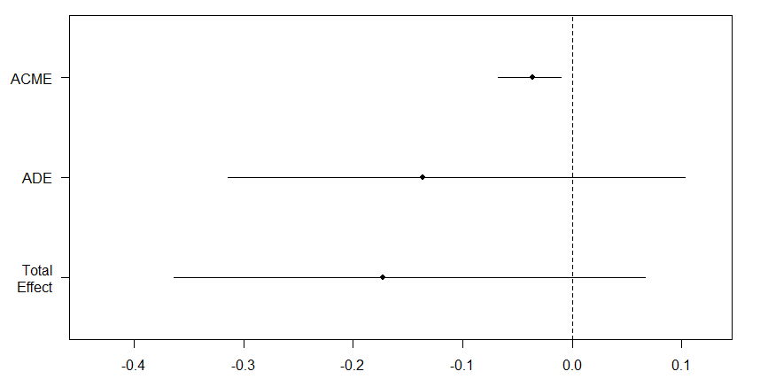
Figure 2. Estimates (points) and 95% confidence intervals for the average causal mediation effect (ACME), average direct effect (ADE), and total effect.
When comparing age group two and group six (adult vs old dogs), result indicate that there was a significant average causal mediation effect (ACME), but the estimated average direct effect and the total effect was not significant. The results suggest that the change in the play variable (mediator) in older dogs in part drove the lower Responsiveness to training personality trait score, as it explained the relationship better than the age of the dog (direct effect) in itself. The average proportion mediated was 18%.

DPQFAC5 – Aggressiveness to animals

Age only

> lm<-lm(bcPower(DPQFAC5new,0.46)~(age), data = data, na.action = na.omit)
> etasq(lm, anova = TRUE, type=3)
Anova Table (Type III tests)

Response: bcPower(DPQFAC5new, 0.46)
Partial eta^2 Sum Sq Df F value Pr(>F)
(Intercept) 0.50765 242.195 1 1201.1953 < 2.2e-16 ***
age 0.01948 4.666 5 4.6284 0.0003459 ***
Residuals 234.897 1165
---
Signif. codes: 0 ‘***’ 0.001 ‘**’ 0.01 ‘*’ 0.05 ‘.’ 0.1 ‘ ’ 1
> summary(lm)

Call:
lm(formula = bcPower(DPQFAC5new, 0.46) ~ (age), data = data,
na.action = na.omit)

Residuals:
Min 1Q Median 3Q Max
-1.30880 -0.31826 -0.00171 0.32050 1.18772

Coefficients:
Estimate Std. Error t value Pr(>|t|)
(Intercept) 1.16976 0.03375 34.658 < 2e-16 ***
ageGroup2 0.01667 0.04433 0.376 0.70696
ageGroup3 0.13627 0.04728 2.883 0.00402 **
ageGroup4 0.13904 0.04645 2.993 0.00282 **
ageGroup5 0.04012 0.04852 0.827 0.40841
ageGroup6 -0.02028 0.04623 -0.439 0.66104
---
Signif. codes: 0 ‘***’ 0.001 ‘**’ 0.01 ‘*’ 0.05 ‘.’ 0.1 ‘ ’ 1

Residual standard error: 0.449 on 1165 degrees of freedom
(36 observations deleted due to missingness)
Multiple R-squared: 0.01948, Adjusted R-squared: 0.01527
F-statistic: 4.628 on 5 and 1165 DF, p-value: 0.0003459

> Residuals <- residuals (lm)
> qqnorm(Residuals)
> shapiro.test (Residuals)

Shapiro-Wilk normality test

data: Residuals
W = 0.9968, p-value = 0.01739

> com=glht(lm,linfct=mcp(age="Tukey"))
> summary(com)

Simultaneous Tests for General Linear Hypotheses

Multiple Comparisons of Means: Tukey Contrasts

Fit: lm(formula = bcPower(DPQFAC5new, 0.46) ~ (age), data = data,
na.action = na.omit)

Linear Hypotheses:
Estimate Std. Error t value Pr(>|t|)
Group2 - Group1 == 0 0.016671 0.044334 0.376 0.99902
Group3 - Group1 == 0 0.136271 0.047275 2.883 0.04599 *
Group4 - Group1 == 0 0.139037 0.046449 2.993 0.03338 *
Group5 - Group1 == 0 0.040122 0.048516 0.827 0.96244
Group6 - Group1 == 0 -0.020277 0.046231 -0.439 0.99794
Group3 - Group2 == 0 0.119600 0.043842 2.728 0.07037 .
Group4 - Group2 == 0 0.122366 0.042950 2.849 0.05056 .
Group5 - Group2 == 0 0.023451 0.045177 0.519 0.99542
Group6 - Group2 == 0 -0.036948 0.042714 -0.865 0.95455
Group4 - Group3 == 0 0.002766 0.045980 0.060 1.00000
Group5 - Group3 == 0 -0.096149 0.048067 -2.000 0.34201
Group6 - Group3 == 0 -0.156548 0.045760 -3.421 0.00838 **
Group5 - Group4 == 0 -0.098915 0.047254 -2.093 0.29083
Group6 - Group4 == 0 -0.159314 0.044905 -3.548 0.00541 **
Group6 - Group5 == 0 -0.060399 0.047040 -1.284 0.79340
---
Signif. codes: 0 ‘***’ 0.001 ‘**’ 0.01 ‘*’ 0.05 ‘.’ 0.1 ‘ ’ 1
(Adjusted p values reported -- single-step method)

Full Model
> lm<-lm(bcPower(DPQFAC5new,0.46)~(age+sensory+height+weight+breed+sex+neuter+offleash_activity+BCS+food+Add_vitamins+trauma+Health_prob+medication+Owner_age+Owner_dog_exp+How_many_dogs_in_house+How_many_people+Child+Age_of_dog_when_arrived+get_dog+Where_dog_is_kept+dog_obedience+play+commands+training+Time_dog_spend_alone+dog_beh_changed_3month), data = data, na.action = na.omit)
> etasq(lm, anova = TRUE, type=3)
Anova Table (Type III tests)

Response: bcPower(DPQFAC5new, 0.46)
Partial eta^2 Sum Sq Df F value Pr(>F)
(Intercept) 0.090987 21.048 1 110.9038 < 2.2e-16 ***
age 0.018420 3.946 5 4.1584 0.0009525 ***
sensory 0.005018 1.060 1 5.5875 0.0182604 *
height 0.001418 0.299 1 1.5735 0.2099614
weight 0.001579 0.333 1 1.7525 0.1858356
breed 0.005218 1.103 1 5.8118 0.0160813 *
sex 0.002190 0.462 1 2.4323 0.1191418
neuter 0.002981 0.629 1 3.3129 0.0690098 .
offleash_activity 0.006275 1.328 4 1.7492 0.1368848
BCS 0.003027 0.638 2 1.6822 0.1864470
food 0.012712 2.707 4 3.5665 0.0067197 **
Add_vitamins 0.001808 0.381 3 0.6690 0.5711499
trauma 0.007208 1.527 1 8.0447 0.0046468 **
Health_prob 0.007521 1.594 4 2.0991 0.0788526 .
medication 0.000037 0.008 1 0.0414 0.8388949
Owner_age 0.000442 0.093 3 0.1634 0.9210305
Owner_dog_exp 0.003252 0.686 2 1.8076 0.1645372
How_many_dogs_in_house 0.000262 0.055 2 0.1453 0.8647575
How_many_people 0.002964 0.625 3 1.0979 0.3489864
Child 0.000093 0.019 1 0.1026 0.7487404
Age_of_dog_when_arrived 0.009424 2.000 3 3.5135 0.0147911 *
get_dog 0.000108 0.023 2 0.0598 0.9420009
Where_dog_is_kept 0.004675 0.988 2 2.6021 0.0745714 .
dog_obedience 0.019678 4.221 3 7.4135 6.429e-05 ***
play 0.000715 0.150 3 0.2643 0.8511409
commands 0.001349 0.284 2 0.7482 0.4734542
training 0.000701 0.147 2 0.3884 0.6782509
Time_dog_spend_alone 0.000315 0.066 3 0.1162 0.9506192
dog_beh_changed_3month 0.002784 0.587 1 3.0932 0.0788946 .
Residuals 210.282 1108
---
Signif. codes: 0 ‘***’ 0.001 ‘**’ 0.01 ‘*’ 0.05 ‘.’ 0.1 ‘ ’ 1
> summary(lm)

Call:
lm(formula = bcPower(DPQFAC5new, 0.46) ~ (age + sensory + height +
weight + breed + sex + neuter + offleash_activity + BCS +
food + Add_vitamins + trauma + Health_prob + medication +
Owner_age + Owner_dog_exp + How_many_dogs_in_house + How_many_people +
Child + Age_of_dog_when_arrived + get_dog + Where_dog_is_kept +
dog_obedience + play + commands + training + Time_dog_spend_alone +
dog_beh_changed_3month), data = data, na.action = na.omit)

Residuals:
Min 1Q Median 3Q Max
-1.20798 -0.29223 0.00088 0.30067 1.16770

Coefficients:
Estimate Std. Error t value Pr(>|t|)
(Intercept) 1.3837036 0.1313923 10.531 < 2e-16 ***
ageGroup2 0.0233984 0.0453945 0.515 0.60634
ageGroup3 0.1297475 0.0488956 2.654 0.00808 **
ageGroup4 0.1190091 0.0503388 2.364 0.01824 *
ageGroup5 0.0261860 0.0537732 0.487 0.62638
ageGroup6 -0.0573886 0.0578182 -0.993 0.32114
sensoryPresent -0.0990558 0.0419053 -2.364 0.01826 *
height -0.0016337 0.0013024 -1.254 0.20996
weight 0.0021307 0.0016095 1.324 0.18584
breedPure -0.0847358 0.0351490 -2.411 0.01608 *
sexMale 0.0429217 0.0275211 1.560 0.11914
neuterNeutered -0.0540700 0.0297068 -1.820 0.06901 .
offleash_activity30mins/1hour -0.0379077 0.0457899 -0.828 0.40793
offleash_activity1/3 -0.1079415 0.0444519 -2.428 0.01533 *
offleash_activity3/7 -0.0576964 0.0526828 -1.095 0.27368
offleash_activity>7 -0.0638412 0.0514923 -1.240 0.21530
BCSNormal -0.0272441 0.0366874 -0.743 0.45788
BCSOverweight -0.0823372 0.0469561 -1.753 0.07979 .
foodTinned and/or Dry food -0.1051971 0.0476484 -2.208 0.02746 *
foodCooked food 0.0281214 0.0390522 0.720 0.47162
foodMixed 0.0651751 0.0412314 1.581 0.11423
foodRaw 0.0391445 0.0431708 0.907 0.36474
Add_vitaminsRarely -0.0433078 0.0347075 -1.248 0.21237
Add_vitaminsOften -0.0215622 0.0396395 -0.544 0.58658
Add_vitaminsDaily -0.0007903 0.0413517 -0.019 0.98476
traumaYes 0.0835928 0.0294723 2.836 0.00465 **
Health_probTooth problem only 0.1221577 0.0441015 2.770 0.00570 **
Health_probJoint & Tooth probs 0.0567985 0.0522646 1.087 0.27738
Health_probJoint problems only 0.0631386 0.0399910 1.579 0.11466
Health_probOther disorders 0.0724829 0.0431997 1.678 0.09366 .
medicationYes -0.0080155 0.0394162 -0.203 0.83889
Owner_age30-39 0.0126925 0.0371572 0.342 0.73272
Owner_age40-49 0.0145717 0.0414156 0.352 0.72503
Owner_age>50 0.0305313 0.0436255 0.700 0.48417
Owner_dog_expHad a dog before -0.0253641 0.0345066 -0.735 0.46246
Owner_dog_expNever had a dog 0.0384646 0.0414810 0.927 0.35398
How_many_dogs_in_houseOne 0.0151077 0.0302980 0.499 0.61814
How_many_dogs_in_houseTwo more 0.0017166 0.0368805 0.047 0.96289
How_many_peopleTwo people 0.0008694 0.0439407 0.020 0.98422
How_many_peopleThree people -0.0377085 0.0535342 -0.704 0.48134
How_many_peopleFour more 0.0318051 0.0546221 0.582 0.56050
ChildYes 0.0126040 0.0393406 0.320 0.74874
Age_of_dog_when_arrived7-12w 0.0708828 0.0347013 2.043 0.04132 *
Age_of_dog_when_arrived3-12m 0.0369878 0.0442849 0.835 0.40377
Age_of_dog_when_arrived>1y -0.0652826 0.0485622 -1.344 0.17912
get_dogborn bought 0.0003251 0.0472103 0.007 0.99451
get_dogpresent 0.0105984 0.0410075 0.258 0.79611
Where_dog_is_keptGarden -0.0277291 0.0464701 -0.597 0.55082
Where_dog_is_keptApartment -0.0881388 0.0433433 -2.034 0.04224 *
dog_obedience2 tasks 0.0566546 0.0512542 1.105 0.26924
dog_obedience3 tasks -0.0582131 0.0490294 -1.187 0.23536
dog_obedience>3 tasks -0.1391010 0.0468529 -2.969 0.00305 **
play30m-1h 0.0029871 0.0480561 0.062 0.95045
play1-3h -0.0151375 0.0489364 -0.309 0.75713
play>3h 0.0183506 0.0592464 0.310 0.75682
commands11-30 0.0380506 0.0329372 1.155 0.24824
commands>30 0.0494048 0.0534102 0.925 0.35516
training2-3 -0.0131831 0.0360419 -0.366 0.71461
training4 more 0.0269726 0.0416556 0.648 0.51743
Time_dog_spend_alone1-2h -0.0112622 0.0449551 -0.251 0.80223
Time_dog_spend_alone3-8h -0.0177099 0.0404807 -0.437 0.66184
Time_dog_spend_alone>8h -0.0290259 0.0518037 -0.560 0.57538
dog_beh_changed_3monthYes 0.0559552 0.0318152 1.759 0.07889 .
---
Signif. codes: 0 ‘***’ 0.001 ‘**’ 0.01 ‘*’ 0.05 ‘.’ 0.1 ‘ ’ 1

Residual standard error: 0.4356 on 1108 degrees of freedom
(36 observations deleted due to missingness)
Multiple R-squared: 0.1222, Adjusted R-squared: 0.07311
F-statistic: 2.488 on 62 and 1108 DF, p-value: 4.968e-09

> Residuals <- residuals (lm)
> qqnorm(Residuals)
> shapiro.test (Residuals)

Shapiro-Wilk normality test

data: Residuals
W = 0.99801, p-value = 0.1773

Reduced Model

> lm<-lm(bcPower(DPQFAC5new,0.46)~(age+sensory+height+weight+breed+sex+neuter+offleash_activity+BCS+food+Add_vitamins+trauma+Health_prob+medication+Owner_age+Age_of_dog_when_arrived+get_dog+Where_dog_is_kept+dog_obedience+play+commands+training+dog_beh_changed_3month), data = data, na.action = na.omit)
> etasq(lm, anova = TRUE, type=3)
Anova Table (Type III tests)

Response: bcPower(DPQFAC5new, 0.46)
Partial eta^2 Sum Sq Df F value Pr(>F)
(Intercept) 0.115071 27.533 1 145.5086 < 2.2e-16 ***
age 0.018045 3.891 5 4.1128 0.001049 **
sensory 0.005304 1.129 1 5.9671 0.014729 *
height 0.001130 0.240 1 1.2661 0.260745
weight 0.001349 0.286 1 1.5121 0.219078
breed 0.005192 1.105 1 5.8406 0.015819 *
sex 0.002442 0.518 1 2.7392 0.098195 .
neuter 0.002731 0.580 1 3.0646 0.080287 .
offleash_activity 0.006625 1.412 4 1.8656 0.114198
BCS 0.003297 0.700 2 1.8511 0.157553
food 0.012159 2.606 4 3.4434 0.008310 **
Add_vitamins 0.001976 0.419 3 0.7385 0.529144
trauma 0.007541 1.609 1 8.5021 0.003618 **
Health_prob 0.007277 1.552 4 2.0506 0.085210 .
medication 0.000056 0.012 1 0.0626 0.802451
Owner_age 0.000284 0.060 3 0.1061 0.956535
Age_of_dog_when_arrived 0.008570 1.830 3 3.2241 0.021937 *
get_dog 0.000124 0.026 2 0.0692 0.933166
Where_dog_is_kept 0.004534 0.964 2 2.5484 0.078660 .
dog_obedience 0.019132 4.130 3 7.2753 7.804e-05 ***
play 0.000665 0.141 3 0.2483 0.862590
commands 0.001429 0.303 2 0.8009 0.449188
training 0.000728 0.154 2 0.4076 0.665351
dog_beh_changed_3month 0.002647 0.562 1 2.9701 0.085091 .
Residuals 211.733 1119
---
Signif. codes: 0 ‘***’ 0.001 ‘**’ 0.01 ‘*’ 0.05 ‘.’ 0.1 ‘ ’ 1
> summary(lm)

Call:
lm(formula = bcPower(DPQFAC5new, 0.46) ~ (age + sensory + height +
weight + breed + sex + neuter + offleash_activity + BCS +
food + Add_vitamins + trauma + Health_prob + medication +
Owner_age + Age_of_dog_when_arrived + get_dog + Where_dog_is_kept +
dog_obedience + play + commands + training + dog_beh_changed_3month),
data = data, na.action = na.omit)

Residuals:
Min 1Q Median 3Q Max
-1.24056 -0.29913 0.00567 0.30524 1.20418

Coefficients:
Estimate Std. Error t value Pr(>|t|)
(Intercept) 1.3649496 0.1131546 12.063 < 2e-16 ***
ageGroup2 0.0202406 0.0450659 0.449 0.65342
ageGroup3 0.1258523 0.0486749 2.586 0.00985 **
ageGroup4 0.1193266 0.0498895 2.392 0.01693 *
ageGroup5 0.0257987 0.0532958 0.484 0.62843
ageGroup6 -0.0565072 0.0573645 -0.985 0.32481
sensoryPresent -0.1018116 0.0416789 -2.443 0.01473 *
height -0.0014544 0.0012926 -1.125 0.26074
weight 0.0019658 0.0015987 1.230 0.21908
breedPure -0.0844225 0.0349323 -2.417 0.01582 *
sexMale 0.0451027 0.0272516 1.655 0.09820 .
neuterNeutered -0.0516750 0.0295183 -1.751 0.08029 .
offleash_activity30mins/1hour -0.0333523 0.0454669 -0.734 0.46338
offleash_activity1/3 -0.1075649 0.0441986 -2.434 0.01510 *
offleash_activity3/7 -0.0474561 0.0520684 -0.911 0.36227
offleash_activity>7 -0.0643359 0.0511399 -1.258 0.20864
BCSNormal -0.0331552 0.0361798 -0.916 0.35966
BCSOverweight -0.0872588 0.0463783 -1.881 0.06017 .
foodTinned and/or Dry food -0.1046577 0.0471236 -2.221 0.02656 *
foodCooked food 0.0254849 0.0384979 0.662 0.50812
foodMixed 0.0615511 0.0404096 1.523 0.12800
foodRaw 0.0381196 0.0428538 0.890 0.37391
Add_vitaminsRarely -0.0446769 0.0343339 -1.301 0.19344
Add_vitaminsOften -0.0245025 0.0390993 -0.627 0.53100
Add_vitaminsDaily -0.0001864 0.0408067 -0.005 0.99636
traumaYes 0.0852561 0.0292389 2.916 0.00362 **
Health_probTooth problem only 0.1181565 0.0437415 2.701 0.00701 **
Health_probJoint & Tooth probs 0.0587334 0.0518558 1.133 0.25761
Health_probJoint problems only 0.0648310 0.0397103 1.633 0.10283
Health_probOther disorders 0.0747003 0.0427926 1.746 0.08115 .
medicationYes -0.0097669 0.0390307 -0.250 0.80245
Owner_age30-39 0.0063459 0.0342349 0.185 0.85298
Owner_age40-49 0.0119820 0.0371720 0.322 0.74726
Owner_age>50 0.0214319 0.0393183 0.545 0.58580
Age_of_dog_when_arrived7-12w 0.0610645 0.0343211 1.779 0.07548 .
Age_of_dog_when_arrived3-12m 0.0328991 0.0440508 0.747 0.45531
Age_of_dog_when_arrived>1y -0.0705237 0.0483640 -1.458 0.14507
get_dogborn bought 0.0109483 0.0467436 0.234 0.81486
get_dogpresent 0.0150605 0.0405747 0.371 0.71057
Where_dog_is_keptGarden -0.0236345 0.0460941 -0.513 0.60823
Where_dog_is_keptApartment -0.0843747 0.0427818 -1.972 0.04883 *
dog_obedience2 tasks 0.0592757 0.0508704 1.165 0.24417
dog_obedience3 tasks -0.0533578 0.0486774 -1.096 0.27325
dog_obedience>3 tasks -0.1345657 0.0465515 -2.891 0.00392 **
play30m-1h 0.0075999 0.0477593 0.159 0.87360
play1-3h -0.0109623 0.0485097 -0.226 0.82126
play>3h 0.0205161 0.0586810 0.350 0.72669
commands11-30 0.0394039 0.0326373 1.207 0.22756
commands>30 0.0488699 0.0526226 0.929 0.35325
training2-3 -0.0159693 0.0357867 -0.446 0.65551
training4 more 0.0249990 0.0412919 0.605 0.54502
dog_beh_changed_3monthYes 0.0545225 0.0316365 1.723 0.08509 .
---
Signif. codes: 0 ‘***’ 0.001 ‘**’ 0.01 ‘*’ 0.05 ‘.’ 0.1 ‘ ’ 1

Residual standard error: 0.435 on 1119 degrees of freedom
(36 observations deleted due to missingness)
Multiple R-squared: 0.1162, Adjusted R-squared: 0.07589
F-statistic: 2.884 on 51 and 1119 DF, p-value: 2.138e-10

> Residuals <- residuals (lm)
> qqnorm(Residuals)
> shapiro.test (Residuals)

Shapiro-Wilk normality test

data: Residuals
W = 0.99784, p-value = 0.1285

> data$food <- as.factor(data$food)
> com=glht(lm,linfct=mcp(food="Tukey"))
> summary(com)

Simultaneous Tests for General Linear Hypotheses

Multiple Comparisons of Means: Tukey Contrasts

Fit: lm(formula = bcPower(DPQFAC5new, 0.46) ~ (age + sensory + height +
weight + breed + sex + neuter + offleash_activity + BCS +
food + Add_vitamins + trauma + Health_prob + medication +
Owner_age + Age_of_dog_when_arrived + get_dog + Where_dog_is_kept +
dog_obedience + play + commands + training + dog_beh_changed_3month),
data = data, na.action = na.omit)

Linear Hypotheses:
Estimate Std. Error t value Pr(>|t|)
Tinned &/or Dry food-Dry food only== 0 -0.10466 0.04712 -2.221 0.17093
Cooked food - Dry food only == 0 0.02548 0.03850 0.662 0.96399
Mixed - Dry food only == 0 0.06155 0.04041 1.523 0.54492
Raw - Dry food only == 0 0.03812 0.04285 0.890 0.89986
Cooked food - Tinned &/or Dry food== 0 0.13014 0.04540 2.867 0.03388 *
Mixed - Tinned and/or Dry food == 0 0.16621 0.04696 3.540 0.00377 **
Raw - Tinned and/or Dry food == 0 0.14278 0.05023 2.843 0.03625 *
Mixed - Cooked food == 0 0.03607 0.03867 0.933 0.88312
Raw - Cooked food == 0 0.01263 0.04179 0.302 0.99816
Raw - Mixed == 0 -0.02343 0.04307 -0.544 0.98246
---
Signif. codes: 0 ‘***’ 0.001 ‘**’ 0.01 ‘*’ 0.05 ‘.’ 0.1 ‘ ’ 1
(Adjusted p values reported -- single-step method)

Outliers removed (1 removed)

> lm<-lm(bcPower(outDPQFAC5new,0.46)~(age+sensory+height+weight+breed+sex+neuter+offleash_activity+BCS+food+Add_vitamins+trauma+Health_prob+medication+Owner_age+Age_of_dog_when_arrived+get_dog+Where_dog_is_kept+dog_obedience+play+commands+training+dog_beh_changed_3month), data = data, na.action = na.omit)
> etasq(lm, anova = TRUE, type=3)
Anova Table (Type III tests)

Response: bcPower(outDPQFAC5new, 0.46)
Partial eta^2 Sum Sq Df F value Pr(>F)
(Intercept) 0.115140 27.351 1 145.4767 < 2.2e-16 ***
age 0.017785 3.806 5 4.0488 0.001202 **
sensory 0.006050 1.279 1 6.8055 0.009209 **
height 0.000982 0.207 1 1.0985 0.294832
weight 0.001180 0.248 1 1.3206 0.250734
breed 0.005195 1.098 1 5.8380 0.015843 *
sex 0.002856 0.602 1 3.2020 0.073820 .
neuter 0.002350 0.495 1 2.6330 0.104948
offleash_activity 0.007285 1.542 4 2.0510 0.085159 .
BCS 0.003134 0.661 2 1.7574 0.172961
food 0.012071 2.568 4 3.4150 0.008728 **
Add_vitamins 0.002075 0.437 3 0.7751 0.507969
trauma 0.006858 1.451 1 7.7198 0.005553 **
Health_prob 0.007841 1.661 4 2.2089 0.066063 .
medication 0.000183 0.038 1 0.2047 0.651058
Owner_age 0.000310 0.065 3 0.1155 0.951016
Age_of_dog_when_arrived 0.008250 1.749 3 3.1002 0.025954 *
get_dog 0.000127 0.027 2 0.0713 0.931218
Where_dog_is_kept 0.004217 0.890 2 2.3675 0.094182 .
dog_obedience 0.020620 4.425 3 7.8463 3.489e-05 ***
play 0.000683 0.144 3 0.2548 0.857973
commands 0.001760 0.371 2 0.9858 0.373456
training 0.000744 0.156 2 0.4161 0.659741
dog_beh_changed_3month 0.002271 0.478 1 2.5443 0.110975
Residuals 210.194 1118
---
Signif. codes: 0 ‘***’ 0.001 ‘**’ 0.01 ‘*’ 0.05 ‘.’ 0.1 ‘ ’ 1
> summary(lm)

Call:
lm(formula = bcPower(outDPQFAC5new, 0.46) ~ (age + sensory +
height + weight + breed + sex + neuter + offleash_activity +
BCS + food + Add_vitamins + trauma + Health_prob + medication +
Owner_age + Age_of_dog_when_arrived + get_dog + Where_dog_is_kept +
dog_obedience + play + commands + training + dog_beh_changed_3month),
data = data, na.action = na.omit)

Residuals:
Min 1Q Median 3Q Max
-1.2470 -0.2964 0.0037 0.3031 1.1243

Coefficients:
Estimate Std. Error t value Pr(>|t|)
(Intercept) 1.360562 0.112803 12.061 < 2e-16 ***
ageGroup2 0.019623 0.044922 0.437 0.66233
ageGroup3 0.127106 0.048521 2.620 0.00892 **
ageGroup4 0.120837 0.049733 2.430 0.01527 *
ageGroup5 0.020514 0.053157 0.386 0.69963
ageGroup6 -0.048145 0.057256 -0.841 0.40060
sensoryPresent -0.108555 0.041612 -2.609 0.00921 **
height -0.001351 0.001289 -1.048 0.29483
weight 0.001832 0.001594 1.149 0.25073
breedPure -0.084133 0.034821 -2.416 0.01584 *
sexMale 0.048659 0.027193 1.789 0.07382 .
neuterNeutered -0.047795 0.029455 -1.623 0.10495
offleash_activity30mins/1hour -0.033162 0.045322 -0.732 0.46450
offleash_activity1/3 -0.111645 0.044080 -2.533 0.01145 *
offleash_activity3/7 -0.046839 0.051902 -0.902 0.36701
offleash_activity>7 -0.062323 0.050981 -1.222 0.22179
BCSNormal -0.033834 0.036065 -0.938 0.34838
BCSOverweight -0.085235 0.046235 -1.843 0.06552 .
foodTinned and/or Dry food -0.105174 0.046973 -2.239 0.02535 *
foodCooked food 0.025453 0.038375 0.663 0.50729
foodMixed 0.061434 0.040280 1.525 0.12750
foodRaw 0.030642 0.042797 0.716 0.47415
Add_vitaminsRarely -0.044570 0.034224 -1.302 0.19308
Add_vitaminsOften -0.027740 0.038991 -0.711 0.47695
Add_vitaminsDaily 0.001044 0.040679 0.026 0.97953
traumaYes 0.081080 0.029182 2.778 0.00555 **
Health_probTooth problem only 0.120558 0.043610 2.764 0.00580 **
Health_probJoint & Tooth probs 0.051417 0.051753 0.994 0.32068
Health_probJoint problems only 0.067981 0.039599 1.717 0.08630 .
Health_probOther disorders 0.078293 0.042674 1.835 0.06682 .
medicationYes -0.017646 0.039003 -0.452 0.65106
Owner_age30-39 0.001533 0.034167 0.045 0.96423
Owner_age40-49 0.011271 0.037054 0.304 0.76104
Owner_age>50 0.020574 0.039194 0.525 0.59974
Age_of_dog_when_arrived7-12w 0.058252 0.034226 1.702 0.08903 .
Age_of_dog_when_arrived3-12m 0.033134 0.043910 0.755 0.45066
Age_of_dog_when_arrived>1y -0.070330 0.048209 -1.459 0.14489
get_dogborn bought 0.008325 0.046603 0.179 0.85825
get_dogpresent 0.014784 0.040445 0.366 0.71478
Where_dog_is_keptGarden -0.026773 0.045960 -0.583 0.56032
Where_dog_is_keptApartment -0.082921 0.042648 -1.944 0.05211 .
dog_obedience2 tasks 0.059101 0.050708 1.166 0.24406
dog_obedience3 tasks -0.055127 0.048526 -1.136 0.25619
dog_obedience>3 tasks -0.141124 0.046459 -3.038 0.00244 **
play30m-1h 0.017042 0.047721 0.357 0.72106
play1-3h -0.001272 0.048473 -0.026 0.97906
play>3h 0.029153 0.058571 0.498 0.61877
commands11-30 0.043670 0.032567 1.341 0.18022
commands>30 0.053949 0.052484 1.028 0.30422
training2-3 -0.013761 0.035681 -0.386 0.69982
training4 more 0.027331 0.041168 0.664 0.50689
dog_beh_changed_3monthYes 0.050355 0.031569 1.595 0.11097
---
Signif. codes: 0 ‘***’ 0.001 ‘**’ 0.01 ‘*’ 0.05 ‘.’ 0.1 ‘ ’ 1

Residual standard error: 0.4336 on 1118 degrees of freedom
(37 observations deleted due to missingness)
Multiple R-squared: 0.1176, Adjusted R-squared: 0.07735
F-statistic: 2.922 on 51 and 1118 DF, p-value: 1.205e-10

