Supplementary Material
SITE SUITABILITY FOR FINFISH MARINE AQUACULTURE IN THE CENTRAL MEDITERRANEAN SEA
Porporato E. M. D.^{1*}, Pastres R.^{1,2} and Brigolin D.^{1,2,3}
¹Dipartimento di Scienze Ambientali, Informatica e Statistica, Università Ca’ Foscari Venezia, Via Torino 155, 30170 Venezia Mestre, Italy
²Bluefarm S.r.l., Marghera, Italy
³Università Iuav di Venezia, Dorsoduro 2196, 30135 Venice, Italy

Table S1. Factors for site suitability, data used for the analysis, spatial resolution and data source.

Spatial data | Spatial resolution | Source
SST - Sea Surface Temperature | 1 km² | SST_MED_SST_L4_NRT_OBSERVATIONS_010_004
SWH - Significant Wave Height | 4 km² | MEDSEA_HINDCAST_WAV_006_012
DH - Distance to Harbour | 1 km² | This study
Impact | 1 km² | Halpern et al., 2008; Micheli et al., 2013
Bass - Days to commercial size | 1 km² | This study
Bream - Days to commercial size | 1 km² | This study

Figure S1. Maps of normalized criteria considered in the analyses: (A) seabass growth; (B) seabream growth; (C) distance to harbour; (D) significant wave height; (E) cumulative impact within the study area.
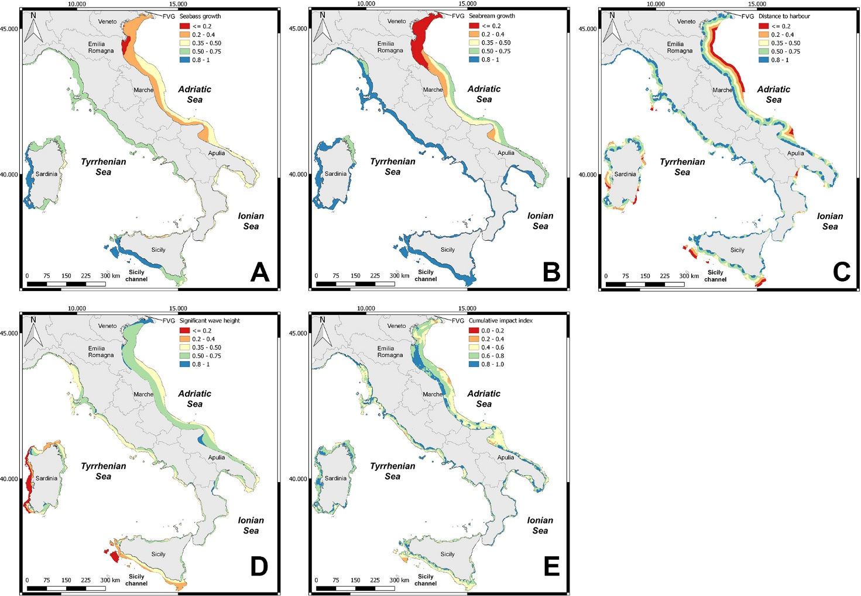

Figure S2. SMCE median results for the 3 scenarios considered: (A) Environmental, (B) Blue Growth, (C) Economic.
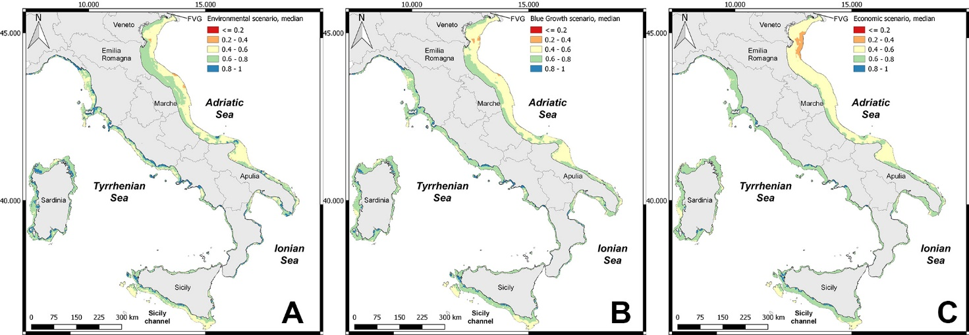

Figure S3. (A) Percentage of area for the 3 scenarios (Environmental, Blue Growth and Economic) within each suitability class (0.0 – 0.2, 0.2 – 0.4, 0.4 – 0.6, 0.6 – 0.8, 0.8 – 1.0). (B) Difference in available area considering the constraints.

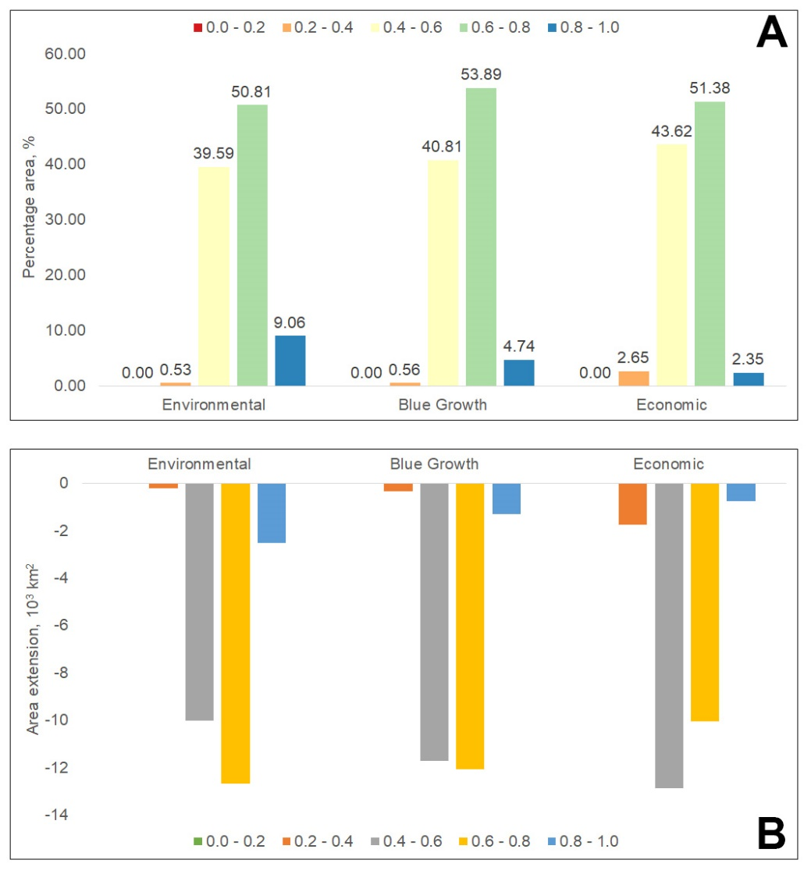

Figure S4. Area extension (10³ km²) of the normalised values for the 5 criteria considered in the SMCE analysis (i.e.: Bass, Bream, SWH, DH and Impact). Values were clustered in 3 classes (low, medium and high).

