Supplementary Materials
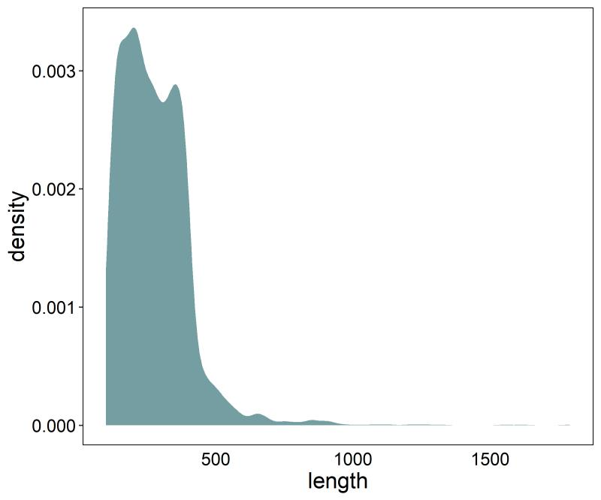
Supplementary Figure 1. The plot of length distribution of 4653 positive enhancer samples.

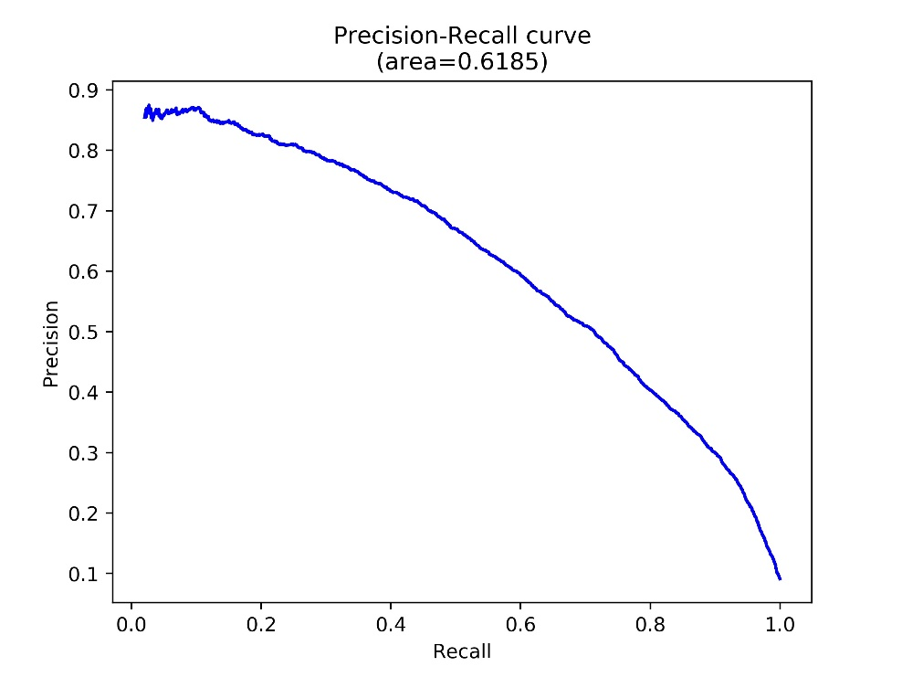
Supplementary Figure 2. The precision-recall curve of the 5-fold-cross-validation test.

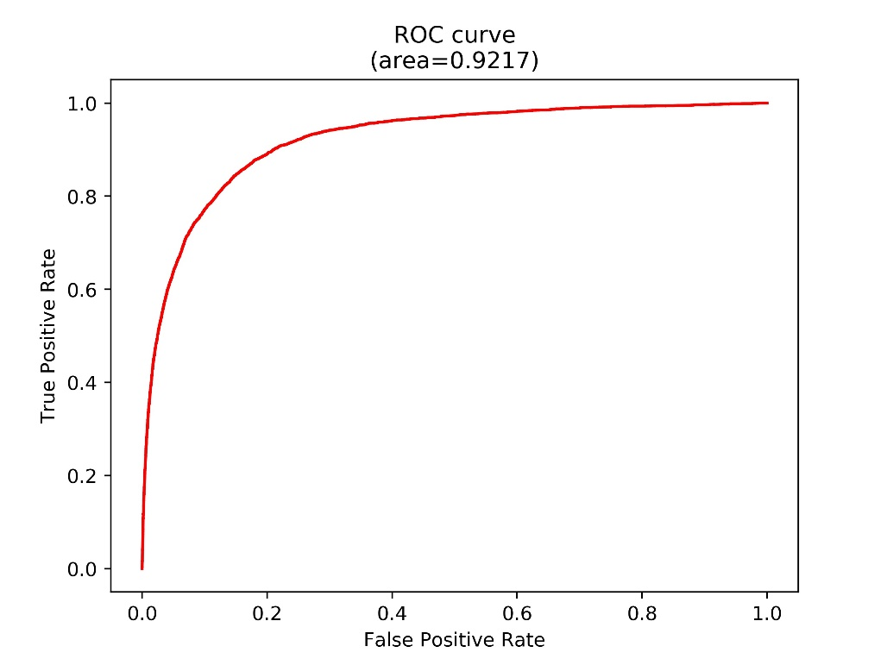
Supplementary Figure 3. The receiver operating characteristic (ROC) curve of the 5-fold-cross-validation test.

