Supplementary Material

Supplementary Data

Not applicable

Supplementary Figures and Tables

SupplementaryTables
Supplementary table 1. Bacterial strains and culture media used in this work
Bacterial strainª | Description | Reference^{b}
Gd | Gluconacetobacter diazotrophicus, endophyte wild type strain
RpsoGMI1000 | Ralstonia pseudosolanacearum GMI1000Wild type strain, Phylotipe I, Origin: French Guyana. | Salanoubat et al., 2002; Safni et al., 2018; Prior et al., 2016.
RpsoGMI1000-GFP | Ralstonia pseudosolanacearum GMI1000-GFP,Pep::GFP, Gm^{R} | Monteiro et al., 2012b
Rso A21 | Ralstonia solanacearum ArgentineIsolation of tomato, variety “El pida” (Bella Vista, Corrientes) | Thiswork
Growth medium | Composition | Reference
BG (Bacto-Glucose) | 10 g/L casein peptone, 1 g/L yeast extract, 1 g/L casaminoacids | Clough et al., 1994
LGI-P  Selective growth medium | 100 g/Lsucrose, 0.2 g/L K₂HPO₄, 0.6 g/L KH₂PO₄, 0.2 g/L MgSO₄·7H₂O, 0.2 g/L CaCl₂·2H₂O, 0.002 g/L Na₂MoO₄·H₂O, 0.01 g/L FeCl₃·6H₂O, pH5.5
mSMSA | 1 g/L casaminoacids, 10 g/L peptone, 5 g/L glucose | Englebrecht et al., 1994 modified by Elphinstone et al., 1996
ªAbbreviations: Gd: Gluconacetobacter diazotrophicus; RpsoGMI1000: R. pseudosolanacearum GMI1000; RpsoGMI1000-GFP: R. pseudosolanacearum GMI1000-GFP; RsoA21: R. solanacearum
^{b}References:
Clough, S., Schell, M. A., Denny, T. (1994). Evidence for involvement of a volatile extracellular factor in Pseudomonas solanacearum virulence gene expression. MolecularPlant-Microbe Interactions. https://doi.org/10.1094/MPMI-7-0621.
Elphinstone, J. G., Hennessy, J.,Wilson, J. K., Stead, D. E. (1996). Sensitivity of different methods for the detection of Ralstoniasolanacearum in potato tuber extracts. EPPO Bull. 26, 663–678. doi: 10.1111/j.1365-2338.1996.tb01511.x.
Englebrecht. M.C. (1994) Modification of a semi-selective medium for the isolation and quantification of Pseudomonassolanacearum. In Bacterial Wilt Newsletter (ed. Hayward, A. C.) 10. 3-5. Australian Centre for International Agricultural Research, Canberra (AU).
Monteiro F., Solé, M., van Dijk, I.., Valls, M. (2012b) A chromosomal insertion toolbox for promoter probing, mutant complementation, and pathogenicity studies in Ralstoniasolanacearum. Mol Plant Microbe Interact.25, 557-568. doi: 10.1094/MPMI-07-11-0201.
Prior, F., Ailloud, Dalsing, B. L.,Remenant, B.,Sanchez,B., Allen, C. (2016) “Genomic and proteomic evidence supporting the division of the plant pathogen Ralstoniasolanacearum into three species”. BMC Genomic 17: 90. doi: 10.1186/s12864-016-2413-z..
Safni, I., Cleenwerck, I., De Vos, P., Fegan, M., Sly, L., Kappler, U. (2014) “Polyphasic taxonomic revision of the Ralstonia solanacearum species complex: proposal to emend the descriptions of Ralstoniasolanacearum and Ralstoniasyzygii and reclassify current R . syzygii strains as Ralstonia syzygii subsp . syzygii subsp . nov., R. solanacearum phylotype IV strains as Ralstonia syzygii subsp . indonesiensis subsp . nov., banana blood disease bacterium strains as Ralstonia syzygii subsp. celebesensis subsp. nov. and R. solanacearum phylotype I and III strains as Ralstonia pseudosolanacearum sp. nov”. Int. J. Syst. Evol. Microbiol. 64, 3087–3103.
Salanoubat, M., Genin, S., Artiguenave, F., Gouzy, J., Mangenot, S., Arlat, M., Billault, A., Brottier, P., Camus, J. C., Cattolico, L., Chandler, M., Choisne, N., Claudel-Renard, C., Cunnac, S., Demange, N., Gaspin, C., Lavie, M., Moisan, A., Robert, C., Saurin, W., Schiex, T., Siguier, P., Thébault, P., Whalen, M., Wincker, P., Levy, M., Weissenbach, J, Boucher, CA. “Genome sequence of the plant pathogen Ralstoniasolanacearum” Nature 415, 497–502.

SupplementaryFigures
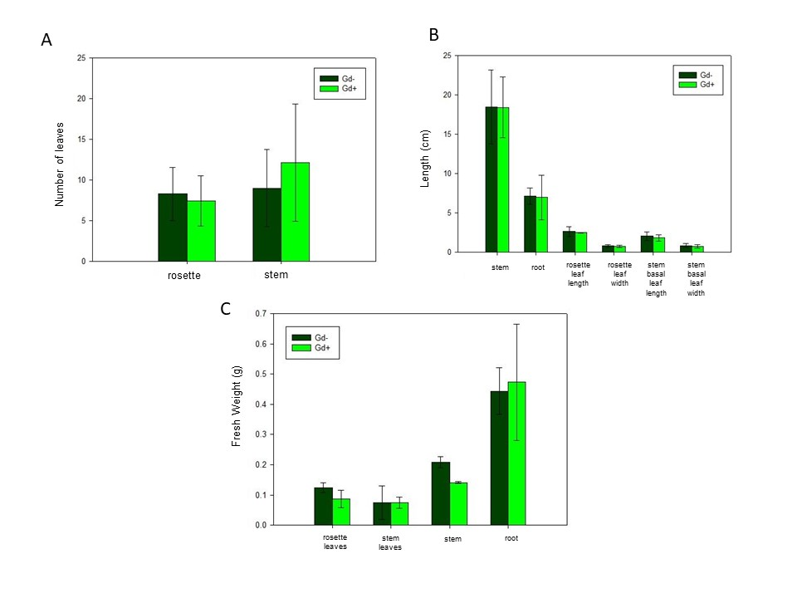Supplementary Figure 1. Bar graph showing different growth parameters in A. thaliana col 0 plants inoculated with G. diazotrophicus (Gd+) and mock inoculated plants (Gd-). (A) number of rosette leaves, number of stem leaves; (B) length of the main root, length of the stem; (C) fresh weight of the different organs: rosette leaves, stem leaves, stem and root, size of rosette leaves, size of stem basal leaves.The error bars represent the standard deviation. Significant differences between treatments are indicated by an asterisk (Student's t test, p<0.05).

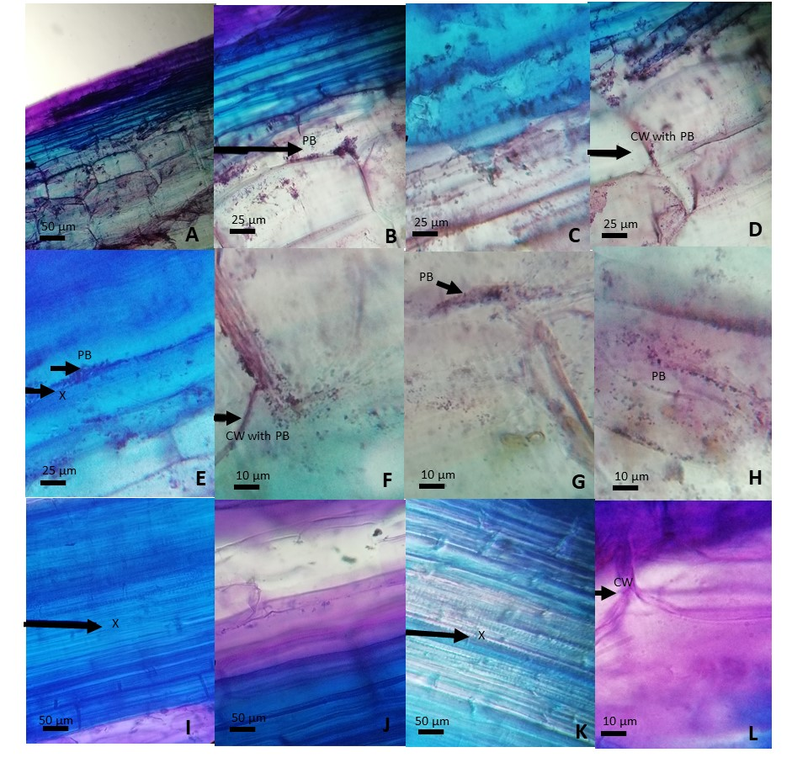

Supplementary Figure 2. A-H, Plants of A. thaliana Col 0 inoculated with R. pseudosolanacearum GMI1000 6 dpi. I-L, Plants of A. thaliana inoculated with G. diazotrophicus 22 dpi and R. solanacearum GMI1000 6 dpi. A-L, longitudinal section of stems stained with 1% (w/v) toluidine blue.CW: cell wall; X: xylem; PB: phytopathogenic bacteria.

Supplementary Figure 3. Phylogenetic tree based on partial eglsequences of 3 Ralstonia solanacearum strains isolated in Argentina (A11, A21, A31) and 45 strains belonging to the phylotypes I-IV within the Ralstonia solanacearum species complex. The evolutionary history was inferred by using the Maximum Likelihood method and Tamura-Nei model (TamuraandNei, 1993). The tree with the highest log likelihood (-2430,81) is shown. Initial trees for the heuristic search were obtained automatically by applying Neighbor-Join and BioNJ algorithms to a matrix of pairwise distances estimated using the Maximum Composite Likelihood (MCL) approach, and then selecting the topology with superior log likelihood value. The tree is drawn to scale, with branch lengths measured in the number of substitutions per site. Bootstrap values higher than 50% are shown next to the branches. This analysis involved 49 nucleotide sequences. There were a total of 653 positions in the final dataset. Evolutionary analyses were conducted in MEGA X (Kumar et al. 2018).
References of Supplementary Figure 3:
1. Tamura K. and Nei M. (1993). Estimation of the number of nucleotide substitutions in the control region of mitochondrial DNA in humans and chimpanzees. Molecular Biology and Evolution 10:512-526.
2. Kumar S., Stecher G., Li M., Knyaz C., and Tamura K. (2018). MEGA X: Molecular Evolutionary Genetics Analysis across computing platforms. Molecular Biology and Evolution 35:1547-1549.

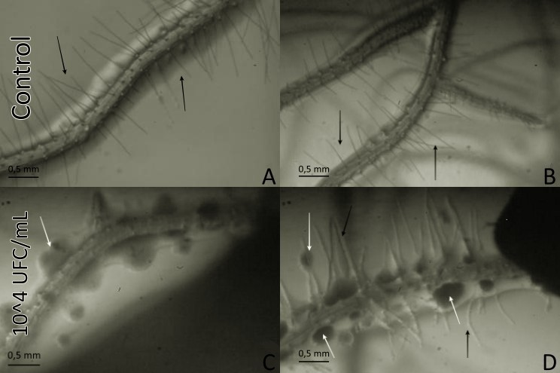

Supplementary Figure 4. Roots of A. thaliana Col 0 seedlings grown in vitro observed with a stereoscopic microscope at 9 dpi with G. diazotrophicus Pal5. A-B, control plants without inoculation; C-D, inoculated plants with suspension of G. diazotrophicus Pal5 with a concentration of 10⁴ CFU / mL. White arrows indicate bacterial colonies; Black arrows indicate radical hairs.

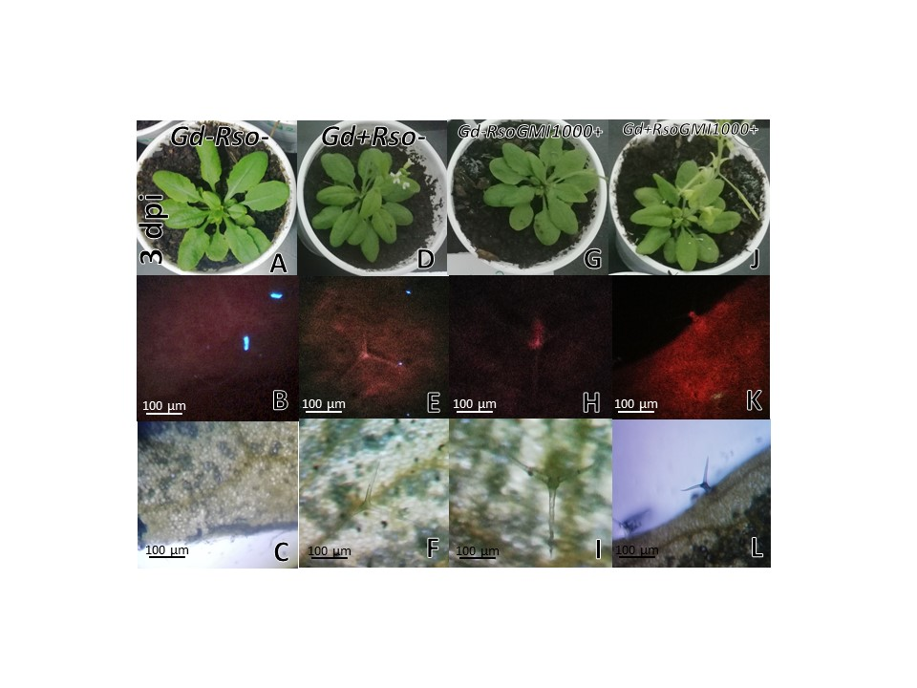
Supplementary Figure 5. A. thaliana sid2 mutants grown with different treatments, images are shown at 3 days post-inoculation with R. pseudosolanacearum GMI1000. (A-C) mock inoculated plants; (D-F) plants inoculated with G. diazotrophicus Pal5; (G-I) plants inoculated with R. pseudosolanacearum GMI1000; (J-L) plants inoculated with G. diazotrophicus and with R. pseudosolanacearum GMI1000. B-K, epifluorescence microscope micrographs of A. thaliana sid2 mutants leaves treated with aniline blue 0.05 % w/v showing portions of the epidermis and trichomes. C-L, light microscope micrographs of A. thaliana sid2 mutant leaves treated with aniline blue 0.05 % w/v showing the same as in the pictures B-K.

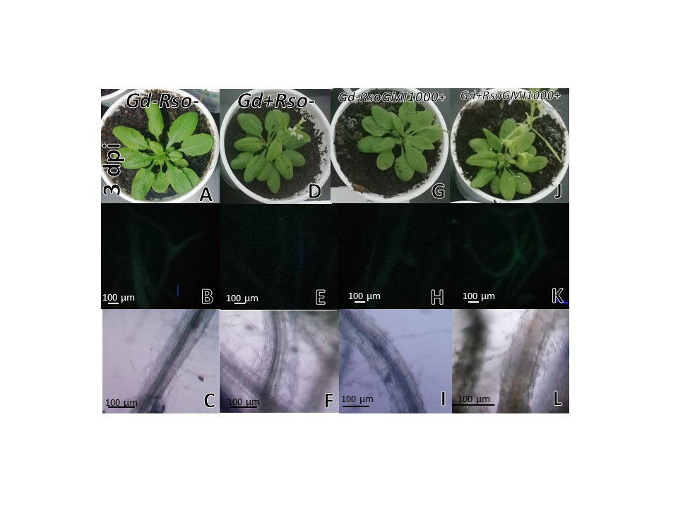Supplementary Figure 6. A. thaliana sid2 mutants grown with different treatments, images are shown at 3 days post-inoculation with R. pseudosolanacearum GMI1000. (A-C) mock inoculated plants; (D-F) plants inoculated with G. diazotrophicus Pal5; (G-I) plants inoculated with R. pseudosolanacearum GMI1000; (J-L) plants inoculated with G. diazotrophicus and with R. pseudosolanacearum GMI1000. B-K, epifluorescence microscope micrographs of A. thaliana sid2 mutant roots treated with aniline blue 0.05 % p/v. C-L, light microscope micrographs of A. thaliana sid2 mutant roots treated with aniline blue 0.05 % p/v showing radical hairs. No deposits of callose are observed in the papillae of the radical hairs of any of the treatments tested (B-K).

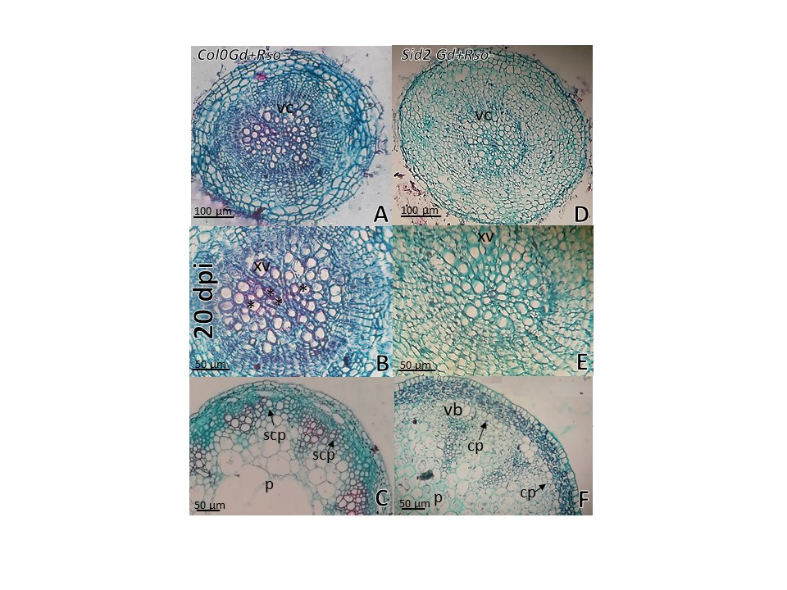
Supplementary Figure 7. Cross sections micrographs of A. thaliana sid2 mutants and Col 0 plants inoculated with G. diazotrophicus at 20 dpi. (A, B-D, E) Root; (C,F) Stem. Staining with safranin-Fast Green. B, Root vascular cylinder details of A. thaliana Col 0(A) showing lignification of the xylematic vessels. E, Root vascular cylinder details of A. thaliana sid2 mutants (D) showing low lignification of the xylematic vessels. C, Stem of A. thaliana col 0 plants showing a greater lignifications and amount of xylematic tissue and sclerosed cortical parenchyma than in A. thaliana sid2 mutants (F). cp=cortical parenchyma, p=pith, scp=sclerosed cortical parenchyma, vb=vascular bundle, vascular cylinder, xv=xylematic vessels. Asterisk indicated more xylematic vessels lignification.

