Supplemental Digital Content 2
Characterization of obesity
In adulthood, Obese (Ob) animals had greater body weight (Figure S2) and visceral fat mass (Figure S3) compared to non-obese (nonOb) animals. In addition, Ob animals had lower lung density, smaller normally aerated lung areas, and larger hypoaerated lung areas compared to nonOb (Figure S4).

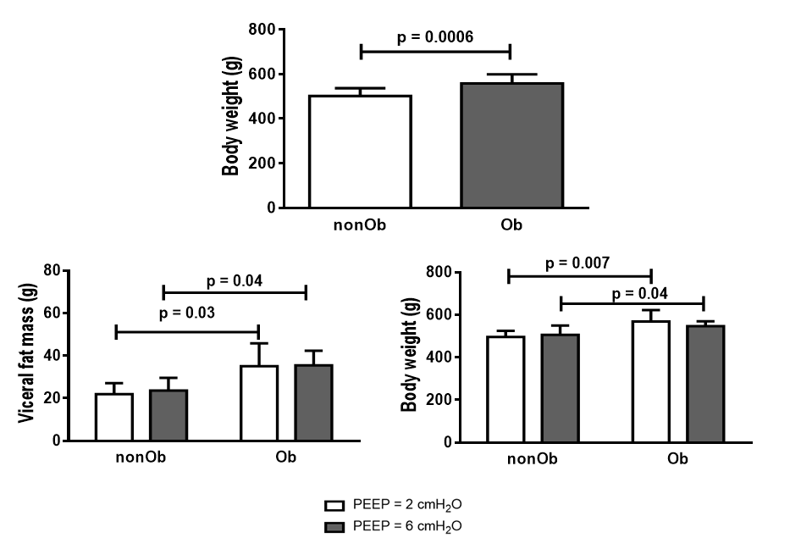
Figure S2: Upper panel: Body weight of non-obese and obese rats at 150 days old (n=14/group). Lower panel: Body weight of non-obese and obese rats after randomization and visceral fat mass of non-obese and obese rats after mechanical ventilation (n=7/group). Values are means + standard deviation.

Figure S3: Visceral fat mass (VFM) area analyzed by computed tomography (CT) in non-obese (nonOb) and obese (Ob) rats at 150 days old (n=14/group). Values are mean + standard deviation.
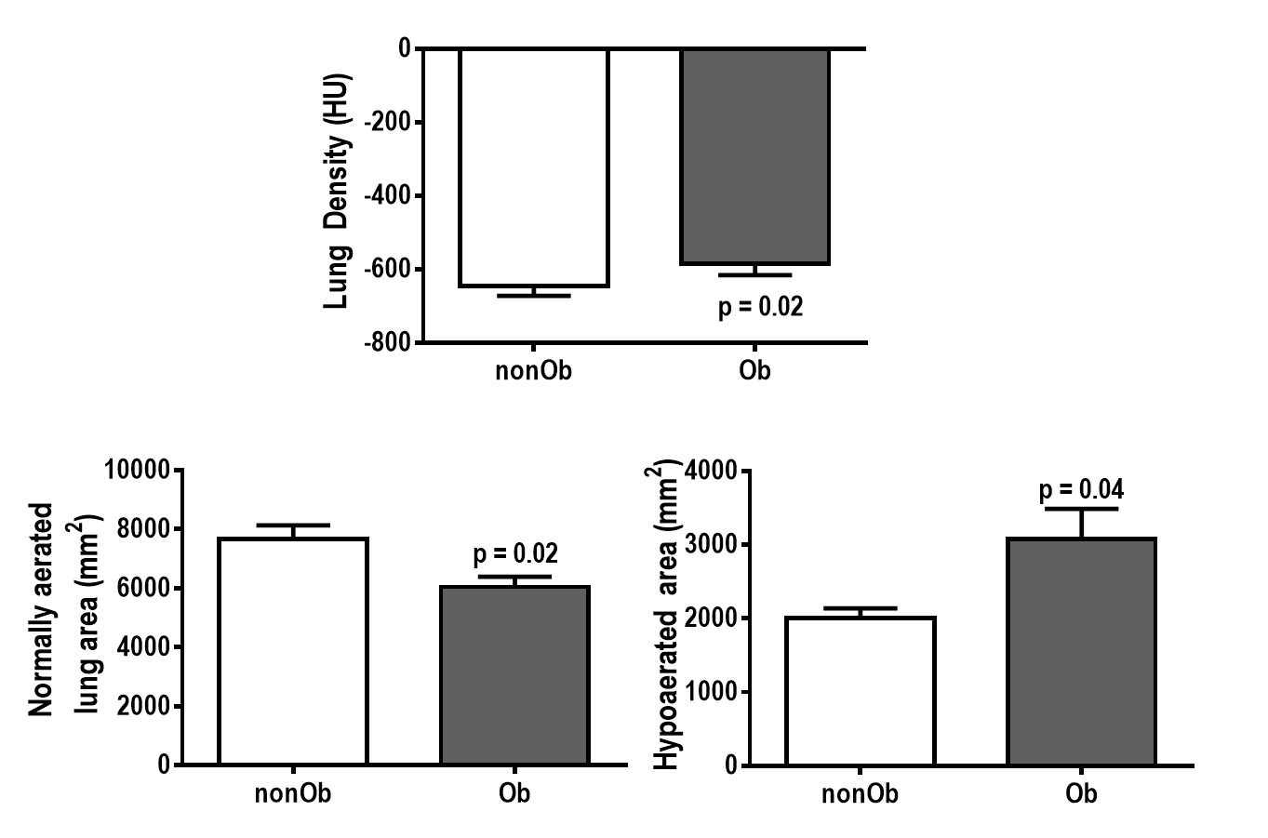
Figure S4: Quantitative analysis of computed tomography (CT) analysis of lung parameters. Upper panel: Lung density (HU). Lower panels: Normally aerated and hypoaerated lung areas (mm²) of non-obese (nonOb) and obese (Ob) rats at 150 days old (n=14/group). Values are mean ± standard deviation.

Respiratory parameters and blood gas analysis at Baseline
At Baseline, respiratory parameters and arterial blood gases were not significantly different between the nonOb and Ob groups, except for mean arterial pressure, which was higher in Ob than in nonOb animals (Table S2).
Table S2: Respiratory parameters and mean arterial pressure at Baseline
 | nonOb |  | Ob
 | PEEP2 | PEEP6 | PEEP2 | PEEP6
V_{T} (mL/kg) | 6.9 ± 0.4 | 6.8 ± 0.6 | 7.0 ± 0.1 | 6.7 ± 0.9
RR (bpm) | 47 ± 2 | 46 ± 2 | 40 ± 3 | 44 ± 5
Est,L (cmH₂O/mL) | 2.0 ± 0.4 | 1.8 ± 0.3 | 3.5 ± 0.3* | 3.6 ± 0.5†*
Est,_{W} (cmH₂O/mL) | 0.4 ± 0.2 | 0.3 ± 0.1 | 0.4 ± 0.2 | 0.4 ± 0.2
pHa | 7.37 ± 0.02 | 7.37 ± 0.04 | 7.38 ± 0.05 | 7.37 ± 0.04
PaCO₂ (mmHg) | 40 ± 4 | 39 ± 2 | 39 ± 3 | 41 ± 3
PaO₂/FiO₂ (mmHg) | 360 ± 47 | 394 ± 37 | 267 ± 45* | 279 ± 41†
MAP (mmHg) | 131 ± 24 | 147 ± 15 | 164 ± 10* | 171 ± 14†

Values are mean ± SD of seven rats in each group. nonOb/PEEP2: V_{T} = 6 mL/kg with PEEP = 2 cmH₂O; nonOb/PEEP6: V_{T} = 6 mL/kg with PEEP = 6 cmH₂O; Ob/PEEP2: V_{T} = 6 mL/kg with PEEP = 2 cmH₂O; Ob/PEEP6: V_{T} = 6 mL/kg with PEEP = 6 cmH₂O. At Baseline, all animals were paralyzed and mechanically ventilated with V_{T} = 7 mL/kg, RR to maintain normocapnia (PaCO₂ 35–45 mmHg; around 45 bpm), inspiratory-to-expiratory ratio = 1:2, fraction of inspired oxygen = 0.4, and PEEP = 2 cmH₂O for 5 min. V_{T}, tidal volume; RR, respiratory rate; Est,L, lung static elastance; Est,w, chest wall static elastance; pHa, arterial pH; PaCO₂, arterial carbon dioxide partial pressure; PaO₂/FiO₂, arterial oxygen partial pressure divided by fraction of inspired oxygen; MAP, mean arterial pressure. *Significantly different from nonOb/PEEP2; †Significantly different from nonOb/PEEP6.
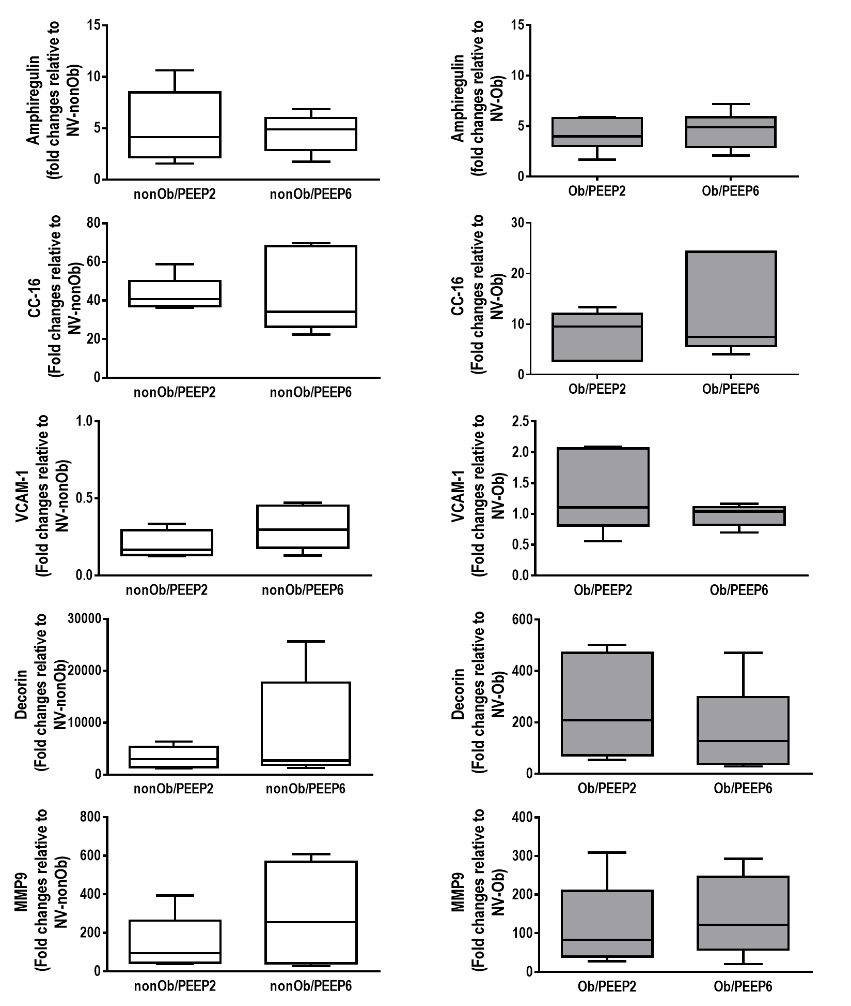
Figure S5: Expression of biologic markers associated with lung damage in mechanically ventilated non-obese (nonOb) and obese (Ob) groups. Low PEEP (2 cmH₂O) and High PEEP (6 cmH₂O). Real-time polymerase chain reaction analysis of amphiregulin, club cell protein (CC-16), vascular cell adhesion molecule (VCAM)-1, decorin, and metalloproteinase (MMP)-9. Relative gene expression was calculated as a ratio of average expression of each gene to the reference gene (36B4) and expressed as fold change relative to non-ventilated animals (NV). Boxes show the interquartile range (25th-75th percentile), while whiskers encompass the range (minimum-maximum) and horizontal lines represent the median in 7 animals/group.

