Supplemental Figures
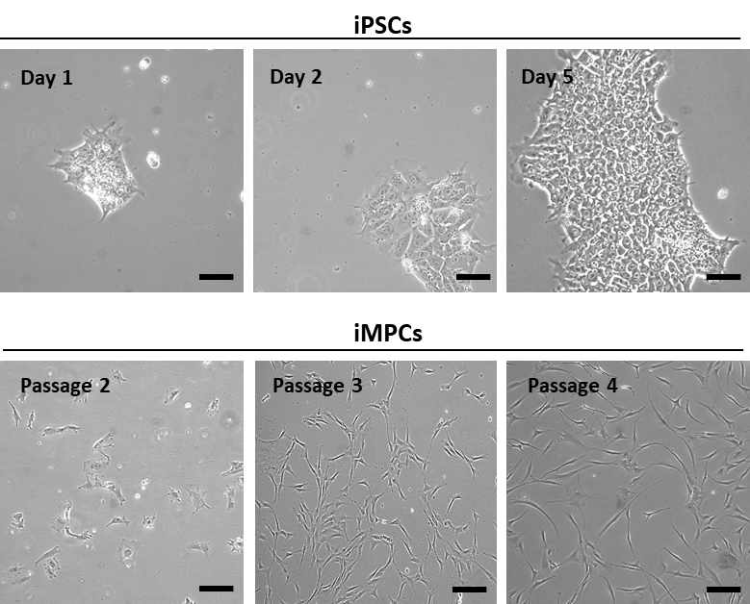

Figure S1. Morphology of the iPSCs and iMPCs at different passages. Bar = 100 µm.

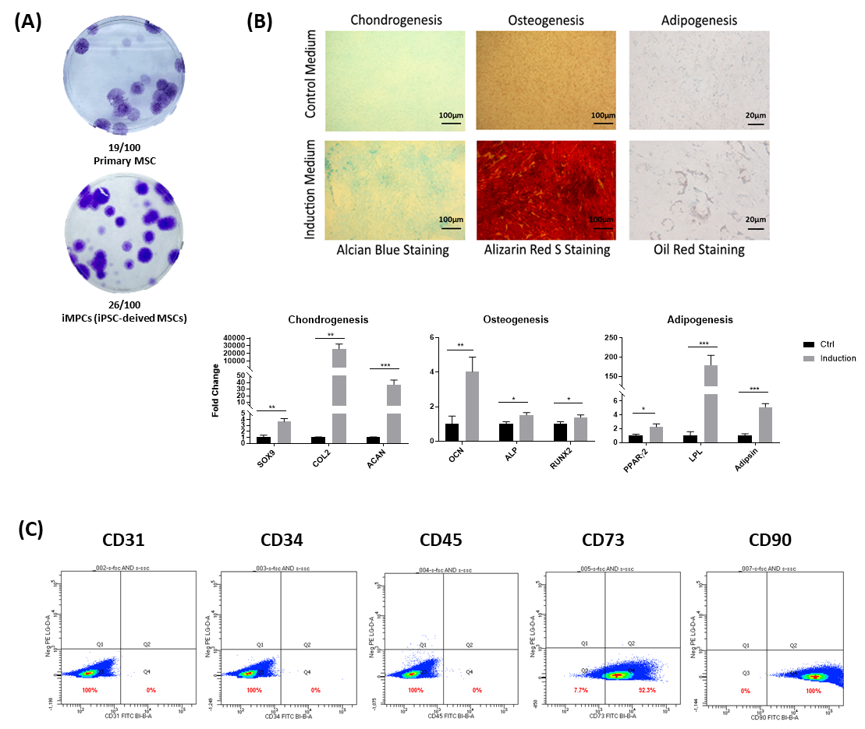

Figure S2. MSC-like characteristics of iMPCs. (A) CFU assay. iMPCs have similar colony forming ability compared to primary MSCs. (B) Tri-lineage differentiation. Compared to unstimulated control, iMPCs showed significant tissue-specific gene expression and displayed positive staining for Alcian Blue, Alizarin Red S, and Oil Red Staining respectively, confirming their ability to undergo chondrogenic, osteogenic and adipogenic differentiation. Gene expression levels of Ctrl are normalized to 1. Values are presented as mean ± SD (N = 4 per group: *, p < 0.05; **, p < 0.01; ***, p< 0.001). (C) Flow cytometric analysis. iMPCs displayed similar cell surface marker profile as primary human MSCs, i.e., negative for CD31, CD34 and CD45, and positive for CD73 and CD90.

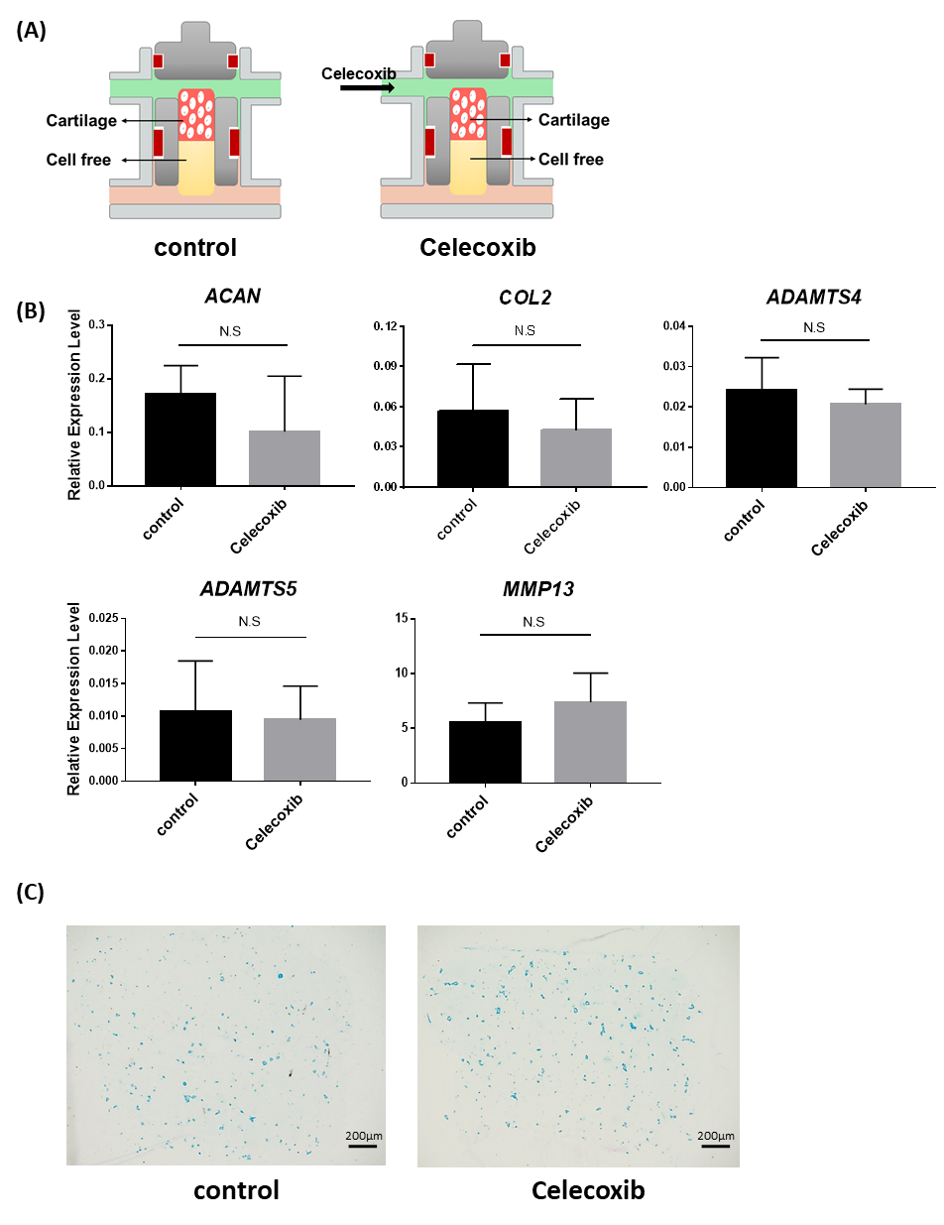

Figure S3. Lack of toxicity of Celecoxib treatment of engineered cartilage. (A) Schematic of control and celecoxib treatment groups. (B) Expression of chondrocyte-associated genes. After Celecoxib treatment, no significant changes in the expression levels of all tested genes were observed. (C) Alcian Blue staining. No significant change in cartilage matrix was seen after Celecoxib treatment.

Table S1. Sequences of primers used for quantitative PCR
Gene | Forward Primer (5'-3') | Reverse Primer (5'-3')
RPL13A | CATAGGAAGCTGGGAGCAAG | GCCCTCCAATCAGTCTTCTG
GAPDH | GGAGCGAGATCCCTCCAAAAT | GGCTGTTGTCATACTTCTCATGG
SOX9 | GGCGGAGGAAGTCGGTGAAGAA | GCTCATGCCGGAGGAGGAGTGT
COL2 | GGATGGCTGCACGAAACATACCGG | CAAGAAGCAGACCGGCCCTATG
ACAN | AGTCACACCTGAGCAGCATC | AGTTCTCAAATTGCATGGGGTGTC
COL10 | CCCTCTTGTTAGTGCCAACC | AGATTCCAGTCCTTGGGTCA
MMP13 | ATGCAGTCTTTCTTCGGCTTAG | ATGCCATCGTGAAGTCTGGT
RUNX2 | GTGATAAATTCAGAAGGGAGG | CTTTTGCTAATGCTTCGTGT
OCN | TCACACTCCTCGCCCTATTG | GAAGAGGAAAGAAGGGTGCC
ALP | ATCTTTGGTCTGGCCCCCATG | AGTCCACCATGGAGACATTCTCTC
BSP2 | CGAATACACGGGCGTCAATG | GTAGCTGTACTCATCTTCATAGGC
TNF-α | CCTCTCTCTAATCAGCCCTCTG | GAGGACCTGGGAGTAGATGAG
IL-1β | ATGATGGCTTATTACAGTGGCAA | GTCGGAGATTCGTAGCTGGA
IL-6 | ACTCACCTCTTCAGAACGAATTG | CCATCTTTGGAAGGTTCAGGTTG
MMP1 | AAAATTACACGCCAGATTTGCC | GGTGTGACATTACTCCAGAGTTG
MMP2 | TACAGGATCATTGGCTACACACC | GGTCACATCGCTCCAGACT
MMP3 | CTGGACTCCGACACTCTGGA | CAGGAAAGGTTCTGAAGTGACC
MMP9 | TGTACCGCTATGGTTACACTCG | GGCAGGGACAGTTGCTTCT
ADAMTS-4 | CTGGCACCTACCTGACTGG | GTAACACGCCTAACAGGGCT
ADAMTS-5 | ATCACCCAATGCCAAGG | AGCAGAGTAGGAGACAAC
TGF-β3 | GGAAAACACCGAGTCGGAATAC | GCGGAAAACCTTGGAGGTAAT

