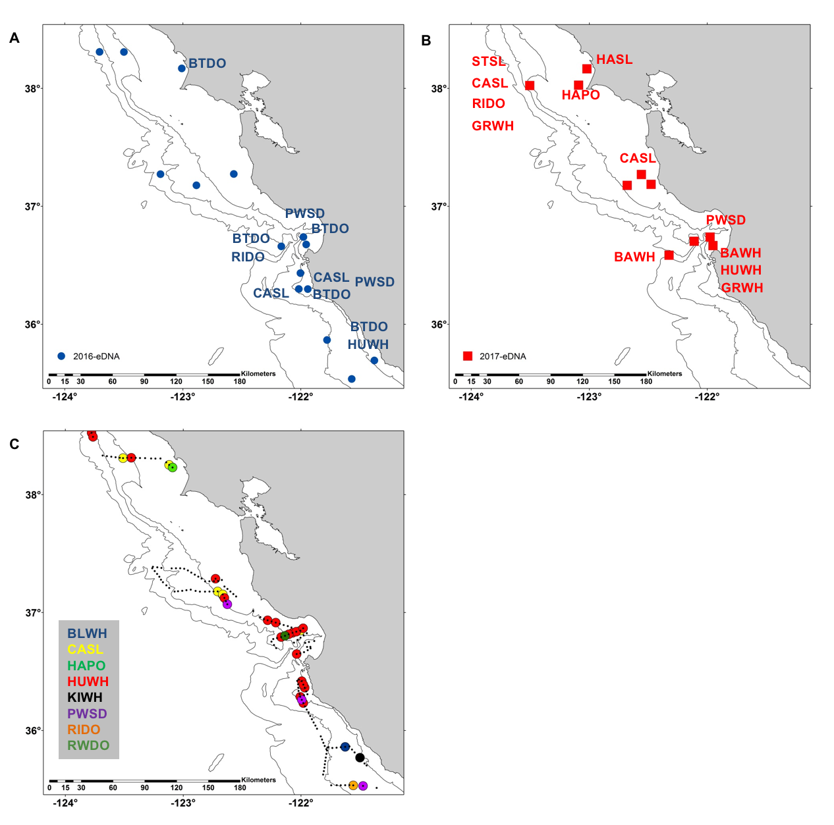
Supplementary Figure S2. Stations where eDNA was collected during (A) 2016 (blue dots) and (B) 2017 (red squares). Marine mammals that were identified by eDNA are listed next to stations with code name for each taxon (code key below). (C) Marine mammals observed by visual survey (presence only; per 3 km interval) during the study’s time period of the 2016 RREAS. Small black dots represent cruise trackline and large dots are sighting locations of mammal genera observed; colored by taxa. Alpha Codes: baleen whale (BAWH), blue whale (BLWH), bottlenose dolphin (BTDO), California sea lion (CASL), grey whale (GRWH), harbor porpoise (HAPO), harbor seal (HASL), humpback whale (HUWH), Pacific white-sided dolphin (PWSD), Risso’s dolphin (RIDO), northern right whale dolphin (RWDO), killer whale (KIWH), and Steller sea lion (STSL). Contours are 200, 1000 and 2000 m isobaths.

