Supplementary Material

Biophysical Control of Bile Duct Epithelial Morphogenesis in natural and synthetic scaffolds.

Anette Funfak¹, Latifa Bouzhir², Emilie Gontran², Nicolas Minier^{1,3}, Pascale Dupuis-Williams^{2,4,*}, Samy Gobaa^{1,*}

¹ Institut Pasteur, Biomaterials and Microfluidics core facility, C2RT, Paris, France
² UMR-S1174 Institut National de la Santé et de la Recherche Médicale, Université Paris-Sud, Orsay, France.
³ Université de Technologie de Compiègne, Alliance Sorbonne Université, Compiègne, France
⁴ École Supérieure de Physique et de Chimie Industrielles de la Ville de Paris, Paris, France.

* These authors contributed equally to the work.

Correspondence
Prof. Pascale Dupuis-Williams
pascale.dupuis-williams@u-psud.fr

Dr. Samy Gobaa
samy.gobaa@pasteur.fr

Movie S1. Three-dimensional nucleus location of NRC cells within different 10-day old cysts cultured in 4.5% PEG-VS hydrogels supplemented with 1200µM RGD. Scale bar:100µm

Movie S2. NRC cysts growth filmed over 48h in a PEG-VS hydrogel with intermediate stiffness containing 1200µM RGD.

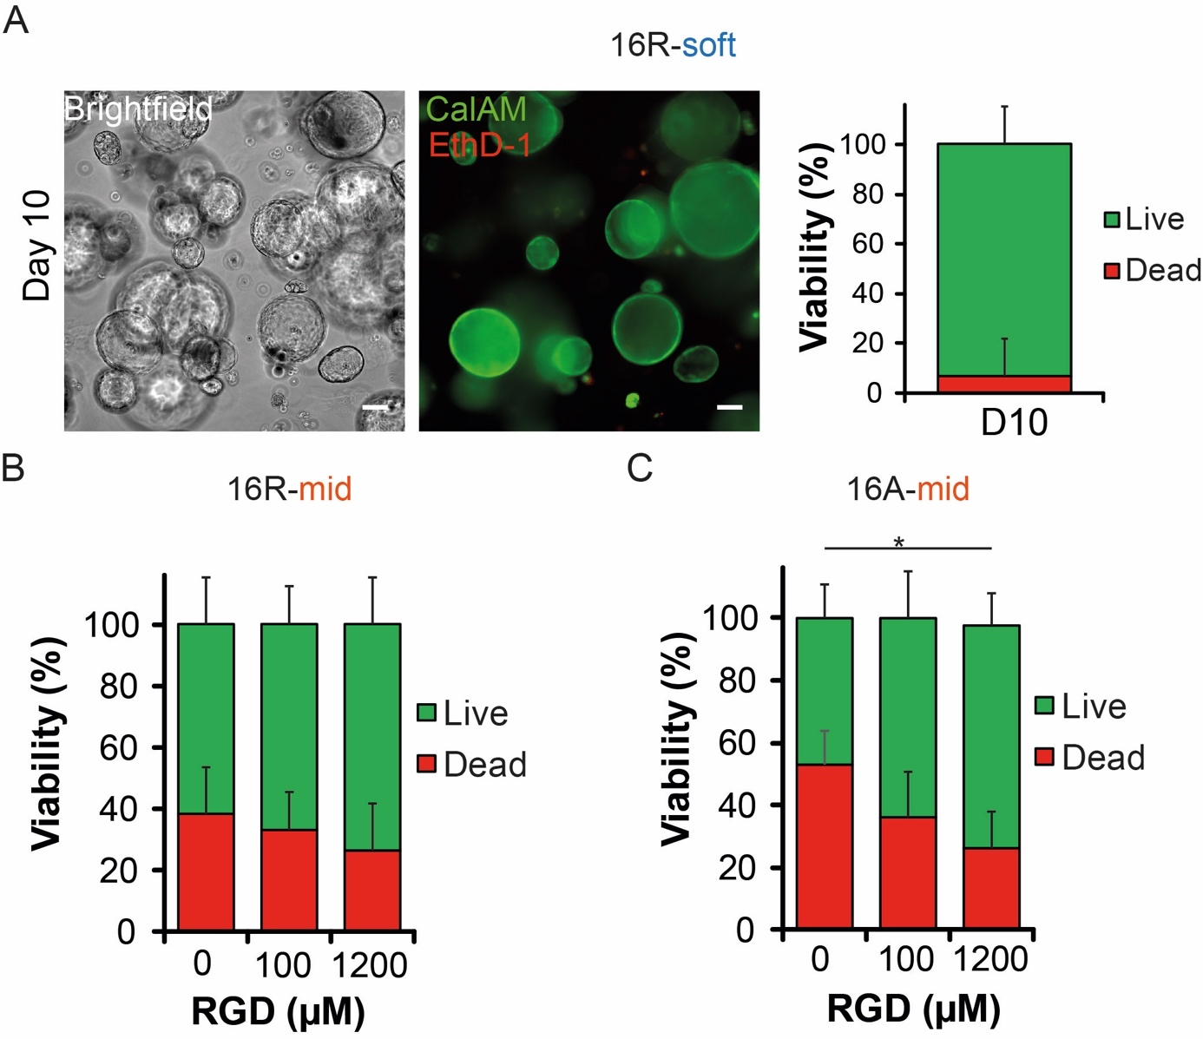
Figure S3. NRC cyst viability at Day 10 for PEG-VS hydrogels crosslinked with a fast (16R) and slow (16A) MMP-degradable peptide sequence. A) Representative brightfield and z-stack confocal images of 10-d-old NRC cysts cultured in a soft PEG-VS hydrogel crosslinked with a fast degradable crosslinker sequence and functionalized with 1200µM RGD (left) and percentage of cell viability at day 10 assessed by CalAM (Live) and EthD-1 (Dead) staining (right). B) Percentage of cell viability for different RGD ligand concentration assessed by CalAM (Live) and EthD-1 (Dead) staining of 10-d-old NRC cysts cultured in 4.5% PEG-VS hydrogel crosslinked with a fast MMP-degradable peptide. C) Percentage of cell viability for different RGD ligand concentration assessed by CalAM (Live) and EthD-1 (Dead) staining of 10-day old NRC cysts cultured in 4.5% PEG-VS hydrogel crosslinked with a slow MMP-degradable peptide. * significant at p<0.05. Error bars represent SD. Scale bar: 100µm.

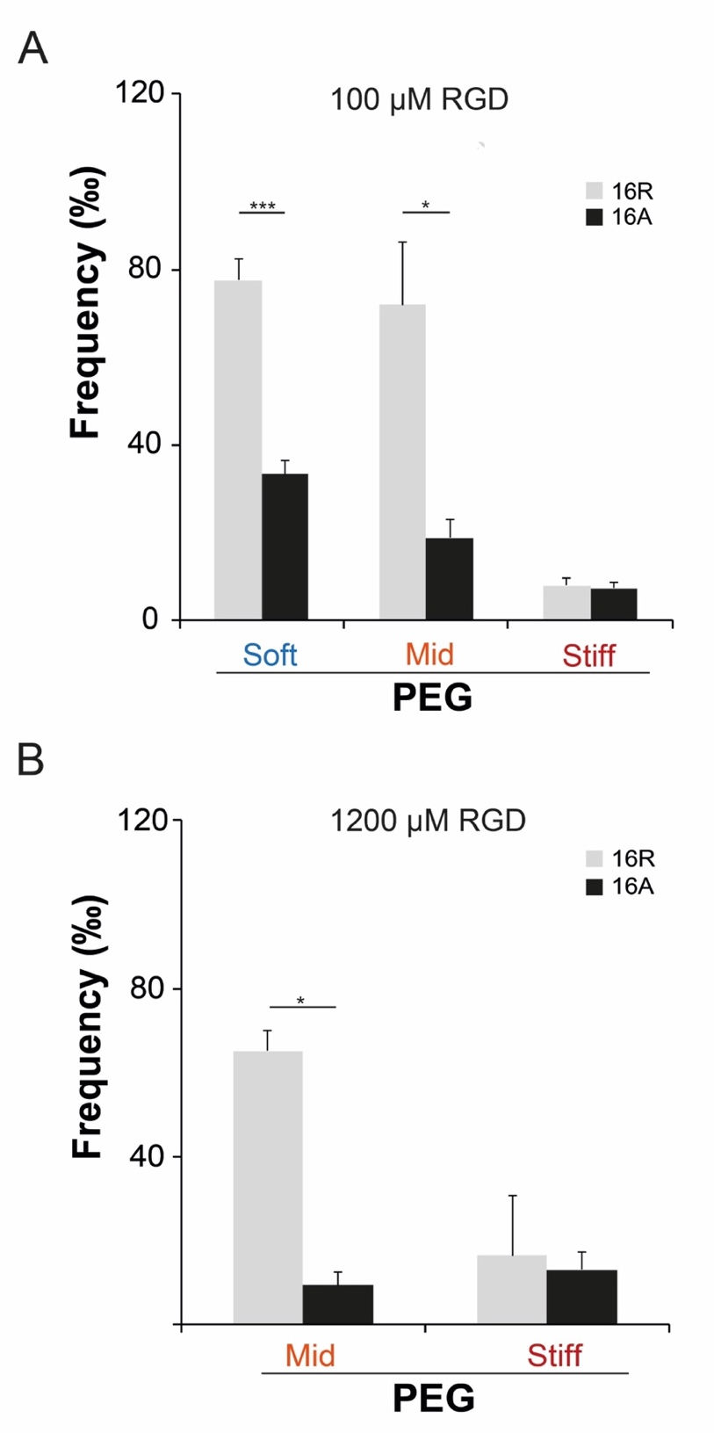
Figure S4. NRC cyst formation. (A) Comparison of cyst formation efficiency between fast and slow MMP-degradable hydrogels with soft, intermediate and stiff matrix when containing 100µM RGD. (B) Comparison of cyst formation efficiency between fast (16R) and slow MMP-degradable (16A) hydrogels with intermediate and stiff matrix when containing 1200µM RGD. *, **, *** significant at p<0.05, p<0.01 and p<0.001 respectively. Error bars represent SEM.

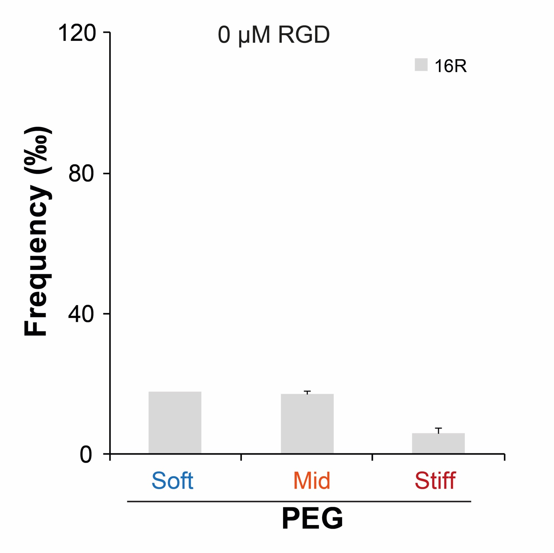
Figure S5. NRC cyst formation. Number of cysts formed in soft, intermediate and stiff hydrogels in absence of the RGD ligand. Error bars represent SEM.
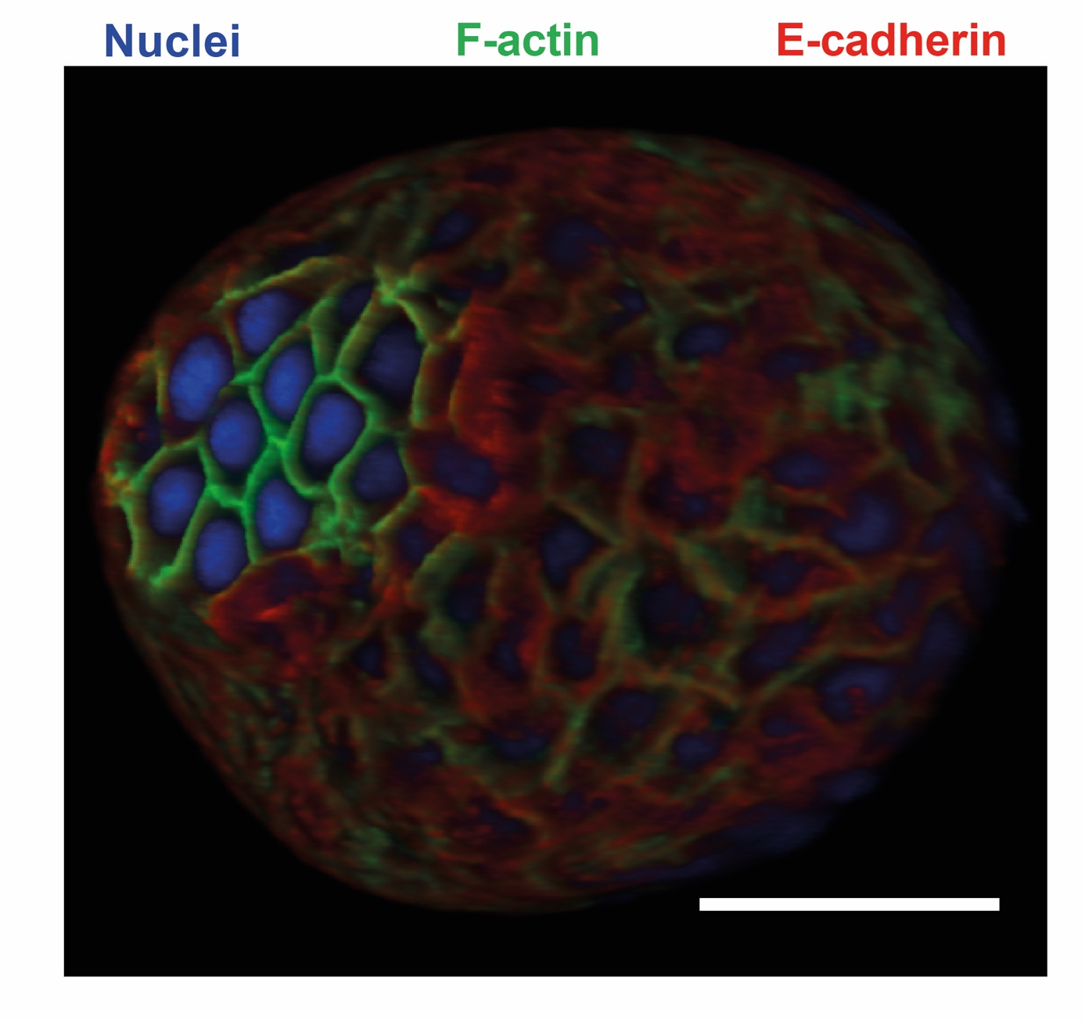
Figure S6. NRC cyst cultured in PEG-VS hydrogels express apical-basolateral polarization. 3D immunostaining image of a cysts marked for basolateral marker E-cadherin and apical marker f-actin. Scale bar: 100µm.

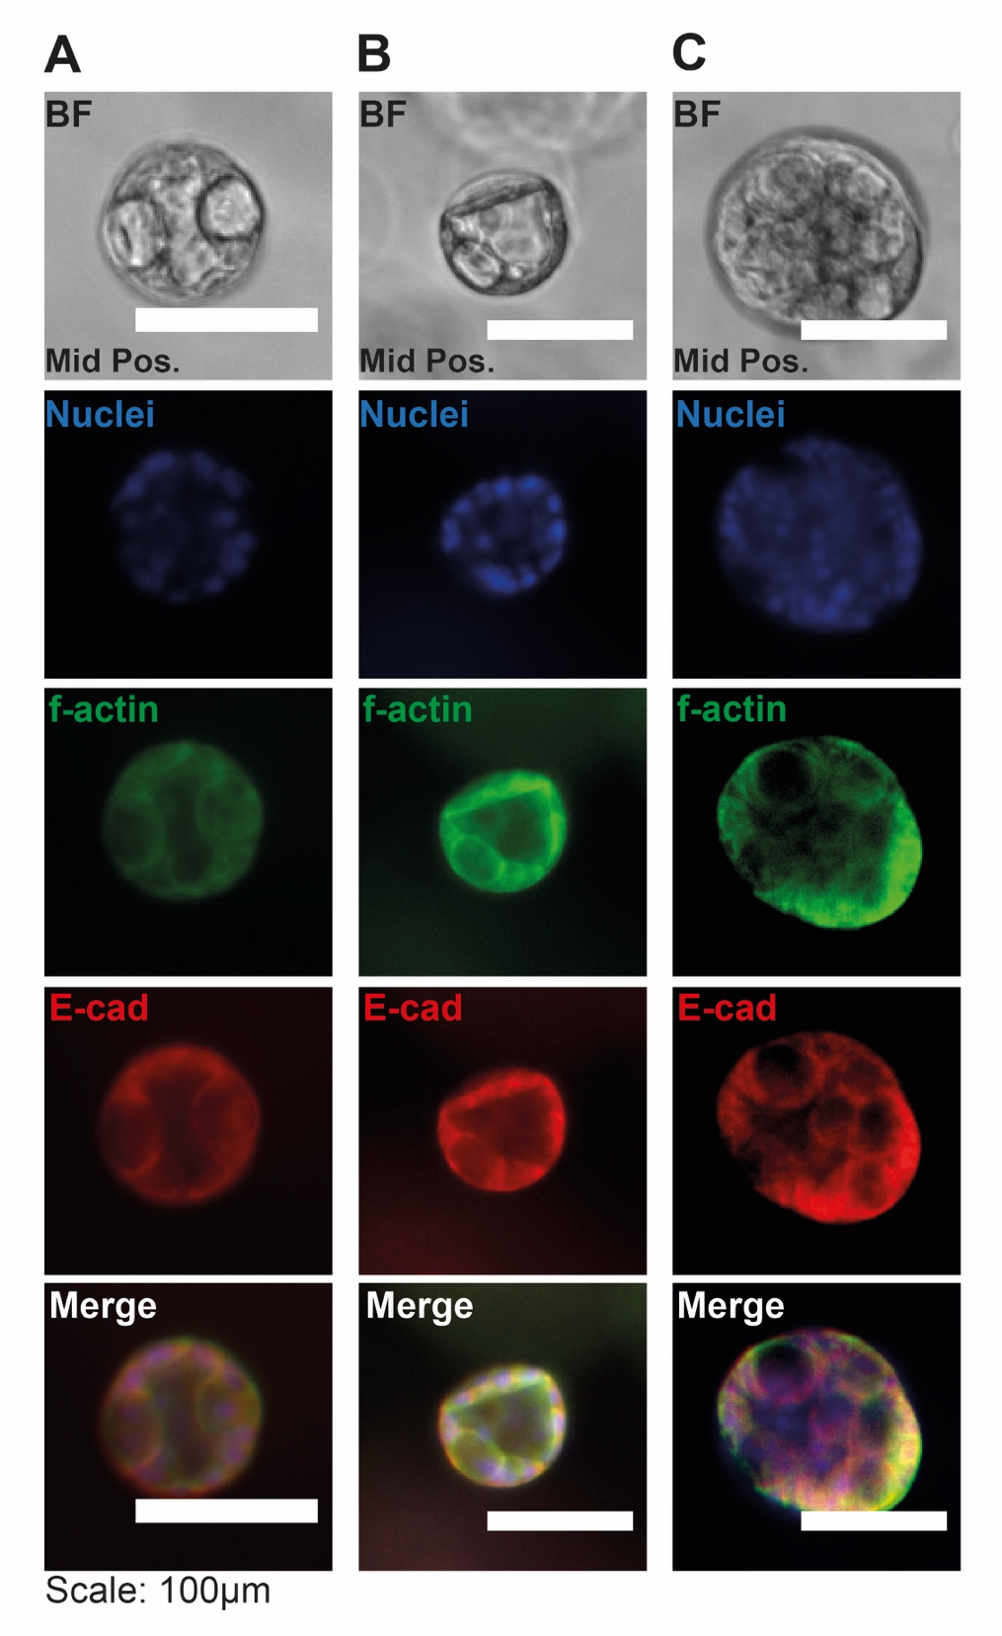
Figure S7. Normal Rat Cholangiocyte (NRC) cysts can retain a multi-lumen phenotype over 18 days of culture in 4.5% PEG-VS hydrogels containing 1200 µM RGD. (A) Three-lumen cyst, (B) two-lumen cyst and (C) 8+ lumen cyst. BF: Brightfield. E-cad: E-cadherin. Scale bar: 100µm.

