Supplementary Material

Supplementary Figure 1. 2,6-DiiodoBodipy showing ISC (Yogo et al., 2005).
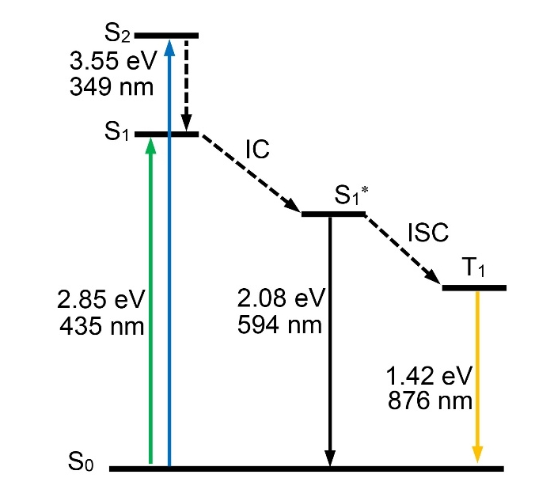

Supplementary Figure 2. The ISC mechanism of iodo-substituted Bodipy. IC denotes internal conversion. Figure reproduced from data in Nakashima et al. (2018).
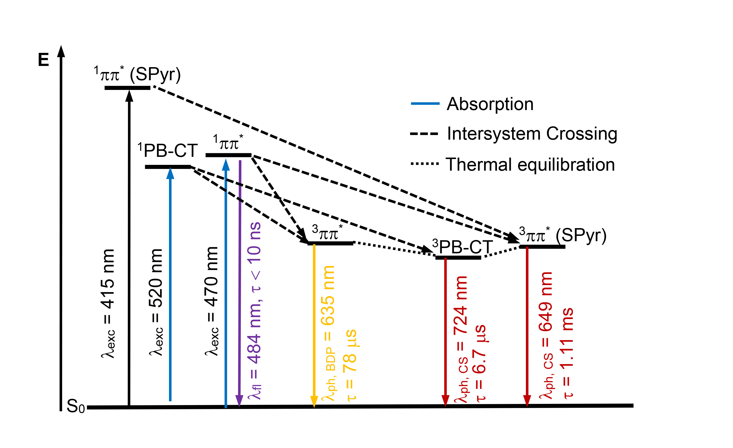

Supplementary Figure 3. The ISC mechanism of σ-Pt-BODIPY complexes. BDP: Bodipy, SPyr: mercaptopyrene, PB-CT: charge-transfer from the mercaptopyrene to BDP ligand. Figure reproduced from data in Irmler et al. (2019b).
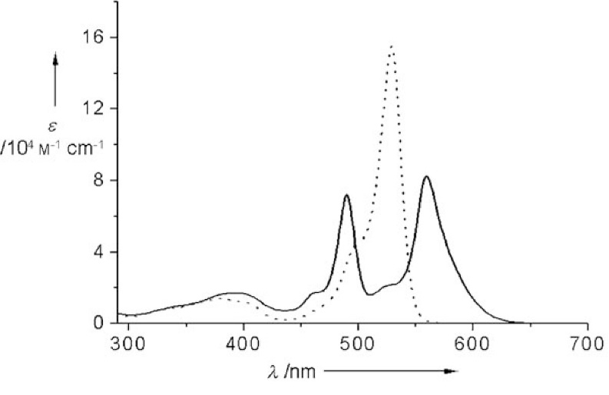

Supplementary Figure 4. The molecular structure and the Uv-vis absorption spectra of Bodipy dimer. Figure reproduced from data in Bröring et al. (2008)
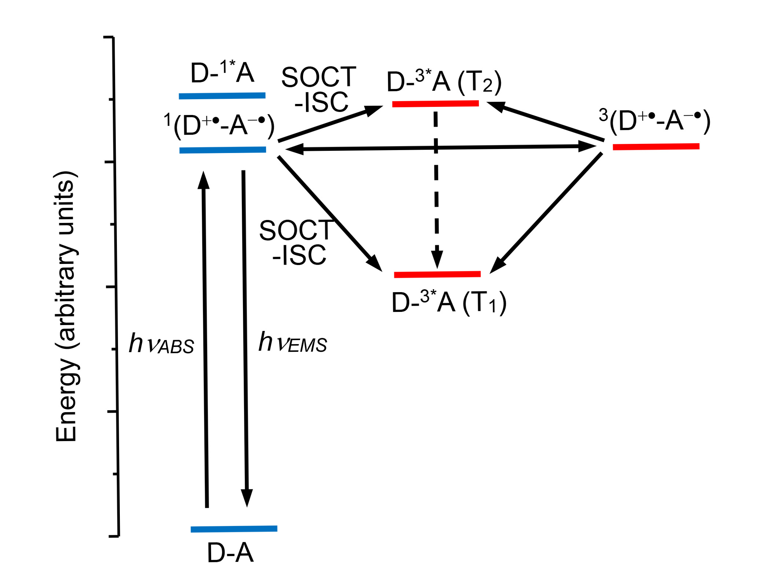

Supplementary Figure 5. SOCT-ISC mechanism. Figure reproduced from data in Dance et al. (2008)
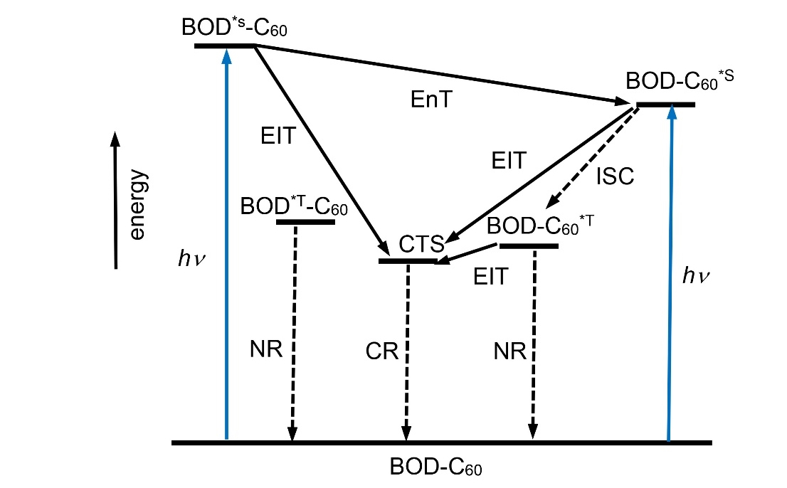

Supplementary Figure 6. The photophysical processes of Bodipy-C₆₀ dyad derivatives. Figure reproduced from data in Ziessel et al. (2009)

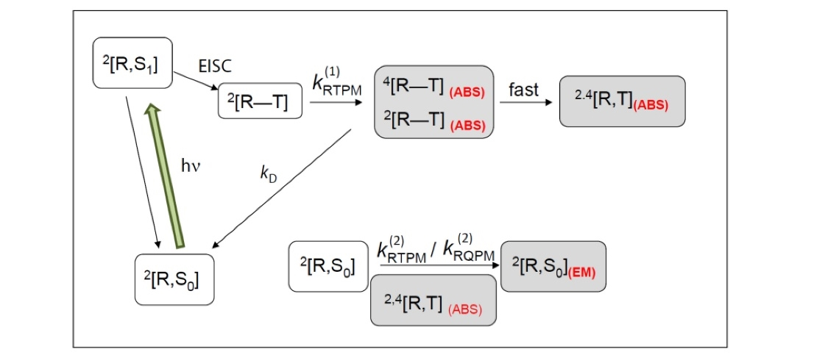

Supplementary Figure 7. The radical enhanced ISC mechanism of 44. Figure reproduced from data in Wang et al. (2017)

REFERENCES
Yogo, T., Urano, Y., Ishitsuka, Y., Maniwa, F., and Nagano, T. (2005). Highly efficient and photostable photosensitizer based on BODIPY chromophore. J. Am. Chem. Soc. 127, 12162−12163. doi: 10.1021/ja0528533

Nakashima, M., Iizuka, K., Karasawa, M., Ishii, K., and Kubo, Y. (2018). Selenium-containing bodipy dyes as photosensitizers for triplet–triplet annihilation upconversion. J. Mater. Chem. C 6, 6208−6215. doi: 10.1039/C8TC00944A

Irmler, P., Gogesch, F.S., Mang, A., Bodensteiner, M., Larsen, C.B., Wenger, O.S., et al. (2019b). Directing energy transfer in Pt(bodipy)(mercaptopyrene) dyads. Dalton Trans. doi: 10.1039/C9DT01737B

Bröring, M., Krüger, R., Link, S., Kleeberg, C., Köhler, S., Xie, X., et al. (2008). Bis(BF₂)-2,2′-bidipyrrins (bisBODIPYs): highly fluorescent BODIPY dimers with large stokes shifts. Chem. Eur. J. 14, 2976−2983. doi: 10.1002/chem.200701912

Dance, Z.E.X., Mickley, S.M., Wilson, T.M., Ricks, A.B., Scott, A.M., Ratner, M.A., et al. (2008). Intersystem crossing mediated by photoinduced intramolecular charge transfer: julolidine−anthracene molecules with perpendicular π systems. J. Phys. Chem. A 112, 4194−4201. doi: 10.1021/jp800561g

Ziessel, R., Allen, B.D., Rewinska, D.B., and Harriman, A. (2009). Selective triplet-State formation during charge recombination in a fullerene/Bodipy molecular dyad (Bodipy=borondipyrromethene). Chem. Eur. J. 15, 7382−7393. doi: 10.1002/chem.200900440

Wang, Z., Zhao, J., Barbon, A., Toffoletti, A., Liu, Y., An, Y., et al. (2017). Radical-enhanced intersystem crossing in new bodipy derivatives and application for efficient triplet-triplet annihilation upconversion. J. Am. Chem. Soc. 139, 7831−7842. doi: 10.1021/jacs.7b02063

