***Supplementary Material***

**Breathable and Wearable MXene-Decorated Air-Laid Paper with Outstanding Folding Endurance and Electromagnetic Interference Shielding Performances**

Chang Ma*a*, Tong Liu*a*, Wei Xin*a*, Guo-Qiang Xi*a,b*, Ming-Guo Ma*a\**

*aEngineering Research Center of Forestry Biomass Materials and Bioenergy, Beijing Key Laboratory of Lignocellulosic Chemistry, College of Materials Science and Technology, Beijing Forestry University, Beijing 100083, PR China；*

*bKey Laboratory for Green Processing of Chemical Engineering of Xinjiang Bingtuan, School of Chemistry and Chemical Engineering,Shihezi University, Shihezi 832003, Xinjiang, PR China.*

**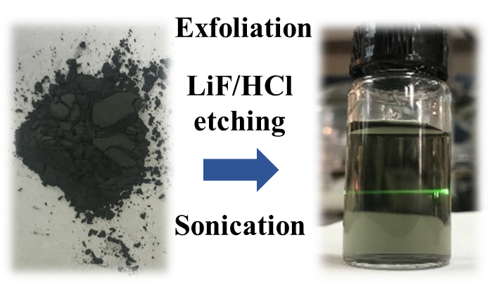**

**Figure S1.** Digital image of MAX phase and the Tyndall effect of MXene nanosheets aqueous suspension after etching.

**F:\AAAAA实验结果\MXene-BC\SEM\20190328\3_m007.tif**

**Figure S2.** The SEM image of MAX phase.

**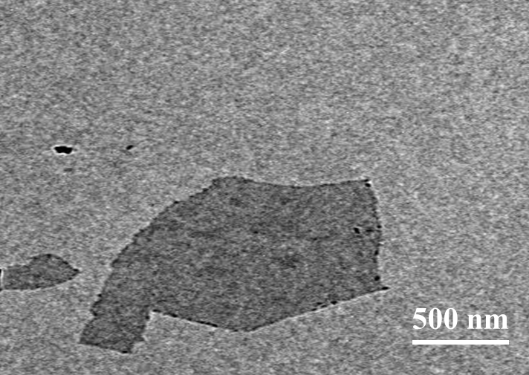**

**Figure S3.** The TEM image of MXene nanosheets.



**Figure S4.** XRD patterns of MAX (Ti3AlC2) phase and MXene nanosheets.

**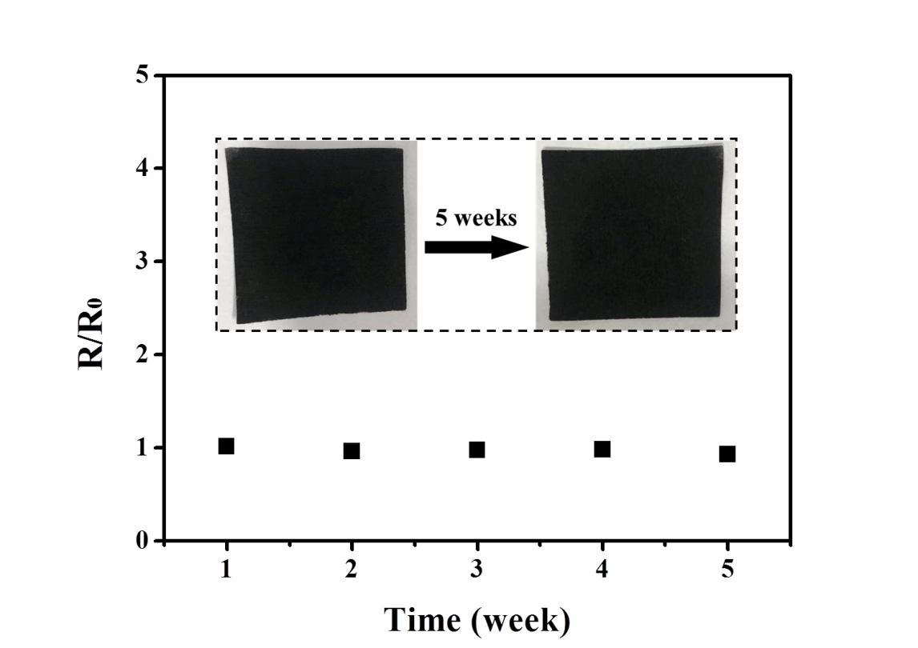**

**Figure S5.** Oxidation stability of MP-20 after a period of time.

**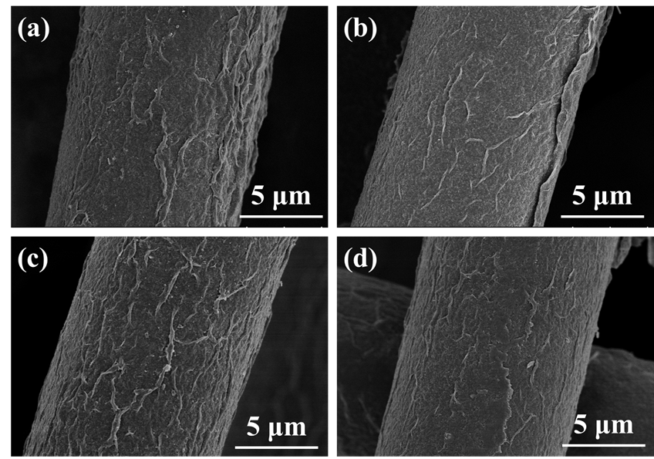**

**Figure S6.** SEM images of (a) the original MP-20; (b) MP-20 after folding; (c) MP-20 after treating by artifical sweat; (d) MP-20 after 5 weeks.

**Table S1.** Comparison of the EMI shielding performance of the MXene/air-laid paper composite and the other materials.

|  |  |  |  |  |  |
| --- | --- | --- | --- | --- | --- |
| **Sample** | **Type** | **Materials** | **Thickness(mm)** | **SSE/t(dB cm2g-1)** | **Reference** |
| 1 | Metal based  Carbon | copper | 3.1 | 32.3 | (Shui et al, 1997) |
| 2 | Ni fiber/PES | 2.85 | 108.7 | (Shui et al, 1997) |
| 3 | SS | 4 | 27.5 | (Li et al, 1994) |
| 4 | CuNi/CNT | 1.5 | 1580 | (Ji et al., 2014) |
| 5 | Ag NW/PI | 0.5 | 2416 | (Ma et al., 2015) |
| 6 | SS/PP | 3.1 | 241.9 | (Ameli et al., 2014) |
| 7 | Graphene/PS | 2.5 | 692 | (Yan et al., 2015) |
| 8 | based  MXene based | Graphene/PEDOT | 0.8 | 841 | (Dalal et al., 2016) |
| 9 | Graphene/Fe3O4 | 0.3 | 1033 | (Song et al., 2015) |
| 10 | MWCNT/PC | 2.1 | 163 | (Pande et al., 2014) |
| 11 | SWCNT/PS | 1.2 | 275 | (Yang et al., 2005) |
| 12 | CB/ABS | 1.1 | 190 | (Al-Saleh et al., 2013) |
| 13 | CB/EPDM | 2 | 15.1 | (Chakrabarti, 2000) |
| 14 | Carbon foam | 2 | 1250 | (Moglie et al., 2012) |
| 15 | Ti3C2Tx/CNFs | 0.047 | 2647 | (Cao et al., 2018) |
| 16 | MXene/air-laid paper | 0.119 | 1931.5 | This work |
|  |  |  | 0.117 | 2001.4 |  |
|  |  |  | 0.116 | 1941.9 |  |

Note:

PES- polyethersulfone

CNT- carbon nanotube

SS- stainless steel

NW- nanowire

PI- polyimide

PP- polypropylene

PS- polystyrene

PEDOT- poly(3,4-ethylenedioxythiophene)

MWCNT- multi-wall carbon nanotube

SWCNT- single-wall carbon nanotube

PC- polycarbonate

CB- carbon black

ABS- acrylonitrile butadiene styrene copolymers

EPDM- ethylene propylene diene monomer

CNFs- cellulose nanofibers

**Table S2.** The mechanical properties of the MXene/air-laid paper composite sheets in different dip-coating cycle numbers.

|  |  |  |  |  |
| --- | --- | --- | --- | --- |
| **Sample** | **Tensile strength (Mpa)** | **Tensile strain (%)** | **Young’s modulus (MPa)** | **Folding endurance** |
| Original  Air-laid paper | 17.34±3.55 | 64.72±6.49 | 103.70±30.49 | 99750 |
| MP-3 | 20.36±2.34 | 53.08±3.87 | 144.69±47.41 | 96539 |
| MP-5 | 23.26±2.07 | 56.61±4.84 | 183.57±58.84 | 98301 |
| MP-10 | 16.97±3.81 | 54.54±2.61 | 152.51±75.45 | 99572 |
| MP-20 | 16.73±1.45 | 55.69±4.64 | 94.70±28.73 | 97564 |

**References**

Al-Saleh, M.H., Saadeh, W.H.,Sundararaj, U. (2013). EMI shielding effectiveness of carbon based nanostructured polymeric materials: A comparative study. *Carbon* 60, 146-156. doi:10.1016/j.carbon.2013.04.008

Ameli, A., Nofar, M., Wang, S.,Park, C.B. (2014). Lightweight Polypropylene/Stainless-Steel Fiber Composite Foams with Low Percolation for Efficient Electromagnetic Interference Shielding. *ACS Applied Materials & Interfaces* 6, 11091-11100. doi:10.1021/am500445g

Cao, W., Chen, F., Zhu, Y., Zhang, Y., Jiang, Y.,Ma, M., et al. (2018). Binary Strengthening and Toughening of MXene/Cellulose Nanofiber Composite Paper with Nacre-Inspired Structure and Superior Electromagnetic Interference Shielding Properties. *ACS Nano* 12, 4583-4593. doi:10.1021/acsnano.8b00997

Dalal, J., Gupta, A., Lather, S., Singh, K., Dhawan, S.K.,Ohlan, A. (2016). Poly (3, 4-ethylene dioxythiophene) laminated reduced graphene oxide composites for effective electromagnetic interference shielding. *Journal of Alloys and Compounds* 682, 52-60. doi:10.1016/j.jallcom.2016.04.276

Ji, K., Zhao, H., Zhang, J., Chen, J.,Dai, Z. (2014). Fabrication and electromagnetic interference shielding performance of open-cell foam of a Cu–Ni alloy integrated with CNTs. *Applied Surface Science* 311, 351-356. doi:10.1016/j.apsusc.2014.05.067

Lin Li,Chung, D.D.L. (1994). Electrical and mechanical properties of electrically conductive polyethersulfone composites. *Composites* 25, 215-224. doi:10.1016/0010-4361(94)90019-1

Ma, J., Wang, K.,Zhan, M. (2015). A comparative study of structure and electromagnetic interference shielding performance for silver nanostructure hybrid polyimide foams. *RSC Advances* 5, 65283-65296. doi:10.1039/c5ra09507g

Moglie, F., Micheli, D., Laurenzi, S., Marchetti, M.,Mariani Primiani, V. (2012). Electromagnetic shielding performance of carbon foams. *Carbon* 50, 1972-1980. doi:10.1016/j.carbon.2011.12.053

Pande, S., Chaudhary, A., Patel, D., Singh, B.P.,Mathur, R.B. (2014). Mechanical and electrical properties of multiwall carbon nanotube/polycarbonate composites for electrostatic discharge and electromagnetic interference shielding applications. *RSC Advances* 4, 13839. doi:10.1039/c3ra47387b

Premamoy Ghosh,Chakrabarti, A. (2000). Conducting carbon black filled EPDM vulcanizates: assessment of dependence of physical and mechanical properties and conducting character on variation of filler loading. *EUROPEAN POLYMER JOURNAL*, 1043-1054. doi:10.1016/S0014-3057(99)00157-3

Shui, X.,Chung, D.D.L. (1997). Nickel filament polymer-matrix composites with low surface impedance and high electromagnetic interference shielding effectiveness. *Journal of Electronic Materials* 26, 928-934. doi:10.1007/s11664-997-0276-4

Song, W., Guan, X., Fan, L., Cao, W., Wang, C.,Zhao, Q., et al. (2015). Magnetic and conductive graphene papers toward thin layers of effective electromagnetic shielding. *Journal of Materials Chemistry A* 3, 2097-2107. doi:10.1039/C4TA05939E

Yan, D., Pang, H., Li, B., Vajtai, R., Xu, L.,Ren, P., et al. (2015). Structured Reduced Graphene Oxide/Polymer Composites for Ultra-Efficient Electromagnetic Interference Shielding. *Advanced Functional Materials* 25, 559-566. doi:10.1002/adfm.201403809

Yang, Y., Gupta, M.C., Dudley, K.L.,Lawrence, R.W. (2005). Novel Carbon Nanotube−Polystyrene Foam Composites for Electromagnetic Interference Shielding. *Nano Letters* 5, 2131-2134. doi:10.1021/nl051375r