Figure S1 Protein classification for proteins identified in the iTRAQ experiment.

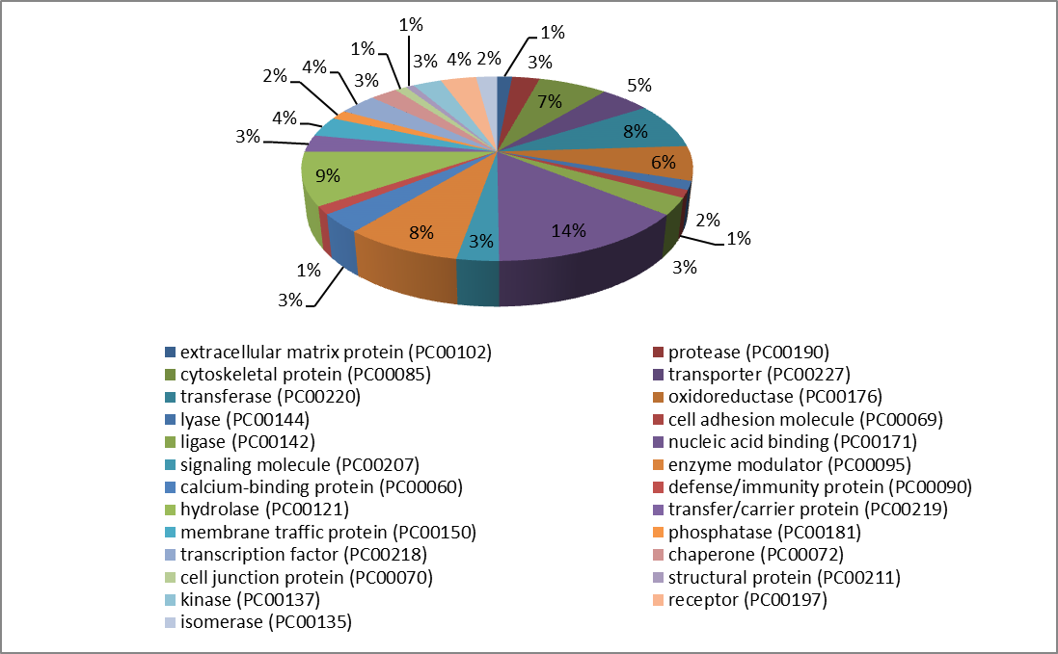

Figure S2 Volcano plot comparing protein expression in full-sibs.

113 vs 117
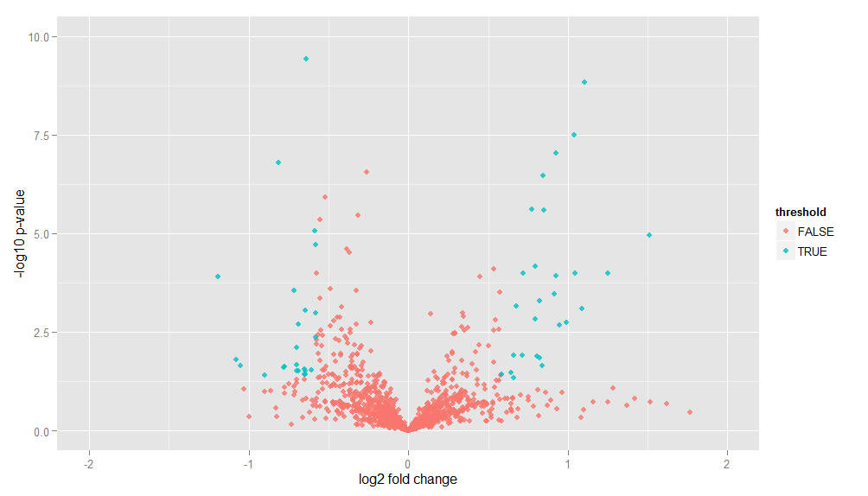

114 vs 118
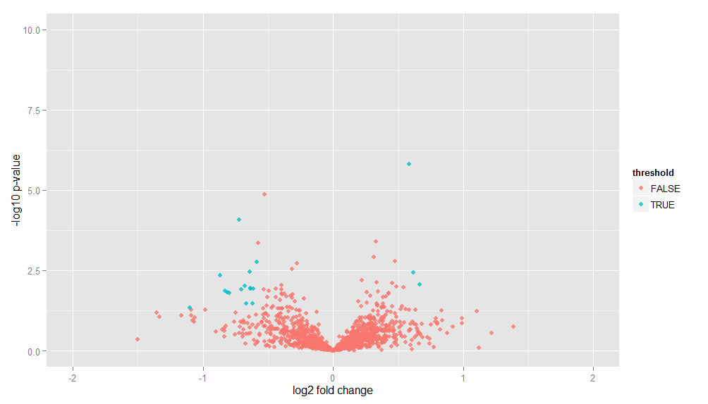

115 vs 119
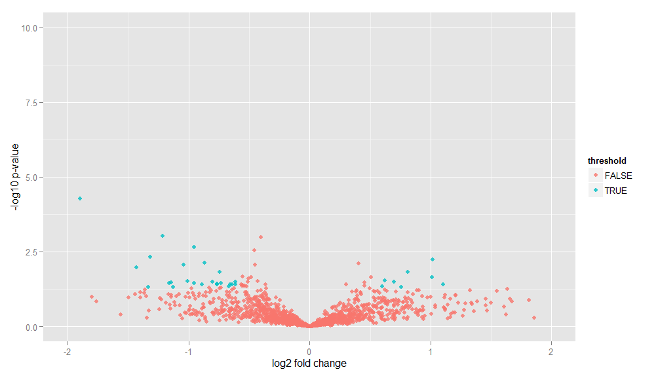

116 vs 121
