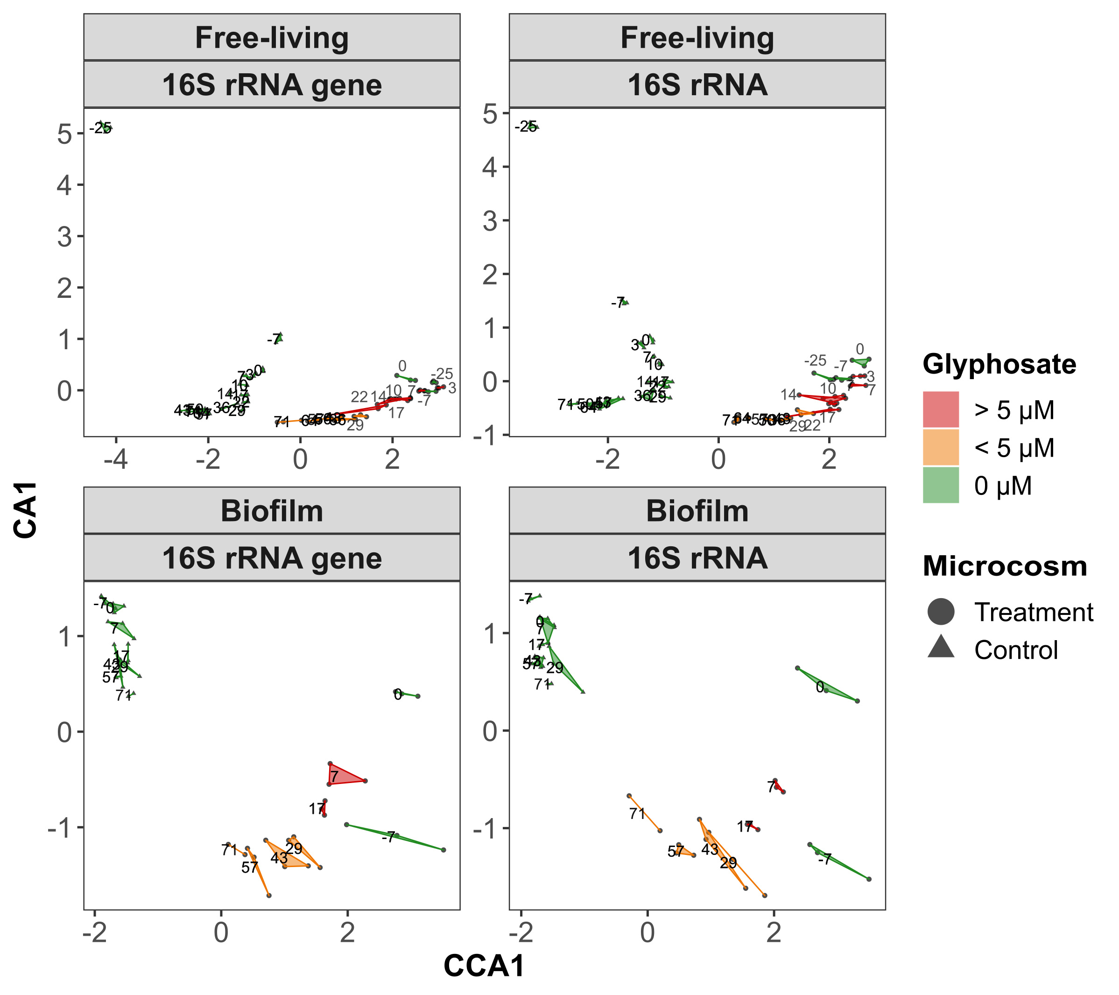
Supplementary Figure 4 A: Canonical correspondence analysis. Free-living communities are partially over-clustering, but a clear separation between treatment and control and largely as well for the different glyphosate concentrations was achieved. Biofilm samples are better separated compared to the NMDS ordination (Figure 3). Treatment communities’ direction of succession changes from day -7 to 0 compared to day 0 to the samples treated with glyphosate (interpreting day 0 as a return point). This change of direction can be assumed in the free-living communities from day -25 to day 0 compared to the following samples.
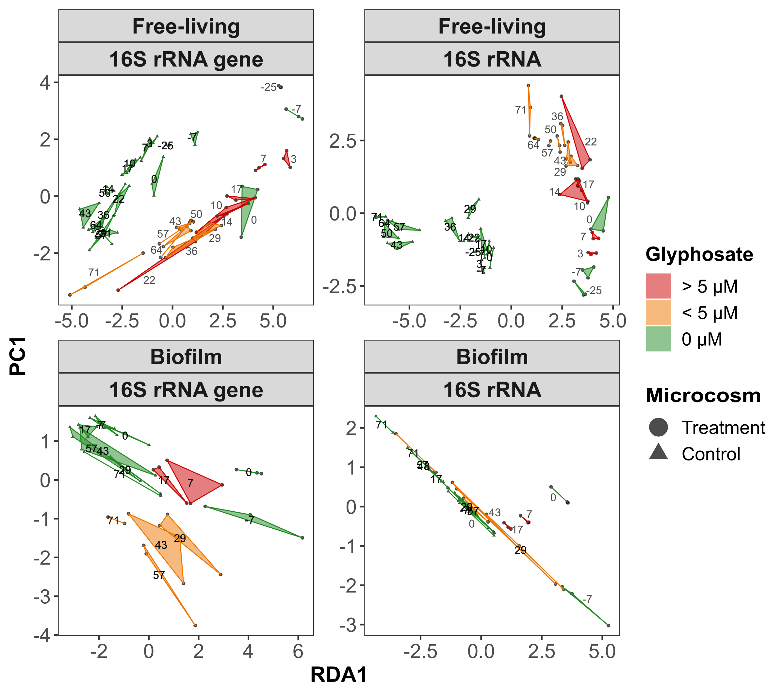
Supplementary Figure 4 B: Redundancy analysis. In the free-living communities, the “turning point” described in Supplementary Figure 4 A can be observed again. 16S rRNA gene samples overlap partially, control and treatment samples are clearly separated. Except shortly after glyphosate addition, the change along the axes converges with the temporal gradient or the glyphosate concentration decrease. The 16S rRNA gene samples are well separated, but show a relative proximity between control and treatment communities. The results for biofilm 16S rRNA communities do not help to explain the impact of glyphosate.

