SUPPLEMENTARY INFORMATION
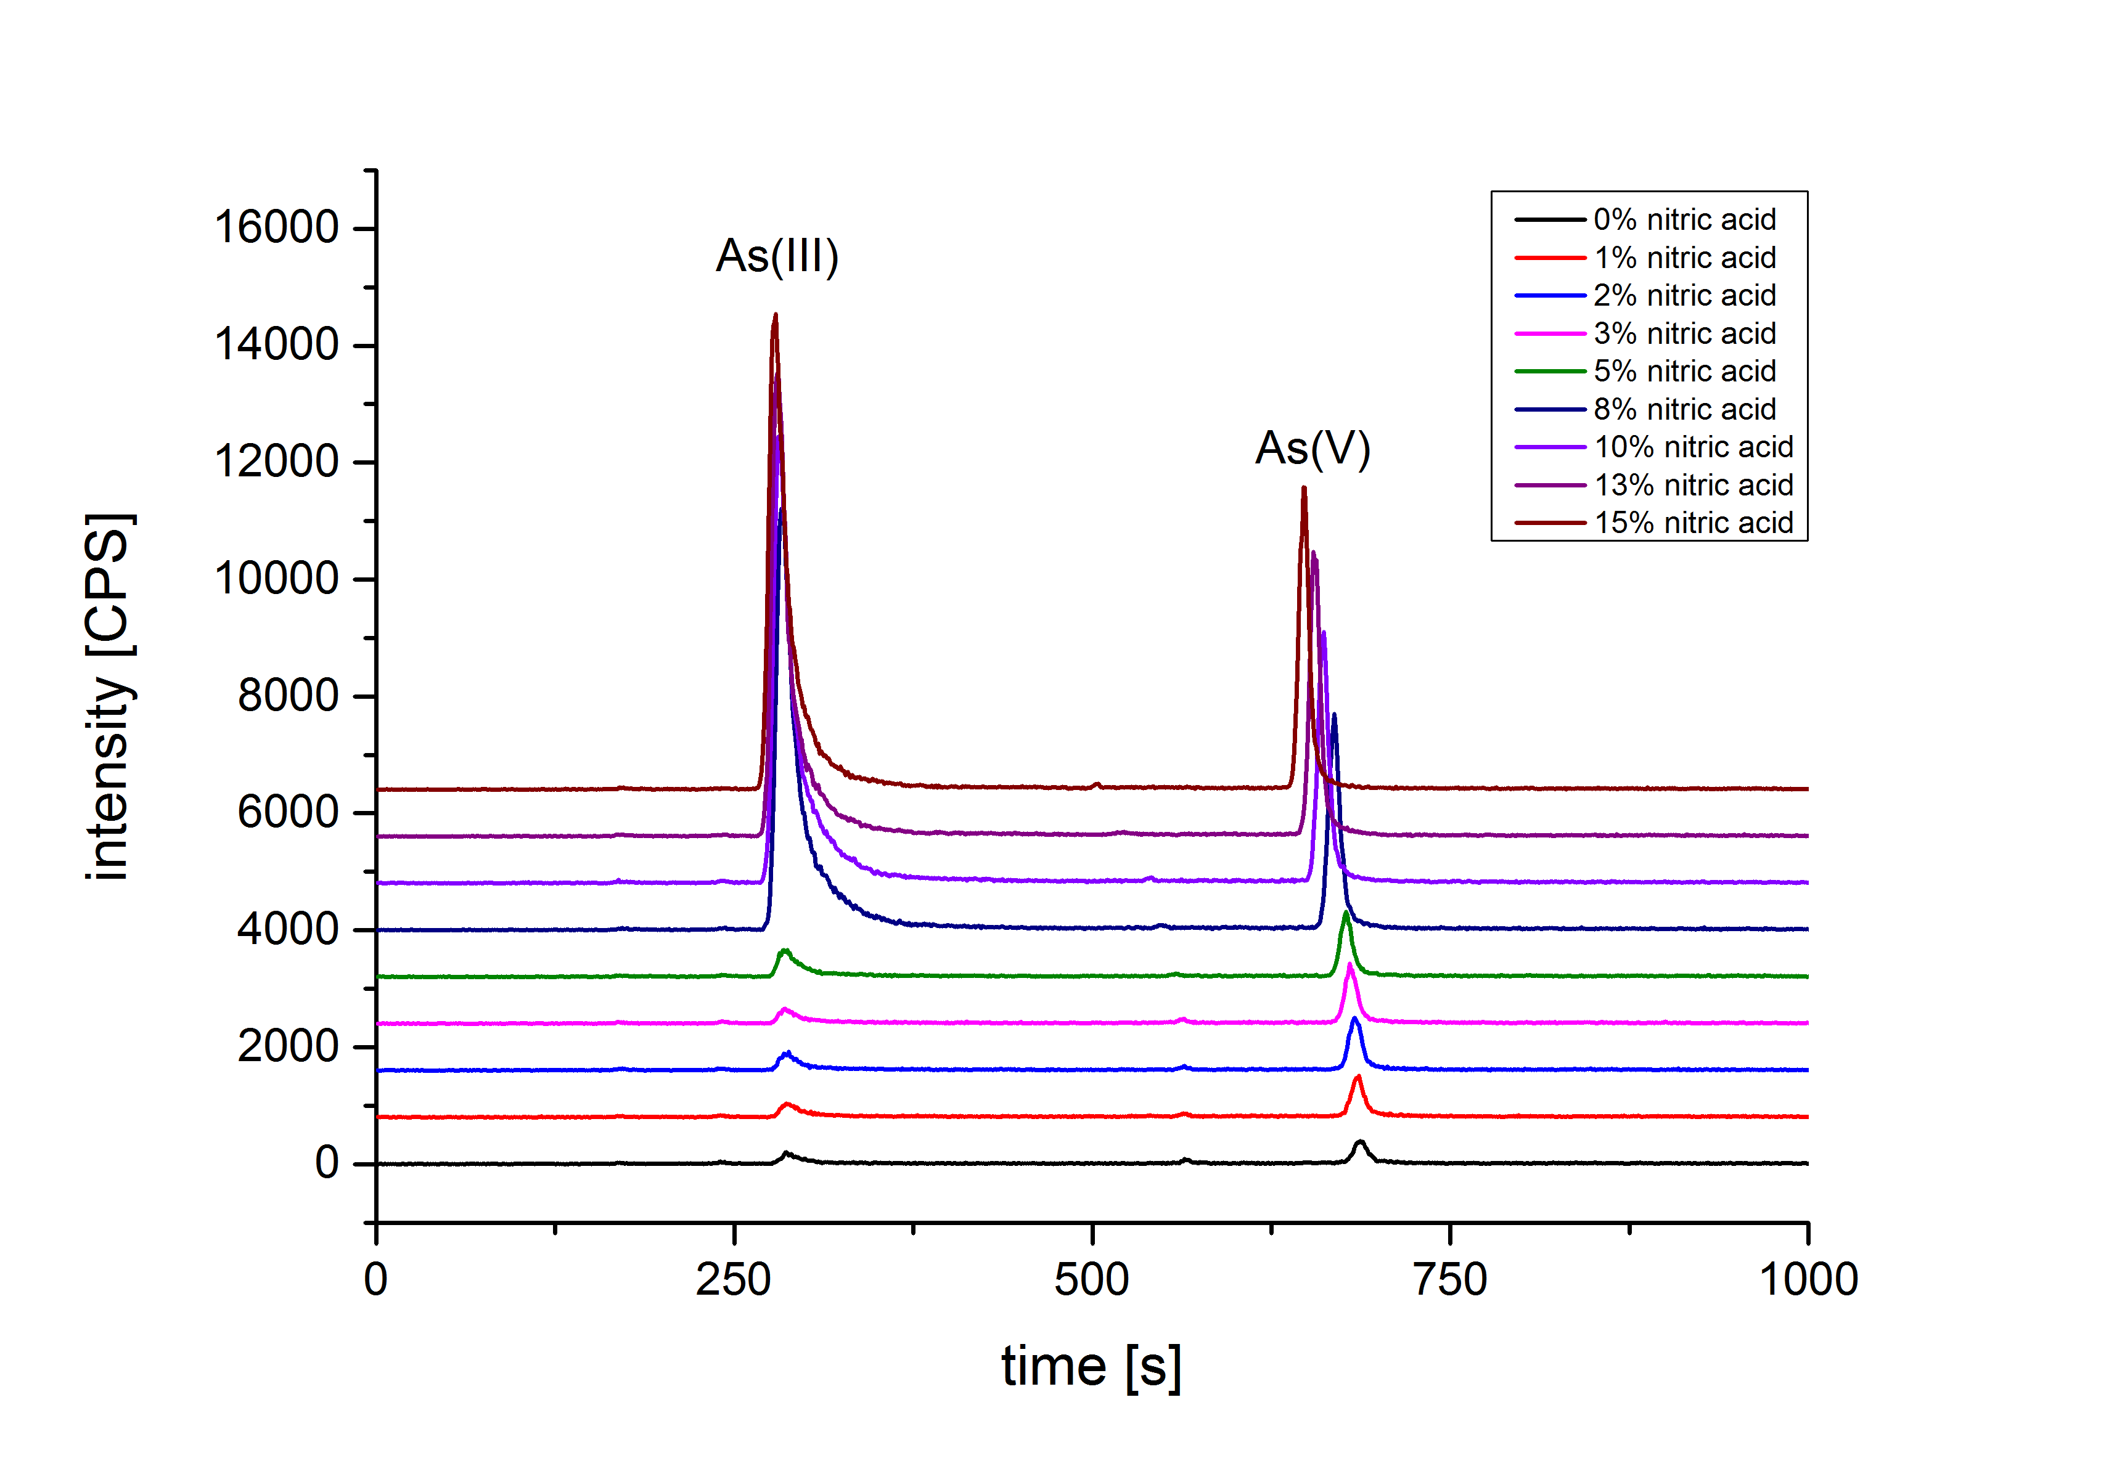
FIGURE 1. Chromatogram of arsenic species in C. sinensis by extracted with different ratios of nitric acid using HPLC-ICP-MS.
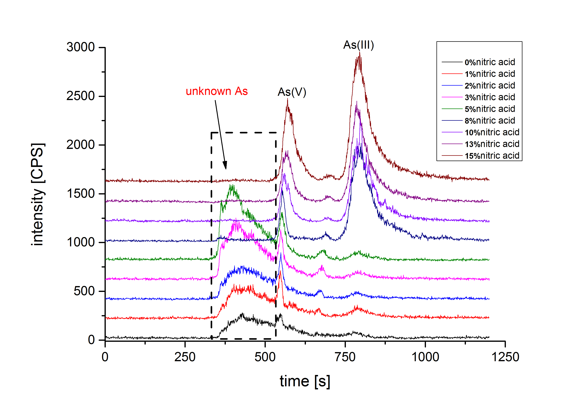
FIGURE 2. Chromatogram of arsenic species extracts with different ratios of nitric acid in C. sinensis by SEC-HPLC-ICP-MS.
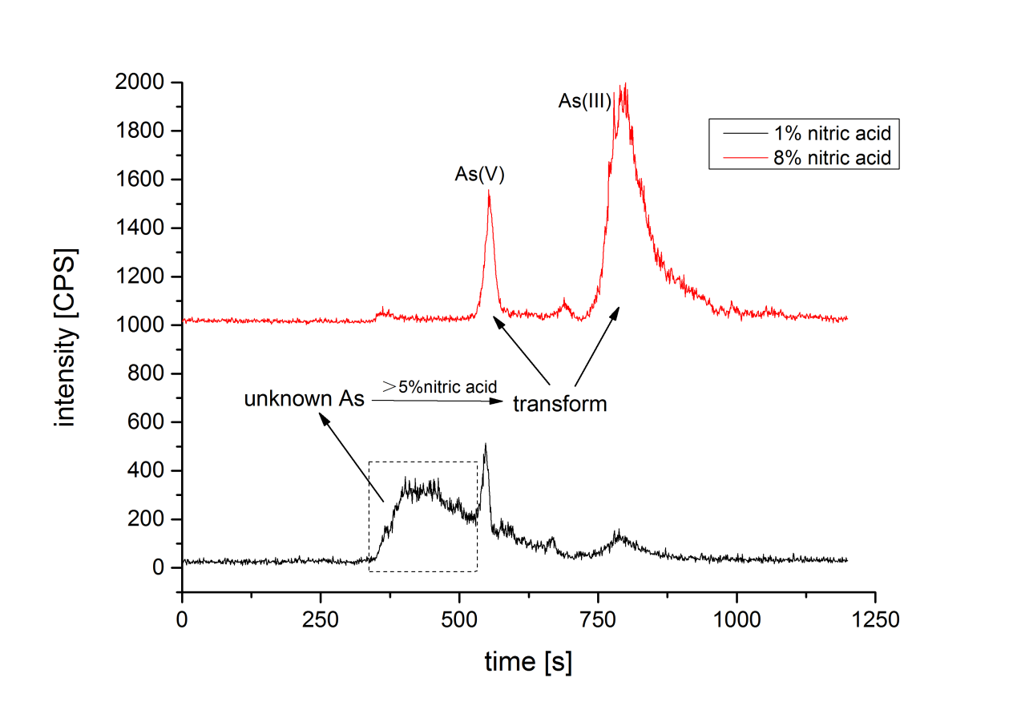
FIGURE 3. Chromatogram of unknown arsenic in C. sinensis and its conversion behavior in the extracts.

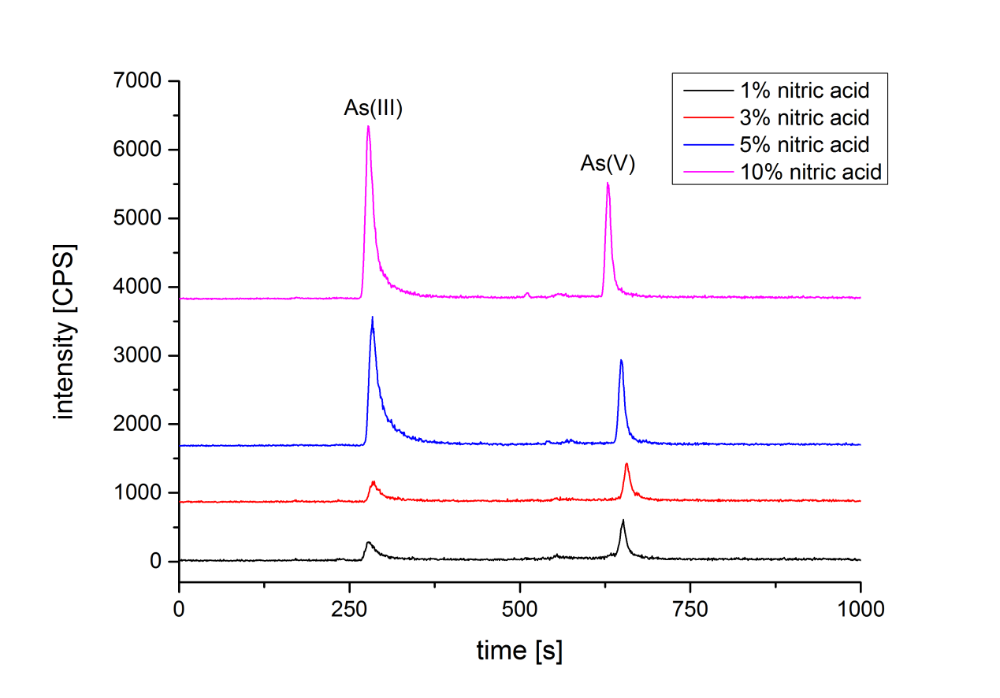
FIGURE 4. Chromatograms of simulated gastric juice extracts treated with different proportions of nitric acid in C. sinensis by HPLC-ICP-MS.
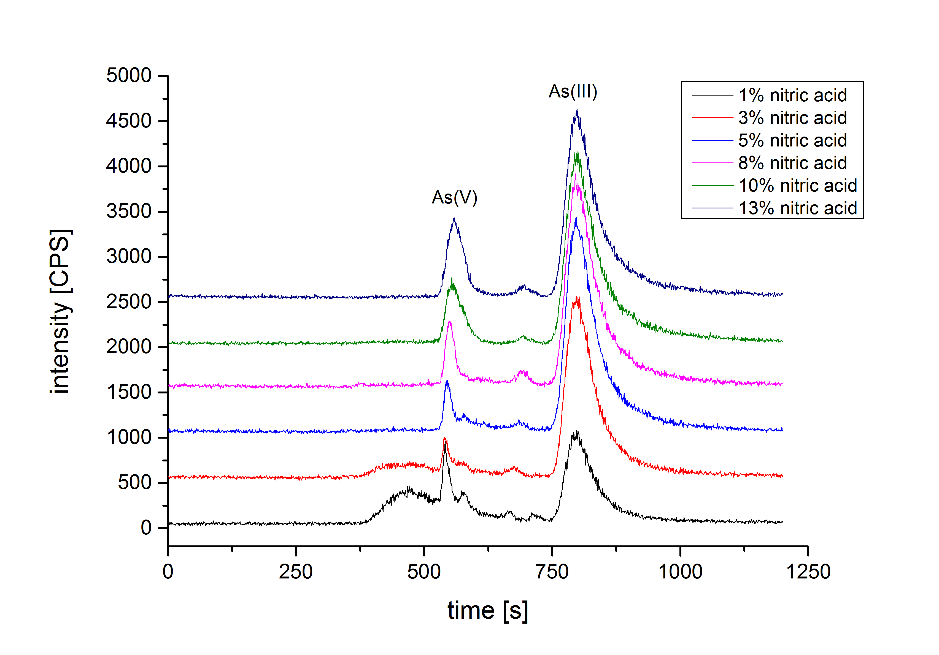
FIGURE 5. Chromatograms of simulated gastric juice extracts treated with different proportions of nitric acid in C. sinensis by SEC-HPLC-ICP-MS.
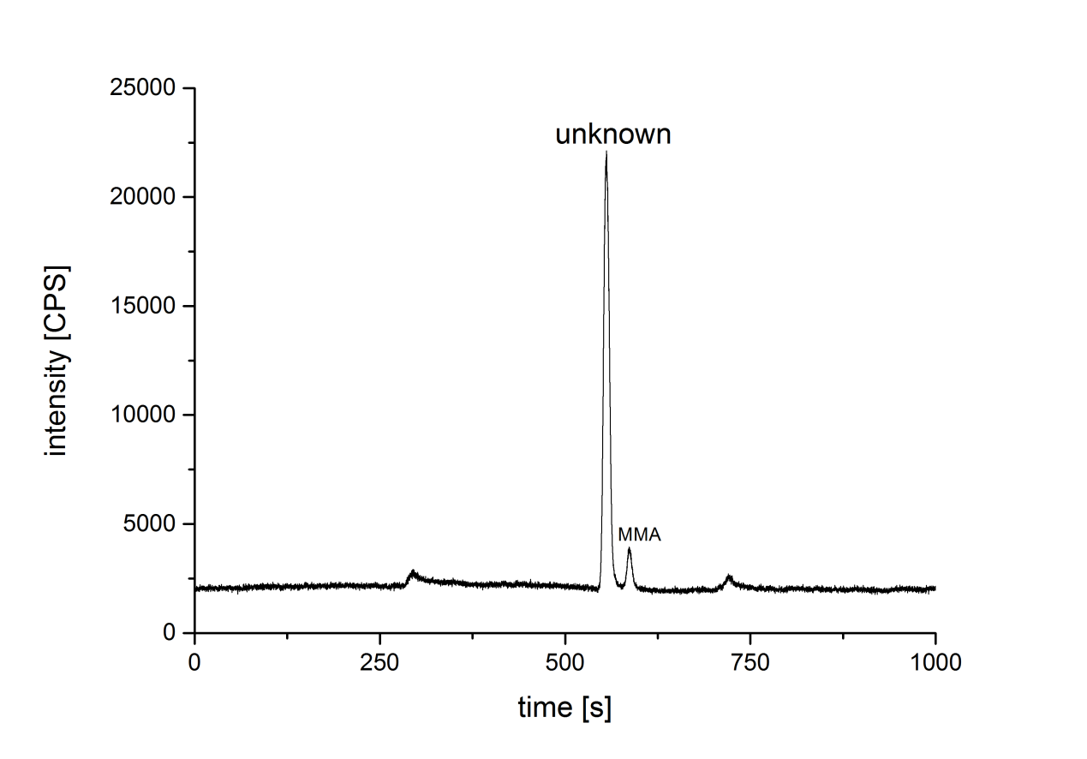
FIGURE 6. MMA conversion chromatogram under extracted conditions.

FIGURE 7. The results of arsenic transformation .

TABLE 1. Sample collection information in present study
Code | Location | Latitude | Longitude
C1 | Qinghai | 32°33′17N | 097°12′17E
C2 | Qinghai | 32°56′31N | 095°43′00E
C3 | Qinghai | 34°13′22N | 100°14′02E
C4 | Qinghai | 34°13′48N | 100°01′50E
C5 | Qinghai | 35°26′45N | 100°36′21E
C6 | Qinghai | 36°00′40N | 099°44′01E
C7 | Qinghai | 34°04′24N | 102°07′08E
C8 | Qinghai | 34°04′24N | 102°16′57E
C9 | Tibet | 31°21′19N | 097°42′22E
C10 | Tibet | 31°04′25N | 096°58′48E
C11 | Tibet | 31°48′33N | 093°34′18E
C12 | Tibet | 31°44′28N | 092°40′24E
C13 | Gansu | 34°04′24N | 102°07′08E
C14 | Yunnan | 28°24′22N | 098°59′07E
C15 | Sichuan | 31°35′06N | 099°41′47E
C16 | Sichuan | 30°00′40N | 100°18′56E
C17 | Qinghai | 32°33′17N | 097°12′17E

