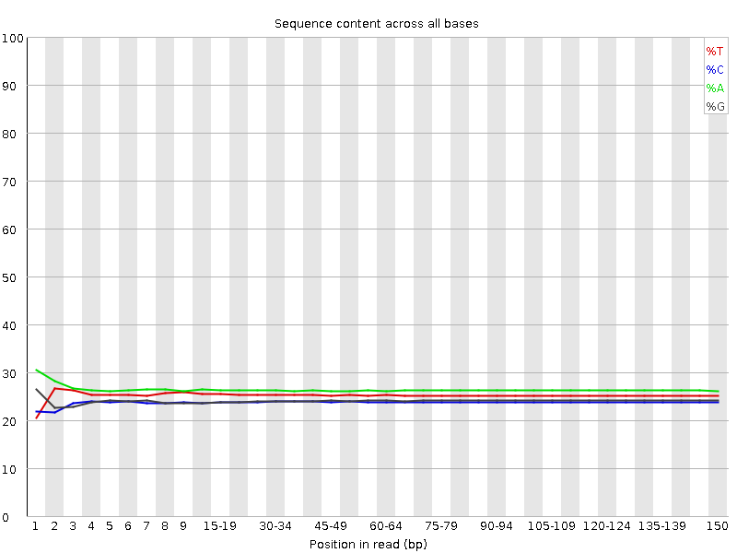
Figure S1 Base distribution for whole-genome resequencing data.

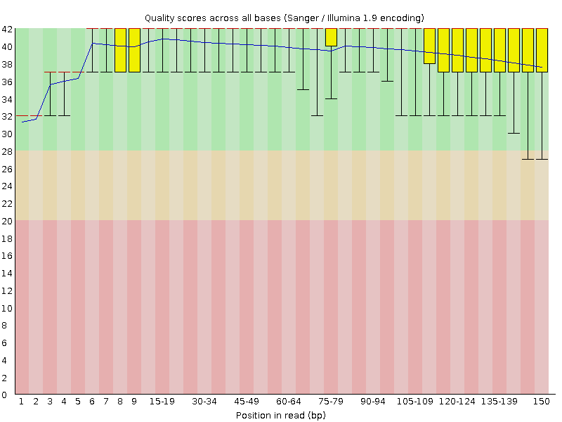
Figure S2 Base quality distribution for whole-genome resequencing data.

Figure S3 GC content and average sequencing depth of the genome data of Gp. lemaneiformis (Zhou et al. 2013).

Zhou, W., Hu, Y. Y., Sui, Z. H., Fu, F., Wang, J. G., Chang, L. P., Guo, W. H., Li, B. B. 2013. Genome Survey Sequencing and Genetic Background Characterization of Gracilariopsis lemaneiformis (Rhodophyta) Based on Next-Generation Sequencing. PloS One 8:e69909.

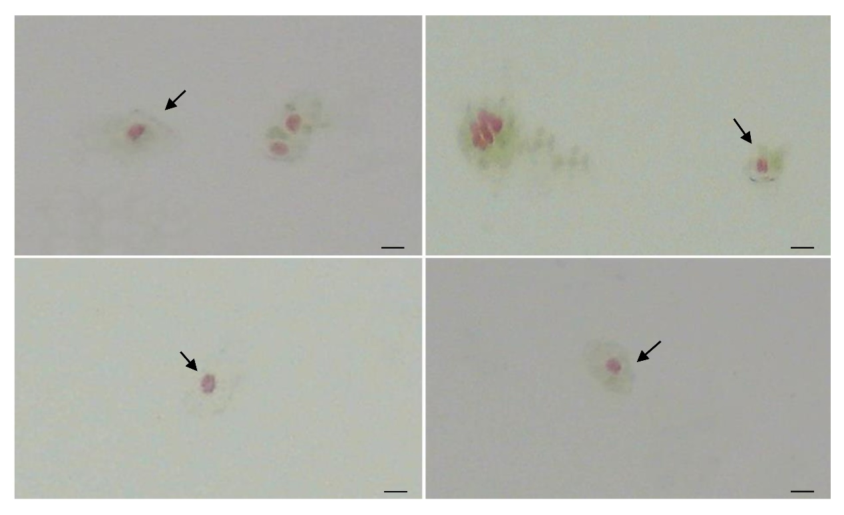
Figure S4 Single cell of gametophyte selected by capillary glass tube (Scale bar: 15 μm)

