Supplement: A crop modeling approach for precision cost-benefit analysis of variable seeding and nitrogen application rates

Supplement
Figure S1. Monthly averaged daily solar radiation, precipitation, and temperature values obtained from Daymet weather service for associated simulation years.
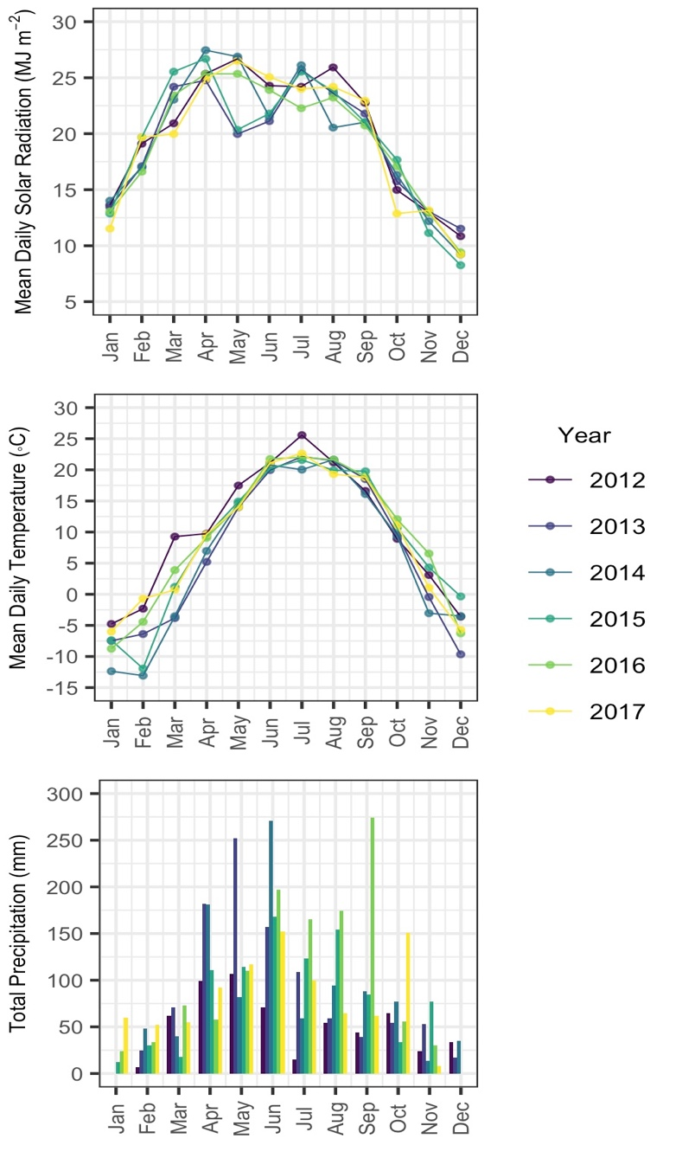

Table S1. Physical soil properties associated with each subfield soil type. Values are converted from data available in SSURGO and used to initialize the APSIM model.
Mapunit Key (Mukey) |  | Symbol |  | Description |  | Area (ha) |  | Bulk density (g/cm³) |  | Drained upper limit (mm/mm) |  | Lower limit (mm/mm) |  | Saturated water capacity (mm/mm) |  | Hydraulic conductivity (mm/day) |  | Initial Organic Carbon (%)
403351 |  | 153 |  | Shandep clay loam, 0 to 1 percent slopes |  | 8.4 |  | 1.38 |  | 3.61 |  | 2.67 |  | 0.48 |  | 259.2 |  | 4.64
403362 |  | 174 |  | Bolan loam, 0 to 2 percent slopes |  | 3.2 |  | 1.53 |  | 2.22 |  | 1.32 |  | 0.42 |  | 2419.2 |  | 1.16
403363 |  | 174B |  | Bolan loam, 2 to 5 percent slopes |  | 6.1 |  | 1.53 |  | 2.22 |  | 1.32 |  | 0.42 |  | 2419.2 |  | 1.16
403374 |  | 198B |  | Floyd loam, 1 to 4 percent slopes |  | 13.6 |  | 1.35 |  | 3.50 |  | 2.46 |  | 0.49 |  | 259.2 |  | 4.35
403393 |  | 377B |  | Dinsdale silty clay loam, 2 to 5 percent slopes |  | 1.0 |  | 1.48 |  | 2.14 |  | 1.25 |  | 0.44 |  | 2419.2 |  | 1.16
403395 |  | 382 |  | Maxfield silty clay loam, 0 to 2 percent slopes |  | 10.1 |  | 1.32 |  | 3.33 |  | 2.06 |  | 0.50 |  | 259.2 |  | 2.90
403397 | 394 |  | Ostrander loam, 0 to 2 percent slopes |  | 4.6 |  | 1.35 |  | 3.06 |  | 1.70 |  | 0.49 |  | 777.6 |  | 2.32 |  | 1.8623482
403398 | 394B |  | Ostrander loam, 2 to 5 percent slopes |  | 0.4 |  | 1.35 |  | 3.06 |  | 1.70 |  | 0.49 |  | 777.6 |  | 2.32 |  | 0.1619433
403404 | 407B |  | Schley silt loam, 1 to 4 percent slopes |  | 8.7 |  | 1.35 |  | 3.50 |  | 2.46 |  | 0.49 |  | 259.2 |  | 4.35 |  | 3.5222672
403442 | 83B |  | Kenyon loam, 2 to 5 percent slopes |  | 12.7 |  | 1.48 |  | 2.14 |  | 1.25 |  | 0.44 |  | 2419.2 |  | 1.16 |  | 5.1417004
403446 | 84 |  | Clyde silty clay loam, 0 to 3 percent slopes |  | 1.3 |  | 0.35 |  | 5.34 |  | 2.21 |  | 0.87 |  | 432.0 |  | 43.50 |  | 0.5263158

Table S2. Yield and ROI RMSE (all soils and years).
N-rate | Group | Sample size | Yield RMSE (kg ha⁻¹) | Yield NRMSE (%) | ROI RMSE (%)
200 | w/ 403446 | 66 | 2171.8 | 21.0 | 27.1
200 | no 403446 | 48 | 1645.0 | 15.5 | 21.5

Table S3. Subfield Yield and ROI RMSE by soil (all years).
SSURGO Soil | Sample size | Yield RMSE (kg ha⁻¹) | ROI RMSE (%)
403351 | 6 | 2157.5 | 24.4
403362 | 6 | 1450.6 | 23.8
403363 | 6 | 1518 | 15.2
403374 | 6 | 1961.8 | 24.3
403393 | 6 | 1645.7 | 21.8
403395 | 6 | 1433.5 | 23.5
403397 | 6 | 2468.1 | 32.2
403398 | 6 | 1917.2 | 29.8
403404 | 6 | 1422.6 | 19.5
403442 | 6 | 1396.4 | 17.9
403446 | 6 | 4524 | 49.7

Table S4. Mean modeled and observed annual yield, profit, and ROI estimates corresponding with each subfield soil. Observations derived from spatially averaged precision yield monitor data.
SSURGO Soil | Modeled Yield (kg ha⁻¹) | Precision Yield (kg ha⁻¹) | Modeled Profit ($ ha⁻¹) | Precision Profit ($ ha⁻¹) | Modeled ROI (%) | Precision ROI (%)
403351 | 9629.3 | 9849.8 | -47.1 | -97.5 | -8.3 | -12.1
403362 | 9814.3 | 10014.9 | 0.8 | -109.5 | -2.6 | -13.0
403363 | 9814.3 | 11078.8 | 0.8 | -15.4 | -2.6 | -2.6
403374 | 9746.3 | 10280.9 | -18.8 | -64.1 | -5.0 | -8.2
403393 | 9871.6 | 11091.7 | 6.3 | -19.8 | -1.9 | -3.0
403395 | 10078.0 | 10597.0 | -0.4 | -57.3 | -2.7 | -7.1
403397 | 13643.2 | 9952.8 | 245.6 | -88.4 | 30.2 | -11.0
403398 | 10770.3 | 10834.2 | 86.0 | -41.3 | 7.7 | -5.5
403404 | 9586.9 | 10824.6 | -22.5 | -46.6 | -5.4 | -5.9
403442 | 9767.3 | 11073.1 | -3.0 | -17.1 | -3.0 | -2.7
403446.0 | 10342.3 | 8231.0 | 32.3 | -196.9 | 1.2 | -23.5
All Soils | 10278.5 | 10348.1 | 25.5 | -68.5 | 0.7 | -8.6

Table S5. Yield and ROI RMSE (all plots and years).
Year | Sample Size | Yield RMSE (kg ha⁻¹) | Yield NRMSE (%) | ROI RMSE (%)
2015 | 48 | 2490.6 | 22.1 | 12.1
2016 | 48 | 3075.2 | 31.2 | 15.4

Table S6. Yield and ROI RMSE by experimental zone (all years).
Zone | Sample Size | Yield RMSE (kg ha⁻¹) | Yield NRMSE (%) | ROI RMSE (%)
Expense-limited | 32 | 1449.6 | 13.1 | 7.1
No-cost | 32 | 4313.6 | 47.9 | 21.3
Revenue | 32 | 1667.6 | 14.4 | 8.4

Table S7. Gap analysis between agronomic and economic optimum seeding density and N-fertilizer rates. Value gaps represent the reduction of inputs or outputs that separates the argonomic optimum from the economic optimum. Negative values indicates an increase of the corresponding input or output value associated with the economic optimum.
Mukey | Year | Seed Density Gap  (seed m²) | N-fertilizer Gap  (kg ha⁻¹) | Yield Gap  (kg ha⁻¹) | ROI Gap  (%) | NO~3~ Leaching Gap  (kg ha⁻¹) | N~2~O Emissions Gap  (kg ha⁻¹)
403351 | 2015 | 5 | 200 | 423.1 | 12.1 | 5.8 | 25.7
403362 | 2015 | 5 | 130 | 466.1 | 10.3 | 3.8 | 10.4
403363 | 2015 | 5 | 130 | 466.1 | 10.3 | 3.8 | 10.4
403374 | 2015 | 6 | 170 | 830.5 | 11.0 | 6.9 | 14.0
403393 | 2015 | 5 | 130 | 474.7 | 10.2 | 1.6 | 9.3
403395 | 2015 | 5 | 180 | 469.8 | 11.7 | 4.2 | 19.9
403397 | 2015 | 5 | 190 | 506.7 | 11.8 | 3.6 | 18.8
403398 | 2015 | 5 | 180 | 483.8 | 11.6 | 3.8 | 16.5
403404 | 2015 | 5 | 130 | 476.1 | 10.2 | 2.7 | 8.5
403442 | 2015 | 5 | 120 | 461.6 | 10.0 | 1.5 | 8.6
403446 | 2015 | 5 | 170 | 507.0 | 11.2 | 2.3 | 20.6
403351 | 2016 | 4 | 25 | 440.8 | 5.6 | 2.7 | 0.5
403362 | 2016 | 2 | 0 | 110.1 | 3.1 | -8.8 | -0.7
403363 | 2016 | 2 | 0 | 110.1 | 3.1 | -8.8 | -0.7
403374 | 2016 | 2 | 10 | 389.6 | 1.6 | -0.5 | -0.1
403393 | 2016 | 1 | 0 | 99.6 | 1.3 | -2.2 | -0.5
403395 | 2016 | 3 | 35 | 728.1 | 2.4 | 8.7 | 1.8
403397 | 2016 | 6 | 60 | 897.1 | 8.0 | 15.2 | 2.9
403398 | 2016 | 6 | 50 | 870.5 | 7.7 | 13.1 | 1.8
403404 | 2016 | 2 | 5 | 289.7 | 2.1 | -4.0 | -0.5
403442 | 2016 | 1 | 5 | 263.3 | 0.3 | -0.9 | -0.2
403446 | 2016 | 3 | 25 | 618.8 | 2.6 | 1.2 | 0.7

