**Supplementary Material**

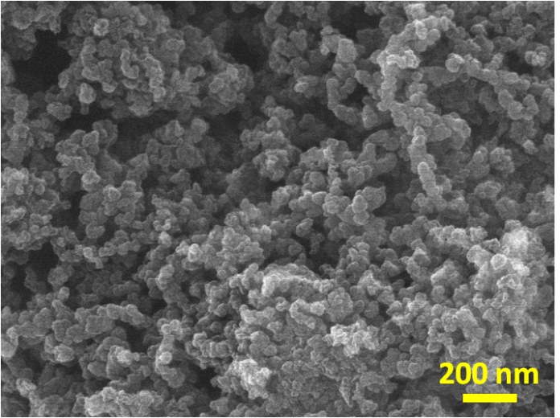

**FIGURE S1** FESEM image of the N-KC sample.

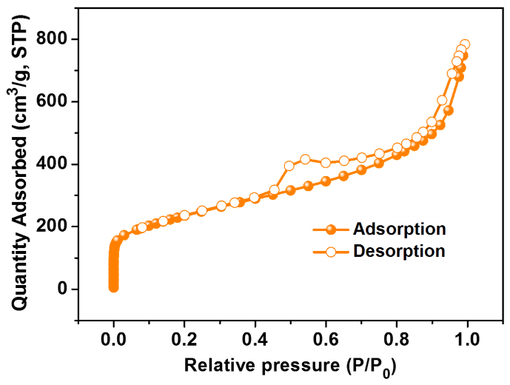

**FIGURE S2** Nitrogen adsorption-desorption isotherm of Co3O4/N-KC sample.

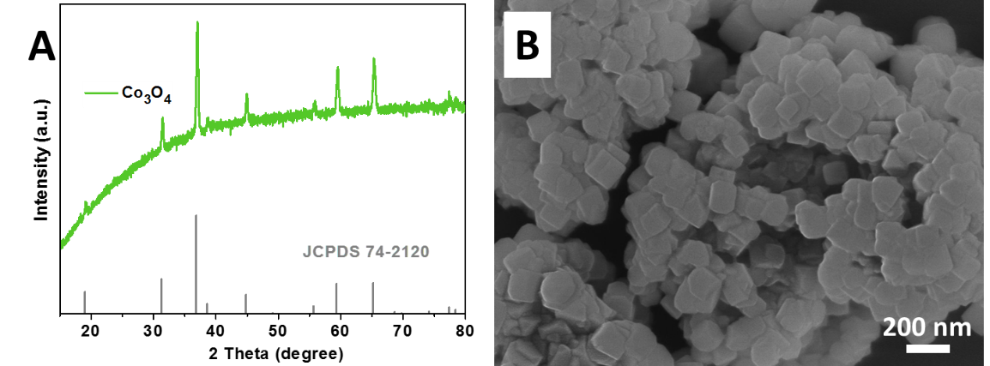

**FIGURE S3** **(A)** XRD pattern and **(B)** FESEM image of the pure Co3O4 sample.

As shown in the XRD pattern (Figure S3A), all the typical diffraction peaks demonstrate that the Co3O4 structure with high purity is synthesized (cubic, Fd-3m, a = b = c = 8.084 Å, JCPDS: 742120). Figure S3B indicates the Co3O4 structure exhibits the shape of nanocube with an average particle size of ~ 85.3 nm.



**FIGURE S4** Co3O4/N-KC sample in O2-saturated KOH (0.1 M) with a scan rate of 5 mV s−1 at the different rotation speeds.

**Table S1** Parameters of ORR performance (*E*onset and Limiting current density) for previously reported non-noble metal samples measured in alkaline solution.

|  |  |  |  |
| --- | --- | --- | --- |
| Sample | *E*onset (V) | Limiting current density (mA cm-2) | Ref |
| Co3O4/N-KC | 0.87 | 5.70 | This work |
| CoIn2S4/S-rGO | 0.93 | ~ 5.57 | Fu et al., 2018 |
| Co/CoO/graphene | 0.87 | 4.53 | Guo et al., 2012 |
| Co3O4-NP/N-rGO | 0.89 | 5.48 | Han, et al., 2018 |
| NiO/MnO2@PANI | 0.92 | ~ 5.51 | He et al., 2017 |
| Co3O4/Co-N-C | 0.83 | 5.10 | Li et al., 2017 |
| N-Carbon/MnO2 | 0.88 | 5.57 | Li et al., 2018 |
| Co3O4/N-rmGO | 0.88 | 4.55 | Liang et al., 2011 |
| CoOx/C | 0.86 | 4.52 | Liu et al., 2014 |
| CaMnO3/S-300 | 0.92 | 5.52 | Peng. et al., 2018 |

**REFERENCES**

Fu, G., Wang, J., Chen, Y., Liu, Y., Tang, Y., Goodenough, J.B., et al. (2018). Exploring indium-based ternary thiospinel as conceivable high-potential air-cathode for rechargeable Zn-air batteries. *Adv. Energy Mater.* 8:1802263. doi: 10.1002/aenm.201802263

Guo, S., Zhang, S., Wu, L., and Sun, S. (2012). Co/CoO nanoparticles assembled on graphene for electrochemical reduction of oxygen. *Angew. Chem. Int. Ed.* 51, 11770-11773. doi: 10.1002/anie.201206152

Han, X., He, G., He, Y., Zhang, J., Zheng, X., Li, L., et al. (2018). Engineering catalytic active sites on cobalt oxide surface for enhanced oxygen electrocatalysis. *Adv. Energy Mater.* 8:1702222. doi: 10.1002/aenm.201702222

He, J., Wang, M., Wang, W., Miao, R., Zhong, W., Chen, S.Y., et al. (2017). Hierarchical mesoporous NiO/MnO2@PANI core-shell microspheres, highly efficient and stable bifunctional electrocatalysts for oxygen evolution and reduction reactions. *ACS Appl. Mater. Interf.* 9, 42676-42687. doi: 10.1021/acsami.7b07383

Li, J., Zhou, Z., Liu, K., Li, F., Peng, Z., Tang, Y., et al. (2017). Co3O4/Co-N-C modified ketjenblack carbon as an advanced electrocatalyst for Al-air batteries. *J. Power Sources* 343, 30-38. doi: 10.1016/j.jpowsour.2017.01.018

Li, Y., Cao, S., Fan, L., Han, J., Wang, M., and Guo, R. (2018). Hybrid shells of MnO2 nanosheets encapsulated by N-doped carbon towards nonprecious oxygen reduction reaction catalysts. *J Colloid Interface Sci* 527, 241-250. doi: 10.1016/j.jcis.2018.05.056

Liang, Y., Li, Y., Wang, H., Zhou, J., Wang, J., Regier, T., et al. (2011). Co3O4 nanocrystals on graphene as a synergistic catalyst for oxygen reduction reaction. *Nat. Mater.* 10, 780-786. doi: 10.1038/nmat3087

Liu, J., Jiang, L., Tang, Q., Wang, E., Qi, L., Wang, S., et al. (2014). Amide-functionalized carbon supports for cobalt oxide toward oxygen reduction reaction in Zn-air battery. *Appl. Catal. B Environ*. 148-149, 212-220. doi: 10.1016/j.apcatb.2013.10.058

Peng, S., Han, X., Li, L., Chou, S., Ji, D., Huang, H., et al. (2018). Electronic and defective engineering of electrospun CaMnO3 nanotubes for enhanced oxygen electrocatalysis in rechargeable Zinc-air batteries. *Adv. Energy Mater.* 8:1800612. doi: 10.1002/aenm.201800612