Supplementary Material

Gravity modeling
The parameters used in the gravity modeling and the model profiles (Figures S1 to S6) that are not in the principal paper are listed below:
The mean thickness of the oceanic crust at the region: Assumpção et al. (2013) presented discrete values for the Mohorovičić discontinuity in the Ceará Basin. Their value is circa 15 km, in similar distance from the continental shelf as the CP area. Castro et al. (1990) have also considered 15 km to his crustal models for the Potiguar Basin.
The mean thickness of the oceanic crust below the CP: Considering the Airy model, the plateau root is estimated at 8.1 km deep. Using the flexure model with parameters from Oliveira (2008), we estimate the deflection in about 5 km. The range thickness considered for the root is between 5 and 8 km.
Mean thickness of the continental crust: The thickness of the continental crust is the limit of the model, and below this depth, we assumed the mantle as homogeneous and removed its effect by the normal gravity. The value considered is 26 km, as calculated by Oliveira (2008), considering the flexure of the lithosphere, for the same area. With gravity models for the North Brazilian Margin, Nóbrega (2011) indicates that 26 km is the minimum value for the thickness near the COB, and it certainly increases quickly towards the continent.
Mean thickness of the sediments: We analyzed the sediments thickness in selected seismic profiles from the 258 survey by WesternGeco (available in: <http://www.brasil-rounds.gov.br/arquivos/Seminarios_r11/tec_ambiental/Bacia_Potiguar.pdf>). Jovane et al. (2016) estimate the sediment thickness above the gravimetric anomaly estimated at 400 m.
Sediment density: The CES-0112-CE well drilled in 1993 by ANP on the continental shelf is used for estimating the sediment density, between 2.0 and 3.2 g/cm³. The average density for the sediment layers considers that the volume of each lithology is 2.2 g/cm³.
Crustal and mantle densities: The densities of the crust and the mantle for the Equatorial Margin are not unique. The average densities used are: 2.7 g/cm³ density for the continental upper crust, 2.8 g/cm³ for the continental lower crust, 2.8 g/cm³ for the transitional crust, 2.85 g/cm³ for the oceanic crust, 3.0 g/cm³ for the modified mantle and 3.2 g/cm³ for the mantle. We based these average values on previous studies (Mohriak et al.,1998; Jilinsk et al., 2013; Nóbrega, 2011).
The 2D forward models used to compose the basement surface and the Moho discontinuity (Figures 7 and 8):
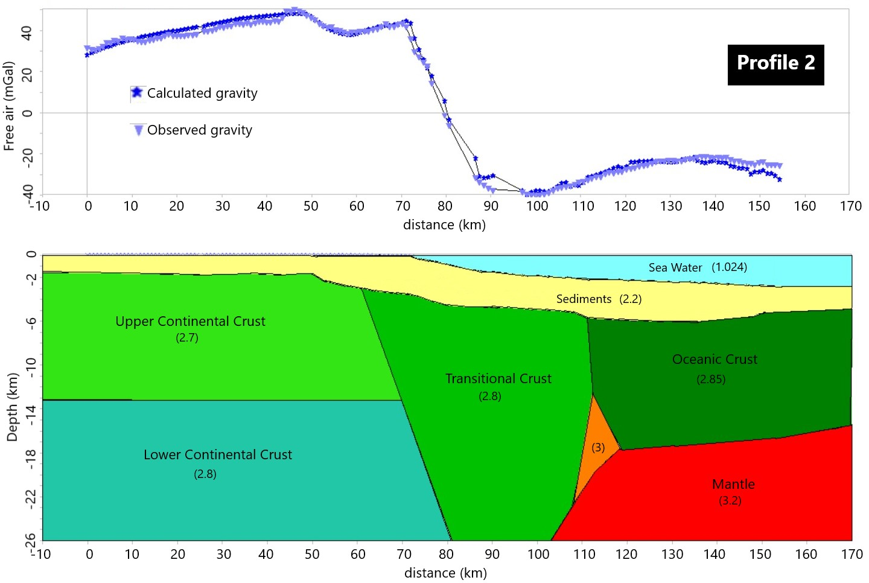
Supplementary Figure 1: Gravimetric model of the profile 2 (S-N) with 2.5x vertical exaggeration. Densities in g/cm³. The density is 3.2 g/cm³ below 26 km depth.
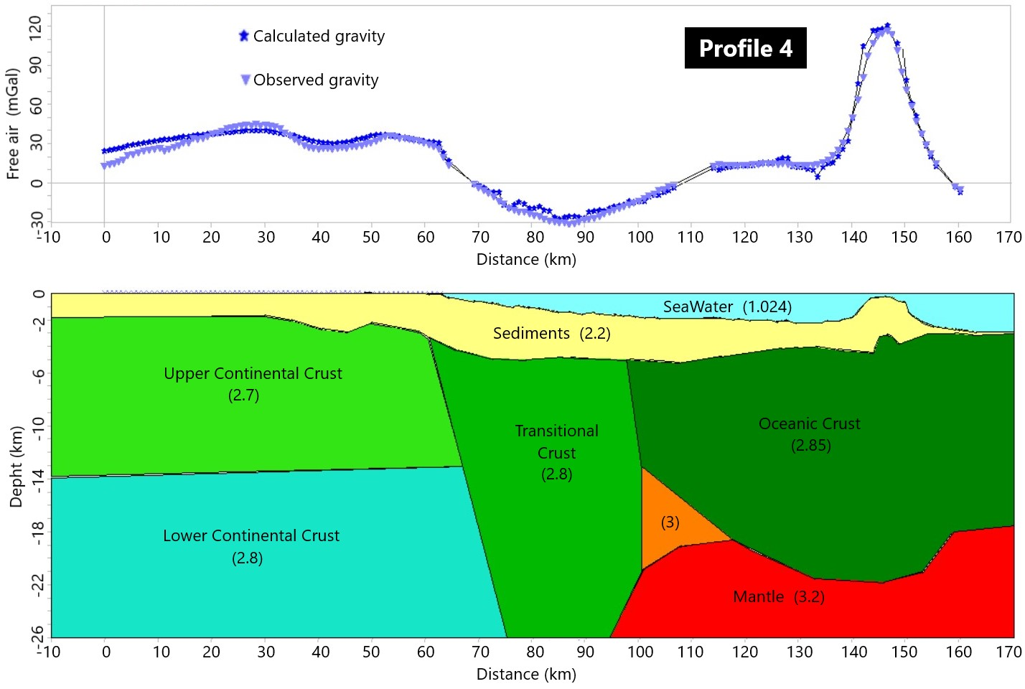
Supplementary Figure 2: Gravimetric model of the profile 4 (S-N) with 2.5x vertical exaggeration. Densities in g/cm³. The density is 3.2 g/cm³ below 26 km depth.

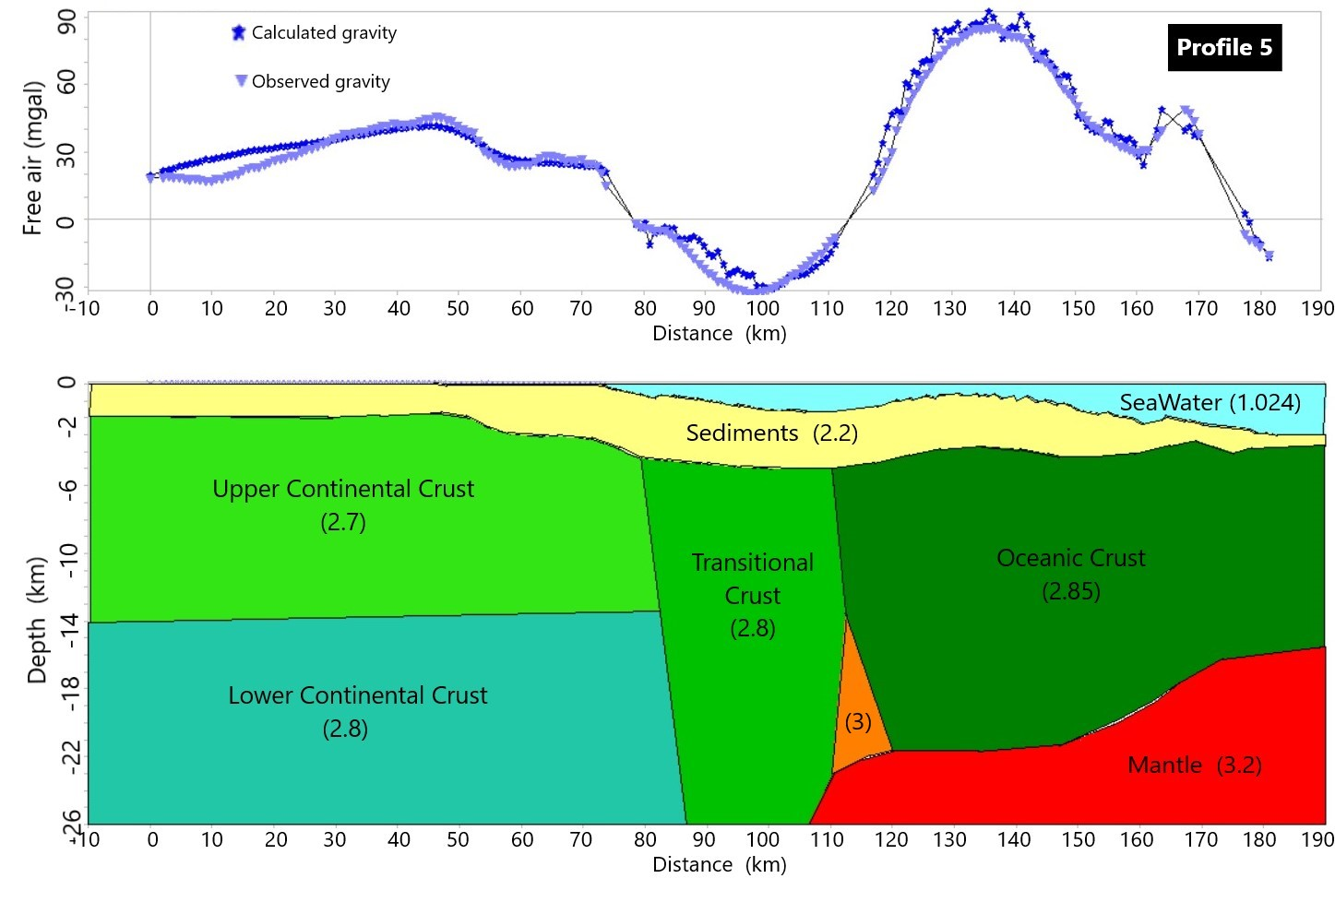
Supplementary Figure 3: Gravimetric model of the profile 5 (S-N) with 2.8x vertical exaggeration. Densities in g/cm³. The density is 3.2 g/cm³ below 26 km depth.

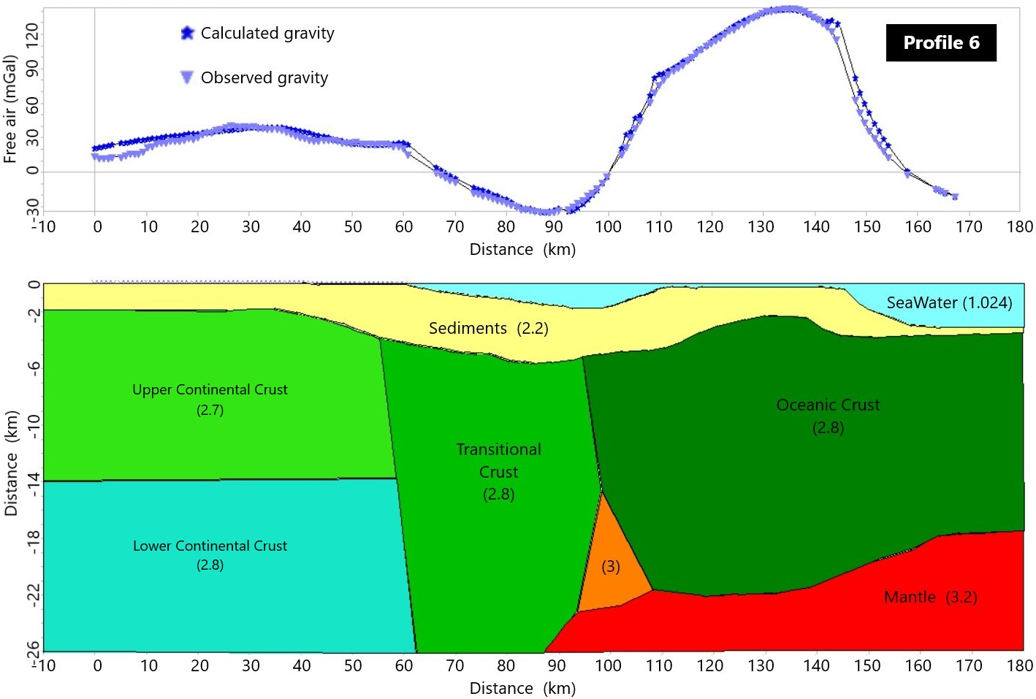
Supplementary Figure 4: Gravimetric model of the profile 6 (S-N) with 2.6x vertical exaggeration. Densities in g/cm³. The density is 3.2 g/cm³ below 26 km depth.

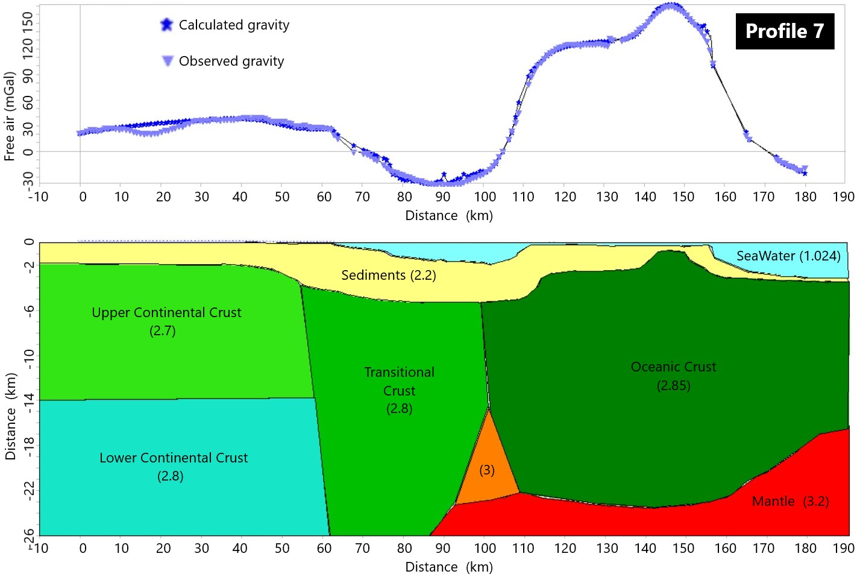
Supplementary Figure 5: Gravimetric model of the profile 7 (S-N) with 2.8x vertical exaggeration. Densities in g/cm³. The density is 3.2 g/cm³ below 26 km depth.

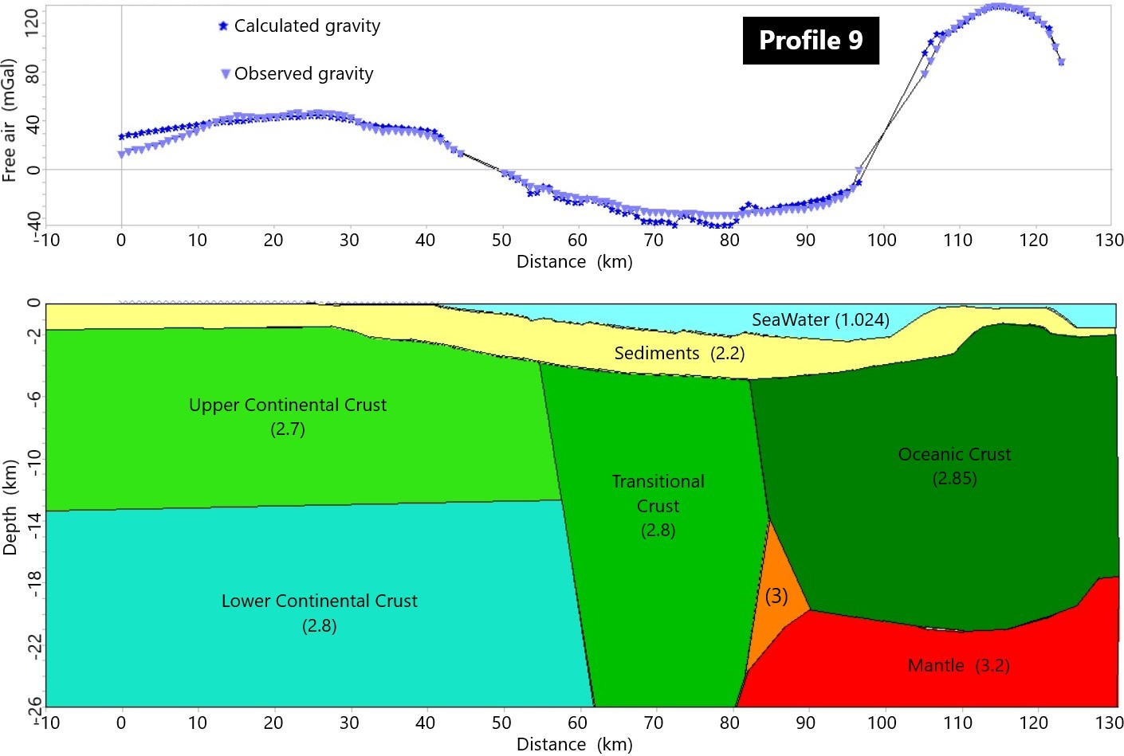
Supplementary Figure 6: Gravimetric model of the profile 9 (S-N) with 1.9x vertical exaggeration. Densities in g/cm³. The density is 3.2 g/cm³ below 26 km depth.

Magnetic modeling
The parameters used on the forward magnetic layer modeling are:
Magnetized layer thickness: The magnetic anomalies do not have deep sources because the rock magnetization needs a thermal stability. The limit for each rock is its Curie temperature; above it the thermal energy is stronger than the magnetic energy and the rocks cannot be magnetized. According to Tharimena et al. (2017) the average limit for a temperature of 500-600 ºC in oceanic lithosphere with 120 Ma is about 30 km.
The layers of the oceanic crust are different, so their magnetization is not homogeneous. The first layer, extrusive or pillow lava layer is the main source of the magnetic anomalies, but the dyke and the gabbro layers also contribute with the magnetization (Gee and Kent, 2007). The mean thickness of the extrusive layer is about 500 m.
The crust around the Ceará Plateau is relatively old, and other magmatic sources as extrusive layers may be representative in the magnetic signal, so, it is considered a 1 km constant thickness layer for modelling. The top of the layer is considered the bathymetric surface.
Magnetization: For the estimation of the magnetization of the oceanic crust there is not a consensual method. There are no samples from the Ceará Plateau, so, it is decided to use published studies. Considering the Ceará Plateau was formed synchronously with the adjacent crust, values are chosen from a sample with similar age and position. The choice is a rock magnetized during the Cretaceous Normal Superchron with 122 Ma, at the Pacific tectonic plate, located at 4ºN with remanent magnetization of 5.9 A/m and the magnetization calculated at the Magnetic Equator of 4.2 A/m (global studies from Juarez et al., 1998). Using those information, it is used 5 A/m for modelling the remanent magnetization.
Parameters of the magnetic field during the survey: The inclination and declination of the total magnetic field during the survey are calculated by the NGDC calculator (https://www.ngdc.noaa.gov/geomag-web/#igrfwmm):
Inclination = -7.2392º
Declination = -21.4236º
Age grid of the area: The estimated age for the oceanic crust is used from the NGDC data bank (MÜLLER et al., 2008) (figure S7).
Polarity grid of the area: The polarity inversions table used for the modelling is from Cande and Kent (1995) (figure S8).

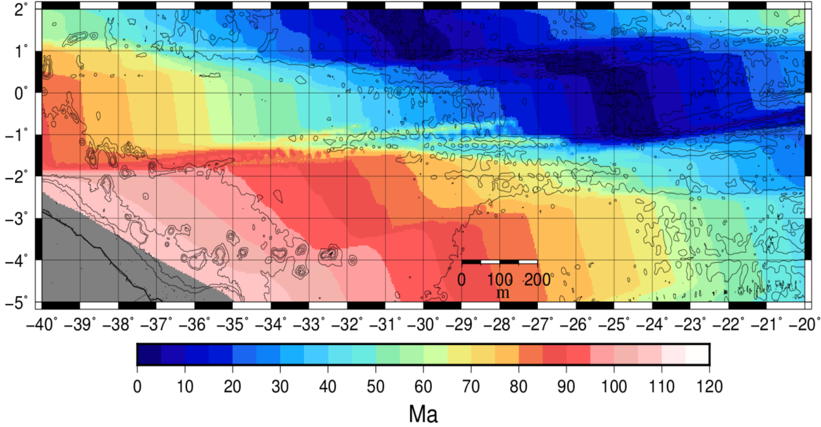
Supplementary Figure 7: Age grid for the oceanic crust at the Equatorial Margin. Bathymetric contour each 1000 m. Grid interval of 30 seconds (approximately 900 m).
Supplementary Figure 8: Magnetic polarity map for the oceanic crust at the Equatorial Margin. Bathymetric contour each 1000 m. Grid interval of 30 seconds (approximately 900 m).

References for the supplementary material
Assumpção, M., Feng, M., Tassara, A., Julia, J. Models of crustal thickness for South America from seismic refraction, receiver functions and surface wave tomography. Tectonophysics, v. 609, p. 82–96, 2013. DOI: 10.1016/j.tecto.2012.11.014.
Cande, S.C., Kent, D.V. Revised calibration of the magnetic polarity time scale for the Late Cretaceous and Cenozoic. J. Geophys. Res., v. 100, p. 6093–6095, 1995. DOI: 10.1029/94jb03098.
Castro, D. L. Interpretação quantitativa de anomalias gravimétricas ar-livre da Margem Continental Norte Brasileira, Setor Nordeste. 1990. Thesis (Master) – Instituto de Geociências, Universidade Federal do Rio Grande do Norte, Natal.
Gee, J.S., Kent, D.V. Source of oceanic magnetic anomalies and the geomagnetic polarity timescale, In: KONO, M., Treatise on geophysics. The Netherlands: Elsevier, 2007. v. 5, p. 455–507. DOI: 10.1016/b978-044452748-6/00097-3.
Jilinski, P., Meju, M.A., Fontes, S.L. Demarcation of continental-oceanic transition zone using angular differences between gradients of geophysical fields. Geophys. J. Int., v. 195, n. 1, p. 276–281, 2013. DOI: 10.1093/gji/ggt216.
Jovane, L., Figueiredo, J.J.P., Alves, D.P.V., Iacopini, D., Giorgioni, M., Vannucchi, P., Moura, D.S., Bezerra F.H.R., Vital, H., Rios, I.L.A., Molina, E.C. Seismostratigraphy of the Ceará Plateau: Clues to Decipher the Cenozoic Evolution of Brazilian Equatorial Margin. Front. Earth Sci., v. 4, n. 90, p. 1–14, 2016. DOI:10.3389/feart.2016.00090.
Juarez, M.T., Tauxe, L., Gee, J.S., Pick, T. The intensity of the Earth's magnetic field over the past 160 million years. Nature, v. 394, n. 6696, p. 878–881, 1998. DOI: 10.1038/29746.
Mohriak, W.U., Bassetto, M., Vieira, I.S. Crustal architecture and tectonic evolution of the Sergipe-Alagoas and Jacuipe basins, offshore Northeastern Brazil. Tectonophysics, v. 288, n. 1–4, p. 199–220, 1998.
Müller, R.D., Sdrolias, M., Gaina, C., Roest, W.R. Age, spreading rates and spreading symmetry of the world's ocean crust. Geochem. Geophys. Geosyst., v. 9, n. 4, 2008. DOI:10.1029/2007GC001743.
Nóbrega, M. Mapeamento de estruturas do embasamento e seus limites crustais no Atlântico Equatorial, adjacente à margem brasileira. 2011. 81 p. Thesis (Master). – Instituto de Geociências, Universidade Federal Fluminense, Niterói.
Oliveira, R.G. Arcabouço geofísico, isostasia e causas do magmatismo cenozoico da Província Borborema e de sua Margem continental (Nordeste do Brasil). 2008. 411 p. PhD Thesis – Centro de Ciências Exatas e da Terra, Universidade Federal do Rio Grande do Norte, Natal.
Tharimena, S., Rychert, C., Harmon, N. A unified continental thickness from seismology and diamonds suggests a melt-defined plate. Science, v. 357, n. 6351, 580–583, 2017. DOI: 10.1126/science.aan0741.

