Supplementary Material
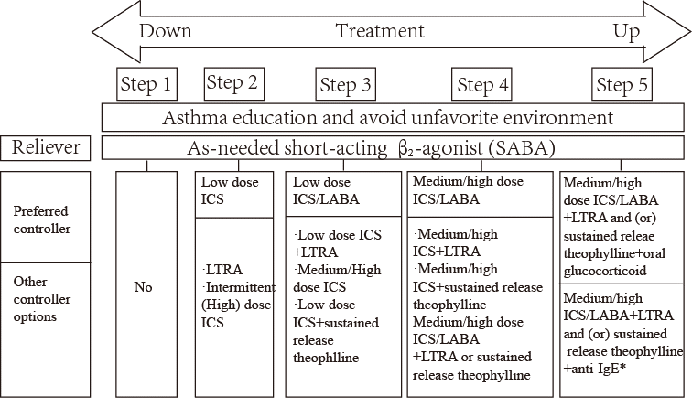
ICS: inhaled corticosteroid; LTRA: Leukotriene receptor antagonists; LABA: Long-acting β2 agonists; *anti-IgE is used for children ≥6 years old
Supplementary Figure 1. Long-term treatment of asthma in children older than or equal to 6 years old.
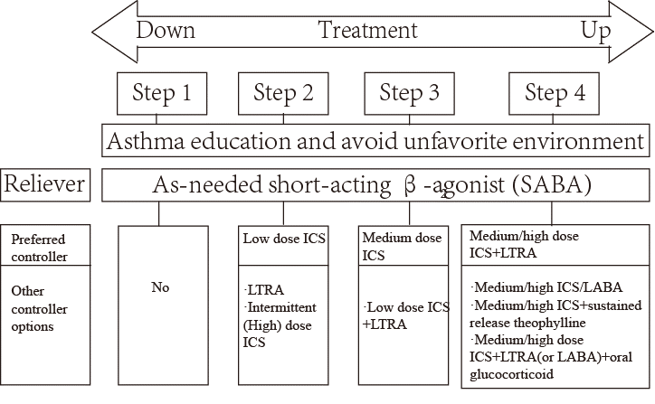
ICS: inhaled corticosteroid; LTRA: Leukotriene receptor antagonists; LABA: Long-acting β2 agonists
Supplementary Figure 2. Long-term treatment of asthma in children younger than 6 years old.

