SUPPLEMENTARY FIGURES

Supplementary figure 1: High resolution imaging identifies hippocampal subfields accurately segmented using automated processing of standard T1-weighted MR images
(A) Panel shows hippocampal subfield volumes determined by high resolution T2-imaging (acquired at 0.4mm in-plane resolution, slice thickness 2mm; x-axis) plotted against standard (1mm isotropic resolution; y-axis) T1 images processed with automated Freesurfer pipeline (v6.0). Each imaging protocol was run sequentially in each participant in the same scan session. Subfields with a cross-correlation coefficient > 0.9 were considered accurate at standard T1 1mm resolution. Those five subfields are highlighted in red box, and (B) depicted on an iso-surface rendering of the whole hippocampus. Only these five subfields are used in subsequent analyses. NB: dentate gyrus here refers to combined segmentation of granule cell layer, molecular layer and dentate gyrus.

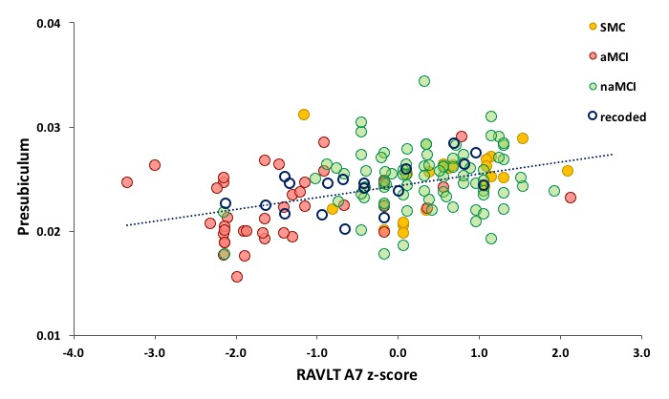

Supplementary Figure 2: Presubiculum volume plotted against delayed recall performance. Participants coloured by group: - consistently categorised as aMCI, naMCI and SMC in both LS and HBA grouping strategies and the 18 recoded subjects.

SUPPLEMENTARY TABLES

Supplementary table 1: Cortical thickness analysis. One-Way ANCOVA analysis of left and right entorhinal cortical thickness. Significant p-values are shown in bold.

Entorhinal thickness (mm) |  |  | Mean Diff | Std. Err | Sig. | 95% Confidence Interval
 |  |  |  |  |  | Lower Bound | Upper Bound
Left | SMC | aMCI | 0.234 | 0.108 | 0.097 | -0.028 | 0.497
 | SMC | naMCI | 0.133 | 0.096 | 0.506 | -0.1 | 0.365
 | aMCI | naMCI | -0.102 | 0.077 | 0.564 | -0.288 | 0.085
Right | SMC | aMCI | .250* | 0.102 | 0.048 | 0.002 | 0.498
 | SMC | naMCI | 0.127 | 0.091 | 0.488 | -0.092 | 0.347
 | aMCI | naMCI | -0.123 | 0.073 | 0.277 | -0.299 | 0.053
Based on estimated marginal means
* The mean difference is significant at the 0.05 level.
b Adjustment for multiple comparisons: Bonferroni.

Supplementary table 2: Follow-up analysis of decline with diagnosis. Repeated measures ANOVA analysis of cognitive function, auditory learning and memory performance measures. Significant p-values are shown in bold.

 |  |  | Mean Diff | Std. Err | Sig. | 95% Confidence Interval
 |  |  |  |  |  | Lower | Upper
MMSE | SMC | aMCI | 1.191* | 0.466 | 0.039 | 0.046 | 2.335
 | SMC | naMCI | 0.158 | 0.380 | 1.000 | -0.775 |  | 1.091
 | aMCI | naMCI | -1.032 | 0.389 | 0.030 | -1.989 | -0.075
LogMem ASS I | SMC | aMCI | 4.819* | 1.066 | 0.000 | 2.206 | 7.432
 | SMC | naMCI | 1.544 | 0.853 | 0.223 | -0.546 | 3.635
 | aMCI | naMCI | -3.275 | 0.875 | 0.001 | -5.421 | -1.129
LogMem ASS II | SMC | aMCI | 6.126* | 0.990 | 0.000 | 3.699 | 8.554
 | SMC | naMCI | 1.244 | 0.792 | 0.362 | -0.698 | 3.186
 | aMCI | naMCI | -4.882 | 0.813 | 0.000 | -6.876 | -2.888
RAVLT 1-5 z-score | SMC | aMCI | 1.188* | 0.268 | 0.000 | 0.531 | 1.844
 | SMC | naMCI | .561* | 0.210 | 0.028 | 0.046 | 1.076
 | aMCI | naMCI | -0.627 | 0.222 | 0.018 | -1.171 | -0.083
RAVLT A7 z-score | SMC | aMCI | 1.575* | 0.293 | 0.000 | 0.856 | 2.294
 | SMC | naMCI | 0.512 | 0.230 | 0.088 | -0.052 | 1.076
 | aMCI | naMCI | -1.063 | 0.243 | 0.000 | -1.659 | -0.467
 | Based on observed means.
 | The error term is Mean Square (Error) = .599.
 | * The mean difference is significant at the .05 level.

Supplementary table 3: Group diagnoses at baseline and follow-up cognitive assessment. *3 aMCI and 1 naMCI had missing diagnosis information at follow-up. DBA = diagnosis at baseline assessment.

Group at baseline | DBA | no change |  | converted to no MCI |  |  |  | converted to aMCI |  | converted to naMCI |  |  | progressed to dementia
 |  | No. | % |  | No. | % | No. |  | % |  | No. | % |  | No. | %
SMC | 15 | 11 | 73.3% |  | - | - | 2 |  | 13.3% |  | 2 | 13.3% |  | 0 | 0%
aMCI* | 14 | 7 | 50.0% |  | 2 | 14.3% | - |  | - |  | 1 | 7.2% |  | 2 | 14.3%
naMCI* | 46 | 26 | 56.5% |  | 13 | 28.2% | 8 |  | 17.4% |  | - | - |  | 3 | 6.5%

