Supplementary information

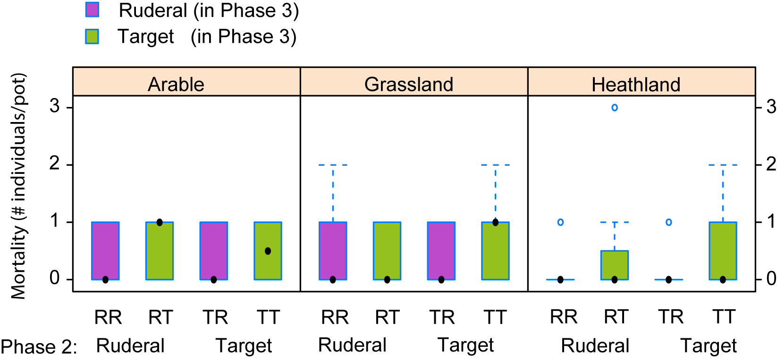

Fig. S1. Phase 3 seedling mortality. No treatment has a significant effect on mortality, for statistical analysis see Table S1. Conventions follow Fig. 1.

Table S1. Type 3 sums of squares decomposition of variance for shoot biomass and plant mortality in Phase 3 of the experiment based on linear mixed models (see Methods).
 | Shoot biomass Phase 3 |  |  | Mortality Phase 3 |  |  | Shoot biomass Phase 2 |  |  | Shoot biomass Phase 1
Terms | d.f. | F | P-value | d.f. | χ² | P-value | d.f. | F | P-value | d.f. | F | P-value
Plant-Phase 3 (P3) | 1,99 | 26.79 | <0.0001 | 1 | 0.70 | 0.4042 | - | - | - | - | - | -
Plant-Phase 2 (P2) | 1,99 | 4.03 | 0.0474 | 1 | 0.03 | 0.8572 | 1,105 | 86.96 | <0.001 | - | - | -
Inoculation | 2,6 | 4.68 | 0.0597 | 2 | 1.28 | 0.5275 | 2,6 | 0.67 | 0.55 | 2,6 | 0.54 | 0.61
P3 x P2 | 1,99 | 4.58 | 0.0349 | 1 | 0.09 | 0.7682 | - | - | - | - | - | -
P3 x Inoc | 2,99 | 5.89 | 0.0038 | 2 | 0.15 | 0.9291 | - | - | - | - | - | -
P2 x Inoc | 2,99 | 1.98 | 0.1436 | 2 | 0.72 | 0.6962 | 2,105 | 4.12 | 0.0189 | - | - | -
P3 x P2 x Inoc | 2,99 | 2.35 | 0.1008 | 2 | 1.38 | 0.5018 | - | - | - | - | - | -

Table S2. Plant group level planned contrasts comparing their performance on soils conditioned by ruderal and target species, respectively, within each soil inoculation treatment. The planned contrasts were tested within the overall shoot biomass P3 model (Table S1).

Plant group | Inoculation | Estimate | SE | z-value | p-value
Ruderal | Arable | 0.559 | 0.278 | 2.01 | 0.0447
 | Grassland | -0.061 | 0.256 | -0.25 | 0.8054
 | Heathland | -0.058 | 0.166 | -0.35 | 0.7256
Target | Arable | 0.053 | 0.065 | 0.81 | 0.4156
 | Grassland | 0.097 | 0.072 | 1.34 | 0.1816
 | Heathland | -0.064 | 0.078 | -0.81 | 0.4154

Table S3. Individual species PSF model using type 3 sums of squares for the overall analysis (a) and planned contrasts (b) to evaluate deviations from neutral feedback (i.e. PSF = 0).

a) overall model decomposition
Factor |  |  | d.f. |  | F-value |  |  | p-value
Plant species |  |  | 5,106 |  | 2.39 |  |  | 0.043
Inoculation |  |  | 2,6 |  | 0.18 |  |  | 0.838
Plant species x Inoculation |  |  | 10,106 |  | 1.87 |  |  | 0.058
b) planned contrasts
Species | Inoculation | Estimate |  | SE |  | d.f. | t-value | p-value
A. montana | Arable | 0.036 |  | 0.403 |  | 104 | 0.089 | 0.929
 | Grassland | -0.065 |  | 0.384 |  | 104 | -0.169 | 0.866
 | Heathland | -0.321 |  | 0.450 |  | 104 | -0.713 | 0.477
C. rotundifolia | Arable | 0.703 |  | 0.637 |  | 104 | 1.104 | 0.272
 | Grassland | 1.007 |  | 0.736 |  | 104 | 1.369 | 0.174
 | Heathland | -0.476 |  | 0.520 |  | 104 | -0.915 | 0.362
F. filliformis | Arable | 0.746 |  | 0.403 |  | 104 | 1.852 | 0.067
 | Grassland | 0.397 |  | 0.384 |  | 104 | 1.034 | 0.304
 | Heathland | 0.023 |  | 0.425 |  | 104 | 0.053 | 0.958
C. cappilaris | Arable | 0.519 |  | 0.482 |  | 104 | 1.077 | 0.289
 | Grassland | 0.088 |  | 0.425 |  | 104 | 0.208 | 0.836
 | Heathland | 0.415 |  | 0.384 |  | 104 | 1.082 | 0.282
L. perenne | Arable | 0.317 |  | 0.384 |  | 104 | 0.826 | 0.411
 | Grassland | -0.025 |  | 0.384 |  | 104 | -0.065 | 0.949
 | Heathland | -0.198 |  | 0.384 |  | 104 | -0.515 | 0.608
M. arvense | Arable | 2.188 |  | 0.520 |  | 104 | 4.206 | <0.0001
 | Grassland | -0.549 |  | 0.450 |  | 104 | -1.219 | 0.226
 | Heathland | -0.941 |  | 0.425 |  | 104 | -2.216 | 0.029

Table S4. Type 3 sums of squares decomposition of variance for shoot biomass in Phase 3 (P3) including Phase 2 (P2) biomass as a continuous predictor.

Terms | d.f. | F | p-value
Phase 2 biomass | 1,87 | 0.8610 | 0.3560
P3 plant group | 1,87 | 106.0291 | <0.0001
P2 plant group | 1,87 | 0.2044 | 0.6523
Soil inoculation | 2,6 | 0.0292 | 0.9714
P2 biomass x P3 plant group | 1,87 | 0.0567 | 0.8124
P2 biomass x P2 plant group | 1,87 | 1.3457 | 0.2492
P3 plant x P2 plant | 1,87 | 0.0246 | 0.8758
P2 biomass x Inoculation | 2,87 | 0.8639 | 0.4251
P3 plant x Inoculation | 2,87 | 30.8547 | 0.0249
P2 plant x Inoculation | 2,87 | 0.0009 | 0.9991
P2 biomass x P3 plant x P2 plant | 1,87 | 1.1982 | 0.2767
P2 biomass x P3 plant x Inoculation | 2,87 | 0.6965 | 0.5011
P2 biomass x P2 plant x Inoculation | 2,87 | 0.6065 | 0.5476
P3 plant x P2 plant x Inoculation | 2,87 | 3.3901 | 0.0382
P2 biomass x P3 plant x P2 plants x Inoculation | 2,87 | 0.9889 | 0.3761

