Supplementary Material
Fine scale assemblage structure of benthic invertebrate megafauna on the North Pacific seamount Mokumanamana
Nicole B. Morgan*, Savannah Goode, E. Brendan Roark, Amy R. Baco
* Correspondence: Amy R. Baco abacotaylor@fsu.edu

Supplementary Figures
Supplementary Figure 1. Abundances for (a) the dominant coral taxa and (b) the other dominant invertebrates on the north slope of Mokumanamana. Y-axis is square root transformed for better visualization.

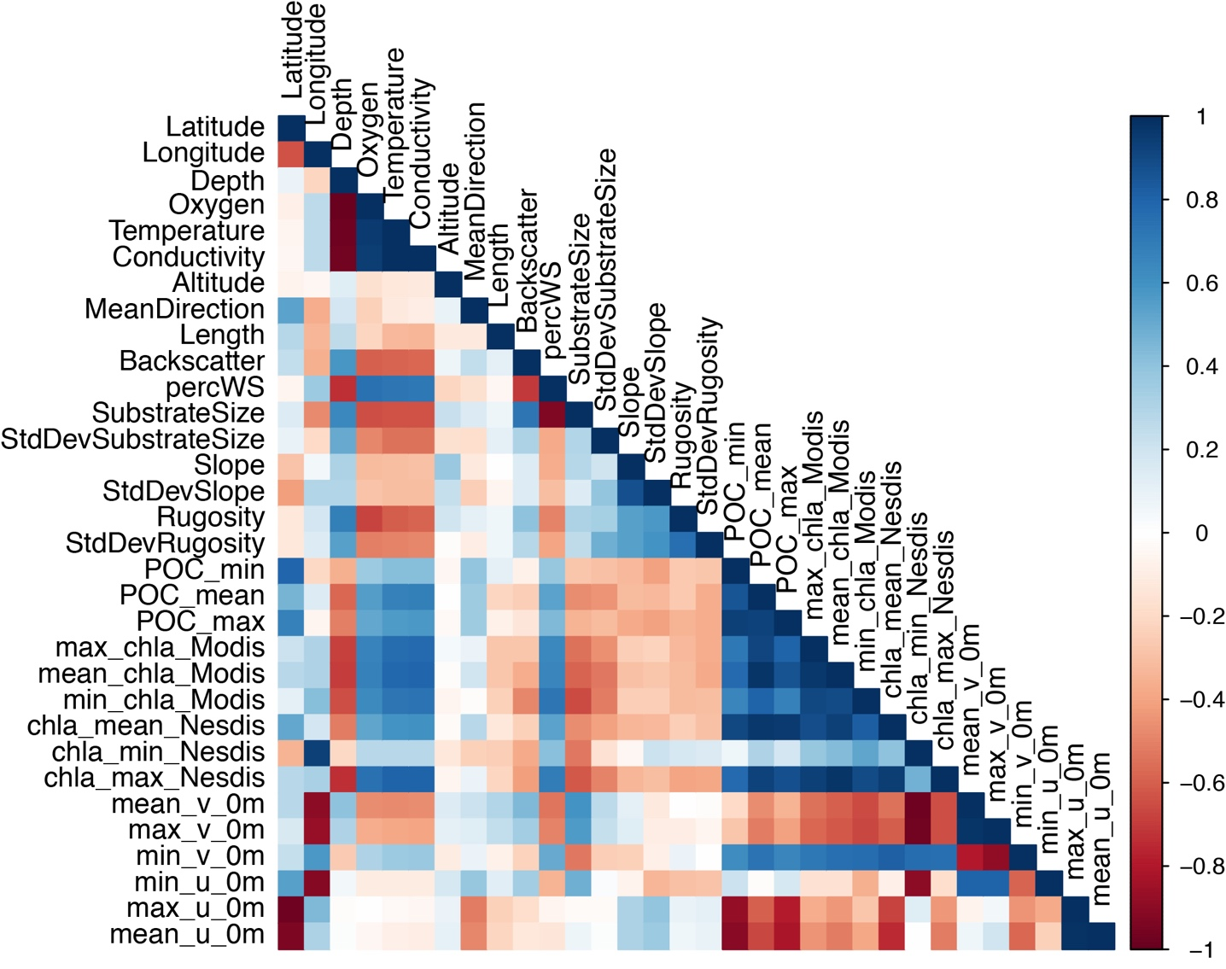
Supplementary Figure 2. Correlation plot for all environmental variables collected.

Supplementary Figure 3. Density plots for abundance-based beta-diversity analysis with each slope resampled 100 times. Panels: a – North side, b – South side, c – West side.
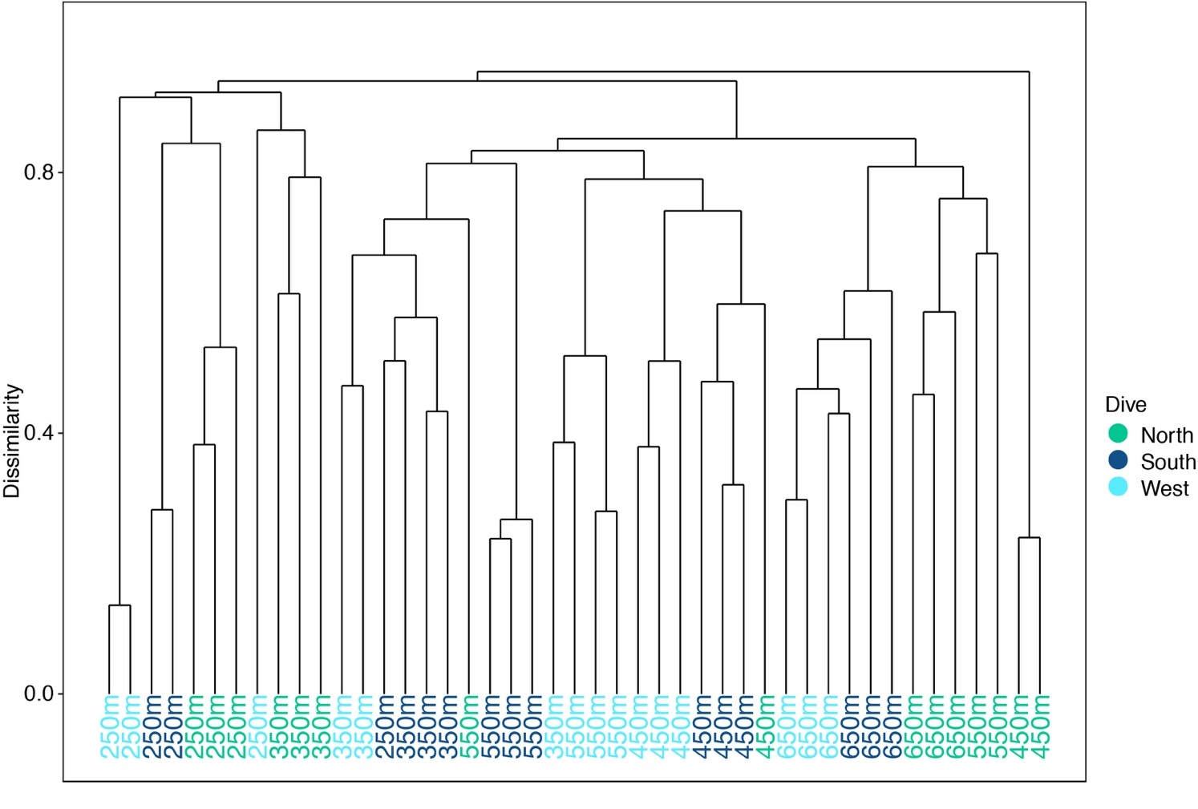
Supplementary Figure 4. Hierarchical cluster diagram for all transects on Mokumanamana. Rightmost transects at 450 m depth were removed from analysis as outliers.
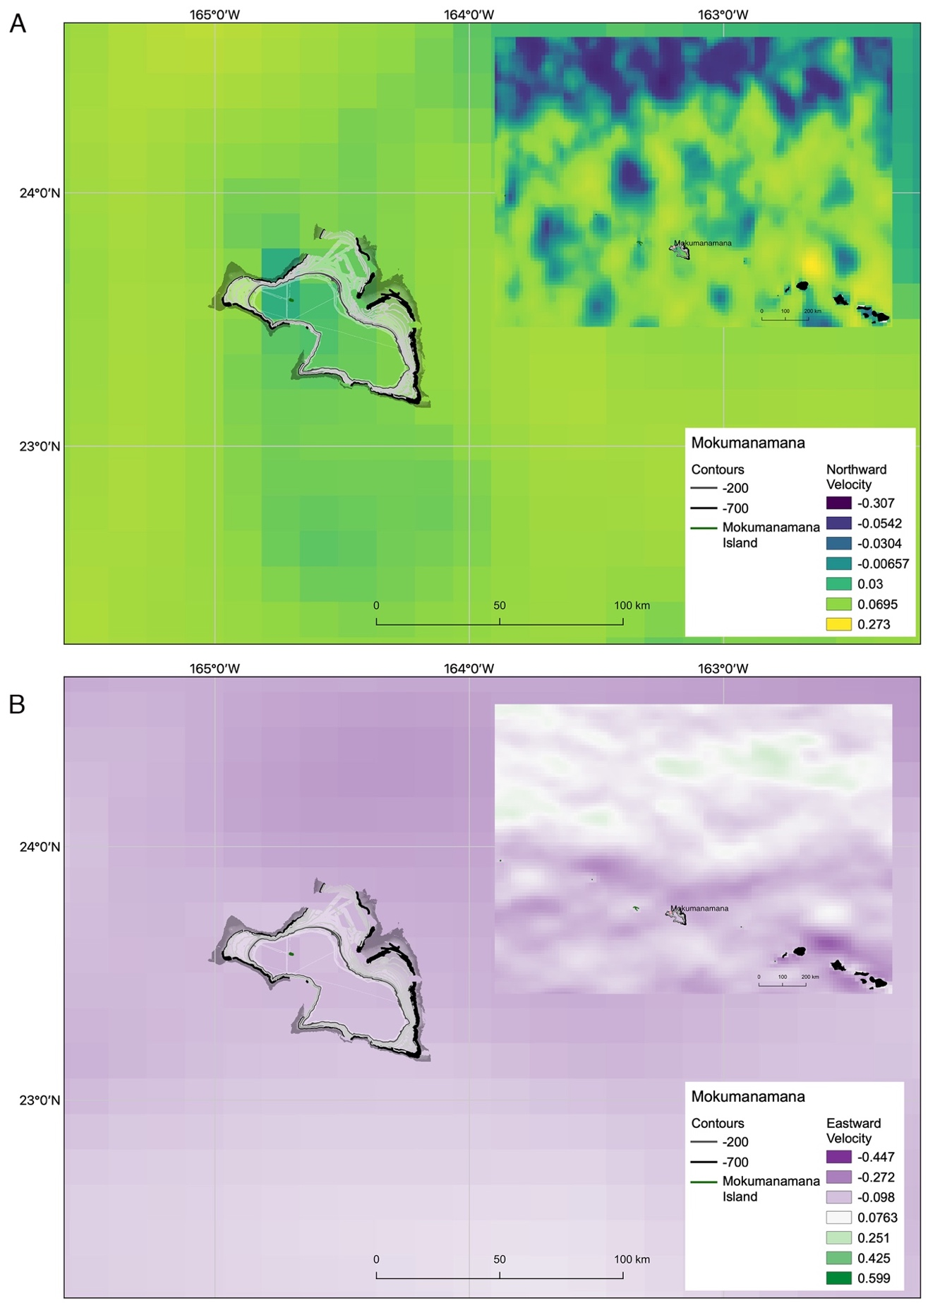
Supplementary Figure 5. Eight-year average surface currents for (A) northward and (B) eastward velocities from HYCOM database.

