Supplement A

Nitrogen and phosphorus additions alter the abundance of phosphorus-solubilizing bacteria and phosphatase activity in grassland soils

Meike Widdig¹, Per-M. Schleuss¹, Alfons R. Weig², Alexander Guhr¹, Lori A. Biederman³, Elizabeth T. Borer⁴, Michael J. Crawley⁵, Kevin P. Kirkman⁶, Eric W. Seabloom⁴, Peter D. Wragg⁷, Marie Spohn¹
¹Department of Soil Biogeochemistry and Soil Ecology, University of Bayreuth, Germany
²Keylab for Genomics and Bioinformatics, University Bayreuth, Germany
³Department of Ecology, Evolution and Organismal Biology, Iowa State University, USA
⁴Department of Ecology, Evolution, and Behavior, University of Minnesota, USA
⁵Department of Life Sciences, Imperial College London, England
⁶School of Life Sciences, University of KwaZulu-Natal, South Africa
⁷Department of Forest Resources, University of Minnesota, USA

Material and Methods

Site descriptions
The Ukulinga site is located at the Ukulinga Research station near Pietermaritzburg, KwaZulu Natal, South Africa (-29.67 N, 30.4 E). It was established in 2009 and nutrients were added for the first time in 2010. Mean annual precipitation (MAP) amounts to 838 mm, occurring mostly during summer (September to April). The mean annual temperature (MAT) is 18 °C. The experiment is located at an elevation of 843 m a.s.l on top of a plateau formed by Ecca group shales (Fynn & O'Connor 2005). The soil has a silty clay to clay texture (5 % sand, 41 % silt, 54 % clay) and pH_{H2O} values are approximately 5.8. The site is burned annually in early August, but not mown.
The Summerveld site is located in Summerveld, Kwa-Zulu Natal, South Africa (-29.81 N, 30.72 E). It was established in 2009 and nutrients were added for the first time in 2010. MAP amounts to 809 mm per year and MAT is 18 °C. The site is situated on a sandstone plateau on a south-facing slope at an elevation of 679 m a.s.l. (Wragg 2017). The soil has a loamy texture (50 % sand, 33 % silt, and 17 % clay) and pH_{H2O} values amount to approximately 5.1. The soil is shallow with an average depth of 16.75 cm. The site is annually burned in winter (June-August).
The Cedar Creek site is located in the Central plains at the Cedar Creek Ecosystem Science Reserve, Minnesota, USA (45.43 N, -93.21 E). It was established in 2007, and nutrients were added for the first time in 2008. The MAT is 6 °C and MAP amounts to 800 mm per year. The site is situated 270 m a.s.l. on the Anoka Sand Plain, an outwash plain of the Wisconsin Glacial Episode, and is underlain by bedrock of Cambrian and Ordovician dolomite, sandstone, and shale (Blinnikov, Bagent & Reyerson 2013). The site is vegetated by tallgrass prairie. The soil has a sandy texture (88 % sand, 9 % silt, and 3 % clay) and pH_{H2O} values amount to 5.1. The site is neither burned nor mown.
The Chichaqua Bottoms site is situated in the Central Plains near Ames, Iowa, USA (41.78 N, -93.38 W). It was established in 2009 and nutrients were added for the first time in 2010. MAP amounts to 891 mm and MAT is 9 °C. The site is located at 275 m a.s.l. on Pleistocene till of the Dows Formation (Prior 1991). The texture of the soil is loamy sand (84 % sand, 11 % silt, 5 % clay) and the pH_{H2O} value amounts to 5.7. The vegetation is a restored tallgrass prairie, which was planted in 2001 (at the first block) and 2003 (at the second and third block). The site is burned every second to third year, but not mown.
The Rookery and Heron's Brook sites are both located at Silwood Park, Ascot, UK (51.41 N, -0.64 E). They were established in 2007 and nutrients were added for the first time in 2008. The MAT is 10 °C and MAP amounts to 678 mm at both sites with little seasonal pattern. The sites are situated 60 m a.s.l. on sands of the Bagshot Formation (British Geological Survey 1999). The texture is sandy loam (Rookery: 75 % sand, 19 % silt, and 6 % clay; Heron’s Brook: 65 % sand, 25 % silt, and 10 % clay) with pH_{H2O} values amount to 4.0 in Rookery and 5.2 in Heron’s Brook. The mesic grasslands are neither burned nor mown.

Tables and Figures

Table S1: Total organic carbon (TOC), total nitrogen (TN), total phosphorus (TP), and soil pH in 0-15 and 15-30 cm soil depth in the control, N, P, and NP treatment at the six grassland sites. The soil at the site Summerveld (summ.za) was only sampled in 0-15 cm depth because of limited soil depth. Numbers depict means ± standard deviations (n=3). Two-way ANOVA was conducted followed by Tukey-Test for multiple comparisons. Lower-case letters indicate significant differences between treatments separately tested for each site and depth increment. Asterisks indicate significant differences between depth increments separately tested for each site and treatment.
 | Site |  | 0-15 cm |  |  |  |  | 15-30 cm
 |  |  | Ctrl | +N | +P | +NP |  | Ctrl | +N | +P | +NP
TOC  (g C kg⁻¹ ) | cdcr.us¹ |  | 9.4 ± 1.1ª | 15.7 ± 8.8ª | 9.0 ± 0.3ª | 11.0 ± 3.4ª |  | 5.2 ± 1.1ª | 10.4 ± 7.8ª | 4.4 ± 0.5^{a*} | 5.8 ± 2.1ª
 | cbgb.us |  | 7.2 ± 2.8ª | 8.2 ± 0.5ª | 6.9 ± 2.3ª | 7.4 ± 2.4ª |  | 4.1 ± 0.5^{a*} | 5.1 ± 0.2^{a*} | 4.0 ± 1.2ª | 4.1 ± 0.9^{a*}
 | hero.uk |  | 36.7 ± 6.8ª | 36.7 ± 6.1ª | 36.5 ± 1.8ª | 37.0 ± 7.7ª |  | 24.4 ± 3.5^{a*} | 24.5 ± 4.2^{a*} | 25.6 ± 4.7^{a*} | 23.9 ± 4.4^{a*}
 | rook.uk |  | 24.3 ± 2.6ª | 28.7 ± 3.2ª | 26.9 ± 1.2ª | 24.9 ± 2.2ª |  | 10.5 ± 1.5^{a*} | 12.8 ± 1.3^{a*} | 11.6 ± 1.3^{a*} | 10.1 ± 0.7^{a*}
 | ukul.za |  | 42.0 ± 2.0ª | 42.5 ± 0.8ª | 44.4 ± 0.5ª | 45.7 ± 0.8ª |  | 37.5 ± 3.6ª | 3.2.0 ± 4.4^{a*} | 34.8 ± 5.3^{a*} | 36.4 ± 0.6^{a*}
 | summ.za² |  | 49.1 ± 3.0ª | 51.1 ± 2.2ª | 51.7 ± 3.0ª | 51.7 ± 1.9ª |  | NA | NA | NA | NA
TN  (g N kg⁻¹ ) | cdcr.us¹ |  | 0.7 ± 0.1ª | 1.1 ± 0.6ª | 0.6 ± 0.1ª | 0.8 ± 0.3ª |  | 0.3 ± 0.1^{a*} | 0.7 ± 0.5ª | 0.3 ± 0.1ª | 0.4 ± 0.1^{a*}
 | cbgb.us |  | 0.6 ± 0.2ª | 0.8 ± 0.1ª | 0.6 ± 0.2ª | 0.7 ± 0.2ª |  | 0.4 ± 0.1^{a*} | 0.5 ± 0.1^{a*} | 0.4 ± 0.1^{a*} | 0.4 ± 0.2^{a*}
 | hero.uk |  | 3.1 ± 0.7ª | 3.1 ± 0.5ª | 3.0 ± 0.2ª | 3.1 ± 0.8ª |  | 2.1 ± 0.3^{a*} | 2.1 ± 0.3ª | 2.1 ± 0.4ª | 2.0 ± 0.4^{a*}
 | rook.uk |  | 2.1 ± 0.2^{ab} | 2.4 ± 0.3^{b} | 2.2 ± 0.1^{ab} | 2.0 ± 0.1ª |  | 1.0 ± 0.1^{a*} | 1.2 ± 0.1^{a**} | 1.0 ± 0.2^{a*} | 0.9 ± 0.1^{a*}
 | ukul.za |  | 2.9 ± 0.3ª | 3.1 ± 0.3^{ab} | 3.3 ± 0.1^{ab} | 3.4 ± 0.1^{b} |  | 2.6 ± 0.2ª | 2.4 ± 0.2^{a*} | 2.6 ± 0.3^{a*} | 2.7 ± 0.1^{a*}
 | summ.za² |  | 2.8 ± 0.2ª | 3.0 ± 0.4ª | 2.9 ± 0.3ª | 3.0 ± 0.1ª |  | NA | NA | NA | NA
TP  (g P kg⁻¹ ) | cdcr.us¹ |  | 0.31 ± 0.03ª | 0.46 ± 0.24ª | 0.58 ± 0.09ª | 0.56 ± 0.11ª |  | 0.24 ± 0.03ª | 0.40 ± 0.19ª | 0.36 ± 0.04ª | 0.38 ± 0.06ª
 | cbgb.us |  | 0.28 ± 0.02ª | 0.24 ± 0.05ª | 0.43 ± 0.04^{b} | 0.41 ± 0.06^{b} |  | 0.24 ± 0.03ª | 0.24 ± 0.02ª | 0.34 ± 0.03^{b*} | 0.35 ± 0.07^{b*}
 | hero.uk |  | 0.62 ± 0.16ª | 0.57 ± 0.07ª | 0.93 ± 0.13ª | 0.96 ± 0.28ª |  | 0.54 ± 0.15ª | 0.48 ± 0.06ª | 0.55 ± 0.17^{a*} | 0.62 ± 0.25^{a*}
 | rook.uk |  | 0.38 ± 0.01ª | 0.38 ± 0.04ª | 0.60 ± 0.06^{b} | 0.61 ± 0.14^{b} |  | 0.27 ± 0.01^{a*} | 0.31 ± 0.04ª | 0.32 ± 0.03^{a*} | 0.31 ± 0.04^{a*}
 | ukul.za¹ |  | 0.45 ± 0.02ª | 0.46 ± 0.08ª | 1.33 ± 0.12^{b} | 1.20 ± 0.15^{b} |  | 0.39 ± 0.02ª | 0.38 ± 0.04ª | 0.74 ± 0.25^{b*} | 0.58 ± 0.01^{b*}
 | summ.za² |  | 0.37 ± 0.01ª | 0.49 ± 0.18ª | 0.60 ± 0.33ª | 0.83 ± 0.7ª |  | NA | NA | NA | NA
pH in H₂O | cdcr.us |  | 5.27 ± 0.09^{b} | 4.70 ± 0.17ª | 5.27 ± 0.10^{b} | 4.84 ± 0.10ª |  | 5.36 ± 0.10^{b} | 5.17 ± 0.19^{ab*} | 5.45 ± 0.23^{b} | 4.96 ± 0.23ª
 | cbgb.us |  | 5.73 ± 0.50ª | 5.68 ± 0.72ª | 5.86 ± 0.47ª | 5.72 ± 0.43ª |  | 5.40 ± 0.66ª | 5.56 ± 0.92ª | 5.58 ± 0.79ª | 5.34 ± 0.63ª
 | hero.uk |  | 5.12 ± 0.21ª | 5.18 ± 0.11ª | 5.08 ± 0.08ª | 5.09 ± 0.15ª |  | 5.24 ± 0.30ª | 5.30 ± 0.09ª | 5.20 ± 0.15ª | 5.22 ± 0.10ª
 | rook.uk |  | 3.76 ± 0.04ª | 3.78 ± 0.02ª | 3.91 ± 0.02ª | 3.87 ± 0.03ª |  | 4.10 ± 0.13^{a*} | 4.08 ± 0.09^{a*} | 4.12 ± 0.10^{a*} | 4.06 ± 0.06^{a*}
 | ukul.za |  | 5.89 ± 0.08ª | 5.58 ± 0.42ª | 5.94 ± 0.09ª | 5.63 ± 0.11ª |  | 5.83 ± 0.10ª | 5.79 ± 0.33ª | 5.72 ± 0.16ª | 5.62 ± 0.16ª
 | summ.za² |  | 5.20 ± 0.04ª | 5.03 ± 0.09ª | 5.01 ± 0.12ª | 4.97 ± 0.13ª |  | NA | NA | NA | NA
¹Data were LOG10 transformed; ²One-Way ANOVA and Tukey Test were performed
Table S2: Regression coefficients and R² of linear mixed-effects model of the relative abundance of phosphorus-solubilizing bacteria (PSB) of all treatments in 0-15 cm depth. R² is the conditional R² according to Nakagawa & Schielzeth (2013). Estimation and p-value of each regression coefficient are displayed.
Linear mixed-effects model of relative abundance of PSB
Coefficients | Estimation | p-value
(Intercept) | -69.244 | 0.000 ***
TOC:TP ratio | 0.098 | 0.000 ***
Sand | 0.311 | 0.000 ***
pH | 10.611 | 0.000 ***
H₂O-P | -1.901 | 0.003 **
R² = 0.71
* significant at p < 0.05, ** significant at p < 0.01, *** significant at p < 0.001

Table S3: Mean number of colony-forming units (CFU) per g soil and relative abundance of phosphorus-solubilizing bacteria (% PSB) in 0-15 and 15-30 cm depth at each site.
Site | ukul.za |  | summ.za | cdcr.us |  | cbgb.us |  | rook.uk |  | hero.uk
Depth | 0-15 cm | 15-30 cm | 0-15 cm | 0-15 cm | 15-30 cm | 0-15 cm | 15-30 cm | 0-15 cm | 15-30 cm | 0-15 cm | 15-30 cm
CFU g⁻¹ | 1.34E+06 | 2.46E+06 | 4.86E+06 | 1.22E+06 | 1.40E+06 | 5.63E+04 | 2.48E+05 | 1.71E+05 | 1.46E+05 | 3.49E+06 | 2.40E+06
% PSB | 6.16 ± 3.91 | 15.7 ± 9.63 | 30.99 ± 13.4 | 12.79 ± 9.93 | 20.01 ± 9.68 | 5.97 ± 3.21 | 11.71 ± 9.98 | 4.16 ± 2.98 | 4.61 ± 2.84 | 14.71 ± 8.32 | 15.71 ± 13.45

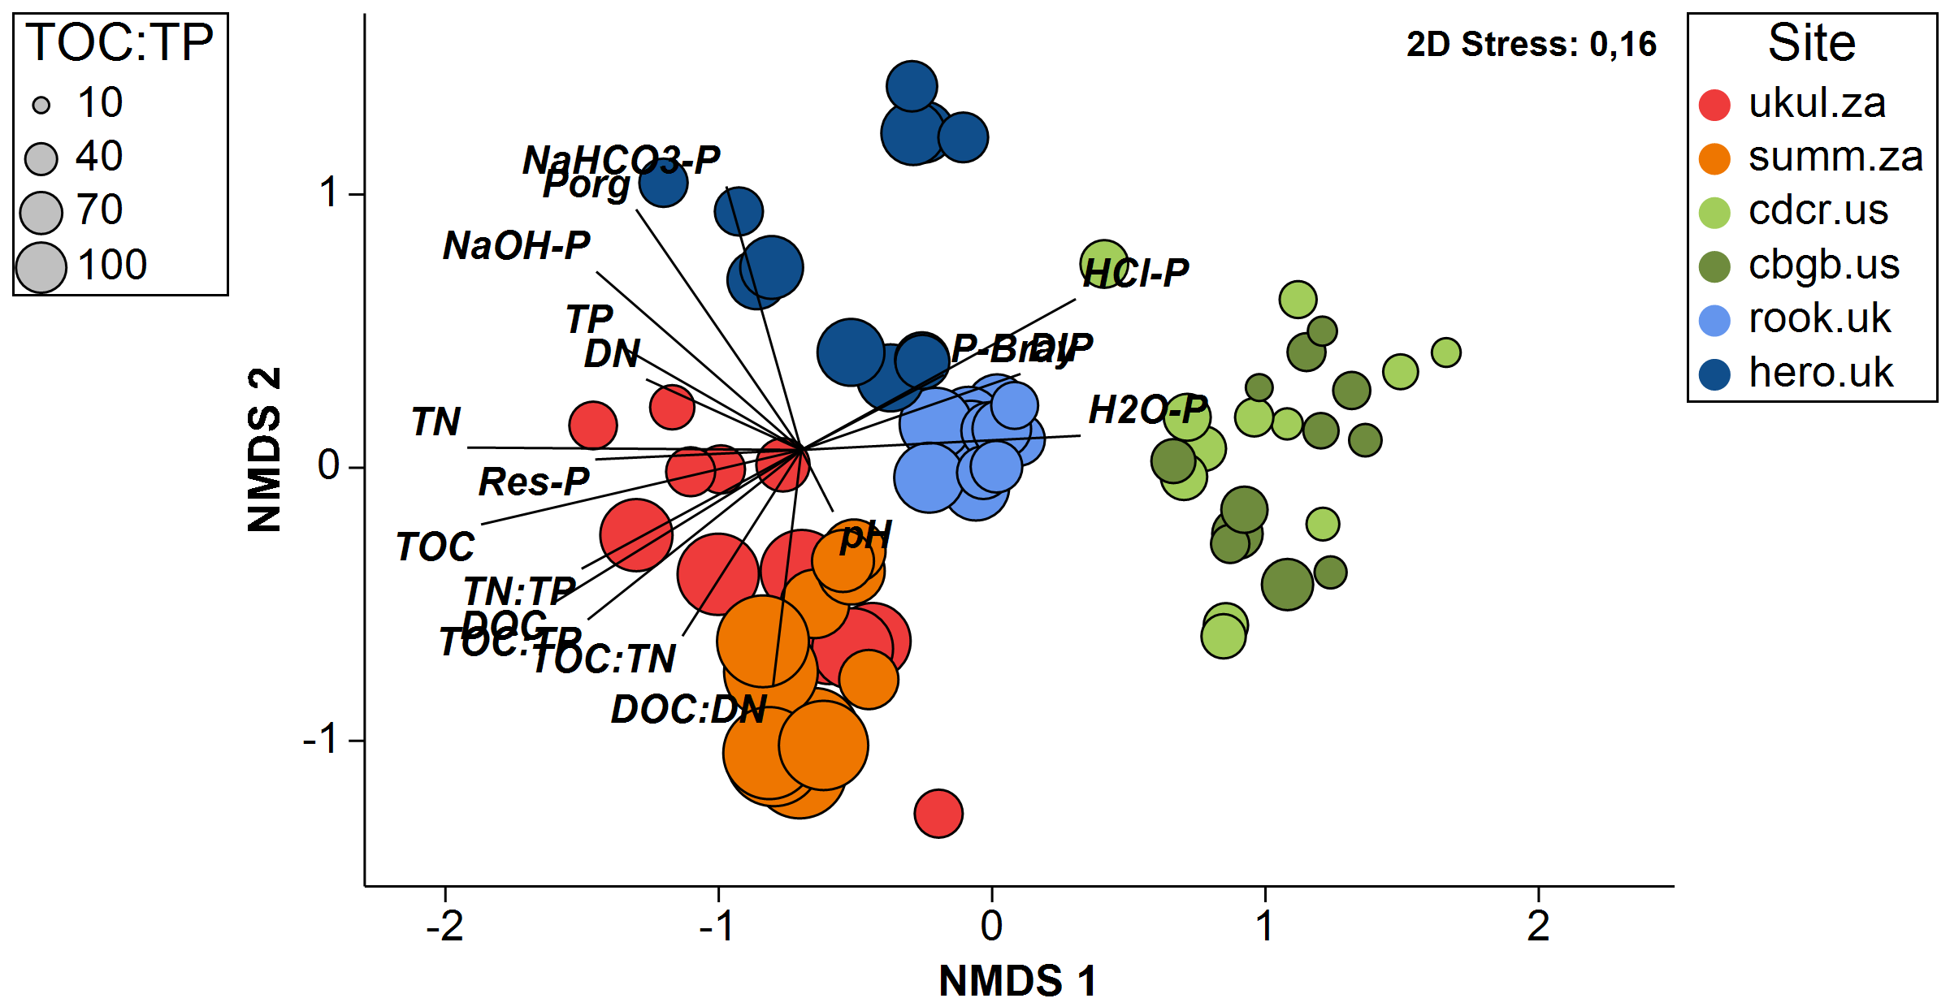
Fig. S1: Soil pH, element concentrations, and P fractions of all topsoil nutrient addition treatments of the sites Ukulinga (ukul.za), Summerveld (summ.za), Cedar Creek (cdcr.us), Chichaqua Bottoms (cbgb.us), Rookery (rook.uk), and Herons Brook (hero.uk) displayed via non-metric multidimensional scaling (nMDS) of Euclidean distances. The included variables are total organic carbon (TOC), total nitrogen (TN), total phosphorus (TP), TOC:TN ratio, TOC:TP ratio, TN:TP ratio, dissolved organic carbon (DOC), dissolved nitrogen (DN), dissolved inorganic phosphorus (DIP), DOC:DN ratio, total organic phosphorus (TOP), Bray-1 P, water-extractable P (H2O-P), labile P (NaHCO3-P), occluded P (NaOH-P),apatite P (HCl-P), residual P (Res-P), and soil pH. The nMDS plot was overlaid by circles whose sizes reflect values of the TOC:TP ratios of all soils and with vectors of the Pearson correlations of the variables.
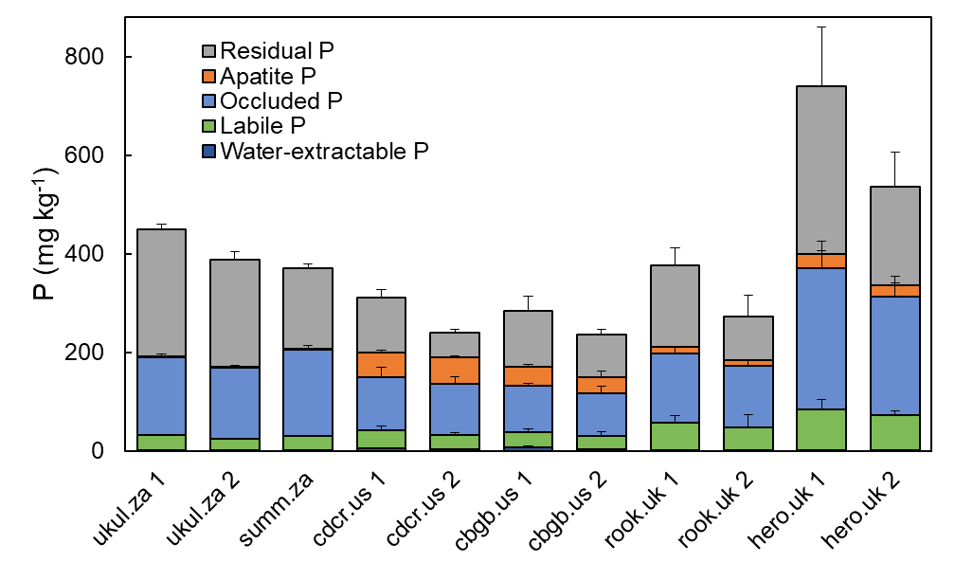
Fig. S2: Soil phosphorus (P) fractions determined by Hedley fractionation in 0-15 cm (1) and 15-30 cm (2) soil depth in the control of the six sampled soils at the site Ukulinga (ukul.za), Summerveld (summ.za), Cedar Creek (cdcr.us), Chichaqua Bottoms (cbgb.us), Rookery (rook.uk), and Heron’s Brook (hero.uk). The soil at the site Summerveld (summ.za) was only sampled in 0-15 cm depth because of limited soil depth. Error bars indicate standard deviations (n=3).
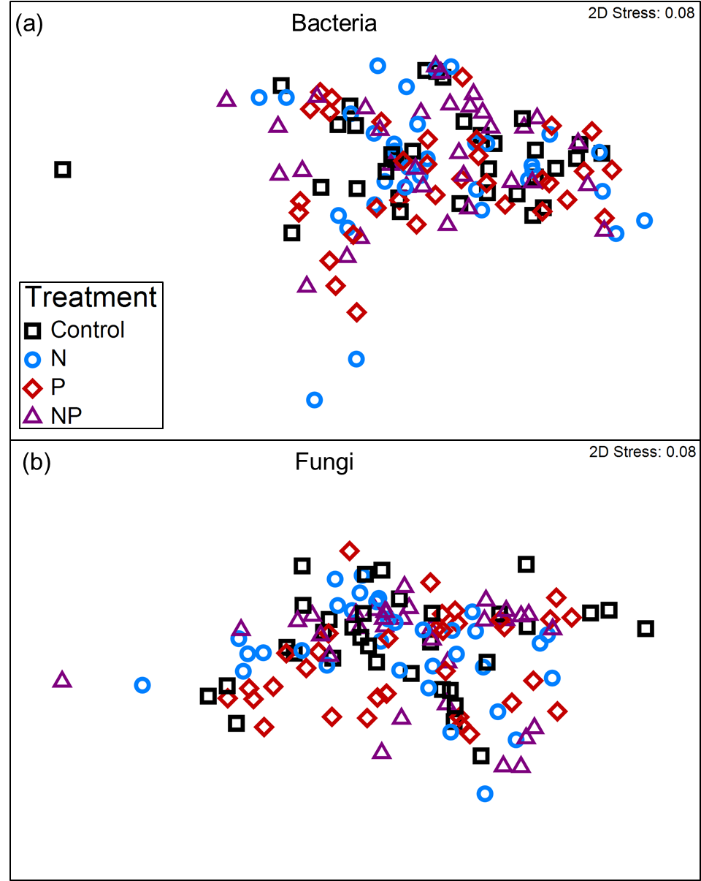
Fig. S3: Effect of nutrient addition (+N, +P, +NP) on bacterial community composition (a) and fungal community composition (b) shown via non-metric multi-dimensional scaling (nMDS) of all six sites and both depth increments (0-15 and 15-30 cm).
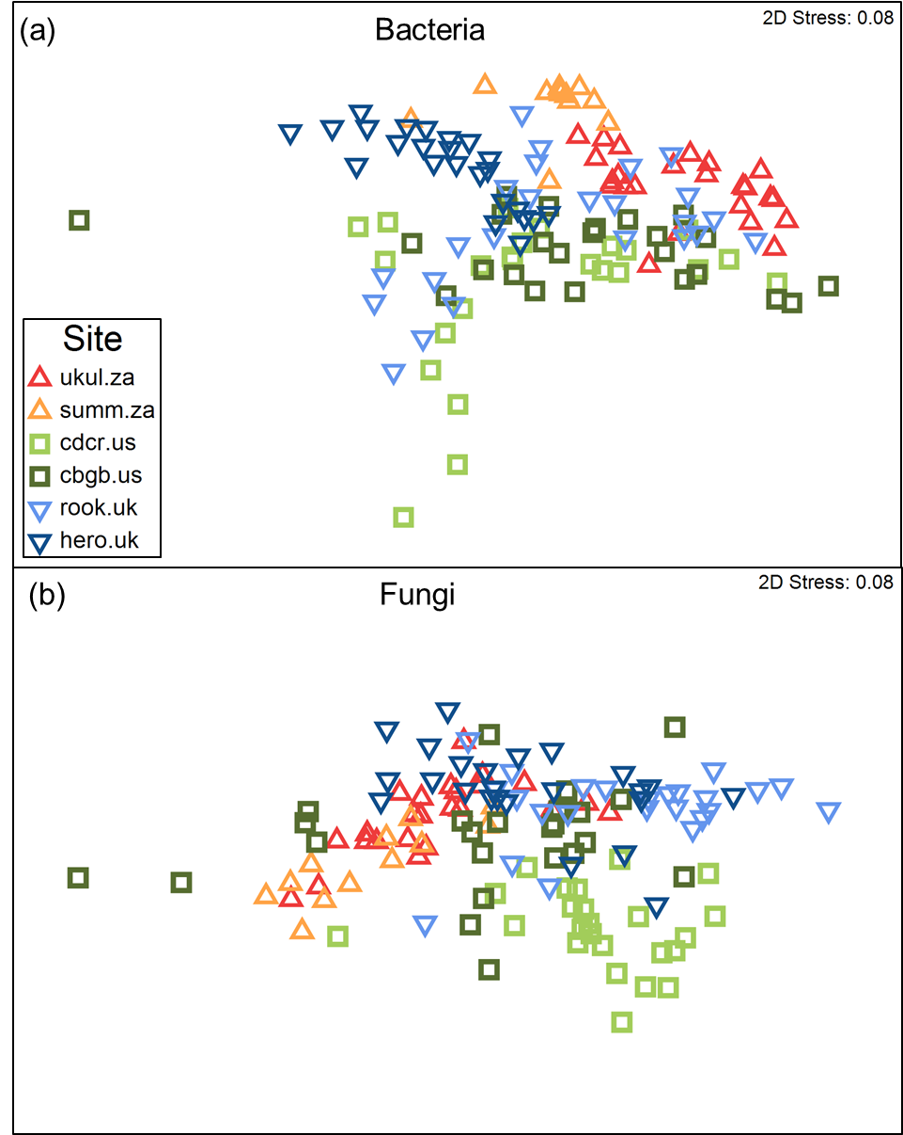
Fig. S4: Bacterial community composition (a) and fungal community composition (b) shown via non-metric multi-dimensional scaling (nMDS) of the six sites Ukulinga (ukul.za), Summerveld (summ.za), Cedar Creek (cdcr.us), Chichaqua Bottoms (cbgb.us), Rookery (rook.uk), and Heron’s Brook (hero.uk) in both depth increments (0-15 and 15-30 cm).

Fig. S5: Relative abundance of phosphorus solubilizing bacteria (PSB) in two soil depth increments at the site (a) Ukulinga in South Africa, (b) Cedar Creek in the USA, (c) Rookery in the UK, (d) Summerveld in South Africa, (e) Chichaqua Bottoms in the USA and (f) Heron’s Brook in the UK in 0-15 and 15-30 cm depth. The soil at the site Summerveld was only sampled in 0-15 cm depth because of limited soil depth. Error bars indicate standard deviations (n=3). Different lower-case letters above the bars indicate significant differences (p < 0.05) between treatments tested separately for each site and depth increment. Significant differences between depth increments separately tested for each site across all treatments are indicated by an asterisk at the right side of the subplot.

Fig. S6: Phosphatase activity in two soil depth increments at the site (a) Ukulinga in South Africa, (b) Cedar Creek in the USA, (c) Rookery in the UK, (d) Summerveld in South Africa, (e) Chichaqua Bottoms in the USA and (f) Heron’s Brook in the UK. The soil at the site Summerveld was only sampled in 0-15 cm depth because of limited soil depth. Error bars indicate standard deviations (n=3). Different lower-case letters above the bars indicate significant differences (p < 0.05) between treatments tested separately for each site and depth increment. Significant differences between depth increments separately tested for each site across all treatments are indicated by an asterisk at the right side of the subplot.

References
Blinnikov, M.S., Bagent, C.M. & Reyerson, P.E. (2013) Phytolith assemblages and opal concentrations from modern soils differentiate temperate grasslands of controlled composition on experimental plots at Cedar Creek, Minnesota. Quaternary International, 287, 101–113.
British Geological Survey (1999) Windsor. England and Wales Sheet 269. Solid and Drift Geology. 1:50 000. British Geological Survey, Keyworth, Nottingham.
Fynn, R.W.S. & O'Connor, T.G. (2005) Determinants of community organization of a South African mesic grassland. Journal of Vegetation Science, 16, 93–102.
Nakagawa, S. & Schielzeth, H. (2013) A general and simple method for obtaining R² from generalized linear mixed-effects models. Methods in Ecology and Evolution, 4, 133–142.
Prior, J.C. (1991) Landforms of Iowa. University of Iowa Press.
Wragg, P.D. (2017) Multiple nutrients control threatened grassland vegetation in eastern South Africa. South African Journal of Botany, 112, 225–236.

