SUPPLEMENTARY MATERIALS

Executive impairment in Alcohol Use Disorder reflects structural changes in large-scale brain networks: A joint Independent Component Analysis on grey-matter and white-matter features

by Crespi, Galandra et al.

Table S1. Neurocognitive performance

 | HC  (mean ± sd) | AUD  (mean ± sd) | DoF | T/U* | p-value | FDR
ENB-2 Global Score | 84.11 ± 7.39 | 77.68 ± 8.21 | 38 | 2.575 | 0.007 | 0.021
Digit Span | 5.78 ± 1.17 | 5.73 ± 1.24 | 38 | 184.0* | 0.358 | 0.420
Immediate recall | 15.22 ± 4.57 | 12.82 ± 4.37 | 38 | 1.695 | 0.049 | 0.110
Delayed recall | 20.33 ± 5.04 | 18.68 ± 5.20 | 38 | 1.013 | 0.159 | 0.318
Interference memory 10’’ | 7.61 ± 1.61 | 6.23 ± 1.90 | 38 | 105.0* | 0.005 | 0.018
Interference memory 30’’ | 6.94 ± 2.01 | 6.41 ± 2.22 | 38 | 169.5* | 0.221 | 0.362
TMT-A | 19.16 ± 5.45 | 29.05 ± 5.98 | 38 | -5.408 | < 0.001 | < 0.001
TMT-B | 68.56 ± 21.79 | 84.91 ± 35.28 | 38 | 132.5* | 0.044 | 0.110
Token Test | 4.97 ± 0.12 | 4.93 ± 0.18 | 38 | 182.0* | 0.338 | 0.420
Phonemic Fluency | 12.72 ± 3.08 | 12.42 ± 3.28 | 38 | 0.296 | 0.384 | 0.420
Abstract verbal reasoning | 5.67 ± 0.97 | 5.59 ± 0.85 | 38 | 185.5* | 0.368 | 0.420
Cognitive estimation | 4.72 ± 0.46 | 4.73 ± 0.55 | 38 | 190.5* | 0.420 | 0.420
Overlapping figures | 36.94 ± 5.51 | 31.09 ± 5.72 | 38 | 3.271 | 0.001 | 0.006
Copy drawing | 1.83 ± 0.38 | 1.64 ± 0.58 | 38 | 166.5* | 0.198 | 0.356
Spontaneous Drawing | 1.89 ± 0.32 | 1.73 ± 0.55 | 38 | 174.0* | 0.263 | 0.395
Clock Test | 9.39 ± 2.35 | 8.36 ± 2.45 | 38 | 102.5* | 0.004 | 0.018
Praxic Abilities | 6.00 ± 0.00 | 5.95 ± 0.21 | 38 | 189.0* | 0.409 | 0.420

The table reports information about both global and single task scores (mean, standard deviation) related to neurocognitive performance obtained at the Brief Neuropsychological Exam-2 (ENB-2, Mondini et al. 2011) by AUD patients and healthy controls. We additionally reported details about statistics used for group comparisons and the relative results. (*) indicates results from non-parametric tests (Mann-Whitney U) used to investigate group comparisons in case of non-normally distributed data. In all the other cases, we assessed group differences with the Student’s t-test for independent samples.
In previous studies (Galandra et al., 2018b, Galandra et al., 2019) we showed that neurostructural and neurofunctional alterations in AUD patients correlate with a proxy of executive performance, obtained as a result of a data reduction procedure (i.e., Principal Component Analysis) applied on ENB-2 scores. Factorial scores of the principal component #3 including TMT-A, Interference memory 10” and 30” tasks (underlined in the table) represent such a proxy, reflecting the basic executive profile we then correlated with ICs emerging from joint ICA. AUD=AUD patients; HC=healthy controls; DoF=Degrees of Freedom; T=Student’s t-Test; U=Mann-Whitney U Test; FDR=False Discovery Rate adjustment applied on raw p-values.

Table S2. Localization and coordinates of IC6

Grey Matter
H | Region | k | Z | x | y | z
R | MCC | 7740 | 6.52 | 2 | -15 | 51
L | Precuneus |  | 5.92 | 0 | -48 | 45
L | Calcarine Gyrus |  | 5.47 | 2 | -86 | 2
L | Cuneus |  | 5.23 | 0 | -72 | 32
L | Posterior-Medial Frontal |  | 5.10 | 0 | 8 | 46
L | PCC |  | 4.20 | 0 | -54 | 33
R | Calcarine Gyrus |  | 4.08 | 10 | -94 | -3
R | Precuneus |  | 3.68 | 14 | -68 | 28
L | Thalamus | 2668 | 8.46 | 0 | -14 | 6
R | Hippocampus |  | 3.71 | 32 | -38 | 2
R | Thalamus |  | 3.67 | 9 | -22 | 18
R | IPL | 1045 | 4.97 | 38 | -46 | 51
R | SPL |  | 3.99 | 28 | -66 | 56
R | Postcentral Gyrus |  | 3.08 | 45 | -36 | 56
L | IPL | 957 | 4.33 | -33 | -54 | 51
L | Postcentral |  | 3.90 | -39 | -36 | 45
L | SPL |  | 3.04 | -20 | -70 | 54
L | Caudate Nucleus | 751 | 4.21 | -15 | 15 | 48
L | Cerebelum (Crus 2) | 648 | 4.55 | -33 | -75 | -40
R | Cerebelum (Crus 2) | 579 | 3.68 | 32 | -80 | -38
R | Cerebelum (IX) | 543 | 3.67 | 15 | -54 | -50
L | Hippocampus | 440 | 4.92 | -33 | -36 | -4
L | Middle Temporal Gyrus | 256 | 4.90 | -40 | -64 | 18
R | Rolandic Operculum | 250 | 3.71 | 46 | -26 | 16
R | Heschls Gyrus |  | 3.51 | 44 | -22 | 15
R | SupraMarginal Gyrus |  | 2.97 | 58 | -26 | 20
R | Middle Frontal Gyrus | 160 | 3.58 | 27 | 34 | 30
R | IFG (p. Opercularis) | 122 | 4.15 | 38 | 15 | 27
R | Middle Temporal Gyrus | 118 | 3.23 | 60 | -30 | 0
L | Superior Medial Gyrus | 92 | 3.50 | -2 | 48 | 18
White Matter
H | Metric and Region | k | Z | x | y | z
- | FA - Fornix | 237 | 7.65 | 0 | -4 | 16
R | FA - Anterior Thalamic Radiation | 41 | 4.16 | 9 | -29 | 15
R | FA - Superior Corona Radiata | 40 | 3.9 | 18 | -9 | 38
R | FA - Corpus Callosum (body) | 38 | 3.55 | 7 | -17 | 27
L | FA - Corpus Callosum (body) | 38 | 3.89 | -5 | -16 | 26
L | FA - Superior Corona Radiata | 36 | 3.33 | -17 | -10 | 37
L | FA - Anterior Thalamic Radiation | 35 | 3.80 | -15 | -32 | 11
R | FA - Corpus Callosum (splenium) | 33 | 3.93 | 27 | -52 | 3
L | FA - Cingulum (hippocampus) | 30 | 3.54 | -23 | -49 | 3
L | FA - Inferior Fronto-occipital Fasciculus | 28 | 5.05 | -33 | -80 | 20
L | FA - Inferior Fronto-occipital Fasciculus | 25 | 3.45 | -35 | -10 | 20
L | FA - Inferior Fronto-occipital Fasciculus | 20 | 4.89 | -13 | -78 | 1
R | FA - Superior Longitudinal Fasciculus | 19 | 4.15 | 43 | -67 | 14
R | FA - Anterior Thalamic Radiation | 16 | 3.98 | 1 | -18 | -7
L | FA - Superior Longitudinal Fasciculus | 15 | 4.13 | -42 | -52 | 39
L | FA - Anterior Thalamic Radiation | 15 | 3.43 | -7 | -21 | 14
L | FA - Anterior Thalamic Radiation | 14 | 4.00 | -4 | -15 | 13
R | FA - Superior Corona Radiata | 14 | 2.84 | 19 | -24 | 37
L | FA - Inferior Fronto-occipital Fasciculus | 13 | 3.60 | -20 | -72 | 1
L | FA - Inferior Fronto-occipital Fasciculus | 12 | 3.29 | -40 | -74 | 9
L | FA - Anterior Thalamic Radiation | 11 | 3.57 | -23 | -34 | 5
R | FA - Superior Longitudinal Fasciculus | 10 | 3.51 | 30 | -56 | 38
R | FA - Superior Longitudinal Fasciculus | 10 | 3.68 | 41 | -55 | 43
L | RD - Corpus Callosum (body) | 10 | 4.33 | -2 | 6 | 24
The table lists the localization of local maxima of significant clusters encompassed in IC6. We reported clusters with size ⪰ 80 voxels for grey matter, and ⪰10 voxels for white matter microstructural features. The anatomical localization of significant clusters was performed with the JHU White-Matter Tractography Atlas and the JHU ICBM-DTI-81 White-Matter Labels (Hua et al., 2008; Wakana et al., 2007) for DTI features, while the SPM Anatomy toolbox (Eickhoff et al., 2005) was used to localize grey matter features. H=hemisphere; k=cluster size (i.e., number of voxels); Z=z-scores; x, y, z=MNI coordinates; MCC=Middle Cingulate Cortex; PCC=Posterior Cingulate Cortex; IPL=Inferior Parietal Lobule; SPL= Superior Parietal Lobule; IFG=Inferior Frontal Gyrus; FA=Fractional Anisotropy; AD=Axial Diffusivity; MD=Mean Diffusivity; RD=Radial Diffusivity.

Table S3. Localization and coordinates of IC8

Grey Matter
H | Region | k | Z | x | y | z
R | Amygdala | 8 | 2.52 | 22 | -6 | -20
L | Amygdala | 8 | 2.54 | -22 | -8 | -20
White Matter
H | Metric and Region | k | Z | x | y | z
R | FA - Corpus Callosum (body) | 2137 | 3.39 | 10 | -26 | 26
- | FA - Corpus Callosum (splenium) | 29 | 3.38 | 0 | -35 | 11
L | FA - Cerebral Peduncle | 28 | 2.78 | -14 | -15 | -13
R | FA - Cerebral Peduncle | 24 | 2.89 | 16 | -12 | -10
L | AD - Corpus Callosum (body) | 2003 | 4.93 | -2 | 6 | 24
R | AD - Anterior Thalamic Radiation | 414 | 7.27 | 11 | -32 | 13
R | AD - Corpus Callosum (genu) | 90 | 3.78 | 3 | 26 | 0
L | AD - Forceps Major | 23 | 2.64 | -26 | -58 | 14
R | AD - Cerebral Peduncle | 20 | 3.61 | 19 | -18 | -7
L | AD - Cerebral Peduncle | 19 | 3.22 | -12 | -13 | -15
R | AD - Corpus Callosum (genu) | 11 | 2.81 | 8 | 32 | 4
L | AD - Forceps Major | 10 | 8.37 | -6 | -41 | 3
L | AD - Cerebral Peduncle | 10 | 3.02 | -17 | -17 | -10
R | AD - Cerebral Peduncle | 10 | 3.10 | 10 | -14 | -17
R | MD - Anterior Thalamic Radiation | 94 | 5.21 | 6 | -5 | 7
L | MD - Corpus Callosum (body) | 93 | 9.27 | -2 | 6 | 24
R | MD - Anterior Thalamic Radiation | 44 | 5.08 | 12 | 6 | 4
L | MD - Anterior Thalamic Radiation | 39 | 6.52 | -4 | -5 | 8
L | MD - Anterior Thalamic Radiation | 34 | 5.11 | -12 | 5 | 5
L | MD - Forceps Major | 28 | 17.1 | -6 | -41 | 3
R | MD - Inferior Fronto-occipital Fasciculus | 28 | 5.34 | 24 | -14 | -9
L | MD - Cingulum (hippocampus) | 25 | 4.98 | -25 | -54 | 4
R | MD - Anterior Thalamic Radiation | 19 | 7.25 | 13 | 13 | -5
L | MD - Corticospinal Tract | 17 | 18.50 | -6 | -9 | -24
R | MD - Inferior Longitudinal Fasciculus | 17 | 5.50 | 39 | -31 | -18
L | MD - Anterior Thalamic Radiation | 15 | 7.59 | -2 | -26 | -4
L | MD - Forceps Major | 14 | 5.02 | -26 | -59 | 4
R | MD - Superior Longitudinal Fasciculus | 14 | 3.78 | 34 | -17 | 59
L | MD - Cerebral Peduncle | 12 | 3.18 | -12 | -25 | -19
L | MD - Fornix | 12 | 5.02 | -30 | -15 | -15
- | MD - Corpus Callosum (genu) | 10 | 4.28 | 0 | 25 | 0
R | MD - Forceps Minor | 10 | 5.42 | 10 | 31 | -12
R | RD - Anterior Thalamic Radiation | 92 | 4.09 | 6 | -5 | 7
L | RD - Forceps Major | 27 | 13.2 | -6 | -41 | 3
L | RD - Corpus Callosum (body) | 26 | 6.43 | -2 | 6 | 24
L | RD - Anterior Thalamic Radiation | 17 | 6.44 | -2 | -26 | -4
L | RD - Corticospinal Tract | 17 | 13.9 | -5 | -11 | -23
R | RD - Inferior Longitudinal Fasciculus | 16 | 4.66 | 39 | -31 | -18
L | RD - Anterior Thalamic Radiation | 16 | 3.47 | -14 | 0 | 6
R | RD - Forceps Minor | 13 | 10.8 | 5 | -41 | 6
L | RD - Forceps Major | 13 | 4.08 | -26 | -59 | 4
L | RD - Inferior Fronto-occipital Fasciculus | 11 | 3.67 | -10 | -90 | -5
R | RD - Forceps Minor | 10 | 4.69 | 10 | 31 | -12

The table lists the localization of local maxima of significant clusters encompassed in IC8. We reported clusters with size ⪰ 5 voxels for grey matter, and ⪰10 voxels for white matter microstructural features. The anatomical localization of significant clusters was performed with the JHU White-Matter Tractography Atlas and the JHU ICBM-DTI-81 White-Matter Labels (Hua et al., 2008; Wakana et al., 2007) for DTI features, while the SPM Anatomy toolbox (Eickhoff et al., 2005) was used to localize grey matter features. H=hemisphere; k=cluster size (i.e., number of voxels); Z=z-scores; x, y, z=MNI coordinates; FA=Fractional Anisotropy; AD=Axial Diffusivity; MD=Mean Diffusivity; RD=Radial Diffusivity.

Table S4. Localization and coordinates of IC11

Grey Matter
H | Region | k | Z | x | y | z
R | Rolandic Operculum | 2018 | 5.50 | 46 | -28 | 18
R | Insula |  | 4.83 | 40 | 16 | 2
L | Heschls Gyrus | 1153 | 5.10 | -46 | -16 | 10
L | Superior Temporal Gyrus |  | 4.42 | -52 | -32 | 16
R | Infirior Temporal Gyrus | 992 | 7.10 | 48 | -56 | -26
L | Cerebelum (Crus 1) | 633 | 4.46 | -18 | -87 | -22
R | Middle Temporal Gyrus | 593 | 6.12 | 45 | -52 | 20
L | Superior Medial Gyrus | 555 | 4.36 | 0 | 42 | 26
L | ACC |  | 3.53 | 3 | 48 | 8
L | Cerebelum (VI) | 481 | 3.44 | -9 | -63 | -9
L | Lingual Gyrus |  | 3.38 | -3 | -63 | 0
L | Calcarine Gyrus |  | 3.01 | -8 | -60 | 6
L | Middle Temporal Gyrus | 433 | 7.77 | -42 | -52 | 16
R | Angular Gyrus | 314 | 4.70 | 32 | -51 | 42
R | Lingual Gyrus | 295 | 4.07 | 10 | -60 | 15
R | Calcarine Gyrus |  | 2.64 | 9 | -54 | 3
L | Middle Occipital Gyrus | 219 | 5.62 | -32 | -62 | 36
L | IFG (p. Triangularis) | 203 | 4.27 | -36 | 38 | 14
R | Middle Frontal Gyrus | 147 | 3.89 | 30 | 15 | 46
R | Middle Occipital Gyrus | 141 | 3.56 | 40 | -74 | 6
L | Postcentral Gyrus | 133 | 4.45 | -54 | -20 | 27
L | Cerebelum (VIII) | 133 | 3.18 | -21 | -69 | -54
L | Hippocampus | 127 | 3.77 | -33 | -38 | -4
L | Middle Frontal Gyrus | 109 | 4.23 | -38 | 14 | 39
White-Matter
H | Metric and Region | k | Z | x | y | z
L | FA - Anterior Thalamic Radiation | 32 | 3.71 | -20 | -55 | 40
L | FA - Inferior Longitudinal Fasciculus | 22 | 3.57 | -34 | -67 | 22
L | FA - Corpus Callosum (body) | 20 | 3.02 | -16 | -14 | 35
R | FA - Superior Longitudinal Fasciculus | 18 | 4.46 | 40 | -52 | 37
R | FA - Inferior Fronto-occipital Fasciculus | 15 | 3.51 | 22 | -58 | 31
L | FA - Superior Longitudinal Fasciculus | 15 | 3.76 | -34 | -42 | 45
R | FA - Inferior Longitudinal Fasciculus | 12 | 3.51 | 34 | -66 | 20
R | FA - Superior Corona Radiata | 12 | 3.21 | 18 | -1 | 37
R | FA - Forceps Major | 11 | 3.13 | 20 | -80 | 1
L | FA - Inferior Longitudinal Fasciculus | 10 | 4.33 | -17 | -84 | -5
- | AD - Fornix | 82 | 7.47 | -1 | -9 | 16
R | AD - Anterior Thalamic Radiation | 43 | 6.9 | 14 | -34 | 7
L | AD - Anterior Thalamic Radiation | 30 | 6.72 | -17 | -34 | 9
R | AD - Anterior Thalamic Radiation | 17 | 4.37 | 3 | -17 | -9
L | AD - Anterior Thalamic Radiation | 13 | 8.24 | -11 | -30 | 6
R | AD - Inferior Longitudinal Fasciculus | 13 | 4.24 | 50 | -52 | 10
- | AD - Fornix | 12 | 6.27 | 0 | -1 | 13
L | AD - Uncinate Fasciculus | 10 | 4.22 | -9 | 11 | -9
- | MD - Fornix | 88 | 8.74 | -1 | -9 | 16
R | MD - Anterior Thalamic Radiation | 49 | 8.26 | 14 | -34 | 7
L | MD - Anterior Thalamic Radiation | 34 | 6.90 | -16 | -33 | 10
R | MD - Anterior Thalamic Radiation | 21 | 4.92 | 11 | 9 | 0
R | MD - Anterior Thalamic Radiation | 20 | 5.29 | 3 | -17 | -9
- | MD - Corpus Callosum (body) | 15 | 4.63 | -1 | 7 | 23
L | MD - Anterior Limb of Internal Capsule | 15 | 4.89 | -11 | 8 | -2
R | MD - Inferior Longitudinal Fasciculus | 14 | 5.76 | 38 | -34 | -19
L | MD - Forceps Major | 14 | 3.37 | -12 | -89 | 21
R | MD - Superior Longitudinal Fasciculus | 12 | 4.67 | 31 | -46 | 56
R | MD - Anterior Thalamic Radiation | 12 | 4.35 | 9 | -30 | -10
R | MD - Anterior Thalamic Radiation | 11 | 3.37 | 2 | -30 | -14
R | MD - Forceps Minor | 11 | 4.93 | 9 | 29 | -11
R | MD - Inferior Longitudinal Fasciculus | 10 | 4.58 | 50 | -52 | -10
L | MD - Uncinate Fasciculus | 10 | 5.22 | -10 | 12 | -10
- | RD - Fornix | 84 | 8.21 | -1 | -9 | 16
R | RD - Anterior Thalamic Radiation | 33 | 7.86 | 14 | -34 | 7
L | RD - Anterior Thalamic Radiation | 32 | 6.04 | -16 | -33 | 10
R | RD - Anterior Thalamic Radiation | 23 | 4.92 | 11 | 9 | 0
R | RD - Anterior Thalamic Radiation | 20 | 5.06 | 3 | -17 | -9
L | RD - Anterior Thalamic Radiation | 17 | 4.96 | -10 | 8 | 0
R | RD - Inferior Longitudinal Fasciculus | 16 | 5.40 | 38 | -34 | -19
- | RD - Corpus Callosum (body) | 16 | 4.56 | -1 | 7 | 23
L | RD - Forceps Major | 13 | 3.72 | -8 | -90 | 20
R | RD - Corticospinal Tract | 11 | 4.21 | 9 | -31 | -10
R | RD - Anterior Thalamic Radiation | 10 | 3.29 | 2 | -30 | -14
R | RD - Forceps Minor | 10 | 4.67 | 9 | 29 | -11

The table lists the localization of local maxima of significant clusters encompassed in IC11. We reported clusters with size ⪰ 80 voxels for grey matter, and ⪰10 voxels for white matter microstructural features. The anatomical localization of significant clusters was performed with the JHU White-Matter Tractography Atlas and the JHU ICBM-DTI-81 White-Matter Labels (Hua et al., 2008; Wakana et al., 2007) for DTI features, while the SPM Anatomy Toolbox (Eickhoff et al., 2005) was used to localize grey matter features. H=hemisphere; k=cluster size (i.e., number of voxels); Z=z-scores; x, y, z=MNI coordinates: ACC=Anterior Cingulate Cortex; IFG= Inferior Frontal Gyrus; FA=Fractional Anisotropy; AD=Axial Diffusivity; MD=Mean Diffusivity; RD=Radial Diffusivity.

Figure S1. Correlation between IC6 and participants’ executive profile

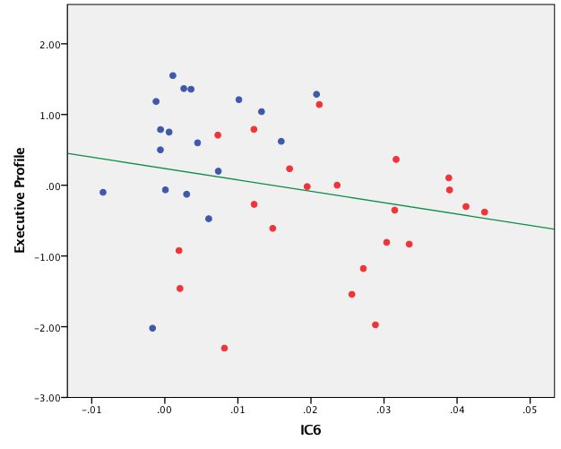

The scatterplot depicts the (non-significant) relationship (green line; r=-0.23, p=0.159) between IC6 mixing coefficients (x-axis) and the participants’ executive profile (i.e., proxy of basic executive performance as a result of a PCA on ENB-2 scores; y-axis). Red dots indicate AUD patients and blue dots indicate HC.

Figure S2. Correlation between IC11 and participants’ executive profile

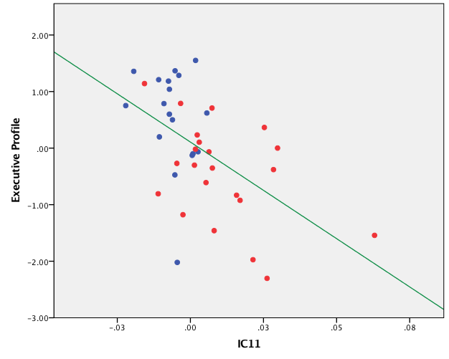
The scatterplot depicts the significant relationship (green line; r=-0.54, p<0.001) between IC11 mixing coefficients (x-axis) and the participants’ executive profile (i.e., proxy of basic executive performance as a result of a PCA on ENB-2 scores; y-axis). Red dots indicate AUD patients and blue dots indicate HC.

Figure S3. Correlation between IC6 and lifetime duration of alcohol abuse

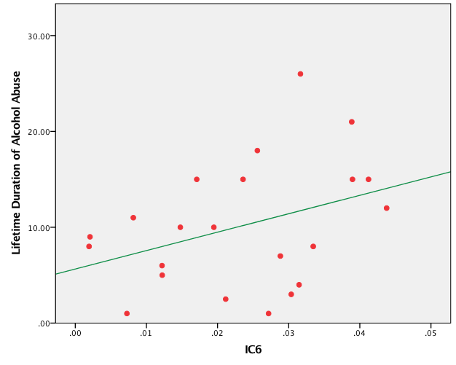
The scatterplot shows the (non-significant) relationship (r=0.37, p=0.09) between AUD patients’ IC6 mixing coefficients (x-axis) and the lifetime duration of alcohol abuse (years; y-axis).
Figure S4. Correlation between IC11 and lifetime duration of alcohol abuse

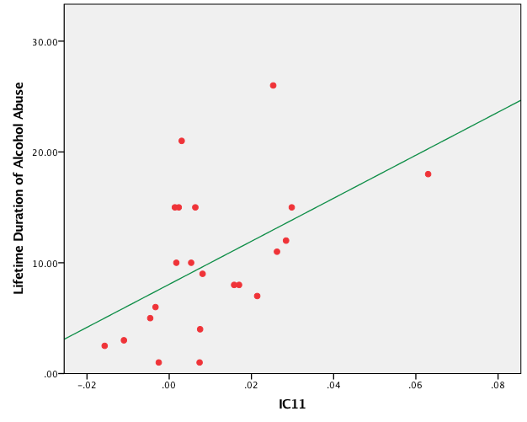
The scatterplot shows the significant relationship (r=0.51, p=0.016) between AUD patients’ IC11 mixing coefficients (x-axis) and the lifetime duration of alcohol abuse (years; y-axis).

Figure S5. Correlation between IC6 and daily alcohol consumption

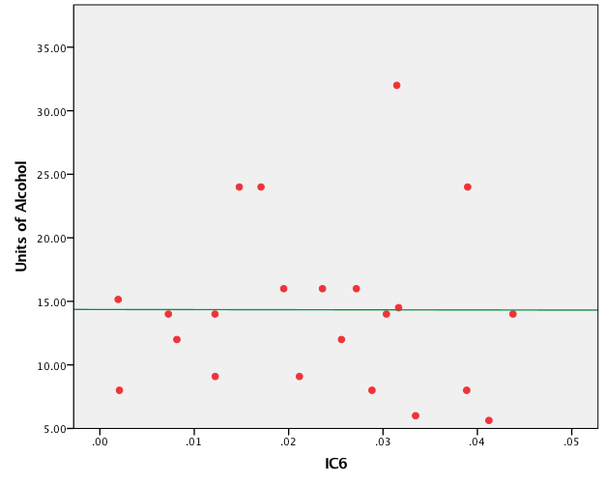
The scatterplot shows the (non-significant) relationship (r=-0.002, p=0.994) between AUD patients’ IC6 mixing coefficients (x-axis) and the daily alcohol consumption (Units of Alcohol; y-axis).

Figure S6. Correlation between IC11 and daily alcohol consumption

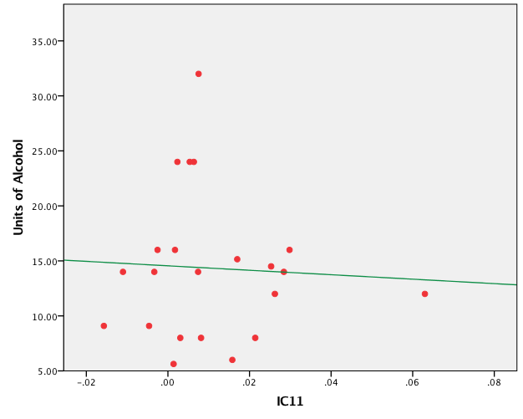
The scatterplot shows the (non-significant) relationship (r=-0.05, p=0.499) between AUD patients’ IC11 mixing coefficients (x-axis) and the daily alcohol consumption (Units of Alcohol; y-axis).

References

Eickhoff S, Stephan KE, Mohlberg H, Grefkes C, Fink GR, Amunts K, et al. (2005). A new SPM toolbox for combining probabilistic cytoarchitectonic maps and functional imaging data. NeuroImage. doi:10.1016/j.neuroimage.2004.12.034

Galandra, C., Basso, G., Manera, M., Crespi, C., Giorgi, I., Vittadini, G., et al. (2018b). Salience network structural integrity predicts executive impairment in alcohol use disorders. Sci. Rep. 8. doi:10.1038/s41598-018-32828-x.

Galandra, C., Basso, G., Manera, M., Crespi, C., Giorgi, I., Vittadini, G., et al. (2019). Abnormal fronto-striatal intrinsic connectivity reflects executive dysfunction in alcohol use disorders. Cortex 115. doi:10.1016/j.cortex.2019.01.004.

Hua, K., Zhang, J., Wakana, S., Jiang, H., Li, X., Reich, D. S., et al. (2008). Tract probability maps in stereotaxic spaces: Analyses of white matter anatomy and tract-specific quantification. Neuroimage. doi:10.1016/j.neuroimage.2007.07.053.

Mondini, S. (2011) Esame Neuropsicologico Breve 2: Una batteria di test per lo screening neuropsicologico. Cortina.

Wakana, S., Caprihan, A., Panzenboeck, M. M., Fallon, J. H., Perry, M., Gollub, R. L., et al. (2007). Reproducibility of quantitative tractography methods applied to cerebral white matter. Neuroimage. doi:10.1016/j.neuroimage.2007.02.049.

