Supplementary Material

Highly Ordered Mesoporous NiCo₂O₄ as a High Performance Anode Material for Li-ion Batteries
Guangyu Wu1*†, Qilong Ren2†, Weinan Xing2*, Jiangang Han2, Pingping Li 2, Bo Li 3*,
Junye Cheng4, Shuilin Wu4, Rujia Zou1 and Junqing Hu1*
1 College of Biology and the Environment, Nanjing Forestry University, Nanjing, China,
2 State Key Laboratory for Modification of Chemical Fibers and Polymer Materials, College of Materials Science and Engineering, Donghua University, Shanghai, China,
3 Department of Vascular Surgery, Shanghai Ninth People’s Hospital, Shanghai JiaoTong University School of Medicine, Shanghai, China,
4 Department of Materials Science and Engineering, Center of Super-Diamond and Advanced Films, City University of Hong Kong, Hong Kong, China
* Correspondence:
Guangyu Wu：gywuchem@163.com
Weinan Xing: xingweinan@126.com
Bo Li: boli@shsmu.edu.cn
Junqing Hu: hu.junqing@dhu.edu.cn

1. Electrochemical Measurements
The electrochemical performances of mesoporous NiCo₂O₄ microspheres were carried out using coin cells (CR2032), in which lithium was used as the counter electrode and reference electrode. The working electrode was constituted by the (70 Wt %) mesoporous NiCo₂O₄ microspheres, (20 Wt %) acetylene carbon black and (10 Wt %) polyvinylidene fluoride (PVDF). After stirring, the mixed materials were pasted uniformly on to the copper foil substrate. Finally, this electrode was moved to a vacuum oven at 60 °C overnight. The microporous polythene (Celgard2400) was used as a separator, and the electrolyte employed was 1 M LiPF6 in ethylene carbonate and diethyl carbonate. The test cells were assembled in an argon-filled glovebox (UniLab, MBRAUN, Germany). The galvanostatic charge-discharge cycling was carried out using NEWARE-BTS battery tester with a potential window of 0.01-3.0V at room temperature. All the cells were measured on an Autolab (PGSTAT302N) electrochemistry workstation.

2. Supplementary Data
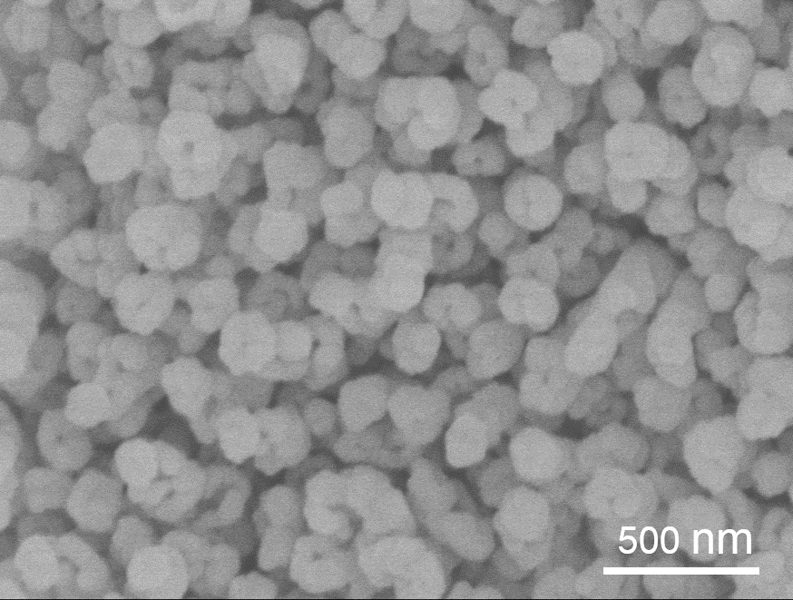
Figure S1. low-resolution SEM image of ordinary NiCo₂O₄.

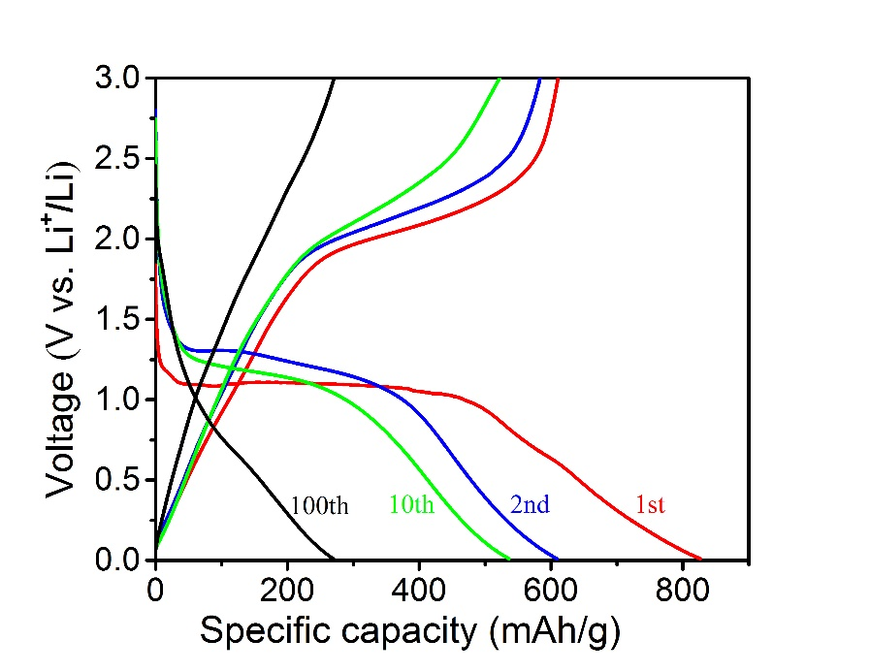
Figure S2. Galvanostatic discharge and charge profiles for 1st, 2nd, 10th, 100th cycles of ordinary NiCo₂O₄ at the current densities of 100 mA.g⁻¹.

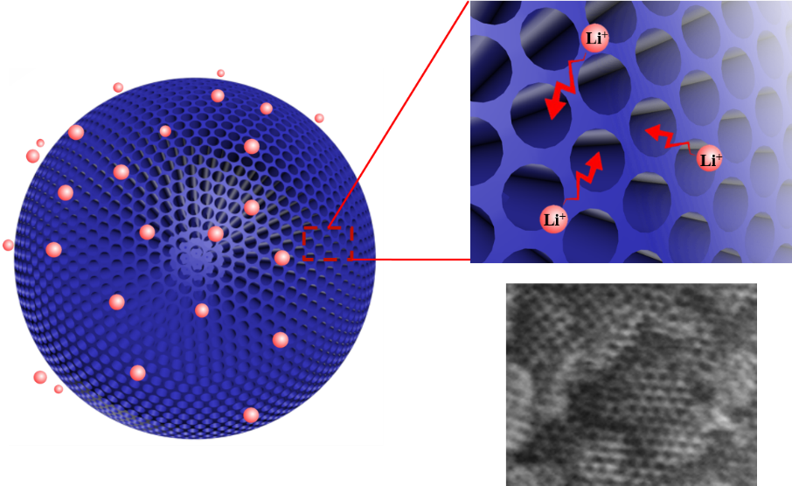
Figure S3. Schematic illustration of the 3D mesoporous network of ion transport
pathways and TEM image of its pore. The scale bar is 10nm.

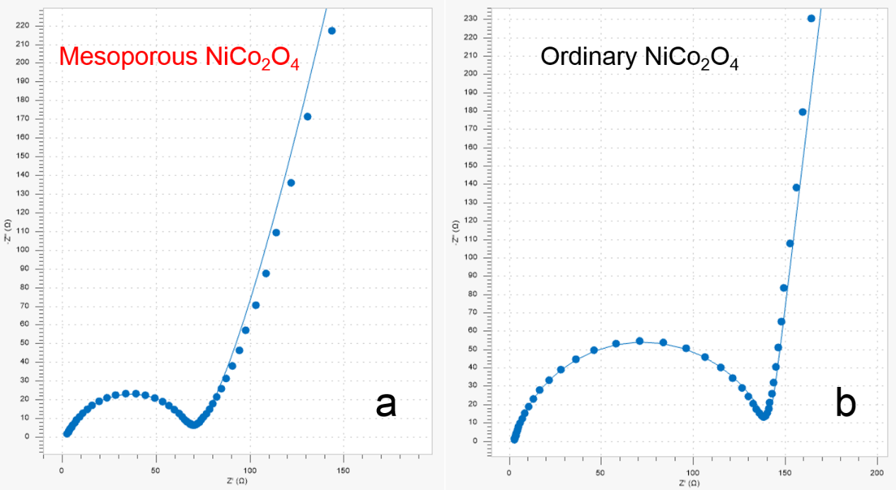
Figure S4. EIS spectra of (a) mesoporous NiCo₂O₄, (b) ordinary NiCo₂O₄ electrodes that contain the fitting curves.

Table S1: Electrochemical impedance spectroscopy (EIS): initial resistance (Rs) and charge transfer resistance (Rct).
Materials Rs (Ω) Rct (Ω)
Ordinary NiCo₂O₄ 2.5 134
Mesoporous NiCo₂O₄ 1.8 1 66

