Supplementary Material

**Hollow** WO3/SnO2**hetero-nanofibers: Controlled synthesis and high efficiency of acetone vapor detection**

**Hongyun Shaoa,b, Minxuan Huanga,b, Hao Fua,b, Shaopeng Wanga,b,c, Liwei Wanga,b,c,*, Jie Lud,*, Yinghui Wanga,b, Kefu Yua,b,\***

a School of Marine Sciences, Guangxi University, Nanning, 530004, China

b Guangxi Laboratory on the Study of Coral Reefs in the South China Sea, Nanning, 530003, China

c Guangxi Key Laboratory of Processing for Nonferrous Metallic and Featured Materials, Nanning, 530003, China

d College of Life Science and Technology, Guangxi University, Nanning, 530004, China

\***Corresponding Authors**

Email: wangliwei0427@163.com; jlu92@163.com; kefuyu@scsio.ac.cn;

**Supplementary Material available:** The following files are available free of charge.

**Fig. S1.** EDS spectrum image of 0.3 wt% WO3/SnO2 HNFs.

**Fig. S2.** Long-term stability of the sensors consisting of WO3/SnO2 HNFs to 100 ppm of acetone within 30 days.

**Fig. S3.** Response/recovery times of 0.3 wt% WO3/SnO2 sample to 100 ppb acetone.

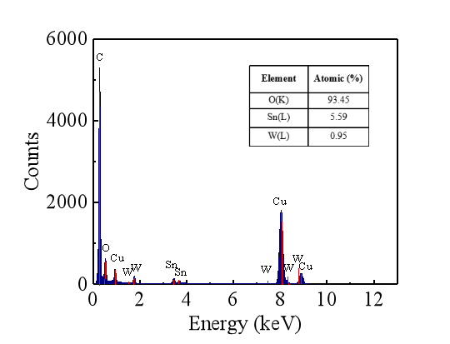

**Fig. S1.** EDS spectrum image of 0.3 wt% WO3/SnO2 HNFs.



**Fig. S2.** Long-term stability of the sensors consisting of pure SnO2 and three groups of WO3/SnO2 (WO3 of 0.1, 0.3, 0.9 wt%) to 100 ppm acetone within 30 days.



**Fig. S3.** Response/recovery times of 0.3 wt% WO3/SnO2 sample to 100 ppb acetone.