Supplementary Material

1. Supplementary text
The choice of the time window width in any spectral analysis is an important issue. For our purposes, it was fundamental to isolate from the seismic trace a proper portion of the signal in order to retrieve information on the anelastic effect on P-waves. In our experimental configuration, it was very important to discard contribution of surface waves from the selected time window. Therefore, we theoretically estimated the arrivals of Rayleigh waves for every source-receiver couples. To this purpose, we considered average surface S-wave velocities of 100 m/s (Serra et al., 2016) and we took into account that V_{R} $\sim$ 0.92 V_{S}. We also computed for each signal the time interval between the start of the time window (0.01 s before the picked P-wave arrival) and the theoretically estimated Rayleigh wave arrival (figure S1a). We observed that only the 4.7% out of the total number of data may include a small portion of surface waves in a 0.126 s wide time window. Still the 1.5% out of the total number of data may include effects of surface waves in a 0.1 s wide time window (figure S1a). On these grounds, we performed again the spectral analyses described in the main text in two different time windows: 1) 0.1 s; 2) 0.08 s. Then, we compared the t* measurements retrieved in different wide time windows: 0.126 s, 0.1 s, 0.08 s (figure S1b, S1c). We observe that t* computed in time windows properly selected in order to exclude theoretical arrivals of surface waves are very similar to those obtained in a fixed 0.126 s wide signal window. In addition to it, a too short time window would lower too much the spectral resolution.
Therefore, we may conclude that a fixed 0.126 s wide time window may include surface waves in the selected signal, but only for a very small number of data (less than 5%). In particular, only source-receiver couples with an “epicentral” distance lower than 20 m are affected by this choice. Nevertheless, the t* measurements are very little influenced by the presence of a small portion of other phases than the P-waves in the selected signal.

2. Supplementary Figures
In this material we provide supplementary figures about influence of the choice of time window on t* measurements (S1), inversion parameters tuning (S2, S3) and attenuation model resolution (S4,S5).
2.1 Supplementary Figures
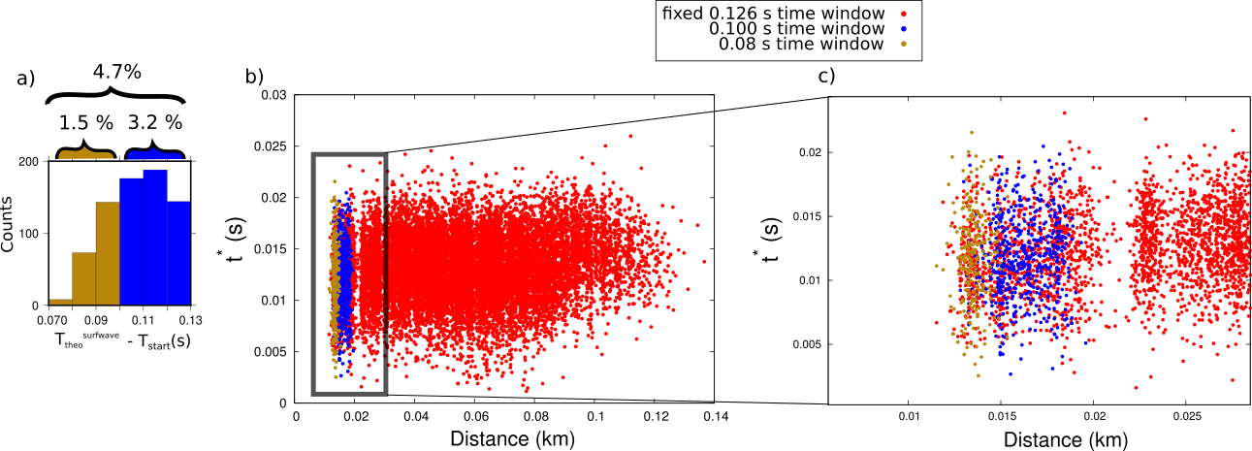
Supplementary Figure 1. a) Histogram of the time intervals between the start of the selected signal time window and the theoretical surface wave arrivals. b) Comparison between t* measurements performed in different signal time windows. The red points represent the t* measured in the fixed 0.126 s wide time window. The blue points represent t* measured in the 0.1 s wide time window. The analyses in this signal time window were performed only for those data for which the theoretical surface wave arrivals were estimated in a time interval between 0.1 and 0.126 s from the start of the signal window. The red points represent t* measured in the 0.08 s wide time window. The analyses in this signal time window were performed only for those data for which the theoretical surface wave arrivals were estimated in a time interval between 0.08 and 0.1 s from the start of the signal window. The black box represents the zoomed-up area of figure c. c) Zoom of the area identified by the black box in figure b.

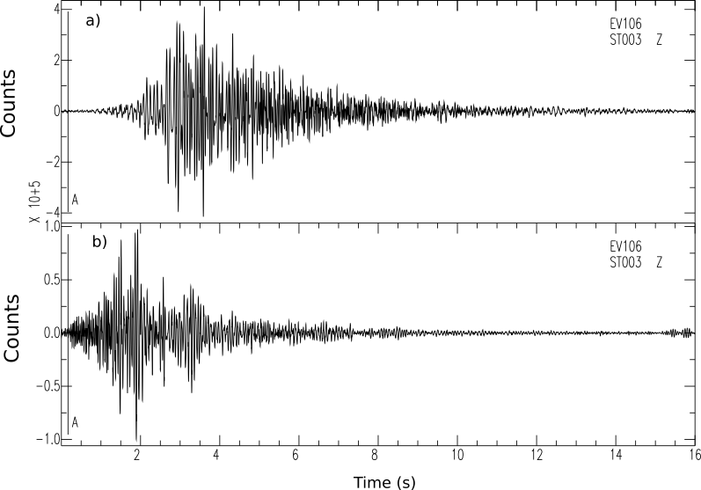
Supplementary Figure 2. a) Raw signal generated by shot 106 and recorded by station 003, about 130 m far from the source. b) Processed signal, after cross-correlation and minimum-phase filter, generated by shot 106 and recorded by station 003. In both figures, the vertical line, A-labeled, represents the P-wave first arrival time.

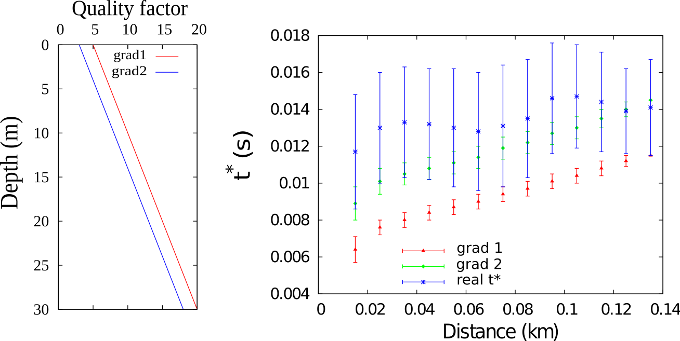
Supplementary Figure 3. Left) Two examples of single linear gradient of variation of Q_{P} as a function of depth. Right) Comparison between synthetic (red and green points) and real (blue points) binned t* distributions as a function of distance. We clearly observe that the single linear gradient of variation of Q_{P} produces an increasing trend of t* as a function of distance, which do not fit the almost constant average trend of real data.

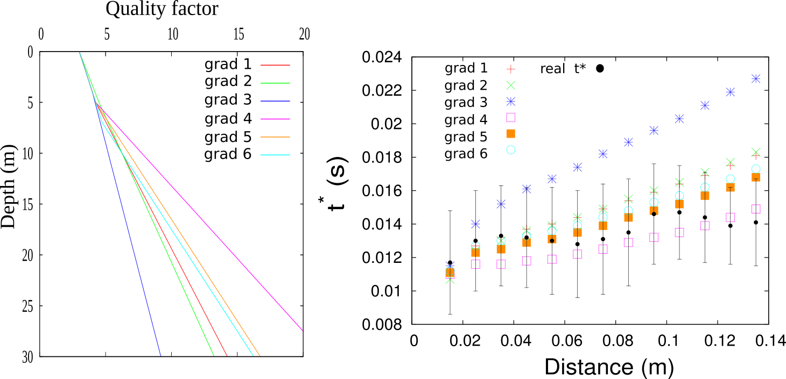
Supplementary Figure 4. Left) 6 examples of Q_{P} models described as piecewise linear profiles composed of two different gradients of variation of Q_{P} as a function of depth Right) Comparison between synthetic and real (black points) binned t* distributions as a function of distance. The same color code of the left figure was adopted. We clearly observe that the two-gradients 1D Q_{P} model produce an increasing trend of t* as a function of distance, which do not fit the almost constant average trend of real data.

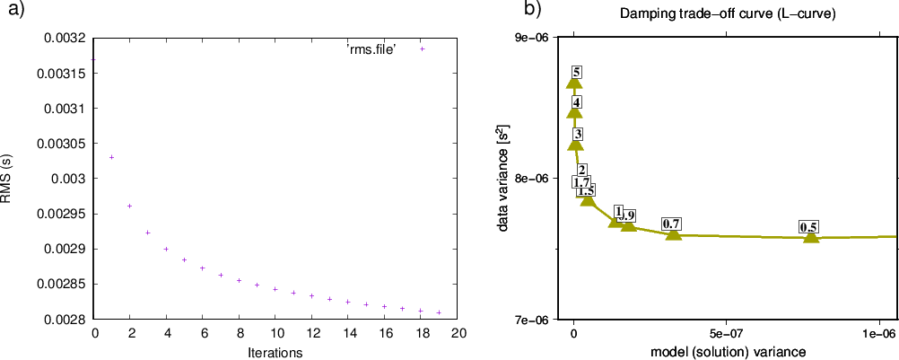
Supplementary Figure 5. a) Rms curve as a function of number of iterations for the inversion procedure. The final RMS reduction is about 15%. b) Trade-off curves for selecting optimal damping value for real data sets. The chosen damping for the inversion is 1.5.

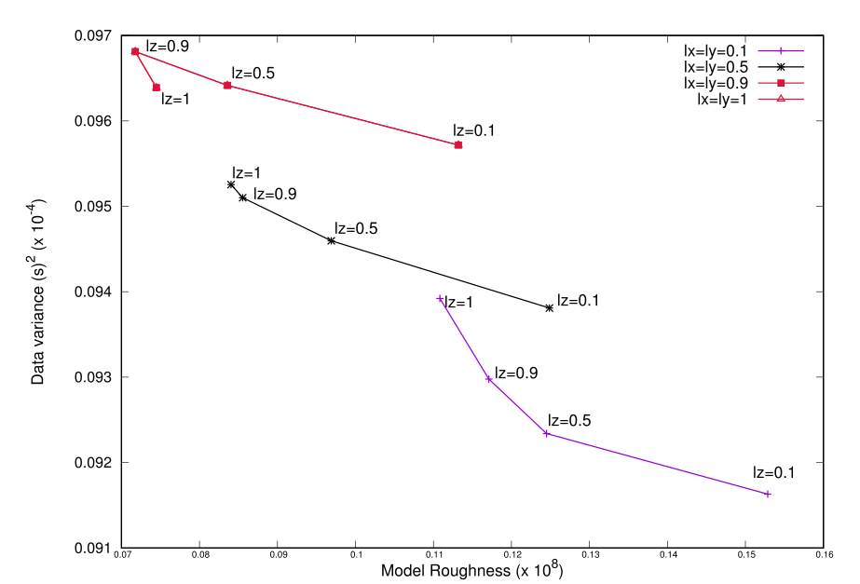.
Supplementary Figure 6. Trade-off curves between residuals variance and model roughness. These have been obtained by fixing the damping parameter to 1.5, retrieved at the previous step, and by changing the combination between smoothing parameters. Each curve represents a different combination between Lx, Ly and Lz. In particular, Lx and Ly parameters are fixed at the same value, and lz changes along the different points of the curve. The correspondence between the different combinations of smoothing parameters and the colors of the curve is shown in the box at the right top of the figure. The selected combination is Lx=Ly=0.1 and Lz=0.5.
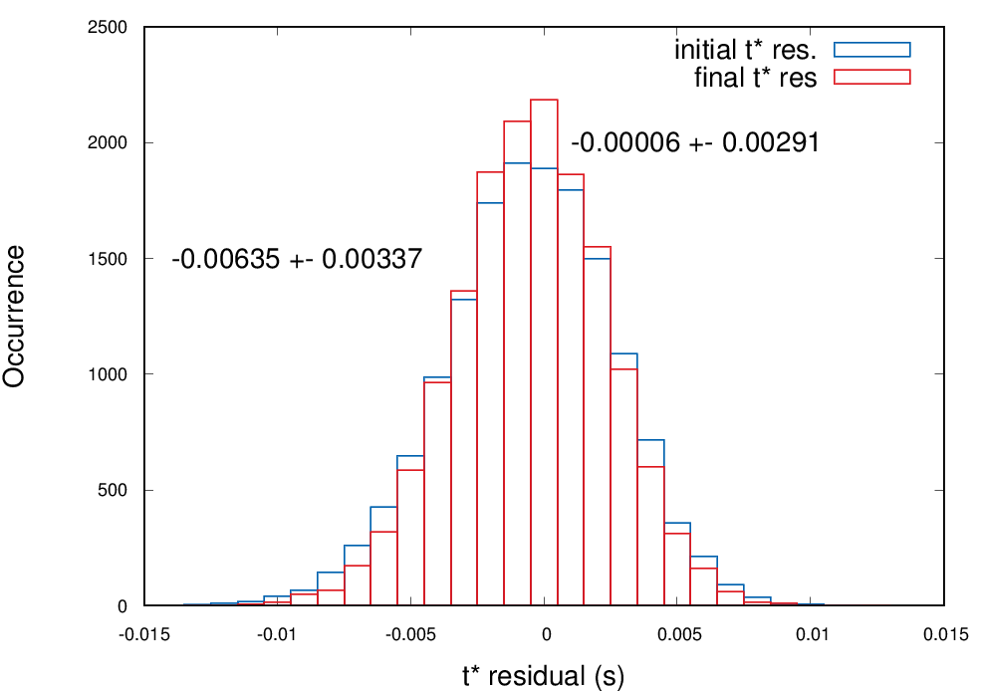

Supplementary Figure 7. Comparison between t* residuals at the initial and the final inversion iteration. For each distribution we reported the mean and the standard deviation.

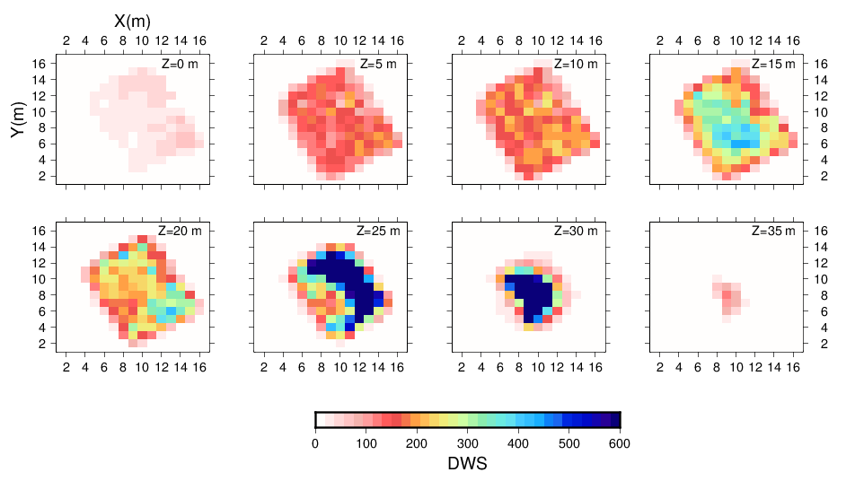
Supplementary Figure 8 Plot of the Derivative Weight Sum (DWS), which measures the ray density in the neighborhood of every node of the model grid (Hauksson and Shearer, 2006). The images show that the 3D and model is well resolved from 5 to 30 km depth. For the contouring of well resolved region in fig. 7 we used the DWS value of 100, i.e. about the 15% of maximum DWS value.
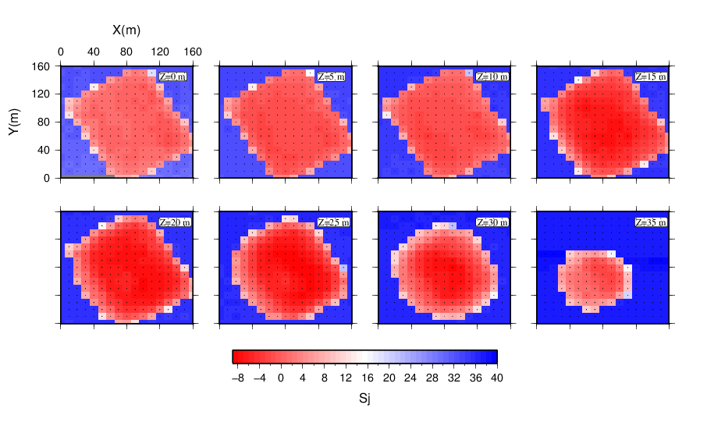

Supplementary Figure 9 Plot of the spread function $S_{j}$ (Michelini and McEvilly, 1991) related to off-diagonal elements of resolution matrix. The images show that the spreading of 3D model nodes is low (high $S_{j}$ values) in well resolved region. For the contouring of well resolved region in fig. 9 we used the Sj value of 0, binding the RDE to be higher than 0.85 (see fig. 7 of main text).

