Supplementary Material

Integrative Multi-kinase Approach for the Identification of Potent Antiplasmodial Hits
Marilia N. N. Lima¹, Gustavo C. Cassiano², Kaira C. P. Tomaz², Arthur C. Silva¹, Bruna K. P. Sousa¹, Leticia T. Ferreira², Tatyana A. Tavella², Juliana Calit³, Daniel Y. Bargieri³, Bruno J. Neves⁴, Fabio T.M. Costa², Carolina Horta Andrade^{1,2*}
¹LabMol – Laboratory for Molecular Modeling and Drug Design, Faculty of Pharmacy, Federal University of Goiás, Goiânia, Brazil
²Laboratory of Tropical Diseases – Prof. Dr. Luiz Jacintho da Silva, Department of Genetics, Evolution, Microbiology and Immunology, Institute of Biology, UNICAMP, Campinas, Brazil
³Department of Parasitology, Institute of Biomedical Sciences, University of São Paulo, São Paulo, Brazil
⁴Laboratory of Cheminformatics, University Center of Anápolis/UniEVANGELICA, Anápolis, Brazil
* Correspondence:
Carolina Horta Andrade
carolina@ufg.br

Supplementary tables
Table S1. Selected inhibitors to generate the shape-based models
Kinase | Template Structure | Template Shape
CDPK1 | IC₅₀ = 0.007 µM  SID 307078537  Template I* | 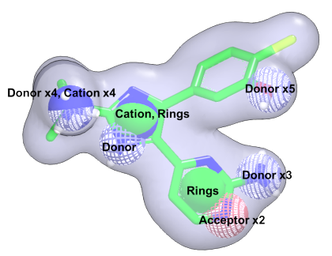
CDPK1 | IC₅₀ = 0.015 µM  SID 307073749  Template II | 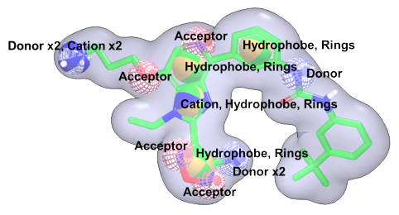
CDPK1 | IC₅₀ = 0.094 µM  SID 307076176  Template III | 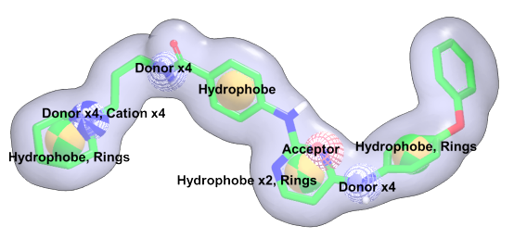
CDPK4 | IC₅₀ = 0.021µM  SID 307068815  Template IV* | 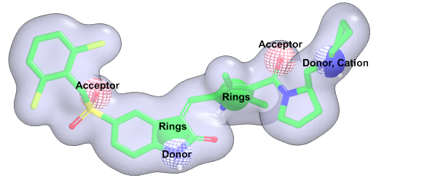
CDPK4 | IC₅₀ = 0.021µM  SID 307068815  Template V | 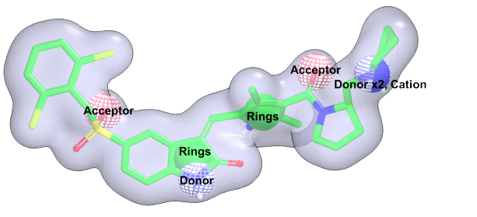
CDPK4 | IC₅₀ = 0.021µM  SID 307068815  Template VI | 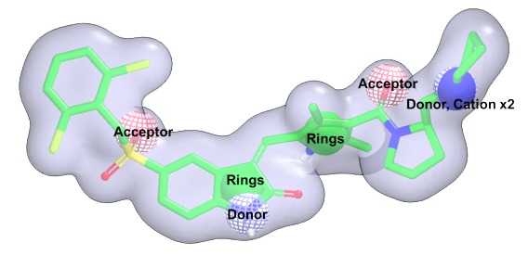
PK6 | IC₅₀ = 0.042µM  SID 307071719  Template VII* | 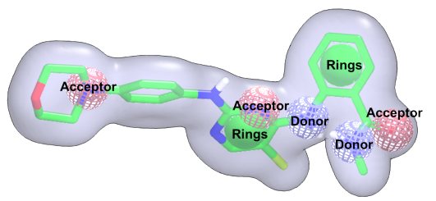
PK6 | IC₅₀ = 0.042µM  SID 307071719  Template VIII | 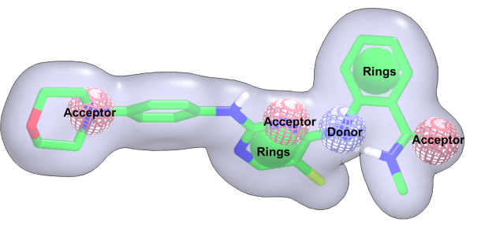
PK6 | IC₅₀ = 0.042µM  SID 307071719  Template XI | 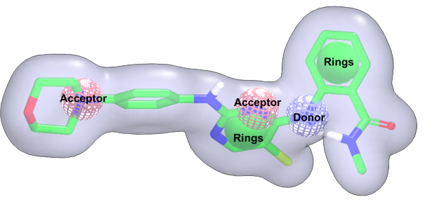
*Selected template.

Table S2. Summarized statistical characteristics of phenotypic ML models after Y-Randomization test.
Model | CCR | SE | SP | PPV | NPV | Coverage
P. falciparum 3D7 strain
Avalon | 0.51 | 0.50 | 0.51 | 0.50 | 0.52 | 1
MACCS | 0.49 | 0.50 | 0.48 | 0.49 | 0.49 | 1
Morgan | 0.49 | 0.46 | 0.52 | 0.49 | 0.48 | 1
FeatMorgan | 0.50 | 0.50 | 0.50 | 0.50 | 0.51 | 1
AtomPair | 0.51 | 0.50 | 0.53 | 0.51 | 0.51 | 1
P. falciparum W2 strain
Avalon | 0.51 | 0.50 | 0.51 | 0.51 | 0.51 | 1
MACCS | 0.49 | 0.51 | 0.47 | 0.49 | 0.49 | 1
Morgan | 0.50 | 0.47 | 0.54 | 0.51 | 0.50 | 1
FeatMorgan | 0.49 | 0.49 | 0.48 | 0.48 | 0.49 | 1
AtomPair | 0.51 | 0.46 | 0.55 | 0.51 | 0.50 | 1
CCR: Correct Classification Rate; SE: Sensitivity; SP: Specificity; PPV: Positive Predictive Value; NPV: Negative Predictive Value; AD: Applicability Domain

Table S3. Docking coordinates and validation metrics of homology modeling obtained using MolProbity webserver.
Kinase | Template | Docking Coordinates | Validation Metrics - MolProbity
 |  |  | Clash Score | Poor rotamers | Favored rotamers | Ramachandran outliers | Ramachandran favored | MolProbity Score
CDPK1 | 3T3U | 19.24Å x 16.06Å x 63.58Å | 7.1 | 0.00% | 99.30% | 0.21% | 98.30% | 1.39
CDPK4 | - | 31.10Å x -12.94Å x -0.14Å | - | - | - | - | - | -
PK6 | 3EZV | 0.70Å x 28.60Å x 9.53Å | 6.77 | 1.47% | 96.70% | 0.34% | 97.25% | 1.64
*For CDPK4 had used 4QOX crystal structure

